hi

Homework3

Fall 2018

by Yuchen Duan, Ruozhong Yang, Fengkai Xu, Biao Feng, and Joseph Loss

**10/21/2018**

**University of Illinois at Urbana-Champaign**

**IE598 - Machine Learning in Finance**

Contents

Chapter 1: Moody’s Bond Rating Classifier 1

Exploratory Data Analysis 1

Preprocessing & Feature Extraction/Selection 1

Model Fitting & Evaluation 1

Hyperparameter Tuning 1

Ensembling 1

Conclusions 1

Chapter 2: USPHCI Economic Activity Forecast 2

Exploratory Data Analysis 2

Preprocessing & Feature Extraction/Selection 2

Model Fitting & Evaluation 2

Hyperparameter Tuning 2

Ensembling 2

Conclusions 2

Appendix 3

Github Repository 3

# Chapter 1: Moody’s Bond Rating Classifier

## Exploratory Data Analysis

We’ve added a few tips (like this one) to help you get started.

When you click tip text, the whole tip is selected. Just start typing to replace it with your own.

The headings, however, are typical annual report headings that you might want to use as-is.

## Preprocessing & Feature Extraction/Selection

We love the cover page of this template. But we also think you should have options. On the Insert tab, click Cover Page for a gallery of choices. And don’t worry about text you’ve already added to that page. It will still be there after you choose another cover.

## Model Fitting & Evaluation

1. Model 1
2. Model 2
3. Model 3

## Hyperparameter Tuning

Insert text here

## Ensembling

INSERT TEXT HERE

## Conclusions

INSERT TEXT HERE

# Chapter 2: USPHCI Economic Activity Forecast

## A close up of a map Description generated with high confidenceExploratory Data Analysis

Figure 3:EDA - Feature Exploration

Figure 1: df.info

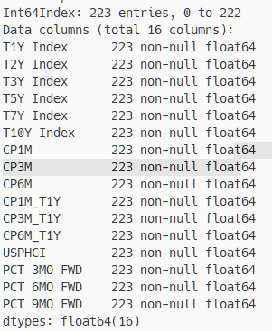

Figure 4: Correlation Matrix of EconCycle Data

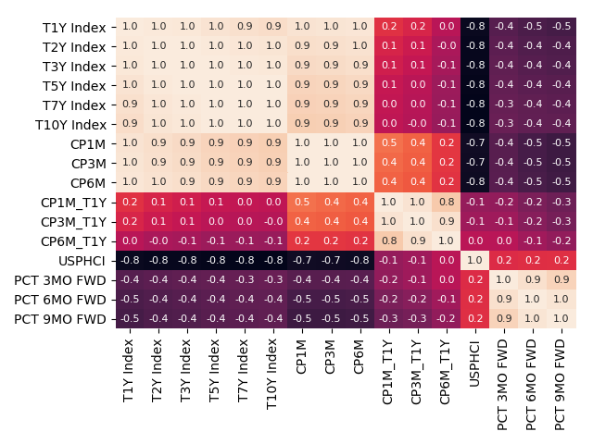

Figure 2: df.describe

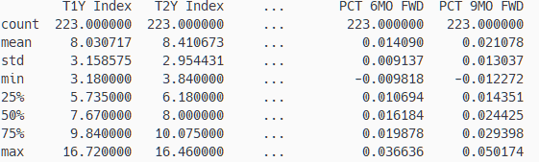

## 

## A screenshot of a cell phone Description generated with high confidenceA screenshot of a cell phone Description generated with high confidence

## Preprocessing & Feature Extraction/Selection

We love the cover page of this template. But we also think you should have options. On the Insert tab, click Cover Page for a gallery of choices. And don’t worry about text you’ve already added to that page. It will still be there after you choose another cover.

## Model Fitting & Evaluation

1. Model 1
2. Model 2
3. Model 3

## Hyperparameter Tuning

Insert text here

## Ensembling

INSERT TEXT HERE

## Conclusions

INSERT TEXT HERE

# Appendix

## Github Repository

[IE598_F18_MLF_GROUP_PROJECT (LINK)](https://github.com/chicago-joe/IE598_F18_MLF_GP/tree/master)