12/13/2018

Joseph Loss (loss2)

**FIN 500: Homework 3**

**Chapter 9**

Q1a. 

Q1b. These portfolios are different from what most investors hold in several ways. The portfolios we created only consist of the optimal risky portfolio P. Most investors hold a risk-free portfolio F and the optimal risky portfolio P. The key here is that the optimal risky portfolio is the same for all investors; the only difference between investors will be the complete portfolio allocation (their allocation between risk-free portfolio F and the optimal risky portfolio P).

The optimal risky portfolio “to rule them all” doesn’t quite hold up in reality either. This is due to many variables, including:

* Difficult to predict expected returns, volatilities, and correlations
* Inconsistent historical estimation
* Self-imposed constraints and investment mandates
* Different investment horizons and different life exposures (health, etc.)

Q1c. As we can see from Figure 9.1 on the following page, constraining the portfolios to non-negative Min/Max has a dramatic effect on the portfolio weight allocation and optimal sharpe ratio. In all three cases (with the exception of AU in the commodity portfolio), the optimal portfolio weight under the new constraint is between only 2 specific investments. In particular, the ETF and Combined portfolios both invested about 45/55 in SPY/AGG and zeroed out everything else!

These constraints have a dramatic effect on our optimal sharpe ratio. The ETF and combined portfolios both saw a -0.45 decrease in their optimal SR, which tells us that constraining ourselves with non-negative portfolio weights is a massive limitation that we’re imposing on our optimal portfolio.

Figure 9.1



**Chapter 12**

Q2a. See Figure 12.1 *Figure 12.1*



Q2b. As we can see from Figure 12.2, almost 95% of the variation is caused by the first 3 principal components. If we were to graph the first principal component, we would see that the first eigenvector has positive values. A change in this direction either increases all yields or decreases all yields, roughly by the same amount *(i.e. approx. parallel shifts in the yield curve).*However, the standard deviation of these components are pretty small, so we should not expect to see huge shifts of the curve in either direction in a single day.

Figure 12.2



**Chapter 14**

Q3a. See Figure 14.1

Q3b. We can see from the multi-index CAPM that most of these stocks are mid or large-cap, as their coefficients are positive and average ~1 for the SPX, while for Russell 2000 the coefficients are negative and small. This imbalance tells us that the stock’s performance is related to the outperformance of mid/large-cap versus small-cap equities.

Furthermore, we can see that the CAPM involving solely the SPX has a slightly higher Adjusted $R^{2}$ than either the SPX/RUT combination model and the RUT model. This would further indicate that the SPX model is a better representation of the data, and perhaps we should consider using the CAPM SPX model versus the other two (SPX/RUT combination doesn’t add much benefit for additional complexity).

Lastly, although all of the models have an insignificant alpha, the CAPM SPX model has a larger positive coefficient for the market index than the CAPM RUT, and it also does not have any negative coefficients like we see in the CAPM SPX/RUT. This likely confirms that that the CAPM SPX model is better than the other two models.

Figure 14.1 CAPM



**Chapter 15**

Q4a. See Figure 15.1

Q4b. The growth rate of Industrial Production and Expected Inflation seem to be the most useful for the majority of the assets, except for HON and GD. In these two, the Inflation Surprise and Curve Factor appear to be more useful, given their coefficients. I’m surprised that IndProd has the best coefficients in nearly every stock/index because most analyses has found that to be the least informative factor!

Figure 15.1



Q5a. See Figure 15.2

Q5b. We would expect to see a greatly reduced variance in the implied risk premium for stocks. However, we see that this is not the case, and this is likely due to the SPX weighting (nearly double that of any other equity).

Figure 15.2



Q6a. See Figure 15.3

Q6b. We can see that the FFM has an insignificant alpha, basically 0 for all equities. However, the t-values are significantly larger, as well as the positive coefficients which is extremely telling of something important. Because the FFM has larger positive coefficients than the market index models, this confirms that a broader-based index (market index + some SMB) yields a better CAPM with a smaller alpha.

Figure 15.3



**Chapter 18**

Q7.

Figure 18.1

Figure 18.2

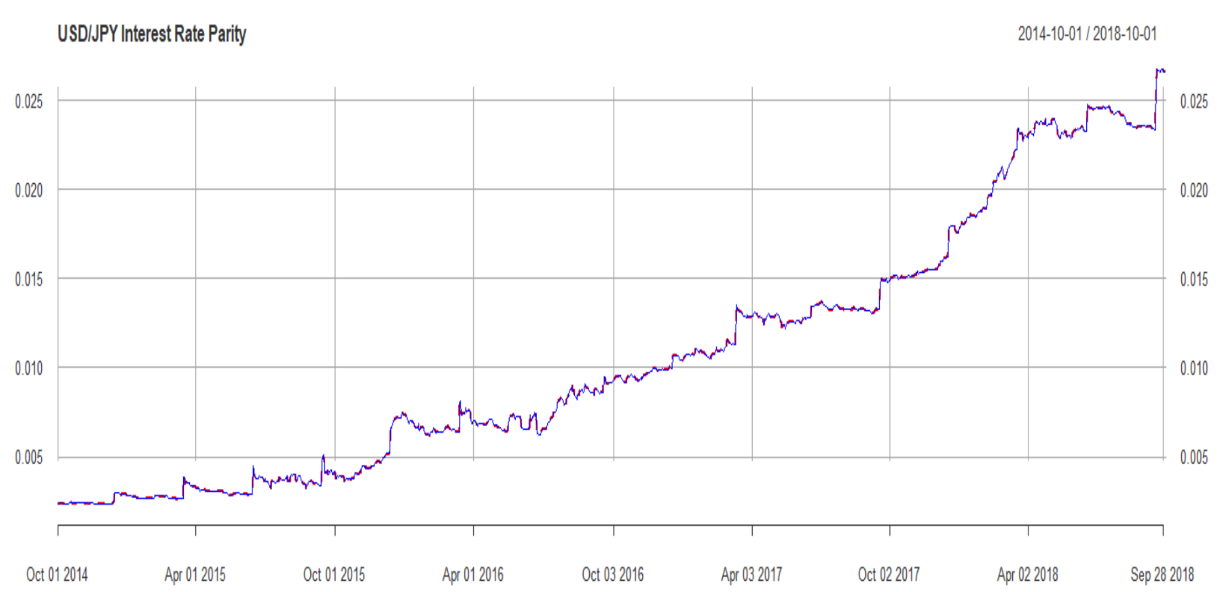

USDJPY Parity (interest rate difference)

Eurodollar Deposits interest rate