**Chapter 2, exercise 1**

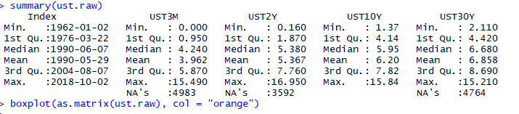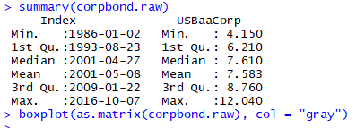

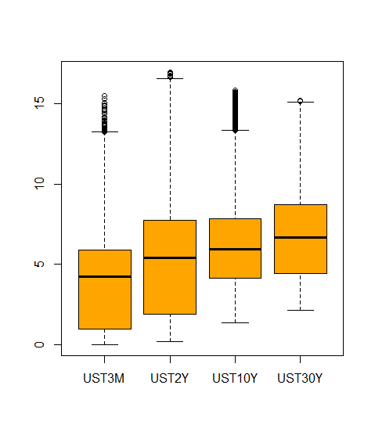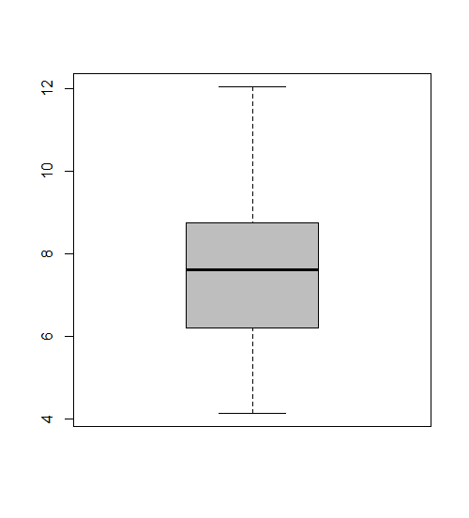

look’s stable in boxplot:

IQR range are small, the distance between Q1 and Q3. And line up to different boxplot mean are in center for some them. But there are some outliers around max.

Corporate Bonds boxplot:

IQR range are small and mean are in center.

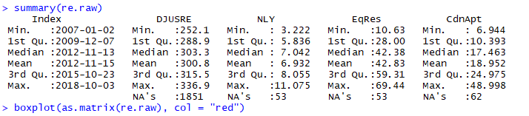



look’s stable in boxplot:

IQR range are small in most of them and don’t line up to different boxplot mean are in center for some them. There are very small amount of outliers.

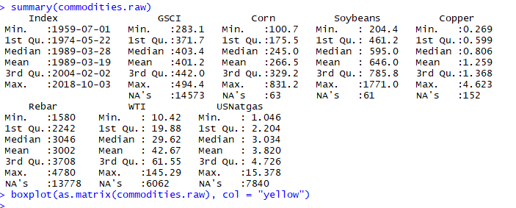



look’s not stable in boxplot:

IQR range are huge and don’t line up to different boxplot mean are not in center for some them. The overall range between max and min are large. And there are many outliers.

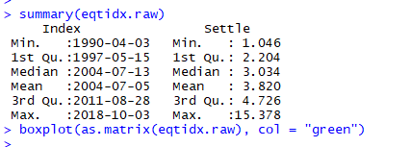



look’s unstable in boxplot:

IQR range are huge and don’t line up to different boxplot mean are not in center for some them. The overall range between max and min are large. And there are many outliers.

Similar to Commodities behaver. It’s tend is wildly.

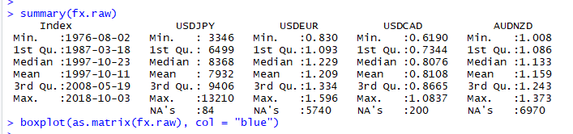

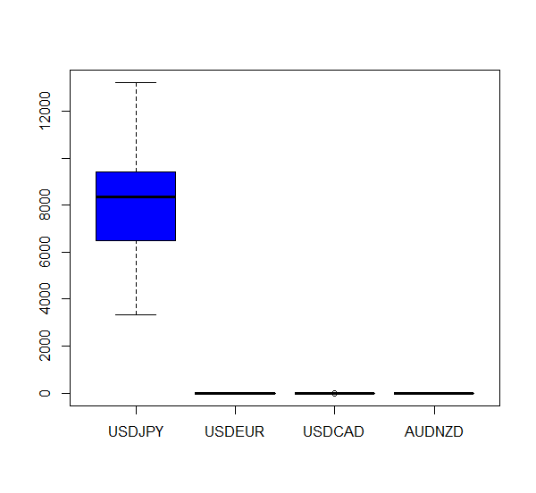

look’s stable in boxplot:

IQR range are small and but don’t line up to different boxplot but mean is in center for some them

It looks stable if only using summary.

**Chapter 2, exercise 2**

1. Fixed income
   1. short-term graphs are similar. The slop can be fit in regression

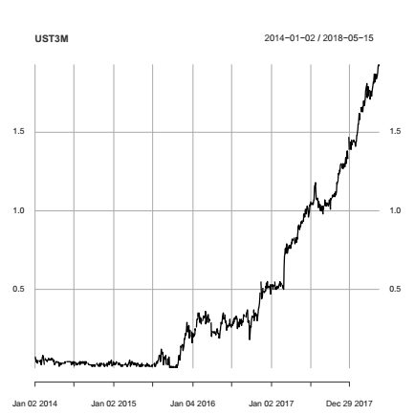 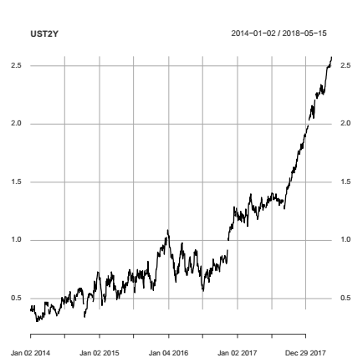

* 1. long term graphs are similar but different from short term. These graphs have many peak and hole

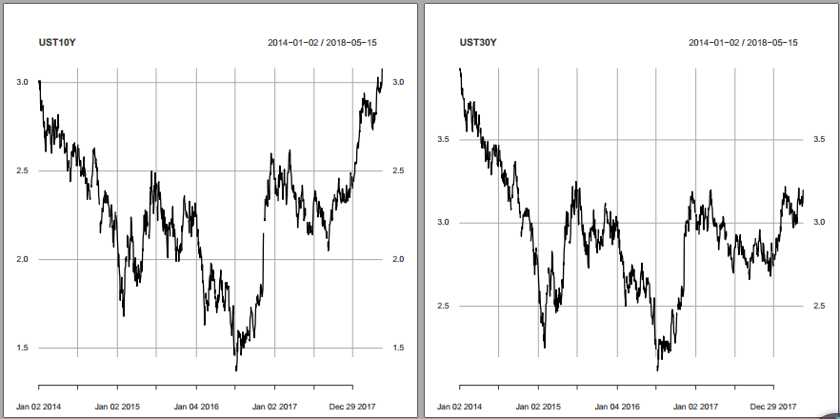

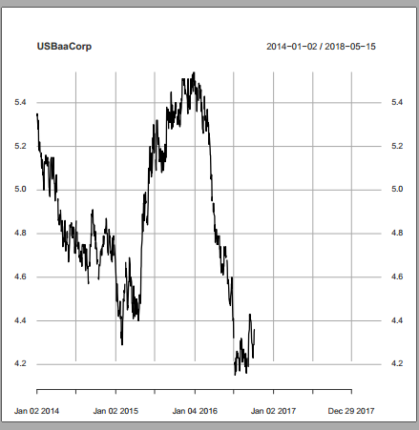

* 1. A graph that is different for all others and missing dates

1. Real Estate Indices (US/Canada) and RE investment/trust firms

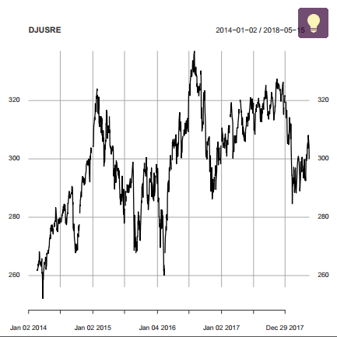 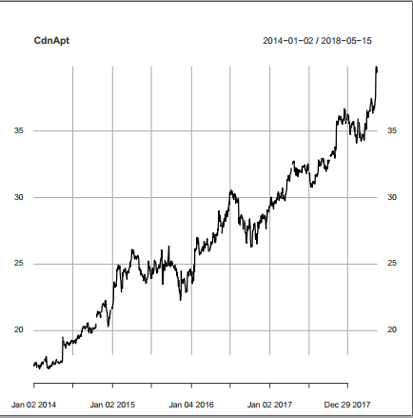

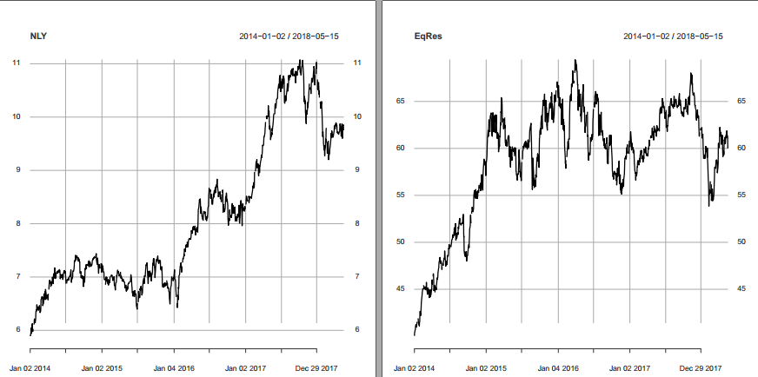

* 1. DJUSRE NLY and EqRes have close behaver going up and down but not to close
  2. CdnApt is different form all of them more liner like short-term ust

1. Commodities

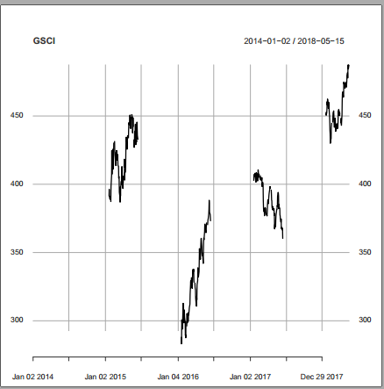

* 1. GSCI graph that is different for all others and missing datas

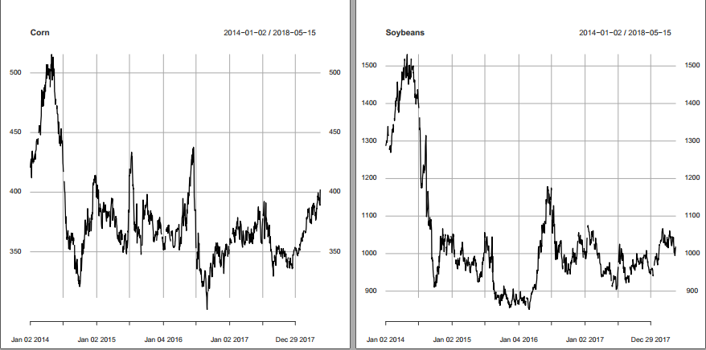 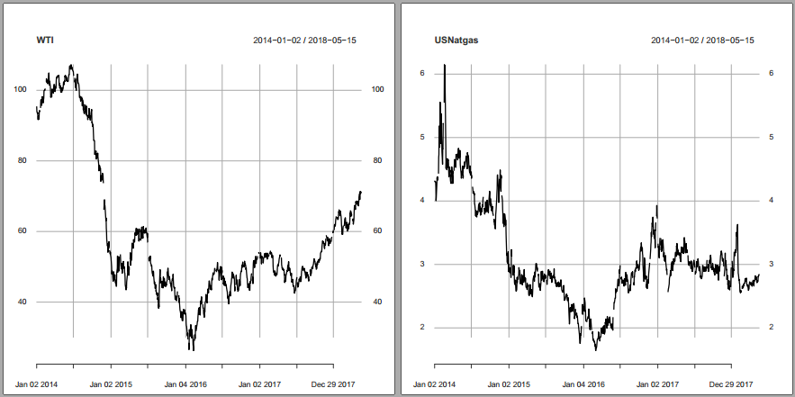

* 1. Corn, Soybeans, WTI, USNatgs have similar shape peak at beginning and drop low then fluctuate like a L shape

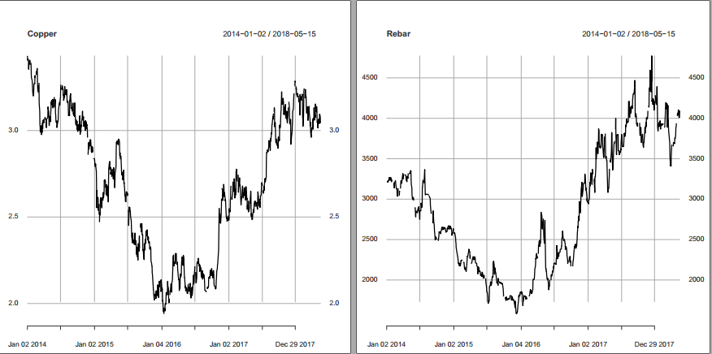

* 1. Copper and Rebar has similar shape bowl shape similar to long-term ust.

1. Indices
   1. This set are similar. For every indice in this set you can find another one that looks almost the same but if your random pick two they could be very different.
   2. SP500 and R2000 has a liner like shape. Similar to DJUSRE NLY and EqRes and short-term fix income

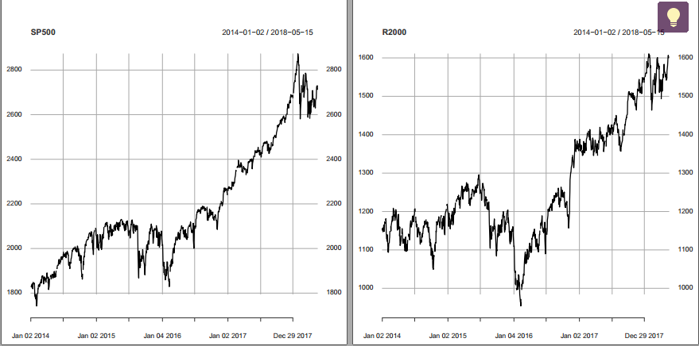

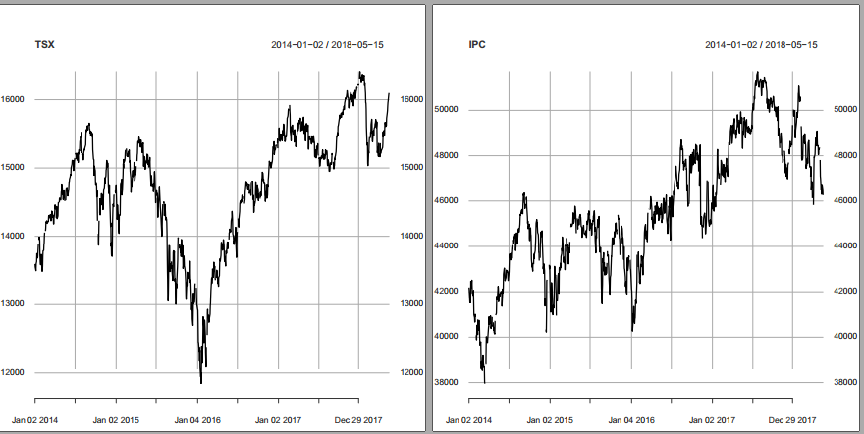

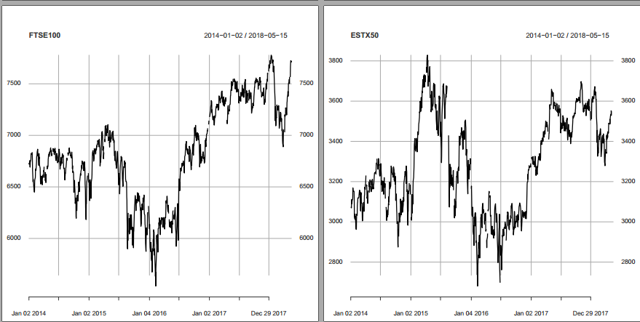

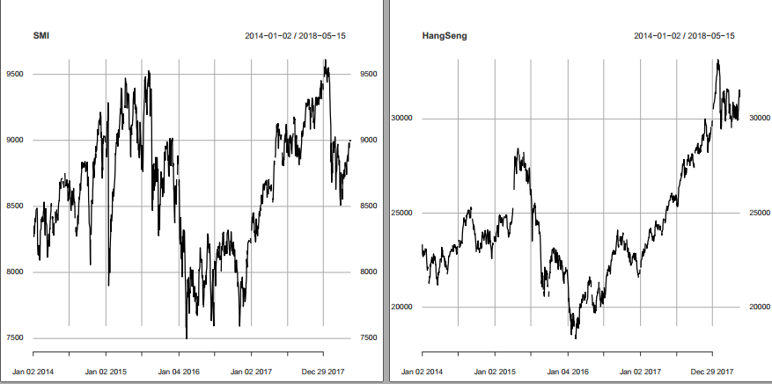

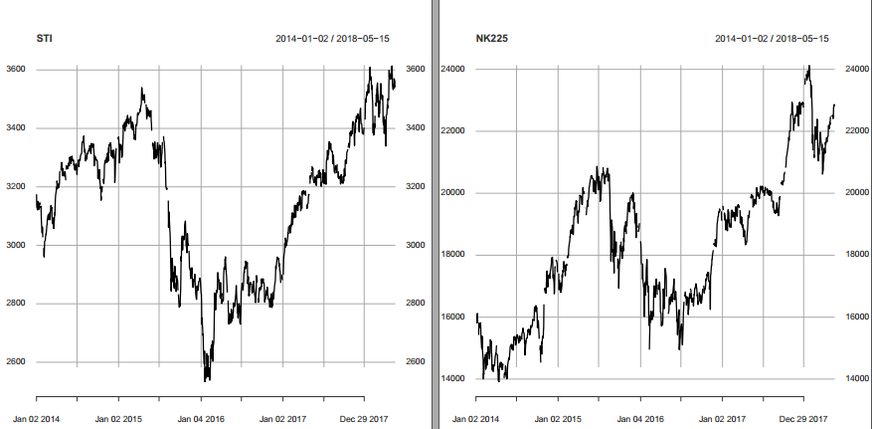

* 1. STI and TSX has a bowl like shape. Similar to Copper and Rebar

1. Foreign-Exchange Rates

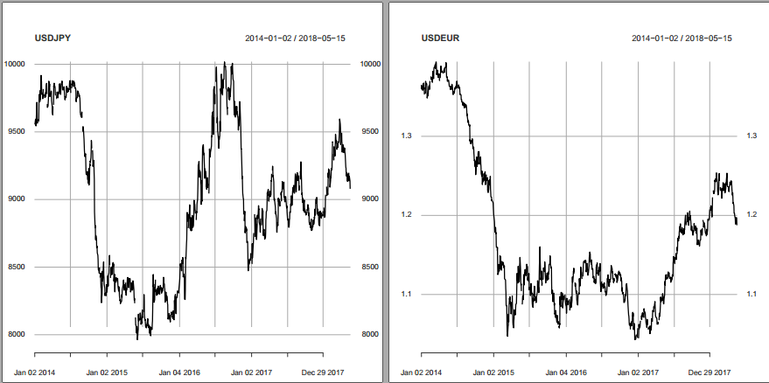

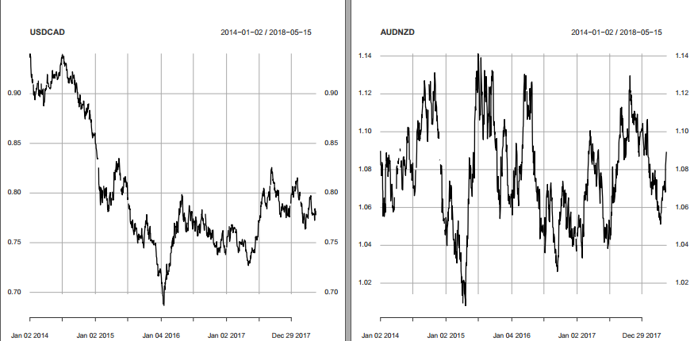

* 1. USDCAD and USDEUR have the similar but everything else have there have their own shape the is different them every other graph.

**Chapter 2, exercise 3**

geometric < equally-weighted portfolio

> r1<- rnorm(10000,0,0.04)

> r2<- rnorm(10000,0,0.04)

> r3<- rnorm(10000,0,0.04)

> r4<- rnorm(10000,0,0.04)

> r5<- rnorm(10000,0,0.04)

> summary(r1)

Min. 1st Qu. Median Mean 3rd Qu. Max.

-1.787e-01 -2.715e-02 2.355e-04 -1.486e-05 2.752e-02 1.406e-01

> summary(r2)

Min. 1st Qu. Median Mean 3rd Qu. Max.

-1.618e-01 -2.703e-02 1.570e-06 -7.522e-05 2.701e-02 1.474e-01

> summary(r3)

Min. 1st Qu. Median Mean 3rd Qu. Max.

-0.1549000 -0.0268300 0.0004448 -0.0000640 0.0272200 0.1531000

> summary(r4)

Min. 1st Qu. Median Mean 3rd Qu. Max.

-0.1540000 -0.0277500 -0.0007971 -0.0005327 0.0265300 0.1453000

> summary(r5)

Min. 1st Qu. Median Mean 3rd Qu. Max.

-1.571e-01 -2.655e-02 -7.880e-05 9.937e-05 2.742e-02 1.381e-01

> x<- ((1+r1)*(1*r2)*(1+r3)*(1+r4)*(1+r5))^1/5

>

> y<- 1/5*((1+r1)+(1*r2)+(1+r3)+(1+r4)+(1+r5))

> for (j in 1:10000) {

+ if(x[j]<y[j]){

+

+ }else{

+  print("geometric > equally-weighted")

+ }

+ }

>

**#Non-of it show** print("geometric > equally-weighted")

>

>

> count<-0

> for (i in 1:5000) {

+ r1<- rnorm(10000,0,0.04)

+ r2<- rnorm(10000,0,0.04)

+ r3<- rnorm(10000,0,0.04)

+ r4<- rnorm(10000,0,0.04)

+ r5<- rnorm(10000,0,0.04)

+

+ r5<-mean(r5)

+ r1<-mean(r1)

+ r2<-mean(r2)

+ r3<-mean(r3)

+ r4<-mean(r4)

+ r5<-mean(r5)

+

+ x<- ((1+r1)*(1*r2)*(1+r3)*(1+r4)*(1+r5))^1/5

+

+ y<- 1/5*((1+r1)+(1*r2)+(1+r3)+(1+r4)+(1+r5))

+ if(x<y){

+

+ #print("geometric < equally-weighted")

+ }else{

+ count<-count+1

+ #print("geometric > equally-weighted")

+ }

+ }

> print(count/5000)

[1] 0

The chance of geometric > equally-weighted is 0/50000000

**Chapter 2, exercise 4**

**always true**

Chapter 3, exercise 1



Fix income spread stable between 0 to 1 most of time CGB1 spread smaller then CGF1 most of time. There is a large spread in 2015 which is unusual but most of time stable.



In Commodities TN’s spread has regular behaver the most spread is between 15 to 5 and some is between 50 to 5 only have a few in 2014 the go over 50.

AL and CU have similar behaver TN but scale smaller.



‘Equity indices stay in a range except two case for HSI. TSX 60 are more stable then HIS

But the range decrease recently. Recently is more stable then between 2015 to 2016



Bit spread grow in recent years and there are many spreads that didn’t follow the normal. Around 2018 there is a pretied that spreads are not close to 0

Chapter 3, exercise 2



Fix income fracspread stable between 0 to 0.01 most of time CGB1 spread smaller then CGF1 most of time. There is a large fracspread in 2015 which is unusual but most of time stable. Other then y value identical with spread graph



In Commodities fracspread the shapes looks similar but more active and more fluctuate



Equity indices spuriously opposite from spread ratio TSX60 bigger then HSI



Bit fracspread decrease in recent years and there is one huge fracspreads in 2016 that didn’t follow the normal.

Chapter 3, exercise 3

Base on the summary the logarithmic spreads seem better behaved the range and the IQR are smaller most of times

|  |
| --- |
| > summary(fi.all$CGB1.spread)  Min. 1st Qu. Median Mean 3rd Qu. Max.  0.01000 0.01000 0.02000 0.02313 0.03000 0.28000  > summary(fi.all$CGB1.fracspread)  Min. 1st Qu. Median Mean 3rd Qu. Max.  6.710e-05 7.188e-05 1.385e-04 1.659e-04 2.156e-04 1.989e-03  > summary(fi.all$CGF1.spread)  Min. 1st Qu. Median Mean 3rd Qu. Max.  0.0100 0.0500 0.0900 0.1457 0.1400 4.8800  > summary(fi.all$CGF1.fracspread)  Min. 1st Qu. Median Mean 3rd Qu. Max.  8.339e-05 4.219e-04 7.098e-04 1.187e-03 1.134e-03 3.963e-02 |
|  |
| |  | | --- | |  | |

This case fix income is the same ratio

> summary(commodities.all$CU.spread)

Min. 1st Qu. Median Mean 3rd Qu. Max.

0.5000 0.5000 1.0000 0.9893 1.0000 5.0000

> summary(commodities.all$CU.fracspread)

Min. 1st Qu. Median Mean 3rd Qu. Max.

6.942e-05 8.928e-05 1.424e-04 1.757e-04 1.818e-04 1.142e-03

> summary(commodities.all$AL.spread)

Min. 1st Qu. Median Mean 3rd Qu. Max.

0.5000 0.5000 0.5000 0.7578 1.0000 5.0000

> summary(commodities.all$AL.fracspread)

Min. 1st Qu. Median Mean 3rd Qu. Max.

0.0002039 0.0002691 0.0003144 0.0004175 0.0005188 0.0023500

> summary(commodities.all$TN.spread)

Min. 1st Qu. Median Mean 3rd Qu. Max.

5.00 5.00 10.00 17.73 25.00 50.00

> summary(commodities.all$TN.fracspread)

Min. 1st Qu. Median Mean 3rd Qu. Max.

0.0002262 0.0002881 0.0006454 0.0009594 0.0013080 0.0034900





There are more outlier in fracspread and the range has grow bigger ratio in commodities.

> summary(idx.new$HSI.spread)

Min. 1st Qu. Median Mean 3rd Qu. Max.

1.000 1.000 2.000 4.228 2.000 153.000

> summary(idx.new$HSI.fracspread)

Min. 1st Qu. Median Mean 3rd Qu. Max.

3.376e-05 4.440e-05 8.508e-05 1.831e-04 9.983e-05 5.565e-03

> summary(idx.new$TSX.spread)

Min. 1st Qu. Median Mean 3rd Qu. Max.

0.100 0.400 0.500 1.206 0.700 33.200

> summary(idx.new$TSX.fracspread)

Min. 1st Qu. Median Mean 3rd Qu. Max.

0.0001060 0.0004362 0.0006351 0.0014490 0.0008926 0.0416800

 

For idx the stability between HSI and TSX switch in this two case.

> summary(fx.all$Bit.spread)

Min. 1st Qu. Median Mean 3rd Qu. Max.

0.0100 0.0800 0.1400 0.6114 0.5300 22.0000

> summary(fx.all$Bit.fracspread)

Min. 1st Qu. Median Mean 3rd Qu. Max.

1.003e-05 3.448e-05 1.857e-04 5.285e-04 6.632e-04 3.258e-02



Bit’s fracspread has less outliers and smaller iqr.

Chapter 3, exercise 4



Adjusted price for TSLA has the largest value



AMD have the highest short volume RGR compare to AMD is too small



For AMD the relation is strong related in this graph short volume decrease the by 10000 times



For RGR short decrease 1000 time compare to AMD they are smaller different but the Adjust price can’t identify the peak in short volume.



TSLA’s adjusted price follow the short volume’s flow. In this case short volume is 5000 in ratio.

Chapter 4, exercise 1

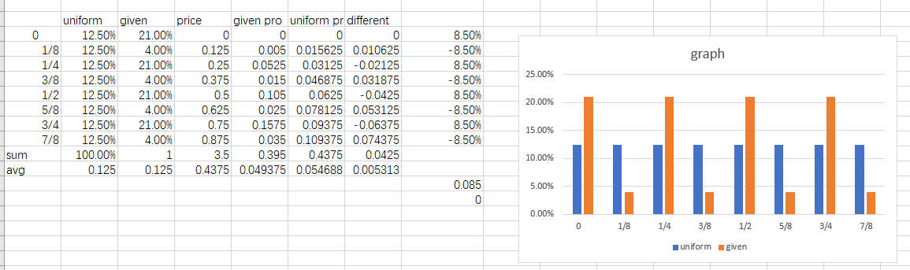

> x<-c(372625*0.21,372625*0.21,372625*0.21,372625*0.21,372625*0.04,372625*0.04,372625*0.04,372625*0.04)

> n <- sum(x); m <- length(x)

> p <- rep(1/m,m)

> K <- sum((x-n*p)^2/(n*p)); K #计算出K值

[1] 172301.8

> # [1] 136.49

> p <- 1-pchisq(K,m-1); p #计算出p值

[1] 0

The resolute is close to 0;

Chapter 4, exercise 2

Chapter 4, exercise 3

"21"="100-499", "22"="500-1999", "23"="2000-4999", "24"="5000+"





Avg realized spread are similar between different size at first until 2010 then it jump around 2014, spread are getting closer after that. the size 24 grow huge spread 2014 compare to others

With more data we can see 2014 is a special case. Realized spread are theoretical profits of a liquidity provider it shows how much price moves within a given look-ahead window.





Similar to Avg realized spread, Avg Effective Spread similar between different size at first until 2010 then it jump around 2014, spread are getting closer after that. the size 24 grow huge spread 2014 compare to others

With more data we can see not only size 24 size 23 also have different behaver between 22 and 21

Avg. Effective Spread are true transaction cost associated with each trade. It compares the execution price to the mid-quote at the time.





The Shr weighted at quote time are different at the beginning get closet and stays that way sense 2010

With more data 2007 is when change start