10/7/2018

Joseph Loss

FIN500

**HW 1 Submission**

Chapter 2, exercise 1 (see next page for summary output)

There are several different asset classes or “groupings” in this analysis: (note: plots were not used for this commentary; only summaries were used to generate this commentary)

1. Fixed-Income (US-Treasury Rates (3-month, 2-year, 10-year, and 30-year) and Moody’s Yield on Seasoned US-Corporate Bonds (BAA))
   1. Using the summary function alone, these fixed-income instruments would appear to be relatively stable, as the Interquartile Range is fairly narrow and the distance between (1Q, Mean) and (3Q, Mean) is roughly the same size. There are outliers, however, as can be seen in the Max. for these instruments (between 12.04 and 16.95).
2. Real Estate (Real Estate Indices (US/Canada) and RE investment/trust firms)
   1. Similar to the fixed income asset class, Real Estate tends to stay in a narrow interquartile range and is balanced pretty evenly around the mean for each instrument. There are very nasty outliers however; for example: the Canadian Apartments REIT has an interquartile range ~14.6 (1Q at 10.39 and 3Q at 24.97), with a mean of 18.95. The max, however, is a whopping 48.99, which is nearly 2.5x the average price!
3. Commodities
   1. In contrast to the previous two asset classes, commodities aren’t very stable at all. These instruments have a wide interquartile range relative to their mean, and the distance between their min/max and mean is much larger still! As a result, I’ve concluded that these instruments have wild and dramatic price movements.
4. Global Equity Indices
   1. Somewhat similar to commodities, these instruments tend to vary wildly; the IQR of these instruments tends to be wide and left or right-leaning when compared to the mean.
5. Foreign-Exchange
   1. The summary data of the FX asset class had some very interesting results. Using the same analysis methodology as before, I would have easily concluded that FX is a fairly stable asset class (aside from USDJPY, it would seem). The narrow IQR and equally-balanced mean (relative to 1Q and 3Q) are what initially led me to this conclusion. However, after generating the plots (more on that in exercise-2), I was very surprised to find that these instruments move around quite often, much more than I had originally thought.

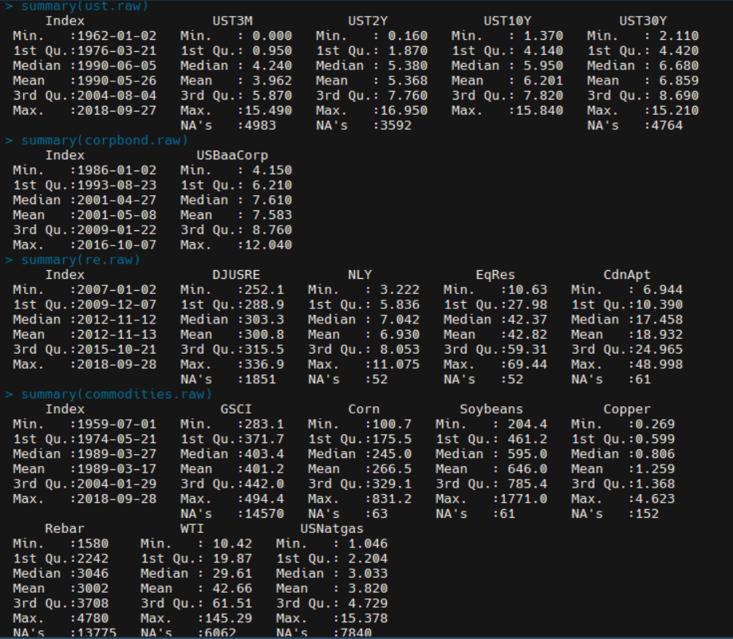

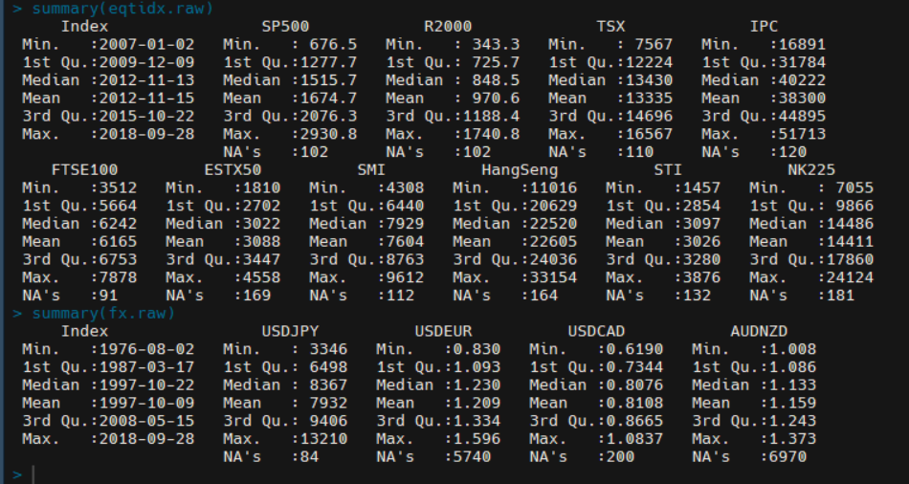

Chapter 2, exercise 2

1. Fixed Income
   1. The short-term (3M and 2Y) tend to mimic each other, and the long-term (10Y and 30Y) tend to mimic each other closely as well, but by no means would I call these “stable.” Since January’14, we’ve seen short-term rates rise from essentially zero (even slightly negative) to nearly 2% on the 3-month and over 2.5% on the 2-year.
   2. In addition, the 10 and 30-year rates have swung dramatically, falling 1.5-2.0% (respectively) to their lows midway through 2016. Rates have then dramatically risen through December 2017, with the 10-year returning to 3.0% and the 30-year rising to 3.0%, which is still almost a full percentage point lower than what it was at the beginning of 2014.
2. Foreign-Exchange
   1. These do not seem to follow much of a pattern at all. Each FX rate appears to follow a different path, but there are times when these paths have greater variance than what appears to be the “norm” for each rate. If there is any pattern that can be discerned, it may be that the FX for a given country does follow somewhat of a similar path (at least weakly) with FX rates of that country and other market participants; the USD-JPY/EUR/CAD plots are a good demonstration of this. While the trajectory of these rates are by no means identical, there is definitely a positive correlation here.
3. Real Estate
   1. These assets follow a similar path, but with varying degrees. EQR and NLY, both significantly involved in the US real estate market (Trust/Investment firms) appear to closely follow the DJUSRE Index (for obvious reasons).
   2. CdnApt (in Canada) resembles the DJUSRE but to a much lesser extent. It would appear that the downturns in the US Real Estate market have some degree of effect on the Canadian market, but the upswings in the Canadian RE market don’t have any affect on the US market.
4. Equities
   1. These instruments seem to follow a somewhat similar path, but this is not always in the case. They follow a similar path especially during global crises, such as the downswing in all markets caused by events such as Brexit and the 2016 US Presidential Election (mainly events in the latter part of 2016).
   2. Overall, it appears that these instruments follow a path in terms of regions. For example, the US and Canadian indices seem to follow each other in a much closer fashion than the US and Asian market indices follow each other. Similarly, the Asian market Indices seem to follow each other in a “group” and the Euro Indices seem to follow each other in a “group” as well, meaning that if there is a downturn in one large market in Europe, one might expect to see a downturn in the other Euro Indices as well, etc.
5. Commodities
   1. Commodity prices do not seem to follow a cohesive path either; each individual commodity follows a different path than other commodities. There are, however, very apparent spikes in prices at different times for each commodity. One good example of dramatic upswings/downswings in price is in Rebar, from early 2016 towards the end of 2017. Another example that shows a different, but dramatic swing in price is in Copper, which moved from lows of 2.0 in early-mid 2016 to 2.5 at the end of 2016, with another large upswing to 3.0 in the middle of 2017.
   2. Note there appears to be a data error in GSCI, as most of the plot is missing data (all of 2014, and the second half of 2015, 2016, and 2017 is missing)

Chapter 2, exercise 3

Given the summary outputs of both the geometric index and equally-weighted portfolio returns, I would rather hold the equally-weighted portfolio. This is because the average return (1.0001) is higher (albeit, only slightly) than the average return of the geometric index.

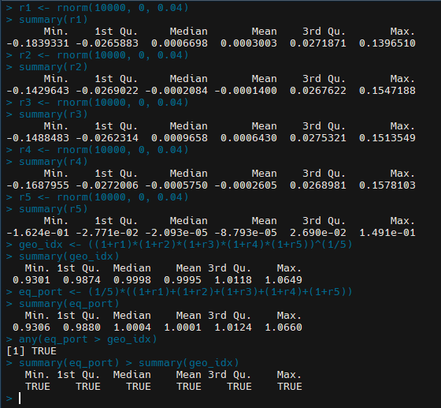

Chapter 2, exercise 4

The screenshot used in exercise 3 will help to answer this question. I generated two inequalities to determine if holding the equally-weighted portfolio is always better than holding the geometric index. I used the any() function to check all time periods (“steps”) for eq_port > geo_idx. This function returned TRUE, meaning that for all of these periods, the eq_port returns were greater than that of the geometric index. In addition, we can see that this inequality is also TRUE for all of the summary statistics generated for both of these investment options; meaning that the min/max/mean are larger in the eq_port than that in the geometric index.

Chapter 3, exercise 1

1. Fixed Income
   1. Spreads seem relatively stable and very narrow for the most part. There are certain times where the spreads jump wildly though, perhaps the Canadian government bond market reacting to events in the US or global markets?
2. Commodities
   1. The spreads for Copper and Aluminum futures on the LME are very narrow, usually 0.5 – 1.0 wide. This indicates that these markets are probably extremely liquid, as the spreads for these commodities rarely widens past 3.0. In contrast, Tin futures have extremely wide spreads, nearly 10 times that of CU/AL. Furthermore, Tin future spreads seem to jump frequently, bouncing around from 5.0 – 25.0, and even 50.0 many times. Either the market isn’t very liquid, Tin futures may be subject to other supply/demand/pricing forces, or it could be that the contracts are quoted in a different degree of numerical precision.
3. Equities
   1. It’s hard to make a judgement call on the equity index spreads here. In 2016, the HIS jumped wildly, bouncing from very narrow (5 – 25) to 50 very often. This tapered down for the majority of 2017, but there were two instances where the spread jumped over to over 100 points! This was probably due to events between the US/Asia, if I had to guess. The TSX is comparatively docile in contrast, spreads are for the most part narrow (good liquidity), and remaining stable throughout the analyzed time period.
4. FX/Crypto
   1. The spread Bitfinex/BTCUSD is exactly as I predicted. The spread became very active starting in the second half of 2017, which is around the same time that the “crypto-craze” became a global phenomenon; as the media and news outlets publicized it more and more, the stupidity just kept piling in, and wild swings in price/spread were caused by buying high, selling low, massive price manipulation, and enough counts of investor that it’s probably classified as treasonous. The spreads have narrowed into 2018, and it is “All Quiet on the Crypto Front” as cryptocurrency has turned into the worst investment of 2018 by a long shot (worst investment quite possibly ever in my biased opinion.)

Chapter 3, exercise 2

1. Fixed Income
   1. The log spreads for fixed income look almost identical to the arithmetic spreads when plotted. There is not much of a difference in commentary here, besides the observation that the spread is exponentially smaller in number, but the width looks the same.
2. Commodities
   1. The logarithmic spreads of CU/AL/TN futures seem to be even more active than the arithmetic spreads. The AL/CU spreads have much more variation than in the previous exercise. TN seems to be just as active, but there are certain periods where the spread is within a given range (.0001 to .0015), disrupted by occasional “spikes” to .002 and above.
3. Equities
   1. The equity indices are very surprising and a bit puzzling to me. The previous analysis of HSI and TSX60 seems to be completely reversed here: the log spreads of TSX60 have various spikes in width throughout the period (particularly in 2016), while the HSI remains very narrow (essentially 0) and barely moves! I’m not sure the exact reason for this, and I haven’t been able to discover much through research but hopefully we’ll discuss this anomaly in class.
4. FX/Crypto
   1. The fractional spreads in this asset class are essentially 0. This highly contrasts the activity that was seen in the arithmetic spreads.

Chapter 3, exercise 3

Comparing the summaries of spreads and fractional spreads, I’ve concluded that the logarithmic spreads are more well-behaved than the regular spreads. This seemed a little counter-intuitive to me at first: the spreads had larger “jumps” because the numbers were much larger, but I wasn’t convinced that log spreads behaved better. To investigate further, I created inequalities for several of the securities and compared the variance of spreads to the variance of logarithmic spreads. This analysis proved my original conclusion to be correct: the variances of logarithmic spreads are smaller (more well-behaved) than the variances for arithmetic spreads.

Chapter 3, exercise 4

There appears to be a relationship between short volume and price in that the higher the short volume, the lower the stock price. For example, TSLA has essentially zero short volume and a stock price that is significantly higher than the prices of AMD and RGR. In contrast, AMD has had massive shorting activity throughout the years; AMD also has the lowest stock price of the three (by a significant amount), as expected according to my hypothesis on this relationship.

Chapter 4, exercise 1

Referring to figure 3, “*The distribution of price fractions across all inside quotes for 100 Nasdaq/NYSE/AMEX securities...”*, I calculated the probability of the random divergence from the uniform distribution of prices to be 0.5313, or 53.13%.

Chapter 4, exercise 2

Chapter 4, exercise 3