**Chapter 6, exercise 1**

1. From the Figure 1, when using US treasury yields as nominal rates, using the TIPS yield as real rates and expected inflation as inflation, it is obvious that the real interest rate plus the inflation is not equal to risk-free rates since the two lines have huge differences at any given point.

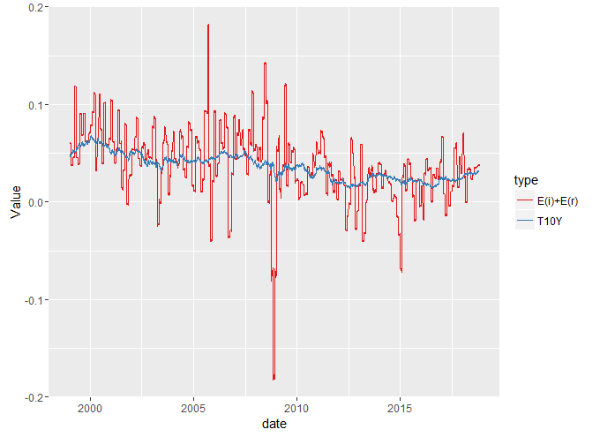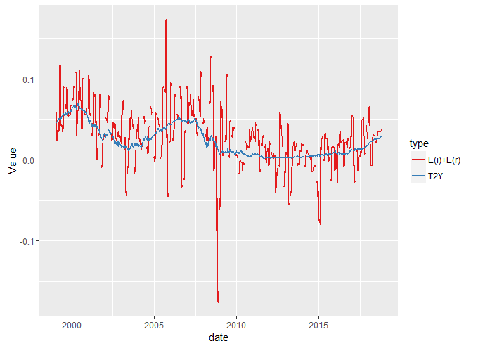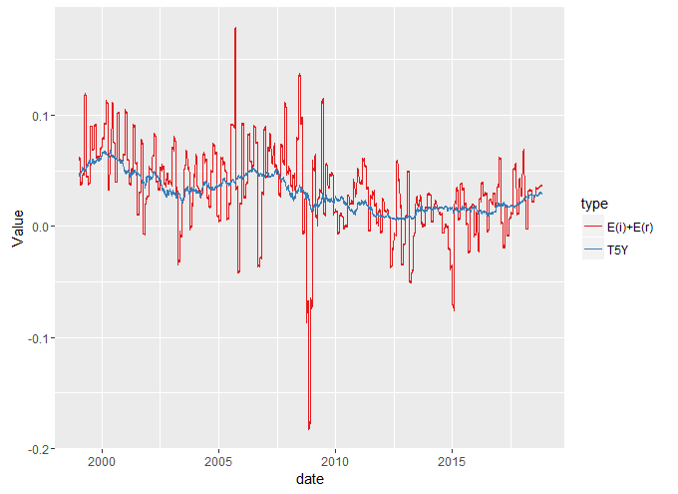

Figure :E(r)+E(i)

1. Based on the Figure 1, since the variance penalty on inflation is a fixed variable, it will not change the shape of the line enough to match the nominal rates.
2. Trying different model. Everything else is the same except inflation equals to MOM-inflation. Showing my Figure 2, the wMOM line is still different but much closer to the nominal rates line, compared with Figure 1.

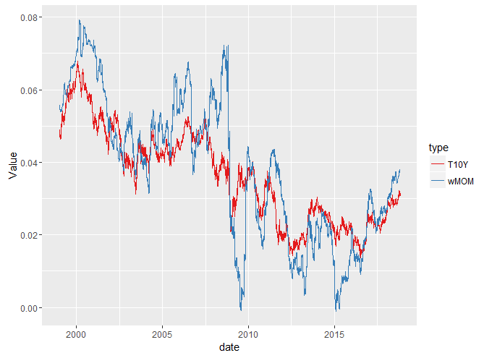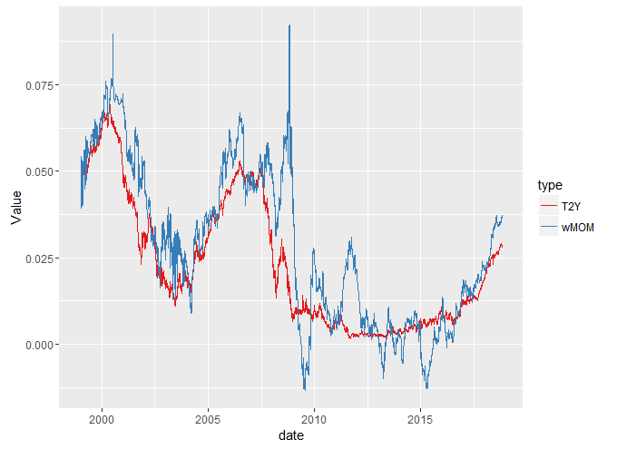

Figure : wMOM

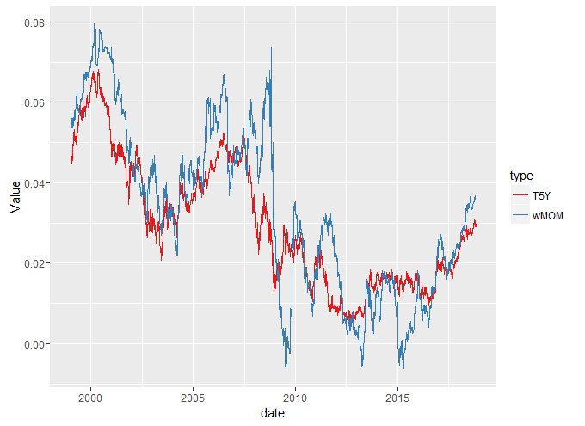

1. Trying another different model. Everything else is the same with the previous wMOM model except adding inflation surprise. Showing my Figure 3, compared to Figure 2, the difference between wSP line and nominal rates line changed little in normal times, but difference gap increased during the critical times, for example, during 2008 financial crisis.

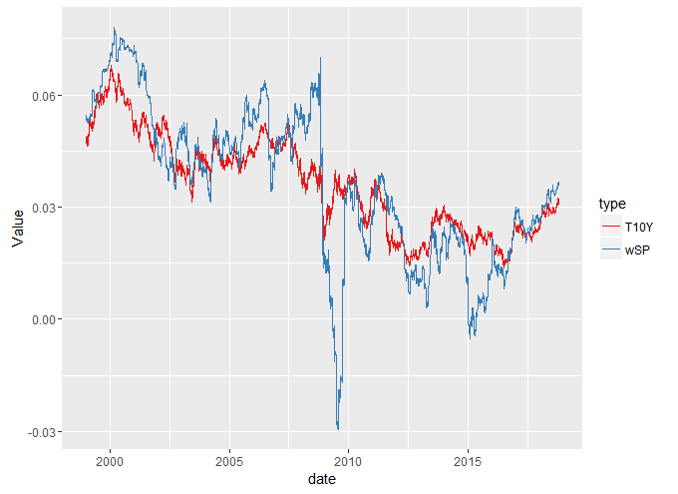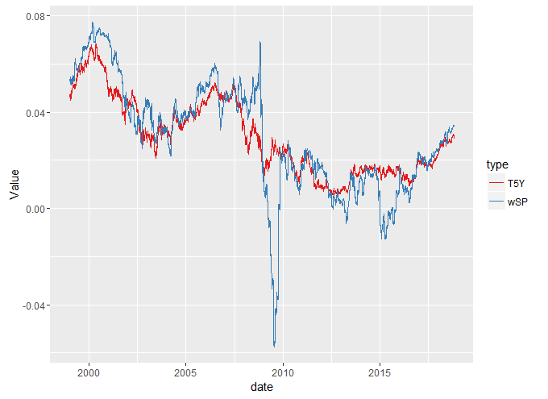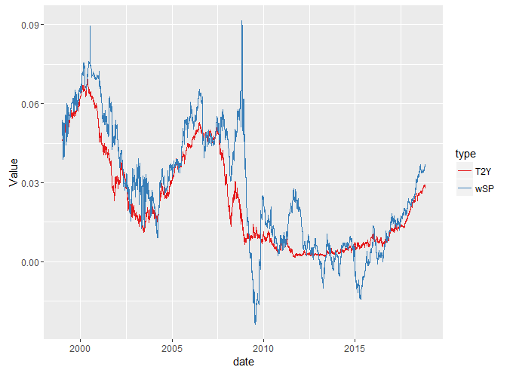

Figure : wSP

1. Everything is the same with the previous wSP model. However, instead of using lambda in wSP model, now using Lambda set, in which I average few days data. The best model is already precise; however, we cannot compute the lambda without knowing the data in front.

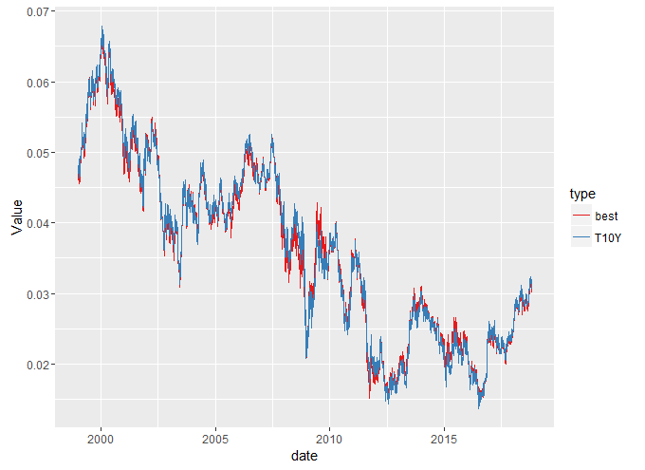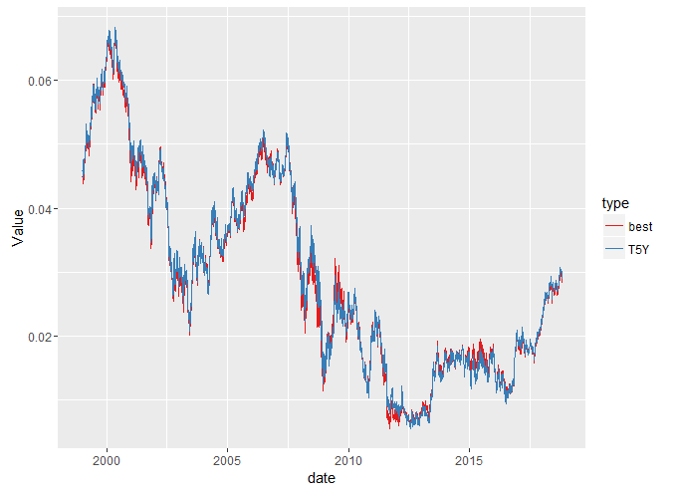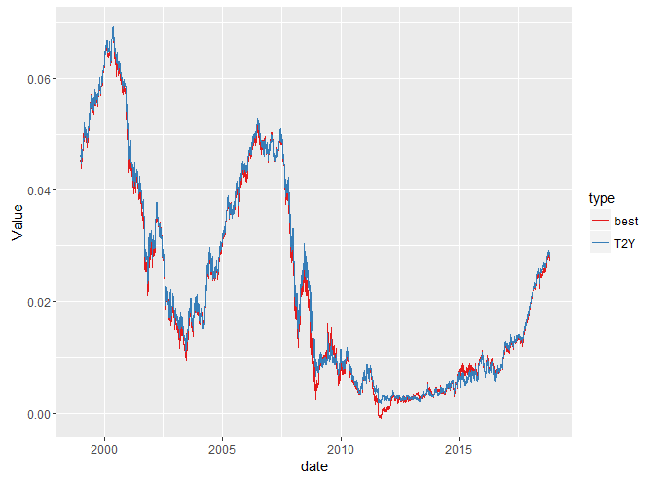

Figure : Best

1. 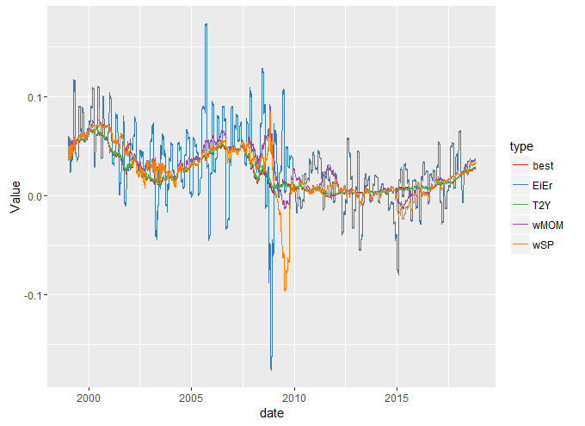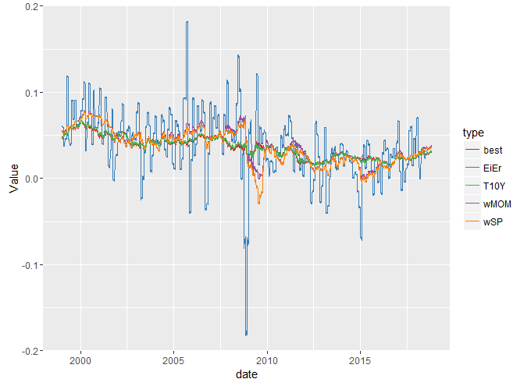Summary

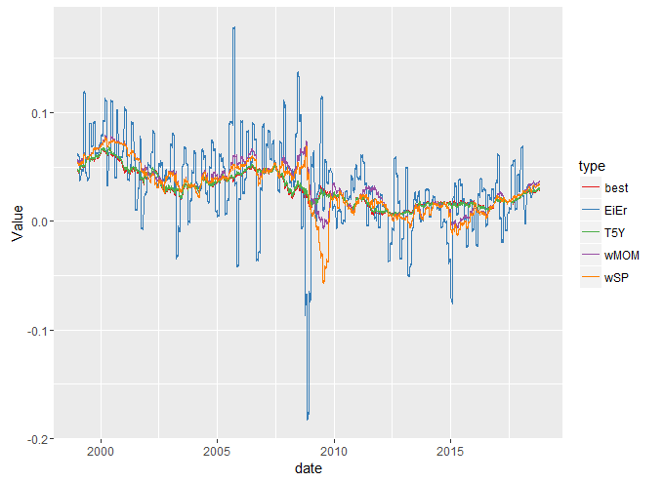

Figure :Summary

|  |  |  |  |
| --- | --- | --- | --- |
| Name | Y02EiEr | Y05EiEr | Y10EiEr |
| MSE | 1.0205E-03 | 1.0854E-03 | 1.1230E-03 |
|  |  |  |  |
| Name | Y02wMOM | Y05wMOM | Y10wMOM |
| MSE | 0.000141402 | 1.1469E-04 | 1.1689E-04 |
|  |  |  |  |
| Name | Y02wSP | Y05wSP | Y10wSP |
| MSE | 0.000225057 | 1.6505E-04 | 1.4401E-04 |
|  |  |  |  |
| Name | Y02best | Y05best | Y10best |
| MSE | 1.41402E-06 | 1.1469E-06 | 1.1689E-06 |

1. Based on equation 6.25, volatility of inflation equals to a portion of volatility ${}_{R}$ It implies that the volatility of inflation is large.

$$E\left(i\right)≈{}_{R}=λ{}_{i}$$

|  |  |  |  |
| --- | --- | --- | --- |
| Name | T2Y | T5Y | T10Y |
| σR | 1.8625E-02 | 1.5727E-02 | 1.2956E-02 |

**Chapter 6, exercise 2**

1. From figure 6, it shows that the error is minor so that the model is a good proximation.

|  |  |
| --- | --- |
| mean(error) | 1.4426E-10 |
| mean(sqerror) | 1.7808E+00 |

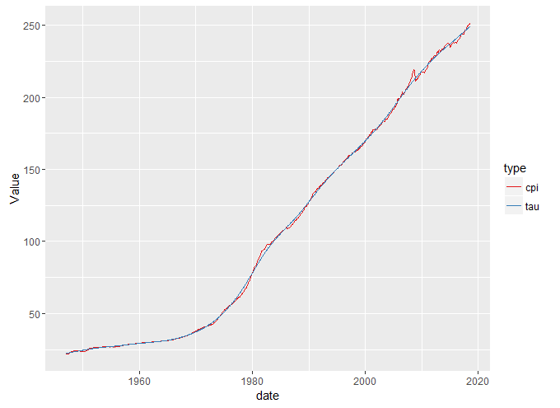

Figure ：TAU Vs. CPI

**Chapter 7, exercise 1**

1. **Risk-Free Price Risk :**

Data from 10/30/15- 10/30/18

1. The table below shows the average yield for each of these instruments.

|  |  |  |  |  |
| --- | --- | --- | --- | --- |
| Name | 3M | 2Y | 10Y | 30Y |
| Average Yield | 9.5858E-03 | 1.4859E-02 | 2.3193E-02 | 2.8539E-02 |

1. Average Log return is negative and close to zero for all cases, however, average log return shows a negative relationship between maturity. Since uncertainty increases as the maturity increases, so the expected return is lower.

|  |  |  |  |  |
| --- | --- | --- | --- | --- |
| Name | 3M | 2Y | 10Y | 30Y |
| Average Log Return | -7.5233E-06 | -5.5103E-05 | -1.0798E-04 | -1.0226E-04 |
|  |  |  |  |  |

|  |  |  |  |  |
| --- | --- | --- | --- | --- |
| Name | 3M | 2Y | 10Y | 30Y |
| Sd | 8.4804E-04 | 9.1344E-03 | 5.3945E-02 | 1.1763E-01 |

1. As the maturity increases, the standard deviation also increases, because there is more uncertainty when maturity is longer.
2. Based on skewness and Kurtosis, the log return of 10 years US treasuries is less likely to be a normal distribution. 3 Month Treasuries has the highest kurtosis since the maturity term is shorter so that the behavior is concentrate within the time frame and cause a higher kurtosis. For all cases, skews are all around zero.

|  |  |  |  |  |
| --- | --- | --- | --- | --- |
| Name | 3M | 2Y | 10Y | 30Y |
| Skewness | -0.343 | 0.519 | 0.008 | -0.327 |
| Kurtosis | 3.690 | 2.661 | 1.365 | 2.552 |

1. **Short-term Credit and Price Risk**

Data from 10/30/15- 10/30/18

**Assumption: Recent data is more relevant, so I use most recent 3 years data.**

1. The standard deviation of Eurodollar futures increases as the maturity increases, because there is more uncertainty when maturity is longer.

|  |  |  |
| --- | --- | --- |
| Name | ED1 | ED8 |
| Sd | 3.7067E-03 | 6.5824E-03 |

1. ED1 has a unique curve as it has extremely large kurtosis and is heavily negative-skewed, maybe due to its high liquidity.

|  |  |  |
| --- | --- | --- |
| Name | ED1 | ED8 |
| Skewness | -5.543 | 0.258 |
| Kurtosis | 54.289 | 2.289 |

1. The difference of standard deviation is approximately same for 3M and 2 Year instruments. However, the pattern of skewness and kurtosis cannot be defined in this situation.

|  |  |  |  |  |  |  |
| --- | --- | --- | --- | --- | --- | --- |
| Name | 3M | 2Y | ED1 | ED8 | Difference-ED1 | Difference-ED8 |
| Sd | 8.4804E-04 | 9.1344E-03 | 3.7067E-03 | 6.5824E-03 | 2.8586E-03 | -2.5520E-03 |
| Skewness | -0.343 | 0.519 | -5.543 | 0.258 | -5.200 | -0.260 |
| Kurtosis | 3.690 | 2.661 | 54.289 | 2.289 | 50.599 | -0.372 |

1. The changes of TED spread over different maturity, compared to changes of CMT or ED over different maturities, is small.

|  |  |  |
| --- | --- | --- |
| Name | TED1 | TED8 |
| Average | 1.384 | 1.980 |
| SD | 10.398 | 11.049 |

1. **Equity Price Risk**

Data from 10/30/15- 10/30/18

**Assumption: Not only analyze group 1 and group 2 together as a portfolio but also analyze them individually**

1. The table below summaries the average price of each equity. It makes sense that S&P 500 has higher average price than Russell 2000 since S&P 500 comprises the companies with large market capitalization.



1. The table Below summaries the average log-returns of each equity instrument. It shows that Group1, Group 2, S&P 500 and Russell 2000 have similar average log-returns. In this situation, the market capitalization of a firm is not directly related to the average log return.



1. The table Below summaries the annualized log-returns of each equity instrument. Overall, the equity yields higher log return than the US treasuries. Because equity generally has higher risks compared with US treasuries, equity need more returns to compensate its risk exposure. Group 1 and Group 2 has similar annualized log return.



1. The table Below summaries the volatility of each equity instrument. Overall, the equity has much higher volatility than US treasuries, since equity has higher risks and volatility is a measurement of risk. Group 2 has higher volatility than group 1.



1. The table Below summaries the skewness and kurtosis of each equity instrument. In equity group, the skewness is different, ranging from -8.9209 to 1.022; the same applies to kurtosis; especially in group 2, SVU and SYMC has extremely large kurtosis.



1. It makes sense that the difference (equity- US treasuries) in volatility is positive among all equity groups since the equity has higher risks. The skewness and kurtosis show no patterns, and I observed some extremely large kurtosis. In group 2, SVU and SYMC has extremely large kurtosis.



1. **Commodity Price Risk**
2. The table below summaries the average price of each commodity. Corn has the highest average price.



1. The table Below summaries the average log-returns of each commodity. Crude oil, US natural Gas and copper yield higher average log return than corn in the las three years.



1. The table Below summaries the annualized log-returns of each commodity. Crude oil and Us natural gas have similar annualized log return, maybe because they are high demand resources.



1. The table Below summaries the annual volatility of each commodity. Crude oil and US natural gas have higher volatility than copper and corn.



1. The table Below summaries the skewness and kurtosis of each commodity. The distribution of Crude oil is similar to normal distribution.



1. It makes sense that the difference (Commodity- US treasuries) in volatility is positive among all commodities since the commodity has higher risks. Moreover, the skewness of all commodity is positive, showing a right-skewed distribution. All commodity has negative difference in kurtosis. It is surprise that in a randomly selected data, the pattern is so clear ( all difference in skewness and standard deviation is positive and all difference in kurtosis is negative).



1. **Heat Map**

1. T2Y has strong correlation with T10Y, T30Y and ED8, since T10Y and T30Y are both US treasury as T2Y; ED8 presents 2 years euro-dollar. It makes sense they are strongly corelated.
2. SPX has strong correlation with RUT, Group 1 and Group 2, since SPX and RUT are both index and Group 1 and Group 2 contains stocks from SPX and RUT. In this way, it makes sense they are strongly corelated.

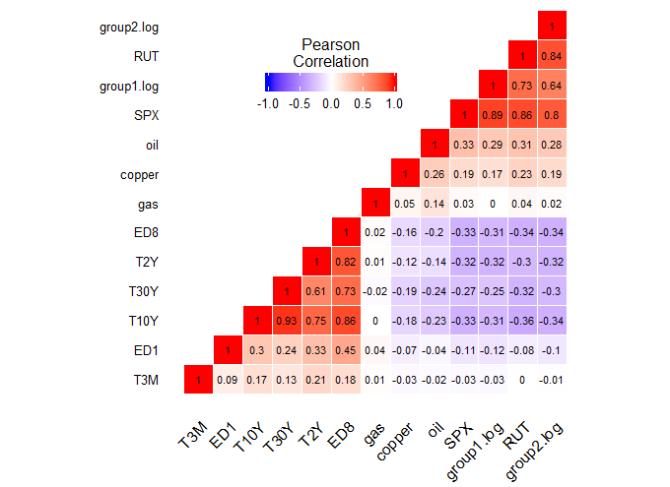

**Chapter 8, exercise 1**



**Chapter 8, exercise 2**

Generally, risk order of all instruments is different under different risk measurement.

* Standard deviation, semi deviation, CF VaR, CF es, Historical VaR and Historical es have similar risk order, only minor difference observed. For example, in CF VaR and semi deviation, Copper and Group 2 switch the risk order.
* Generally lower return corresponds to lower risk. In most risk measures, corn has high level of risks (in standard deviation, semi deviation and CF vaR, Corn ranks second), but corn has relatively low level of the return.
* Positive skewness generally means lower risks, however; using skewness to measure risks is not precise. For example, oil has strong positive skewness, which means it has relatively low risks, but oil has high volatility and high return under other risks measurement. (oil ranks second under standard deviation and semi deviation.) The risk order of skewness is conflict with the order of other risk measurement, which may indicate using skewness solely as a risk indicator is not precise.
* The overall risk order in kurtosis is different from other risk measures. Kurtosis may be influenced by the high liquidity of instruments. For example, Euro dollar has extremely high kurtosis and may be caused by its liquidity of euro dollar.

**Chapter 8, exercise 3**

Group 1 has surprisingly low risks. Under multiple risk measurement, group I has lower risk rank than its comparable (Group 2, SPX and RUT), but yields relatively high level of return. The reason maybe that Group 1 contains diversified portfolio of stocks which eliminate its risks.