**Chapter 9, part a**

The All Portfolios has a higher E(return)

|  |  |  |
| --- | --- | --- |
| **portfolios** | **Sharpe Ratios** | **return** |
| ETF | 1.3537 | 0.0777 |
| Comm | 0.2658 | 0.0781 |
| All | 1.3783 | 0.0832 |

Table 1: Sharpe Ratios

|  |  |  |  |  |  |  |  |
| --- | --- | --- | --- | --- | --- | --- | --- |
| **portfolios** | **w.SPY** | **w.IWM** | **w.AGG** | **w.FEZ** | **w.ACWI** | **w.IYR** |  |
| ETF | 1.0000 | 0.0523 | 0.7514 | (0.1021) | (0.5954) | (0.1062) |  |
|  |  |  |  |  |  |  |  |
| **portfolios** | **w.WTI** | **w.AU** | **w.CU** | **w.Corn** |  |  |  |
| Comm | (0.3548) | 0.4439 | (0.0891) | 1.0000 |  |  |  |
|  |  |  |  |  |  |  |  |
| **portfolios** | **w.SPY** | **w.IWM** | **w.AGG** | **w.FEZ** | **w.ACWI** | **w.IYR** | **w.WTI** |
| All | 1.0000 | 0.0378 | 0.6825 | (0.1127) | (0.5273) | (0.1141) | (0.0283) |
|  |  |  |  |  |  |  |  |
| **portfolios** | **w.AU** | **w.CU** | **w.Corn** |  |  |  |  |
| All | 0.0157 | 0.0037 | 0.0499 |  |  |  |  |

**Chapter 9, part b**

Table 2: Portfolios weight

those portfolios have a higher Sharpe Ratios which mean with the same level of risk taking the return are higher. In terms of E[return] is much higher than risk free rate. In each of the three Portfolios there is one section weight 1.

**Chapter 9, part c**

Table 3: Portfolios weight with min 0

|  |  |  |  |  |  |  |  |
| --- | --- | --- | --- | --- | --- | --- | --- |
| **portfolios** | **Sharpe Ratios** | **return** |  |  |  |  |  |
| ETF | 0.9119 | 0.0550 |  |  |  |  |  |
| Comm | 0.2160 | 0.0586 |  |  |  |  |  |
| All | 0.9273 | 0.0616 |  |  |  |  |  |
|  |  |  |  |  |  |  |  |
| **portfolios** | **w.SPY** | **w.IWM** | **w.AGG** | **w.FEZ** | **w.ACWI** | **w.IYR** |  |
| ETF | 0.3873 | 0.0000 | 0.6127 | (0.0000) | 0.0000 | (0.0000) |  |
|  |  |  |  |  |  |  |  |
| **portfolios** | **w.WTI** | **w.AU** | **w.CU** | **w.Corn** |  |  |  |
| Comm | 0.0000 | (0.0000) | 0.0000 | 1.0000 |  |  |  |
|  |  |  |  |  |  |  |  |
| **portfolios** | **w.SPY** | **w.IWM** | **w.AGG** | **w.FEZ** | **w.ACWI** | **w.IYR** | **w.WTI** |
| All | 0.4317 | 0.0000 | 0.5271 | (0.0000) | (0.0000) | 0.0000 | 0.0000 |
|  |  |  |  |  |  |  |  |
| **portfolios** | **w.AU** | **w.CU** | **w.Corn** |  |  |  |  |
| All | 0.0000 | 0.0000 | 0.0413 |  |  |  |  |

When set min >=0 it limits the possibilities range of each portfolios, because it doesn’t allow short. Overall the Sharpe Ratios and return are lower. By observing the portfolios weight there are may section weight close to zero.

**Chapter 12, part a**

|  |  |  |  |  |  |  |
| --- | --- | --- | --- | --- | --- | --- |
| eigenvectors | |  |  |  |  |  |
|  |  | PC1 | PC2 | PC3 | PC4 | PC5 |
|  | T3M | 0.039355 | -0.27812 | 0.723718 | -0.52165 | 0.349589 |
|  | T6M | 0.068119 | -0.34177 | 0.458055 | 0.310244 | -0.75097 |
|  | T1Y | 0.119864 | -0.37845 | 0.104743 | 0.726927 | 0.530008 |
|  | T2Y | 0.279606 | -0.54092 | -0.33672 | -0.18639 | 0.060229 |
|  | T5Y | 0.457308 | -0.3153 | -0.28329 | -0.21761 | -0.11383 |
|  | T10Y | 0.489525 | 0.060959 | -0.02526 | -0.05102 | -0.09106 |
|  | T20Y | 0.483835 | 0.32757 | 0.145179 | 0.072362 | 0.028843 |
|  | T30Y | 0.467334 | 0.399486 | 0.200244 | 0.115238 | 0.08496 |
|  |  |  |  |  |  |  |
| eigenvalues | |  |  |  |  |  |
|  | 7.66E-07 | 8.15E-08 | 4.40E-08 | 2.24E-08 | 1.53E-08 |  |

Table 4: top 5 eigenvalues and corresponding eigenvectors.

**Chapter 12, part b**

for eigenvectors principle component 1 and 2 holds the pattern where higher the Maturity higher the value, with some noise T3M’s PC2 is higher than T6M’s PC2. PC4 and higher are mostly noise data. From the pattern Long-run treasuries have a heavier weight to yield change.

**Chapter 14, part a**

|  |  |  |  |  |  |  |  |  |
| --- | --- | --- | --- | --- | --- | --- | --- | --- |
| all |  |  |  |  |  |  |  |  |
|  | BA.xs.Est | BA.xs.pt | GD.xs.Est | GD.xs.pt | HON.xs.Est | HON.xs.pt | LMT.xs.Est | LMT.xs.pt |
| (Intercept) | 0.000721 | 3.98E-02 | 0.000191 | 4.89E-01 | 0.000281 | 1.97E-01 | 0.000443 | 1.16E-01 |
| alldata.xs[, 1] | 1.269890 | 1.93E-46 | 1.001946 | 1.58E-46 | 1.107049 | 2.44E-82 | 0.845577 | 2.69E-33 |
| alldata.xs[, 2] | (0.121708) | 7.51E-02 | (0.088849) | 9.92E-02 | (0.083525) | 4.94E-02 | (0.139894) | 1.11E-02 |
|  |  |  |  |  |  |  |  |  |
|  | NOC.xs.Est | NOC.xs.pt | QCOM.xs.Est | QCOM.xs.pt | RTN.xs.Est | RTN.xs.pt | UTX.xs.Est | UTX.xs.pt |
| (Intercept) | 0.000594 | 5.81E-02 | (0.000364) | 4.69E-01 | 0.000474 | 1.19E-01 | 0.000022 | 9.33E-01 |
| alldata.xs[, 1] | 0.900063 | 6.25E-31 | 1.163879 | 5.05E-21 | 0.887158 | 8.80E-32 | 0.944636 | 1.84E-46 |
| alldata.xs[, 2] | (0.088930) | 1.45E-01 | (0.026030) | 7.91E-01 | (0.140149) | 1.82E-02 | (0.031744) | 5.32E-01 |
|  |  |  |  |  |  |  |  |  |
| SPX |  |  |  |  |  |  |  |  |
|  | BA.xs.Est | BA.xs.pt | GD.xs.Est | GD.xs.pt | HON.xs.Est | HON.xs.pt | LMT.xs.Est | LMT.xs.pt |
| (Intercept) | 0.000725 | 3.89E-02 | 0.000194 | 4.82E-01 | 0.000284 | 1.93E-01 | 0.000448 | 1.14E-01 |
| alldata.xs[, 1] | 1.141325 | 5.29E-116 | 0.908091 | 9.83E-118 | 1.018818 | 3.22E-194 | 0.697802 | 1.38E-74 |
|  |  |  |  |  |  |  |  |  |
|  | NOC.xs.Est | NOC.xs.pt | QCOM.xs.Est | QCOM.xs.pt | RTN.xs.Est | RTN.xs.pt | UTX.xs.Est | UTX.xs.pt |
| (Intercept) | 0.000597 | 0.05698297 | (0.000363) | 0.4700245 | 0.000478 | 0.1165738 | 0.000023 | 0.9302719 |
| alldata.xs[, 1] | 0.806123 | 5.56E-80 | 1.136382 | 2.36E-64 | 0.739114 | 1.39E-72 | 0.911104 | 2.26E-129 |
|  |  |  |  |  |  |  |  |  |
| RUT |  |  |  |  |  |  |  |  |
|  | BA.xs.Est | BA.xs.pt | GD.xs.Est | GD.xs.pt | HON.xs.Est | HON.xs.pt | LMT.xs.Est | LMT.xs.pt |
| (Intercept) | 0.000879578 | 2.36E-02 | 0.000316 | 3.01E-01 | 0.000419 | 1.10E-01 | 0.000549 | 7.05E-02 |
| alldata.xs[, 2] | 0.760993013 | 4.41E-72 | 0.607604 | 1.25E-73 | 0.685985 | 1.25E-114 | 0.447867 | 1.88E-44 |
|  |  |  |  |  |  |  |  |  |
|  | NOC.xs.Est | NOC.xs.pt | QCOM.xs.Est | QCOM.xs.pt | RTN.xs.Est | RTN.xs.pt | UTX.xs.Est | UTX.xs.pt |
| (Intercept) | 0.000706 | 3.50E-02 | (0.000219) | 6.77E-01 | 0.000584 | 7.27E-02 | 0.000139542 | 6.29E-01 |
| alldata.xs[, 2] | 0.536704 | 2.83E-51 | 0.782983 | 4.76E-45 | 0.476516 | 9.05E-44 | 0.624873472 | 7.69E-85 |

Summery In this model the t-stats are low only GD’s, QCOM lm and UTX’s lm have high Pr(>|t|) value (the green col means higher t-state p value). When there have both SPX and RUT SPX weight more. (red)

**Chapter 14, part b**

From the finding when there is both SPX and RUT(multi-factor), SPX are always weight more which make sense all the stock in the portfolios relate to large cap in US so there should be a large correlation between them. That is also why confidence level is higher with SPX only. But even CAMP is a good model because there is only one risk factor it can’t simulate market as good. That is why overall Pr(>|t|) is not high.

**Chapter 15, part a (4)**

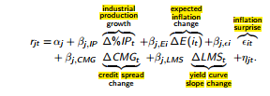

|  |  |  |  |  |  |  |  |  |
| --- | --- | --- | --- | --- | --- | --- | --- | --- |
|  | SPX.xs.Est | SPX.xs.t | RUT.xs.Est | RUT.xs.t | BA.xs.Est | BA.xs.t | GD.xs.Est | GD.xs.t |
| (Intercept) | -7.96E-04 | 0.960066 | -3.41E-03 | 0.8616152 | 9.54E-03 | 0.7357842 | 3.30E-03 | 0.8828714 |
| Indprod | -2.66E-02 | 0.6129906 | -6.70E-02 | 0.3002956 | -1.37E-01 | 0.1411778 | -7.10E-02 | 0.3371867 |
| Ex infl diff | -1.04E-02 | 0.8569189 | 1.98E-02 | 0.7800689 | -3.61E-02 | 0.7251038 | 1.56E-02 | 0.8475243 |
| Infl surp | 3.22E-02 | 0.3532617 | 4.74E-02 | 0.2682236 | 1.19E-02 | 0.8475264 | 5.78E-02 | 0.2376872 |
| BAA-T10 | 9.62E-06 | 0.9475036 | 3.30E-05 | 0.854727 | -5.50E-05 | 0.8323003 | -4.10E-05 | 0.842319 |
| T30-T3m | 1.01E-02 | 0.8692956 | 2.03E-02 | 0.7877642 | -1.19E-01 | 0.274767 | 7.32E-02 | 0.3962367 |
|  |  |  |  |  |  |  |  |  |
|  | HON.xs.Est | HON.xs.t | LMT.xs.Est | LMT.xs.t | NOC.xs.Est | NOC.xs.t | QCOM.xs.Est | QCOM.xs.t |
| (Intercept) | -7.80E-03 | 0.7111824 | -3.29E-05 | 0.9987367 | 1.04E-02 | 0.6530745 | 1.40E-02 | 0.6970326 |
| Indprod | -3.88E-02 | 0.5770211 | -8.06E-02 | 0.240562 | -8.19E-02 | 0.2861783 | -1.45E-01 | 0.221453 |
| Ex infl diff | 1.96E-02 | 0.7979872 | -6.07E-03 | 0.9358776 | -1.10E-01 | 0.1911889 | 9.19E-02 | 0.4815743 |
| Infl surp | 6.87E-02 | 0.1360197 | 2.31E-02 | 0.6112535 | -1.37E-02 | 0.7868135 | -7.80E-04 | 0.9920757 |
| BAA-T10 | 6.82E-05 | 0.7248851 | 4.20E-06 | 0.9824499 | -8.98E-05 | 0.6741985 | -8.78E-05 | 0.7907101 |
| T30-T3m | 6.78E-02 | 0.4040261 | 1.53E-02 | 0.848071 | -9.01E-03 | 0.9198974 | -2.20E-01 | 0.1126422 |
|  |  |  |  |  |  |  |  |  |
|  | RTN.xs.Est | RTN.xs.t | UTX.xs.Est | UTX.xs.t |  |  |  |  |
| (Intercept) | 9.96E-03 | 0.6554046 | 1.16E-03 | 0.9571367 |  |  |  |  |
| Indprod | -3.28E-02 | 0.6565117 | -1.08E-01 | 0.1322165 |  |  |  |  |
| Ex infl diff | 2.52E-02 | 0.7558242 | -2.09E-02 | 0.7898299 |  |  |  |  |
| Infl surp | 8.59E-05 | 0.9985938 | 5.29E-02 | 0.2631434 |  |  |  |  |
| BAA-T10 | -8.59E-05 | 0.6755786 | -5.98E-07 | 0.9975998 |  |  |  |  |
| T30-T3m | -1.25E-02 | 0.8843037 | -2.86E-02 | 0.731993 |  |  |  |  |

**Chapter 15, part b (4)**

There are high Pr(>|t|) value (green) so there is high confidence that it is >|t|. The coefficient of the model is low for most of them. Which mean low Est high sigma over all this model is not a good fit for the return.

**Chapter 15, part a (5)**

|  |  |  |  |  |  |  |  |  |
| --- | --- | --- | --- | --- | --- | --- | --- | --- |
|  | SPX.xs.Est | SPX.xs.t | RUT.xs.Est | RUT.xs.t | BA.xs.Est | BA.xs.t | GD.xs.Est | GD.xs.t |
| mu | 0.000709 | 8.65E-05 | 0.000465 | 0.09762437 | 0.001327 | 0.001498195 | 0.000613 | 7.44E-02 |
| omega | 0.000004 | 6.12E-08 | 0.000010 | 0 | 0.000026 | 0.006371395 | 0.000023 | 1.43E-02 |
| alpha1 | 0.214635 | 0.00E+00 | 0.123862 | 0 | 0.108448 | 0.002065443 | 0.095921 | 3.42E-03 |
| beta1 | 0.721114 | 0.00E+00 | 0.776553 | 0 | 0.769410 | 0 | 0.722721 | 8.90E-14 |
|  |  |  |  |  |  |  |  |  |
|  | HON.xs.Est | HON.xs.t | LMT.xs.Est | LMT.xs.t | NOC.xs.Est | NOC.xs.t | QCOM.xs.Est | QCOM.xs.t |
| mu | 0.000850 | 4.24E-03 | 0.000900 | 0.003456983 | 0.001007 | 0.002510788 | 0.000042 | 0.9424988 |
| omega | 0.000005 | 4.22E-15 | 0.000002 | 0.102295827 | 0.000001 | 0.340967016 | 0.000002 | 0 |
| alpha1 | 0.090927 | 6.88E-15 | 0.032689 | 0 | 0.037744 | 0.00072258 | 0.000174 | 0 |
| beta1 | 0.865718 | 0.00E+00 | 0.946450 | 0 | 0.952775 | 0 | 0.993884 | 0 |
|  |  |  |  |  |  |  |  |  |
|  | RTN.xs.Est | RTN.xs.t | UTX.xs.Est | UTX.xs.t |  |  |  |  |
| mu | 0.000780 | 1.69E-02 | 0.000573 | 0.07532958 |  |  |  |  |
| omega | 0.000021 | 3.25E-02 | 0.000011 | 0 |  |  |  |  |
| alpha1 | 0.122039 | 1.97E-03 | 0.091381 | 0 |  |  |  |  |
| beta1 | 0.720231 | 5.23E-12 | 0.822184 | 0 |  |  |  |  |

**Chapter 15, part b (5)**



This model work better it a small p value which mean high CI that the coefficient is right. For this model betal1 always weight the most.

It’s log likelihood is high (LLH). Higher the LLH more accuracy the model

**Chapter 15, part a (6)**

|  |  |  |  |  |  |  |  |  |
| --- | --- | --- | --- | --- | --- | --- | --- | --- |
|  | BA.xs.Est | BA.xs.t | GD.xs.Est | GD.xs.t | HON.xs.Est | HON.xs.t | LMT.xs.Est | LMT.xs.t |
| (Intercept) | 0.000746 | 2.59E-03 | 0.000230 | 2.39E-01 | 0.000255 | 0.1079216 | 0.000452 | 2.33E-02 |
| SPX | 1.141541 | 1.07E-230 | 0.907906 | 9.61E-234 | 1.022100 | 0 | 0.693854 | 1.15E-146 |
| SMB | (0.000143) | 7.69E-01 | (0.000291) | 4.51E-01 | (0.000295) | 0.3455922 | (0.000495) | 2.09E-01 |
| HML | 0.000755 | 1.21E-01 | 0.000851 | 2.66E-02 | 0.000442 | 0.1554768 | (0.000982) | 1.22E-02 |
|  |  |  |  |  |  |  |  |  |
|  | NOC.xs.Est | NOC.xs.t | QCOM.xs.Est | QCOM.xs.t | RTN.xs.Est | RTN.xs.t | UTX.xs.Est | UTX.xs.t |
| (Intercept) | 0.000610 | 5.76E-03 | (0.000404) | 2.55E-01 | 0.000485 | 2.40E-02 | 0.000061 | 7.40E-01 |
| SPX | 0.801930 | 2.99E-157 | 1.136313 | 5.81E-127 | 0.735573 | 1.75E-142 | 0.912177 | 4.41E-257 |
| SMB | (0.000196) | 6.54E-01 | (0.000792) | 2.59E-01 | (0.000581) | 1.71E-01 | 0.000350 | 3.36E-01 |
| HML | (0.000786) | 7.02E-02 | (0.001209) | 8.34E-02 | (0.000487) | 2.49E-01 | 0.001278 | 4.23E-04 |

**Chapter 15, part b (6)**

This model and CAPM model are agree SPX weight the most as Market R it have a very small p value. For most of them have a negative SMB and small weight of HML. The coefficient of the SPX is not much different from CAPM.

**Chapter 18**

The different between JPY using 1 USD the invest in market. (JPY number easier to visual)

$$\left(1+r_{τ,USD}\right)*X_{t,\frac{USD}{JPY}}≅\left(1+r_{τ,JPY}\right)*E\left(X_{t+τ,\frac{USD}{JPY}} \right)$$

The JPY risk free rate miss data in this case I **omit** the missing data

Because we are looking for difference don’t have to make up value.

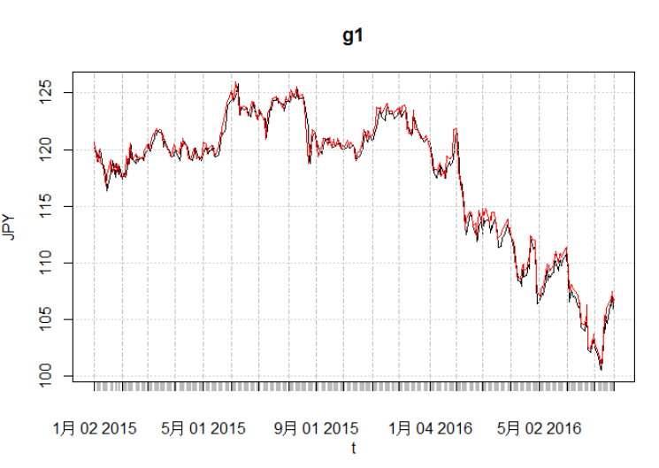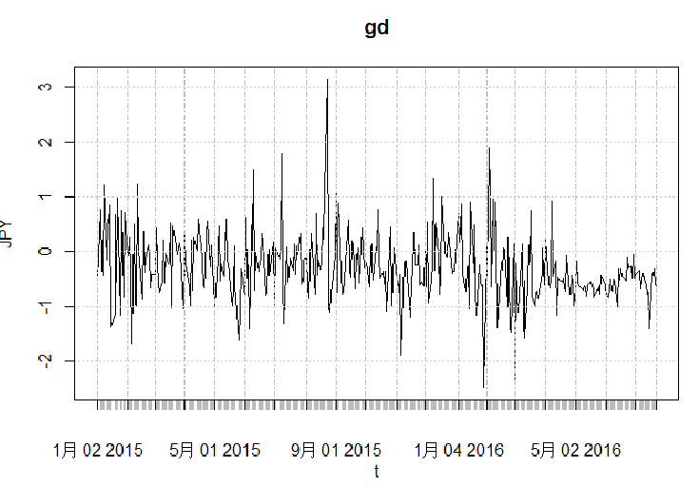

|  |
| --- |
| > mean(gd) |
| [1] -0.272633 |
| > sd(gd) |
| [1] 0.610984 |
| > library(moments) |
| > skewness(gd,na.rm = T) |
| 0.704454 |
| > kurtosis(gd,na.rm = T) |
| 6.201839 |
|  |

**Chapter 22 part a**

> result$par

[1] 0.3068807 0.9870448

> result$value

[1] 1599.768

**Chapter 22 part b**

The par value of the model fit is ~ 0.3 and 1 the payoff is high but the risk level is high too

**Chapter 22 part c**

To add a new risky factor. Or bootstrapping to find lower standard error.

**Chapter 22 part d**

Log return the model