Thank you for your interest in PCDC data.
Please send your completed proposal and any questions to: pcdc_requests@lists.uchicago.edu

Date*
Click or tap here to enter text.

Disease Group Name *
Please specify name of disease group(s) for which data is being requested.
Click or tap here to enter text.
Principal Investigator*
Click or tap here to enter text.
Institute Affiliation*
Click or tap here to enter text.

Cooperative Group
Required for INSTRuCT

☐ COG ☐ CWS ☐ EpSSG ☐ Not a member of one of these Cooperative Groups

Email Address*
Click or tap here to enter text.

First & Last Authors
please specify first and last author
Click or tap here to enter text.

Co-Authors
please specify all other authors. A complete list of authors in expected order is highly recommended. Middle authors will be ordered alphabetically by last name if no meaningful difference in contribution.
Click or tap here to enter text.

Title of Research Proposal*
Click or tap here to enter text.

Background and Significance*
Please provide a brief summary of the research project’s background, including a clear description of the project’s significance
Click or tap here to enter text.

Specific Aims *
Please provide in list form a description of the specific aims of the project, including the study objective and hypothesis to be evaluated
Click or tap here to enter text.
Methods *
Please provide in list form a clear description of the research methods to be used to address each of the specific aims. Please include inclusion and exclusion criteria, main outcome measure and any other variables of interest.
Click or tap here to enter text.

Statistical Analysis Plan
Please describe in list form how you will analyze the requested data, including descriptive, bivariate and multivariable analyses and any other planned advanced analyses.
Click or tap here to enter text.

Statistician
Please specify the statistician (name, email, and their affiliated institution/organization) who will be assigned to the project. For INRG data, if you would like to perform the analyses locally, please include the CV of your biostatistician and provide a detailed statistical plan.
Click or tap here to enter text.

Project Timeline
For INSTRuCT and MaGIC data- All investigators requesting data should ensure that the project is completed within a reasonable timeframe. Every effort should be made to meet the timepoints outlined below:
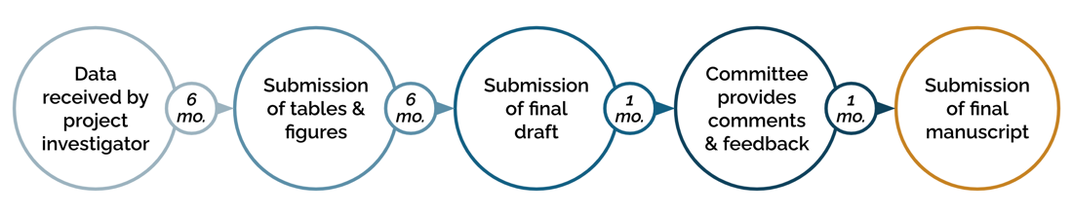
If you foresee challenges in adhering to this timeline, please describe below:
Click or tap here to enter text.

Funding, if applicable
Please explain how the project will be supported.
Click or tap here to enter text.

Data Portal Pilot | Did you utilize the PCDC Data Portal Cohort Explorer Tool to determine study feasibility or sample size for this project?  - Yes  - No
Did you utilize the PCDC Data Portal Kaplan-Meier Survival Analysis Tool for early hypothesis exploration for this project?
- Yes
- No
If you utilized the Kaplan-Meier Survival Analysis Tool, have you attached the relevant entries from your personal hypothesis record along with the project request?
- Yes - attached
- No - not applicable

*Required fields

