Step 1: In ‘SNEAKER_ECOMMERCE_WEBSITE-PROJECT/frontend/package.json’ file, add the following code:

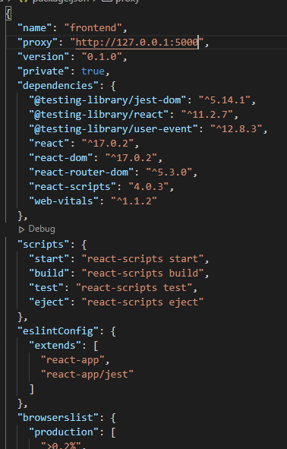

*Note: 127.0.0.1 is Loopback IP of Localhost*

Step 2: Install ‘axios’ (Terminal)

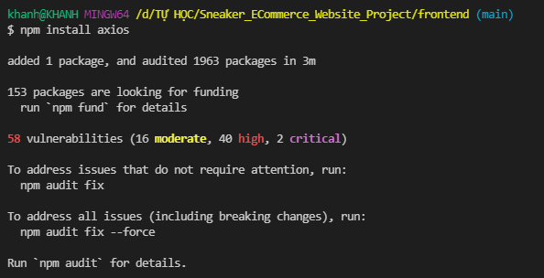

Step 3: In ‘SNEAKER_ECOMMERCE_WEBSITE-PROJECT/frontend/src/screens/HomeScreen.js’ file, update the folowing code:

import React, { useState, useEffect } from 'react';

import { Link } from 'react-router-dom';

import data from '../data';

Remove it

import axios from 'axios';

Add it

function HomeScreen (props) {

    const [products, setProducts] = useState([]);

    useEffect(() => {

        const fetchData = async () => {

            const { data } = await axios.get("/api/products");

            setProducts(data);

        }

        fetchData();

        return () => {

            //

        };

    }, [])

    return <ul className="products">

    {

Replace from “data.products” to “products” (State)

        products.map(product =>

            <li key={product._id}>

                <div className="product">

                    <Link to={'/product/' + product._id}>

                        <img className="product-image" src={product.image} alt="product1"/>

                    </Link>

                    <div className="product-name">

                        <Link to={'/product/' + product._id}>{product.name}</Link>

                    </div>

                    <div className="product-brand">{product.brand}</div>

                    <div className="product-price">${product.price}</div>

                    <div className="product-rating">{product.rating} Stars ({product.numReviews} Reviews)</div>

                </div>

            </li>)

    }

    </ul>

}

export default HomeScreen;

Result

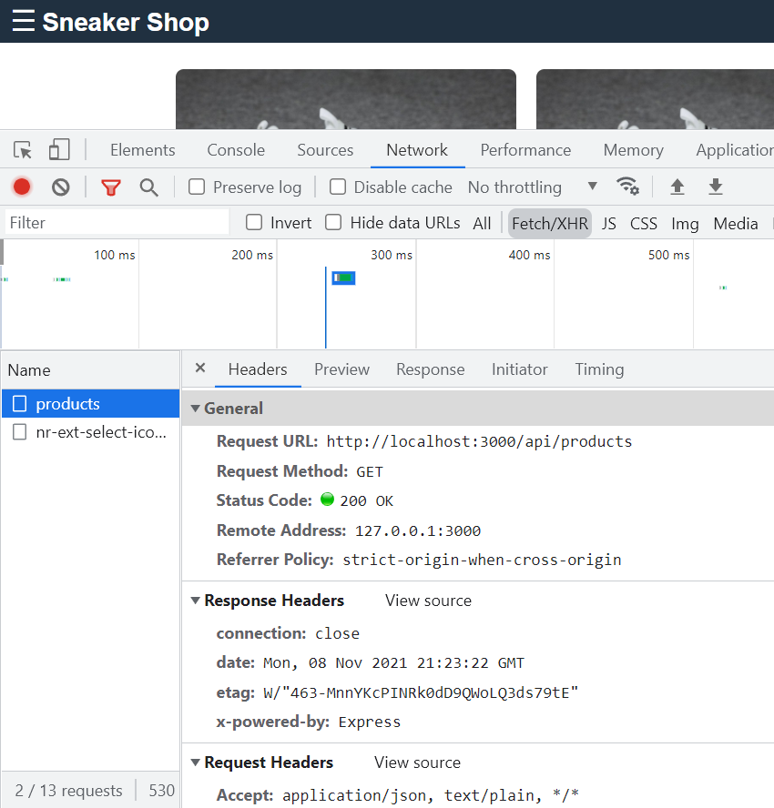

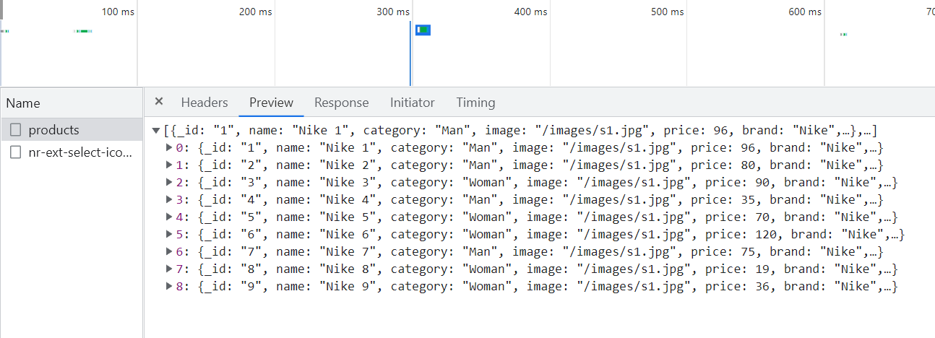

Fix Some Errors

Error 1: If you get the error like 2 pictutes below:

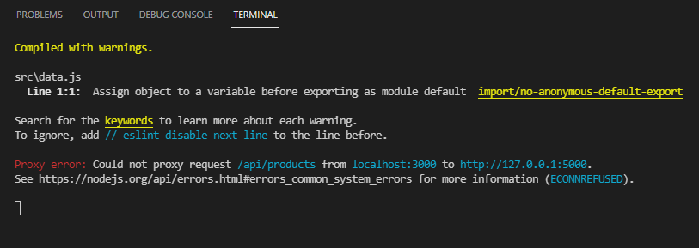

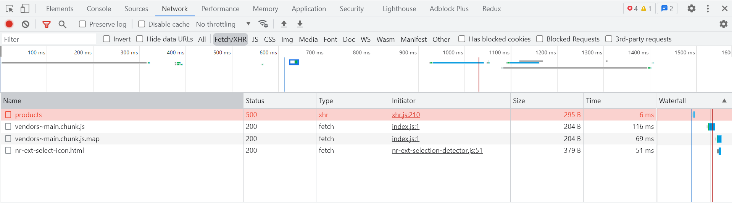

(Solution) for Error 1

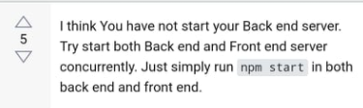

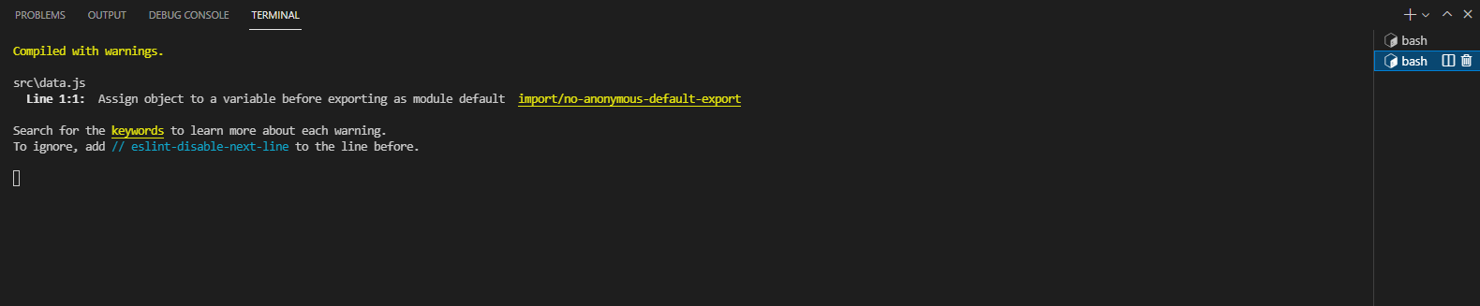

Npm start “backend” folder and “frontend” folder

Error 2: If you get the error like the pictute below: (in Console Tab of Dev Tool)

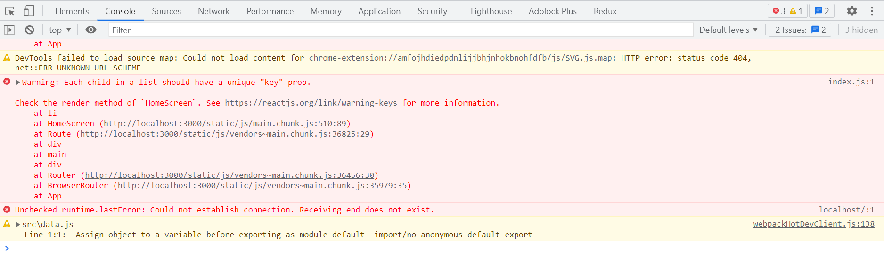

(Solution)

In ‘SNEAKER_ECOMMERCE_WEBSITE-PROJECT/frontend/src/screens/HomeScreen.js’ file

import React, { useState, useEffect } from 'react';

import { Link } from 'react-router-dom';

import axios from 'axios';

function HomeScreen (props) {

    const [products, setProducts] = useState([]);

    useEffect(() => {

        const fetchData = async () => {

            const { data } = await axios.get("/api/products");

            setProducts(data);

        }

        fetchData();

        return () => {

            //

        };

    }, [])

    return <ul className="products">

    {

Add key

        products.map(product =>

            <li key={product._id}>

                <div className="product">

                    <Link to={'/product/' + product._id}>

                        <img className="product-image" src={product.image} alt="product1"/>

                    </Link>

                    <div className="product-name">

                        <Link to={'/product/' + product._id}>{product.name}</Link>

                    </div>

                    <div className="product-brand">{product.brand}</div>

                    <div className="product-price">${product.price}</div>

                    <div className="product-rating">{product.rating} Stars ({product.numReviews} Reviews)</div>

                </div>

            </li>)

    }

    </ul>

}

export default HomeScreen;