**- Install redux (Terminal)**

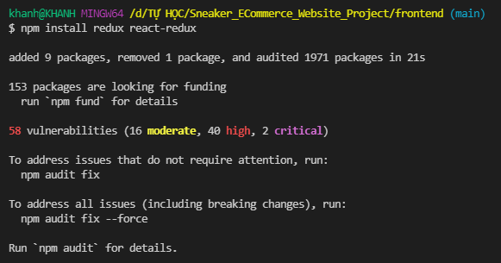

**- Create “SNEAKER_ECOMMERCE_WEBSITE_PROJECT/frontend/src/store.js” file, add the following code:**

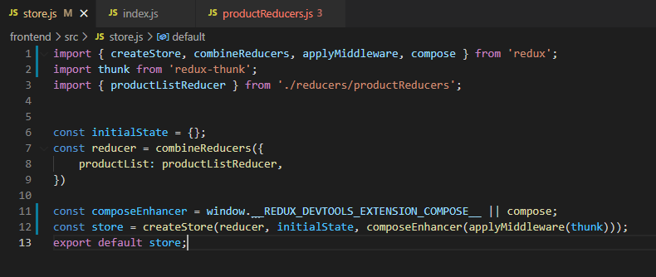

**- Create “SNEAKER_ECOMMERCE_WEBSITE_PROJECT/frontend/src/reducers” folder.**

**- Create “SNEAKER_ECOMMERCE_WEBSITE_PROJECT/frontend/src/reducers/productReducers.js” file, add the following code:**

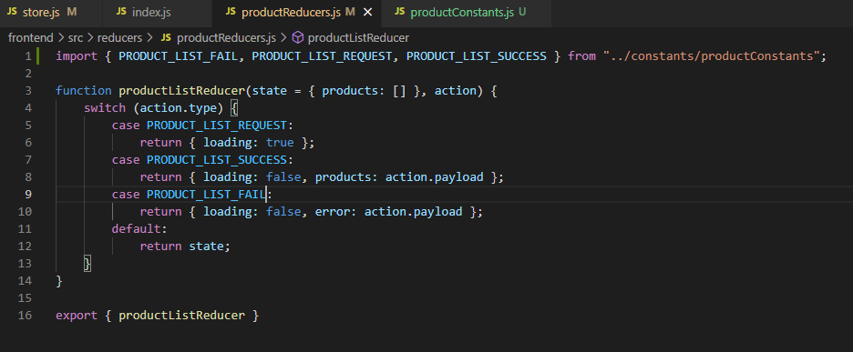

**- In “SNEAKER_ECOMMERCE_WEBSITE_PROJECT/frontend/src/index.js” file, update the following code:**

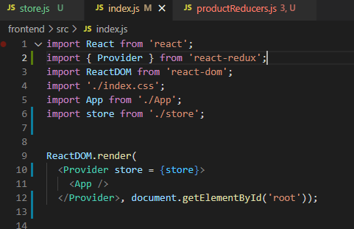

**- Install “redux-thunk” (Terminal)**

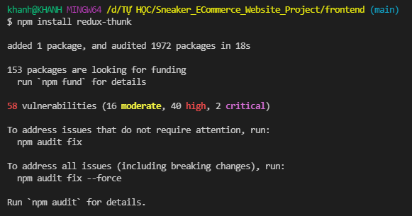

**- Create “SNEAKER_ECOMMERCE_WEBSITE_PROJECT/frontend/src/constants” folder.**

**- Create “SNEAKER_ECOMMERCE_WEBSITE_PROJECT/frontend/src/constants/productConstants.js” file, add the following code:**

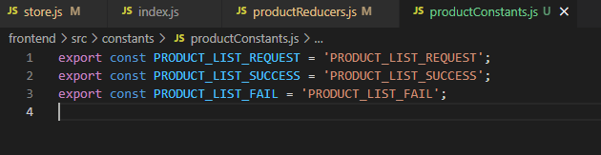

**- Run project.**

+ Step 1: (Terminal)

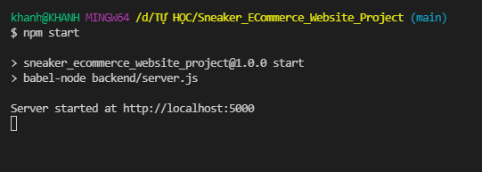

+ Step 2: (Terminal)

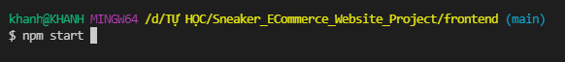

Error 1: If you get the error like below:

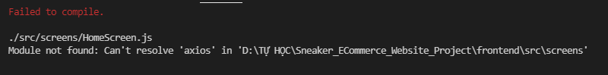

(Solution) for Error 1

- You should install again ‘axios’

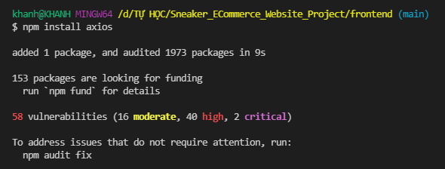

- Check “SNEAKER_ECOMMERCE_WEBSITE_PROJECT/frontend/src/package.json” file.

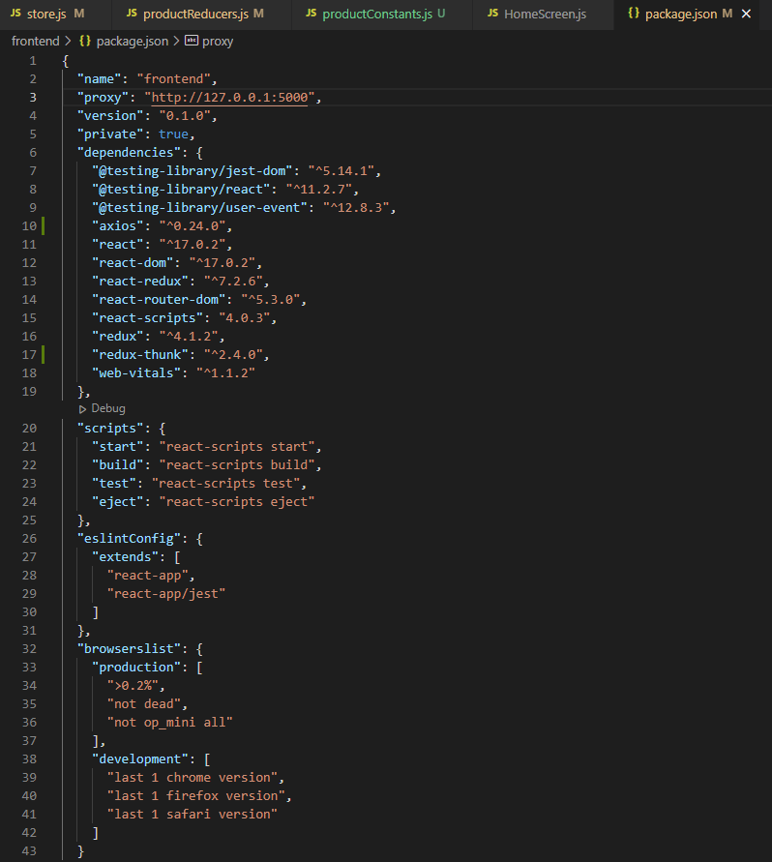

Result (Run project)

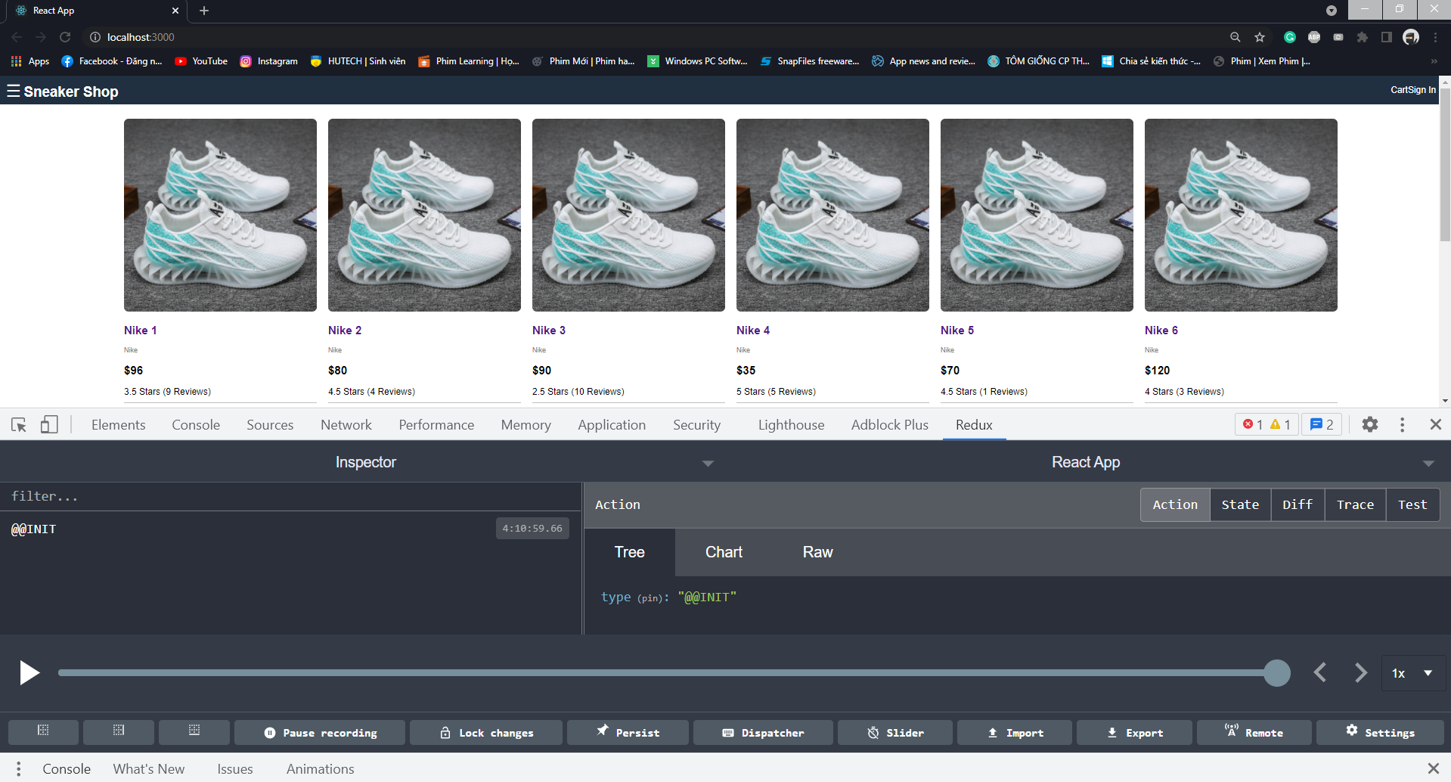

**- In “SNEAKER_ECOMMERCE_WEBSITE_PROJECT/frontend/src/screens/HomeScreen.js” file, update the following code:**

(The code has not been updated)

import React, { useState, useEffect } from 'react';

import { Link } from 'react-router-dom';

import axios from 'axios';

function HomeScreen (props) {

    const [products, setProducts] = useState([]);

    useEffect(() => {

        const fetchData = async () => {

            const { data } = await axios.get("/api/products");

            setProducts(data);

        }

        fetchData();

        return () => {

            //

        };

    }, [])

    return <ul className="products">

    {

        products.map(product =>

            <li key={product._id}>

                <div className="product">

                    <Link to={'/product/' + product._id}>

                        <img className="product-image" src={product.image} alt="product1"/>

                    </Link>

                    <div className="product-name">

                        <Link to={'/product/' + product._id}>{product.name}</Link>

                    </div>

                    <div className="product-brand">{product.brand}</div>

                    <div className="product-price">${product.price}</div>

                    <div className="product-rating">{product.rating} Stars ({product.numReviews} Reviews)</div>

                </div>

            </li>)

    }

    </ul>

}

export default HomeScreen;

(Updated code)

import React, { useState, useEffect } from 'react';

import { Link } from 'react-router-dom';

Remove

import axios from 'axios';

import { useSelector, useDispatch } from 'react-redux';

Add

import { listProducts } from '../actions/productActions';

function HomeScreen (props) {

    const productList = useSelector(state => state.productList);

Add

    const { products, loading, error } = productList;

    const dispatch = useDispatch();

    useEffect(() => {

        dispatch(listProducts());

Add

        return () => {

            //

        };

    }, [])

    return loading ? <div>Loading...</div>:

Add

    error ? <div>{error}</div>:

    <ul className="products">

    {

        products.map(product =>

            <li key={product._id}>

                <div className="product">

                    <Link to={'/product/' + product._id}>

                        <img className="product-image" src={product.image} alt="product1"/>

                    </Link>

                    <div className="product-name">

                        <Link to={'/product/' + product._id}>{product.name}</Link>

                    </div>

                    <div className="product-brand">{product.brand}</div>

                    <div className="product-price">${product.price}</div>

                    <div className="product-rating">{product.rating} Stars ({product.numReviews} Reviews)</div>

                </div>

            </li>)

    }

    </ul>

}

export default HomeScreen;

**- Create “SNEAKER_ECOMMERCE_WEBSITE_PROJECT/frontend/src/actions” folder.**

**- Create “SNEAKER_ECOMMERCE_WEBSITE_PROJECT/frontend/src/actions/productActions.js” file, add the following code:**

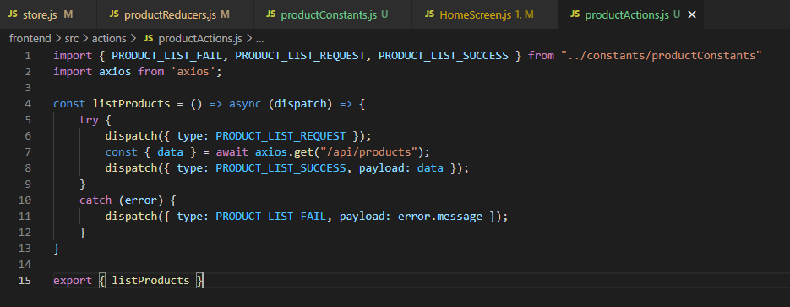

**Result**

