- Install redux (Terminal)

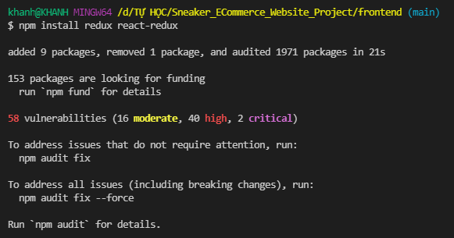

- Create “SNEAKER_ECOMMERCE_WEBSITE_PROJECT/frontend/src/**store.js**” file, add the following code:

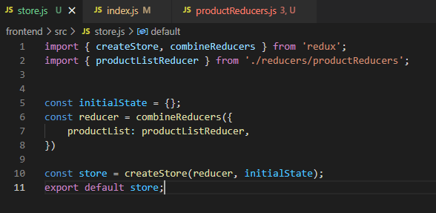

- Create “SNEAKER_ECOMMERCE_WEBSITE_PROJECT/frontend/src/**reducers**” folder.

- Create “SNEAKER_ECOMMERCE_WEBSITE_PROJECT/frontend/src/reducers/**productReducers.js**” file, add the following code:

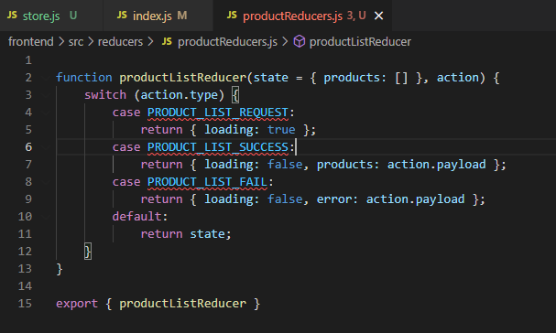

- In “SNEAKER_ECOMMERCE_WEBSITE_PROJECT/frontend/src/**index.js**” file, update the following code:

