项目名称 | 工业以太网交换机 | 保密密级 | 内部公开
文档编号 |  | 文档版本 | v1.0

网管优化需求测试验证报告

拟 制 | 何建国 | 日 期 | 2015-4-25
审 核 |  | 日 期
审 批 |  | 日 期

Hangzhou Obtelecom Electronic Technology Co., Ltd.
杭州中威电子股份有限公司
版 本 历 史
序号 | 版本 | 修订内容 | 修订人 | 修订日期
1 | 1.0 | 初稿 | 何建国 | 2015-5-25

目 录
1. 编写目的 1
2. 准备工作 1
3. 测试验证 2
3.1 第一阶段需求验证 2
3.1.1 设备寻呼验证 2
3.1.2 端口配置验证 3
3.1.2.1 设置端口配置 3
3.1.2.2 获取端口配置 4
3.1.3 获取端口状态验证 5
3.1.4 获取邻居信息验证 6
3.1.4.1 邻居探测功能验证 6
3.1.4.2 获取邻居信息验证 7
3.1.5 流量统计验证 9
3.1.5.1 统计读取 9
3.1.5.2 统计清零 10
3.1.6 告警配置验证 11
3.1.6.1 设置告警配置 11
3.1.6.2 获取告警配置 11
3.1.7 速率限制验证 12
3.1.7.1 设置速率限制配置 12
3.1.7.2 获取速率限制配置 13

编写目的
该文档由网络开发组向软件组起稿的板卡软件测试验证报告，其目的一是为了检验网络组开发人员的开发成果；二是以此报告作为软件组开发的输入，为软件组提供完备的底层软硬件平台支撑；另一方面，该文档为网络组和软件组之间的联调起到了一定的桥梁作用，降低了软件组的开发难度，解决了软件开发组在开发过程中产生的迷惑，明确了需求和期望结果，加快了开发周期，从而更好地完成网络组提出的需求。

文档适用目标范围包括：网络开发组开发人员、软件组相关开发人员等。

准备工作
- 板卡一块：GE22103MA v1.20（1千兆光1千兆电3百兆电）
板卡的MAC地址 ：00-A0-1D-11-22-33
主机的MAC地址 ：D0-67-E5-2A-74-E3

- 安装发包工具软件xcap-1.0.2，并创建报文组，如下图

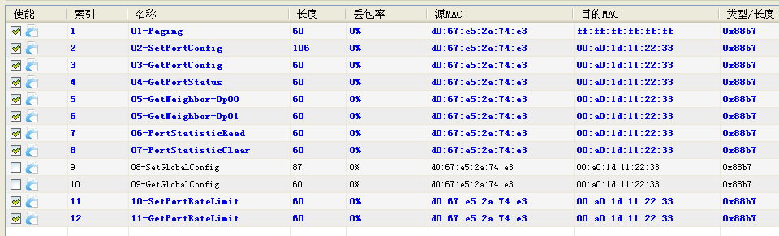

测试验证

第一阶段需求验证

设备寻呼验证
- 验证方法：通过xcap发送一条寻呼命令，查看板卡接收到的消息和回应消息。
- 验证结果：
消息说明 | 网络报文数据 | 备注
寻呼命令 | RxMsg: Paging  FF FF FF FF FF FF D0 67 E5 2A 74 E3 C0 28 00 01  88 B7 78 B6 C1 00 02 00 90 00 3C 00 01 FF FF FF  FF FF FF FF 00 00 00 00 00 00 00 00 00 00 00 00  00 00 00 00 00 00 00 00 00 00 00 00 00 00 00 00  (msg_type: 0x90, req_id: 0x0001, code: 0xff) | 背景  中的字节  不用关心
寻呼回应 | TxMsg: Paging  D0 67 E5 2A 74 E3 00 A0 1D 11 22 33 C0 00 00 01  88 B7 00 A0 1D 00 02 00 92 00 3C 00 01 00 A0 1D  11 22 33 FF 00 00 E2 21 03 07 FF FF FF FF 05 13  07 13 00 01 00 00 00 09 C0 A8 05 CC 00 00 00 00  (msg_type: 0x92, req_id: 0x0001, code: 0xff) | 背景  中的字节  不用关心

寻呼回应解析：
字段 | 网络字节 | 验证结果说明
SwitchType | E2 21 03 07 FF FF FF FF | 与产品型号唯一编码一致
PortNum | 05 | 与设备实际端口数一致
HardwareVersion | 13 07 | 版本号为v1.3.7，符合版本定义规则
SoftwareVersion | 13 00 | 版本号为v1.3.0.0，符合版本定义规则
ChipType | 01 | 0b’00-000001:Marvell 88E6095
FeatureMask | 00 00 00 09 | 对照功能掩码
IpAddress | C0 A8 05 CC | IP地址：192.168.5.204

图片截图：

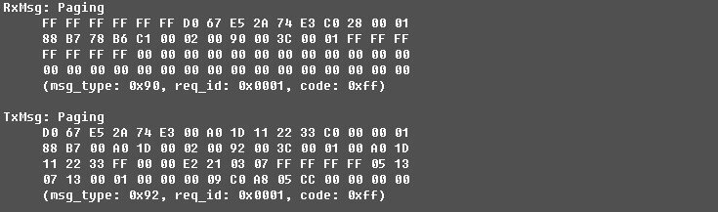

端口配置验证

设置端口配置
- 验证方法：通过xcap发送一条设置端口配置命令，查看板卡接收到的消息和回应消息。
- 验证结果：
消息说明 | 网络报文数据 | 备注
设置端口配置 | RxMsg: Set Port Configuration  00 A0 1D 11 22 33 D0 67 E5 2A 74 E3 00 28 E0 01  88 B7 00 A0 1D 00 02 00 91 00 6A 00 02 00 A0 1D  11 22 33 A1 00 05 E0 99 40 28 A0 99 40 40 10 99  40 40 10 99 40 40 10 99 40 40 00 00 00 00 00 00  00 00 00 00 00 00 00 00 00 00 00 00 00 00 00 00  00 00 00 00 00 00 00 00 00 00 00 00 00 00 00 00  00 00 00 00 00 00 00 00 00 00 00 00 00 00  (msg_type: 0x91, req_id: 0x0002, code: 0xa1) | 背景  中的字节  不用关心
消息回应 | TxMsg: Set Port Configuration  D0 67 E5 2A 74 E3 00 A0 1D 11 22 33 C0 00 00 01  88 B7 00 A0 1D 00 02 00 92 00 40 00 02 00 A0 1D  11 22 33 A1 00 00 00 00 00 00 00 00 00 00 00 00  00 00 00 00 00 00 00 00 00 00 00 00 00 00 00 00  (msg_type: 0x92, req_id: 0x0002, code: 0xa1) | 背景  中的字节  不用关心
设置端口配置消息解析：
描述 | 网络字节 | 验证结果说明
Port1的配置 | E0 99 40 28 | 千兆光口、最大速率1000M、接收和发送阀值100%、禁用邻居探测、启用端口、千兆全双工、流控禁用
Port2的配置 | A0 99 40 40 | 千兆电口、最大速率1000M、接收和发送阀值100%、禁用邻居探测、启用端口、自适应、流控禁用
Port3的配置 | 10 99 40 40 | 百兆电口、最大速率100M、接收和发送阀值100%、禁用邻居探测、启用端口、自适应、流控禁用
Port4的配置 | 10 99 40 40 | 百兆电口、最大速率100M、接收和发送阀值100%、禁用邻居探测、启用端口、自适应、流控禁用
Port5的配置 | 10 99 40 40 | 百兆电口、最大速率100M、接收和发送阀值100%、禁用邻居探测、启用端口、自适应、流控禁用
EEPROM存放显示：
(OBSwitch) > debug eeprom dump 600
0x00000600: 05 e0 99 40 28 a0 99 40 40 10 99 40 40 10 99 40
0x00000610: 40 10 99 40 40 ff ff ff ff ff ff ff ff ff ff ff
0x00000620: ff ff ff ff ff ff ff ff ff ff ff ff ff ff ff ff
0x00000630: ff ff ff ff ff ff ff ff ff ff ff ff ff ff ff ff
图片截图：
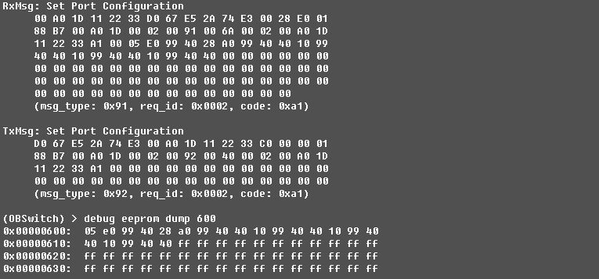

获取端口配置
- 验证方法：通过xcap发送一条获取端口配置命令，查看板卡接收到的消息和回应消息。
- 验证结果：
消息说明 | 网络报文数据 | 备注
获取端口配置 | RxMsg: Get Port Configuration  00 A0 1D 11 22 33 D0 67 E5 2A 74 E3 00 28 E0 01  88 B7 00 A0 1D 00 02 00 90 00 3C 00 03 00 A0 1D  11 22 33 41 00 00 00 00 00 00 00 00 00 00 00 00  00 00 00 00 00 00 00 00 00 00 00 00 00 00 00 00  (msg_type: 0x90, req_id: 0x0003, code: 0x41) | 背景  中的字节  不用关心
消息回应 | TxMsg: Get Port Configuration  D0 67 E5 2A 74 E3 00 A0 1D 11 22 33 C0 00 00 01  88 B7 00 A0 1D 00 02 00 92 00 40 00 03 00 A0 1D  11 22 33 41 00 05 E0 99 40 28 A0 99 40 40 10 99  40 40 10 99 40 40 10 99 40 40 00 00 00 00 00 00  (msg_type: 0x92, req_id: 0x0003, code: 0x41) | 背景  中的字节  不用关心
检查回应的端口配置内容是否和EEPROM存放的配置一致。
(OBSwitch) > debug eeprom dump 600
0x00000600: 05 e0 99 40 28 a0 99 40 40 10 99 40 40 10 99 40
0x00000610: 40 10 99 40 40 ff ff ff ff ff ff ff ff ff ff ff
0x00000620: ff ff ff ff ff ff ff ff ff ff ff ff ff ff ff ff
0x00000630: ff ff ff ff ff ff ff ff ff ff ff ff ff ff ff ff
图片截图：
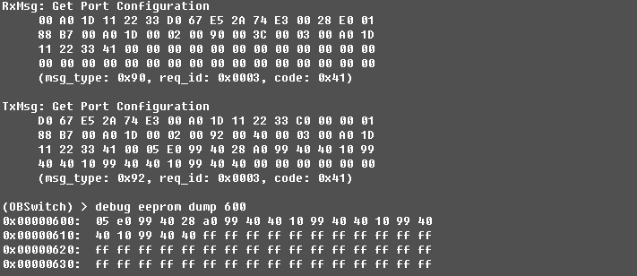

获取端口状态验证
- 验证方法：通过xcap发送一条获取端口状态命令，查看板卡接收到的消息和回应消息。
- 验证结果：
消息说明 | 网络报文数据 | 备注
获取端口状态 | RxMsg: Get Port Stauts  00 A0 1D 11 22 33 D0 67 E5 2A 74 E3 00 28 E0 01  88 B7 00 A0 1D 00 02 00 90 00 3C 00 04 00 A0 1D  11 22 33 02 00 00 00 00 00 00 00 00 00 00 00 00  00 00 00 00 00 00 00 00 00 00 00 00 00 00 00 00  (msg_type: 0x90, req_id: 0x0004, code: 0x02) | 背景  中的字节  不用关心
消息回应 | TxMsg: Get Port Stauts  D0 67 E5 2A 74 E3 00 A0 1D 11 22 33 C0 00 00 01  88 B7 00 A0 1D 00 02 00 92 00 40 00 04 00 A0 1D  11 22 33 02 00 05 04 AC 9C 04 9C 00 00 00 00 00  00 00 00 00 00 00 00 00 00 00 00 00 00 00 00 00  (msg_type: 0x92, req_id: 0x0004, code: 0x02) | 背景  中的字节  不用关心
获取端口状态回应解析：
描述 | 网络字节 | 验证结果说明
Port1的状态 | 04 | Link Down、已启用
Port2的状态 | AC | Link Up、千兆全双工、已启用
Port3的状态 | 9C | Link Up、百兆全双工
Port4的状态 | 04 | Link Down、已启用
Port5的状态 | 9C | Link Up、百兆全双工
图片截图：
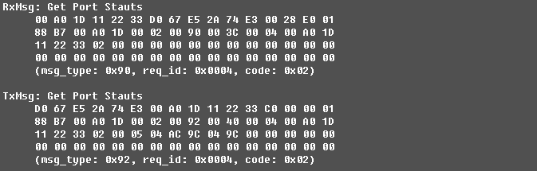

获取邻居信息验证
在获取邻居信息之前，首先要打开本设备的端口邻居探测功能（见端口配置），设备才能自动探测到端口的邻居信息，以便网管来获取设备的邻居表信息。

邻居探测功能验证
- 验证步骤：
  - 准备两张板卡GE22103MA（1千兆光1千兆电3百兆电）
  - 启用1号板卡Port4邻居探测功能
消息说明 | 网络报文数据 | 备注
设置端口配置 | RxMsg: Set Port Configuration  00 A0 1D 11 22 33 D0 67 E5 2A 74 E3 00 28 E0 01  88 B7 00 A0 1D 00 02 00 91 00 6A 00 02 00 A0 1D  11 22 33 A1 00 05 E0 99 40 28 A0 99 40 40 10 99  40 40 10 99 40 40 10 99 40 40 00 00 00 00 00 00  00 00 00 00 00 00 00 00 00 00 00 00 00 00 00 00  00 00 00 00 00 00 00 00 00 00 00 00 00 00 00 00  00 00 00 00 00 00 00 00 00 00 00 00 00 00  (msg_type: 0x91, req_id: 0x0002, code: 0xa1) | 背景  中的字节  不用关心
消息回应 | TxMsg: Set Port Configuration  D0 67 E5 2A 74 E3 00 A0 1D 11 22 33 C0 00 00 01  88 B7 00 A0 1D 00 02 00 92 00 40 00 02 00 A0 1D  11 22 33 A1 00 00 00 00 00 00 00 00 00 00 00 00  00 00 00 00 00 00 00 00 00 00 00 00 00 00 00 00  (msg_type: 0x92, req_id: 0x0002, code: 0xa1) | 背景  中的字节  不用关心
设置端口配置消息解析：
描述 | 网络字节 | 验证结果说明
Port1的配置 | E0 99 40 28 | 千兆光口、最大速率1000M、接收和发送阀值100%、禁用邻居探测、启用端口、千兆全双工、流控禁用
Port2的配置 | A0 99 40 40 | 千兆电口、最大速率1000M、接收和发送阀值100%、禁用邻居探测、启用端口、自适应、流控禁用
Port3的配置 | 10 99 40 40 | 百兆电口、最大速率100M、接收和发送阀值100%、禁用邻居探测、启用端口、自适应、流控禁用
Port4的配置 | 10 99 C0 40 | 百兆电口、最大速率100M、接收和发送阀值100%、启用邻居探测、启用端口、自适应、流控禁用
Port5的配置 | 10 99 40 40 | 百兆电口、最大速率100M、接收和发送阀值100%、禁用邻居探测、启用端口、自适应、流控禁用

  - 用网线相连1号板卡的Port4和2号板卡的Port5，重新上电1号板卡后，1号板卡会自动探测Port4的
邻居设备，并获取相应的邻居信息。
在CLI里我们可以通过命令show ports来显示端口信息（端口状态、端口配置信息、端口邻居信息）

获取邻居信息验证
- 验证方法：通过xcap发送一条获取邻居信息命令，查看板卡接收到的消息和回应消息。
- 验证结果：
消息说明 | 网络报文数据 | 备注
消息回应 | RxMsg: Get NeighborInfo  00 A0 1D 11 22 33 D0 67 E5 2A 74 E3 00 28 E0 01  88 B7 00 A0 1D 00 02 00 90 00 3C 00 05 00 A0 1D  11 22 33 03 00 00 00 00 00 00 00 00 00 00 00 00  00 00 00 00 00 00 00 00 00 00 00 00 00 00 00 00  (msg_type: 0x90, req_id: 0x0005, code: 0x03)  TxMsg: Get NeighborInfo  D0 67 E5 2A 74 E3 00 A0 1D 11 22 33 C0 00 00 01  88 B7 00 A0 1D 00 02 00 92 00 54 00 05 00 A0 1D  11 22 33 03 00 05 41 02 00 01 01 00 00 00 00 00  00 00 00 00 00 00 00 00 00 00 00 00 00 00 00 02  01 00 00 00 00 00 00 00 00 00 00 00 00 00 00 00  00 00 00 00  (msg_type: 0x92, req_id: 0x0005, code: 0x03)  RxMsg: Get NeighborInfo  00 A0 1D 11 22 33 D0 67 E5 2A 74 E3 00 28 E0 01  88 B7 00 A0 1D 00 02 00 90 00 3C 00 05 00 A0 1D  11 22 33 03 00 01 00 00 00 00 00 00 00 00 00 00  00 00 00 00 00 00 00 00 00 00 00 00 00 00 00 00  (msg_type: 0x90, req_id: 0x0005, code: 0x03)  TxMsg: Get NeighborInfo  D0 67 E5 2A 74 E3 00 A0 1D 11 22 33 C0 00 00 01  88 B7 00 A0 1D 00 02 00 92 00 54 00 05 00 A0 1D  11 22 33 03 00 05 C2 02 00 03 01 00 00 00 00 00  00 00 00 00 00 00 00 00 00 00 00 00 00 00 01 04  03 00 A0 1D 11 22 00 06 C0 A8 05 DC E2 21 03 FF  FF FF FF FF  (msg_type: 0x92, req_id: 0x0005, code: 0x03)  RxMsg: Get NeighborInfo  00 A0 1D 11 22 33 D0 67 E5 2A 74 E3 00 28 E0 01  88 B7 00 A0 1D 00 02 00 90 00 3C 00 05 00 A0 1D  11 22 33 03 00 01 00 00 00 00 00 00 00 00 00 00  00 00 00 00 00 00 00 00 00 00 00 00 00 00 00 00  (msg_type: 0x90, req_id: 0x0005, code: 0x03)  TxMsg: Get NeighborInfo  D0 67 E5 2A 74 E3 00 A0 1D 11 22 33 C0 00 00 01  88 B7 00 A0 1D 00 02 00 92 00 3E 00 05 00 A0 1D  11 22 33 03 00 05 83 01 00 05 01 00 00 00 00 00  00 00 00 00 00 00 00 00 00 00 00 00 00 00  (msg_type: 0x92, req_id: 0x0005, code: 0x03) | 背景  中的字节  不用关心
获取邻居信息回应内容检查：
描述 | 网络字节 | 验证结果说明
Port1的邻居信息 | 00 01 01 00 00 00 00 00 00 00 00 00 00 00 00 00 00 00 00 00 00 00 | 无邻居信息
Port2的邻居信息 | 00 02 01 00 00 00 00 00 00 00 00 00 00 00 00 00 00 00 00 00 00 00 | 无邻居信息
Port3的邻居信息 | 00 03 01 00 00 00 00 00 00 00 00 00 00 00 00 00 00 00 00 00 00 00 | 无邻居信息
Port4的邻居信息 | 01 04 03 00 A0 1D 11 22 00 06 C0 A8 05 DC E2 21 03 FF FF FF FF FF | 邻居探测使能，本地端口号4，端口状态Forwarding，邻居MAC=00-A0-1D-11-22-00，邻居端口号6，邻居IP=192.168.5.220，邻居设备型号：E2-21-03-FF-FF-FF-FF-FF
Port5的邻居信息 | 00 05 01 00 00 00 00 00 00 00 00 00 00 00 00 00 00 00 00 00 00 00 | 无邻居信息

图片截图：
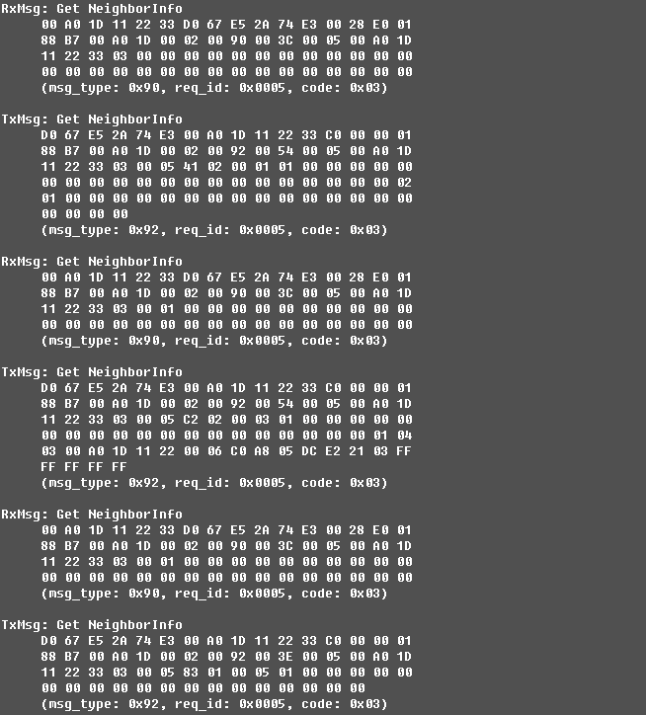

流量统计验证

统计读取
- 验证方法：通过xcap发送一条端口统计数据读取命令，查看板卡接收到的消息和回应消息。
- 验证结果：
消息说明 | 网络报文数据 | 备注
统计数据读取 | RxMsg: Port Statistics  00 A0 1D 11 22 33 D0 67 E5 2A 74 E3 00 30 E0 01  88 B7 00 A0 1D 00 02 00 91 00 3C 00 06 00 A0 1D  11 22 33 B2 00 05 00 00 00 00 0C 00 00 00 00 00  00 00 00 00 00 00 00 00 00 00 00 00 00 00 00 00  (msg_type: 0x91, req_id: 0x0006, code: 0xb2) | 背景  中的字节  不用关心
消息回应 | TxMsg: Port Statistics  D0 67 E5 2A 74 E3 00 A0 1D 11 22 33 C0 00 00 01  88 B7 00 A0 1D 00 02 00 92 01 2D 00 06 00 A0 1D  11 22 33 B2 00 05 00 00 00 00 0C FF F0 00 02 BA  1A 00 00 00 00 00 00 00 24 00 00 07 01 00 00 00  DD 00 00 00 00 00 00 1B C4 00 00 00 00 00 00 00  2A 00 00 00 01 00 00 00 01 00 00 00 00 00 00 00  00 00 00 00 00 00 00 00 00 00 00 00 00 00 00 1B  84 00 00 00 00 00 00 00 2B 00 00 00 00 00 00 00  00 00 00 00 00 00 02 DB C7 00 00 00 00 00 00 00  65 00 00 07 02 00 00 01 1E 00 00 00 00 00 00 00  00 00 00 00 00 00 00 00 00 00 00 00 00 00 00 00  00 00 00 00 00 00 00 00 00 00 00 00 00 00 00 00  00 00 00 00 00 00 00 00 00 00 00 00 00 00 00 00  00 00 00 00 00 00 00 00 00 00 00 00 00 00 00 00  00 00 00 00 00 00 00 00 00 00 00 00 00 00 00 00  00 00 00 00 00 00 00 00 00 00 00 00 00 00 00 00  00 00 00 00 00 00 00 00 00 00 00 00 00 00 00 00  00 00 00 00 00 00 00 00 00 00 00 00 00 00 00 00  00 00 00 00 00 00 00 00 00 00 00 00 00  (msg_type: 0x92, req_id: 0x0006, code: 0xb2) | 背景  中的字节  不用关心
统计数据读取命令回应内容检查：
描述 | 网络字节 | 验证结果说明
PortNum | 05 | 端口数
Opcode | 00 | 读操作
PortMap[4] | 00 00 00 0C | 统计端口3，4
ValidItemMask[2] | FF F0 | 有效统计项掩码
Counters | -- | 上表带颜色隔离的4组统计数据可以看出前面两组有统计数据

图片截图：
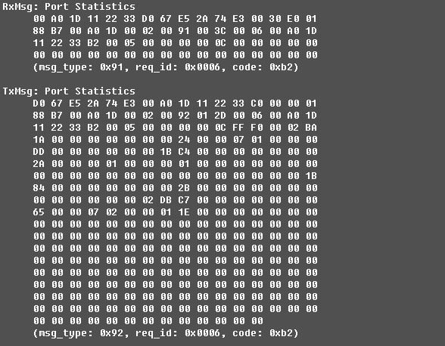

统计清零
- 验证方法：通过xcap发送一条端口统计数据清零命令，查看板卡接收到的消息和回应消息。
- 验证结果：
消息说明 | 网络报文数据 | 备注
统计数据清零 | RxMsg: Port Statistics  00 A0 1D 11 22 33 D0 67 E5 2A 74 E3 00 30 E0 01  88 B7 00 A0 1D 00 02 00 91 00 3C 00 07 00 A0 1D  11 22 33 B2 00 05 01 00 00 00 0C 00 00 00 00 00  00 00 00 00 00 00 00 00 00 00 00 00 00 00 00 00  (msg_type: 0x91, req_id: 0x0007, code: 0xb2) | 背景  中的字节  不用关心
消息回应 | TxMsg: Port Statistics  D0 67 E5 2A 74 E3 00 A0 1D 11 22 33 C0 00 00 01  88 B7 00 A0 1D 00 02 00 92 01 2D 00 07 00 A0 1D  11 22 33 B2 00 05 01 00 00 00 0C 00 00 00 00 00  00 00 00 00 00 00 00 00 00 00 00 00 00 00 00 00  00 00 00 00 00 00 00 00 00 00 00 00 00 00 00 00  00 00 00 00 00 00 00 00 00 00 00 00 00 00 00 00  00 00 00 00 00 00 00 00 00 00 00 00 00 00 00 00  00 00 00 00 00 00 00 00 00 00 00 00 00 00 00 00  00 00 00 00 00 00 00 00 00 00 00 00 00 00 00 00  00 00 00 00 00 00 00 00 00 00 00 00 00 00 00 00  00 00 00 00 00 00 00 00 00 00 00 00 00 00 00 00  00 00 00 00 00 00 00 00 00 00 00 00 00 00 00 00  00 00 00 00 00 00 00 00 00 00 00 00 00 00 00 00  00 00 00 00 00 00 00 00 00 00 00 00 00 00 00 00  00 00 00 00 00 00 00 00 00 00 00 00 00 00 00 00  00 00 00 00 00 00 00 00 00 00 00 00 00 00 00 00  00 00 00 00 00 00 00 00 00 00 00 00 00 00 00 00  00 00 00 00 00 00 00 00 00 00 00 00 00 00 00 00  00 00 00 00 00 00 00 00 00 00 00 00 00  (msg_type: 0x92, req_id: 0x0007, code: 0xb2) | 背景  中的字节  不用关心

图片截图：
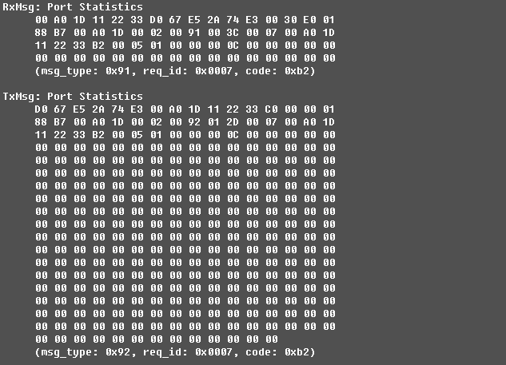

告警配置验证

设置告警配置
- 验证方法：通过xcap发送一条全局配置命令，查看板卡接收到的消息和回应消息。
- 验证结果：
消息说明 | 网络报文数据 | 备注
设置告警配置 |  | 背景  中的字节  不用关心
消息回应 |  | 背景  中的字节  不用关心
设置消息字段检查：
描述 | 网络字节 | 验证结果说明
EEPROM存放显示：
图片截图：

获取告警配置
- 验证方法：通过xcap发送一条获取告警配置命令，查看板卡接收到的消息和回应消息。
- 验证结果：
消息说明 | 网络报文数据 | 备注
获取告警配置 |  | 背景  中的字节  不用关心
消息回应 |  | 背景  中的字节  不用关心
检查回应的配置内容是否和EEPROM存放的配置一致。
图片截图：

速率限制验证

设置速率限制配置
- 验证方法：通过xcap发送一条速率限制配置命令，查看板卡接收到的消息和回应消息。
- 验证结果：
消息说明 | 网络报文数据 | 备注
设置速率限制 | RxMsg: Set Rate  00 A0 1D 11 22 33 D0 67 E5 2A 74 E3 00 30 E0 01  88 B7 00 A0 1D 00 02 00 91 00 3C 00 0A 00 A0 1D  11 22 33 A5 00 05 00 00 00 00 C4 06 C4 07 00 00  00 00 00 00 00 00 00 00 00 00 00 00 00 00 00 00  (msg_type: 0x91, req_id: 0x000a, code: 0xa5) | 背景  中的字节  不用关心
消息回应 | TxMsg: Set Rate  D0 67 E5 2A 74 E3 00 A0 1D 11 22 33 C0 00 00 01  88 B7 00 A0 1D 00 02 00 92 00 40 00 0A 00 A0 1D  11 22 33 A5 00 00 00 00 00 00 00 00 00 00 00 00  00 00 00 00 00 00 00 00 00 00 00 00 00 00 00 00  (msg_type: 0x92, req_id: 0x000a, code: 0xa5) | 背景  中的字节  不用关心
设置消息字段检查：
描述 | 网络字节 | 验证结果说明
Port1的配置 | 00 00 | 不做做速率限制配置
Port2的配置 | 00 00 | 不做做速率限制配置
Port3的配置 | C4 06 | 限制端口输入广播报文最大速率为1Mbps，限制输出速率为4M
Port4的配置 | C4 07 | 限制端口输入广播报文最大速率为1Mbps，限制输出速率为8M
Port5的配置 | 00 00 | 不做做速率限制配置
EEPROM存放显示：
(OBSwitch) > debug eeprom dump 800
0x00000800: 05 00 00 00 00 c4 06 c4 07 00 00 ff ff ff ff ff
0x00000810: ff ff ff ff ff ff ff ff ff ff ff ff ff ff ff ff
0x00000820: ff ff ff ff ff ff ff ff ff ff ff ff ff ff ff ff
0x00000830: ff ff ff ff ff ff ff ff ff ff ff ff ff ff ff ff
图片截图：
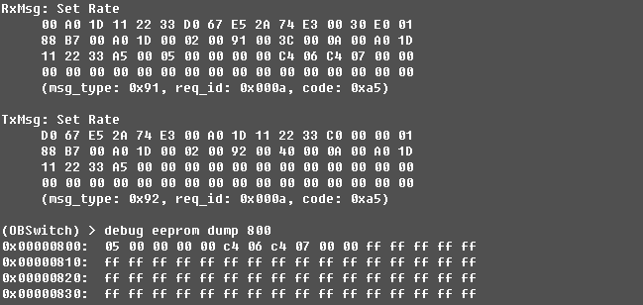

获取速率限制配置
- 验证方法：通过xcap发送一条获取速率限制配置命令，查看板卡接收到的消息和回应消息。
- 验证结果：
消息说明 | 网络报文数据 | 备注
获取  速率限制配置 | RxMsg: Get Rate  00 A0 1D 11 22 33 D0 67 E5 2A 74 E3 00 30 E0 01  88 B7 00 A0 1D 00 02 00 90 00 3C 00 0B 00 A0 1D  11 22 33 45 00 00 00 00 00 00 00 00 00 00 00 00  00 00 00 00 00 00 00 00 00 00 00 00 00 00 00 00  (msg_type: 0x90, req_id: 0x000b, code: 0x45) | 背景  中的字节  不用关心
消息回应 | TxMsg: Get Rate  D0 67 E5 2A 74 E3 00 A0 1D 11 22 33 C0 00 00 01  88 B7 00 A0 1D 00 02 00 92 00 40 00 0B 00 A0 1D  11 22 33 45 00 05 00 00 00 00 C4 06 C4 07 00 00  00 00 00 00 00 00 00 00 00 00 00 00 00 00 00 00  (msg_type: 0x92, req_id: 0x000b, code: 0x45) | 背景  中的字节  不用关心
检查回应的配置内容是否和EEPROM存放的配置一致。
(OBSwitch) > debug eeprom dump 800
0x00000800: 05 00 00 00 00 c4 06 c4 07 00 00 ff ff ff ff ff
0x00000810: ff ff ff ff ff ff ff ff ff ff ff ff ff ff ff ff
0x00000820: ff ff ff ff ff ff ff ff ff ff ff ff ff ff ff ff
0x00000830: ff ff ff ff ff ff ff ff ff ff ff ff ff ff ff ff
图片截图：
