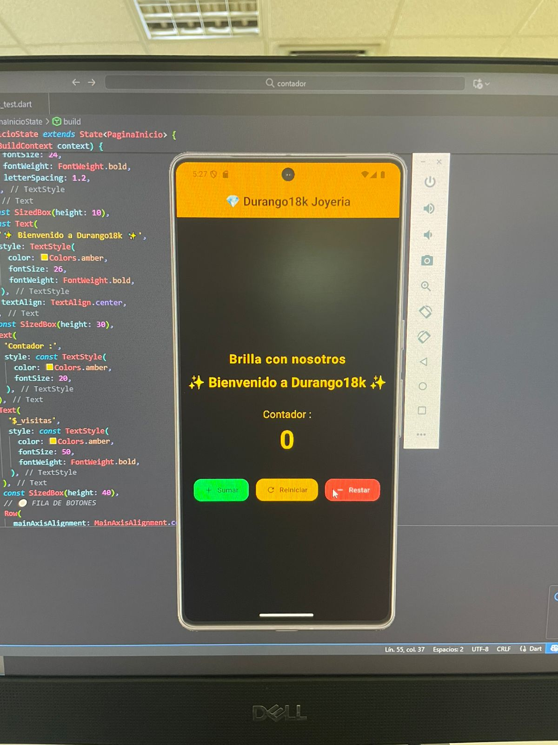

import 'package:flutter/material.dart';

void main() {

runApp(const DurangoApp());

}

class DurangoApp extends StatelessWidget {

const DurangoApp({super.key});

@override

Widget build(BuildContext context) {

return MaterialApp(

debugShowCheckedModeBanner: false,

title: 'Durango18k Joyeria',

theme: ThemeData(

colorScheme: ColorScheme.fromSeed(seedColor: Colors.amber),

useMaterial3: true,

),

home: const PaginaInicio(),

);

}

}

class PaginaInicio extends StatefulWidget {

const PaginaInicio({super.key});

@override

State<PaginaInicio> createState() => _PaginaInicioState();

}

class _PaginaInicioState extends State<PaginaInicio> {

int _visitas = 0;

void _aumentarVisitas() {

setState(() {

_visitas++;

});

}

void _disminuirVisitas() {

setState(() {

if (_visitas > 0) _visitas--;

});

}

void _reiniciarVisitas() {

setState(() {

_visitas = 0;

});

}

@override

Widget build(BuildContext context) {

return Scaffold(

backgroundColor: Colors.black,

appBar: AppBar(

backgroundColor: Colors.amber[700],

title: const Text(

'💎 Durango18k Joyeria',

style: TextStyle(

fontWeight: FontWeight.bold,

color: Color.fromARGB(255, 14, 0, 0),

),

),

centerTitle: true,

),

body: Center(

child: Column(

mainAxisAlignment: MainAxisAlignment.center,

children: [

const Text(

'Brilla con nosotros',

style: TextStyle(

color: Colors.amber,

fontSize: 24,

fontWeight: FontWeight.bold,

letterSpacing: 1.2,

),

),

const SizedBox(height: 10),

const Text(

'✨ Bienvenido a Durango18k ✨',

style: TextStyle(

color: Colors.amber,

fontSize: 26,

fontWeight: FontWeight.bold,

),

textAlign: TextAlign.center,

),

const SizedBox(height: 30),

const Text(

'Contador :',

style: TextStyle(

color: Colors.amber,

fontSize: 20,

),

),

Text(

'$_visitas',

style: const TextStyle(

color: Colors.amber,

fontSize: 50,

fontWeight: FontWeight.bold,

),

),

const SizedBox(height: 40),

// 🔘 FILA DE BOTONES

Row(

mainAxisAlignment: MainAxisAlignment.center,

children: [

// Botón de sumar

ElevatedButton.icon(

onPressed: _aumentarVisitas,

icon: const Icon(Icons.add),

label: const Text('Sumar'),

style: ElevatedButton.styleFrom(

backgroundColor: Colors.greenAccent,

foregroundColor: Colors.black,

padding: const EdgeInsets.symmetric(

horizontal: 20, vertical: 12),

shape: RoundedRectangleBorder(

borderRadius: BorderRadius.circular(15),

),

),

),

const SizedBox(width: 15),

// Botón de reiniciar

ElevatedButton.icon(

onPressed: _reiniciarVisitas,

icon: const Icon(Icons.refresh),

label: const Text('Reiniciar'),

style: ElevatedButton.styleFrom(

backgroundColor: Colors.amber,

foregroundColor: Colors.black,

padding: const EdgeInsets.symmetric(

horizontal: 20, vertical: 12),

shape: RoundedRectangleBorder(

borderRadius: BorderRadius.circular(15),

),

),

),

const SizedBox(width: 15),

// Botón de restar

ElevatedButton.icon(

onPressed: _disminuirVisitas,

icon: const Icon(Icons.remove),

label: const Text('Restar'),

style: ElevatedButton.styleFrom(

backgroundColor: Colors.redAccent,

foregroundColor: Colors.white,

padding: const EdgeInsets.symmetric(

horizontal: 20, vertical: 12),

shape: RoundedRectangleBorder(

borderRadius: BorderRadius.circular(15),

),

),

),

],

),

],

),

),

);

}

}