le

| Oluwaseun Olanrewaju Alade  (Full Stack Python Developer / Engineer) | **Cassino**  **03043 Province of Frosinone**  **Italy**  **(+39) 333-460-1230**  **ladeforsuccess@gmail.com** |
| --- | --- |

January 11, 2023

Dear Hiring Manager,

**The position of Full Stack Python Developer (6141) Amsterdam, The Netherlands**

I am writing to express my interest in the python developer position that you have advertised. I believe that my experience and skills make me a strong candidate for this position. I am a highly motivated and progress-focused Full Stack Python Developer with a long standing background in this industry.

I have been working as a full stack python developer for the past five years, and I have extensive experience with both front-end and back-end development. I have worked on projects of all sizes, from small personal projects to large enterprise systems. My experience has given me the opportunity to work with many different technologies, including Python, JavaScript, html, css, Django Web Framework, Postgresql, Material UI library, Django Rest Framework, SQL, Typescript, Bootstrap, ReactJS, Machine learning, Docker, Jupyter Lab, Jupyter Notebook, Mysql, Sqlite3, Github, Visual Studio Code, and Amazon Web Service (AWS).

I hold a Master degree in Computer Science with a First Class Degree Honours. My core strengths are my ability to learn quickly and my attention to detail. I pride myself on being able to pick up new technologies quickly and efficiently. I also take pride in my ability to write clean code that is easy to read and maintain. I believe that these skills are essential for any developer who wants to be successful in today’s competitive job market.

I am experienced in:

* Creating and implementing the website’s overarching architecture.
* Creating database technology for the website and implementing it.
* Creating application logic and the required files for backend operations.
* Creating front-end user interface.
* Integrating the API with the front-end user interface.
* Optimizing website for mobile and tablet devices.
* Ascertaining the website’s responsiveness.

**I am ready and willing to start working immediately. My notice period is 1 week.** I am a hard worker and a team player. I am always willing to put in the extra effort to get the job done. I also believe in working collaboratively with my team members to achieve common goals. I am confident that I have the skills and experience that would make me the perfect candidate for this position. I would be grateful for the opportunity to discuss this further with you in an interview. I would like to thank you for your time and consideration and I look forward to hearing from you soon.

Sincerely,

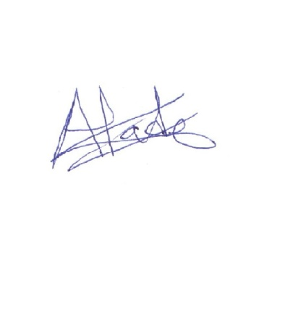

Oluwaseun Alade

<https://github.com/chicheskybaba>

<https://sites.google.com/view/oluwaseunolanrewajualade/home>

ssh -i virtualmachinekey.pem [ec2-user@54.226.16.71](mailto:ec2-user@54.226.16.71)

### **Endpoint & port**

Endpoint

mysql-db-1.cqg8vtwkrvas.us-east-1.rds.amazonaws.com

Port

3306

# Python3 code to Check for

# balanced parentheses in an expression

def check(my_string):

  brackets = ['()', '{}', '[]']

  while any(x in my_string for x in brackets):

    for br in brackets:

      my_string = my_string.replace(br, '')

  return not my_string

# Driver code

string = "{[]{()}}"

print(string, "-", 1

  if check(string) else 0)

# Python code to sort a list by creating

# another list Use of sorted()

def Sorting(lst):

  lst2 = sorted(lst, key=len)

  return lst2

# Driver code

lst = ["rohan", "amy", "sapna", "muhammad",

  "aakash", "raunak", "chinmoy", "olanrewaju"]

print(Sorting(lst))