Department: 資工系
Student ID: 112550081
Name: 許秉棋
Problem 1.
Ciphertext:
GYOMXNOGNG QUGN ETNMX MPLMZOMXYM K TMMJOXA XEN TKZ ZMQEBMF TZEQ KJKZQ EX YEXNMQLJKNOXA NHM TJEEF ET XMI CXEIJMFAM IHOYH
MKYH WMKZ RZOXAG IONH ON
a (112550081_1_a.py).
Letter | Count | Frequency
M | 17 | 14.0%
X | 11 | 9.1%
N | 10 | 8.3%
E | 10 | 8.3%
O | 9 | 7.4%
Z | 7 | 5.8%
K | 7 | 5.8%
T | 6 | 5.0%
G | 5 | 4.1%
Y | 5 | 4.1%
Q | 5 | 4.1%
J | 5 | 4.1%
H | 5 | 4.1%
A | 4 | 3.3%
I | 4 | 3.3%
F | 3 | 2.5%
L | 2 | 1.7%
U | 1 | 0.8%
P | 1 | 0.8%
B | 1 | 0.8%
C | 1 | 0.8%
W | 1 | 0.8%
R | 1 | 0.8%
b.
Using the standard English letter frequency distribution as a reference, we align the most frequent letters in the ciphertext with those in English:
The most frequent letter in the ciphertext is M (14.0%), which likely corresponds to E (12.7%) in English plaintext. The second most frequent is X (9.1%), suggesting it maps to T (9.1%). Similarly, N and E in the ciphertext (both ~8.3%) are candidates for A and O respectively.
So we might decrypt: “SCIENTISTSMUSTOFTENEXPERIENCEAFEELINGNOTFARREMOVEDFROMALARMONCONTEMPLATINGTHEFLOODOFNEWKNOWLEDGEWHICHEACHYEARBRINGSWITHIT”
c.
From part (b), the most frequent letter in the ciphertext is M, which we expect corresponds to E in English plaintext. By testing various structured cipher models, we find that a consistent affine (linear) relationship holds across all letters:
$C≡aP+b (mod 26)$
To verify, we check several plaintext–ciphertext pairs (confirmed by full decryption):
Plaintext P | P value | C value | Ciphertext C
E | 4 | 12 | M
S | 18 | 6 | G
I | 8 | 14 | O
C | 2 | 24 | Y
Every letter satisfies the same linear formula with the same constants. Therefore, a specific mathematical relationship does exist: the encryption is an affine cipher, where each plaintext letter P is mapped to ciphertext C via a fixed linear function modulo 26.
d.
To determine the values of a and b, we use two known plaintext–ciphertext pairs to set up a system of equations: E->M: P=4, C=12 and S->G: P=18, C=6. Then substituting into $C≡aP+b (mod 26)$:
$4a+b≡12 (mod 26)$ | $(1)$
$18a+b≡6 (mod 26)$ | $$(2)$$
Subtracting (1) from (2): $14a≡-6 ≡20 (mod 26)$ and then dividing both sides by 2: $7a≡10 (mod 13)$. Since $7×2≡14≡1 (mod 13)$, the inverse of 7 mod 13 is 2. Thus: $a≡2×10=20≡7 \left(mod 13\right)→a=7$.
Substituting a = 7 back into (1):
$$4\left(7\right)+b≡12 \left(mod 26\right)$$
$$28+b≡12 (mod 26)$$
$$b≡12-2=10 \left(mod 26\right)→b=10$$
And we apply $f\left(x\right)=7x+10 (mod 26)$ to the full plaintext for verification:
Plaintext | P | 7P+10 mod 26 | C | Ciphertext
S | 18 | 136 mod 26 = 6 | G | y
E | 4 | 38 mod 26 = 12 | M | y
I | 8 | 66 mod 26 = 14 | O | y
N | 13 | 101 mod 26 = 23 | X | y
So the value for a and b are: $a=7, b=10$.
e.
In a monoalphabetic substitution cipher, the key is a permutation of the 26 letters of the alphabet, each plaintext letter is mapped to a unique ciphertext letter. The total number of possible keys is therefore:
$$\left|K\right|=26!=403,291,461,126,605,635,584,000,000≈4×{10}^{26}$$
While this key space is astronomically large that far beyond the reach of any brute-force search, it’s not secure in practice. The reason is that it preserves the statistical structure of the plaintext: each plaintext letter always maps to the same ciphertext letter, so the frequency distribution of letters is unchanged. As demonstrated in part (b), frequency analysis can break this cipher with only moderate amount of ciphertext, regardless of how large the key space is.
f.
For $f\left(x\right)=ax+b (mod 26)$, the key is the pair $(a,b)$ subject to the constraint that $\gcd\left(a,26\right)=1$ (so that the function is a valid bijection and decryption is possible. Valid values of a: must satisfy $\gcd\left(a, 26\right)=1$. Since $26=2×13$, we exclude multiples of 2 and 13:
$$a∈\left\{1, 3, 5, 7, 9, 11, 15, 17, 19, 21, 23, 25\right\}→12 choices$$
Valid values of b: any integer from 0 to 25:
$$b∈\left\{0, 1, …, 25\right\}→26 choices$$
$${|K|}_{affine}=12×26=312$$
This is drastically smaller than $26!≈4×{10}^{26}$, making exhaustive search trivial (as shown in part (g)). And one of the approaches to increase the key space might apply the affine cipher multiple times with different keys, i.e., compose several affine transformations:
$$f_{1}\left(f_{2}\left(x\right)\right)=a_{1}\left(a_{2}x+b_{2}\right)+b_{1}=\left(a_{1}a_{2}\right)x+\left(a_{1}b_{2}+b_{1}\right) (mod 26)$$
However, the composition of two affine ciphers is still an affine cipher, so this does not increase the effective key space. A more effective approach is to use a polyalphabetic substitution cipher (e.g., the Vigenère cipher), where a different affine (or shift) key is applied to each position in the plaintext, breaking the fixed letter-to-letter mapping and making frequency analysis much harder.

g (112550081_1_g.py).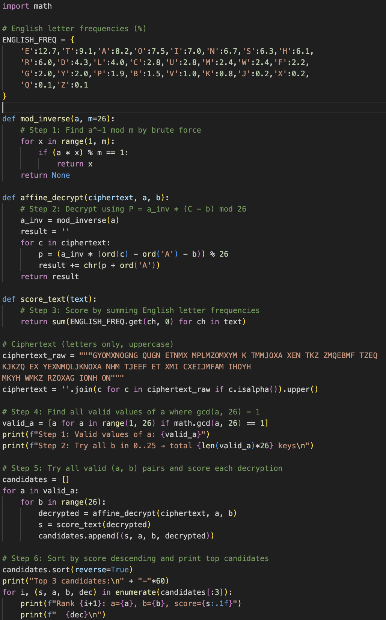
Step 1: Identify All Valid Values of $f\left(x\right)=ax+b \left(mod 26\right)$ to be a valid encryption function, it must be a bijection (one-to-one mapping), every plaintext letter must map to a unique ciphertext letter. This requires that the decryption function $f^{-1}(x)$ exist, which is only possible when $a$ has a modular inverse mod 26. The condition is: $\gcd\left(a,26\right)=1$. Since $26=2×13$, we must exclude any $a$ that is divisible by 2 or 13. This gives exactly 12 valid values we mentioned in part e.
Step 2: Enumerate All Key Pairs $(a,b)$. The shift parameter $b$ can be any integer from 0 to 25 (26 choices), with no additional constraint, the total keys to try is 312 keys.
Step 3: For each candidate key $(a,b)$, we compute the modular inverse $a^{-1}(mod 26)$ and apply the decryption formula to every letter in the ciphertext:
$$P=a^{-1}∙\left(C-b\right) (mod 26)$$
For example, with $a=7,b=10$, $a^{-1}=15$ since $7×15=105≡1 (mod 26)$, For $C=M=12$: $P=15×\left(12-10\right)=30≡4=E$
Step 4: Score Each Decryption by English Letter Frequency. Not all 312 decryptions produce readable English. We assign a score to each candidate plain text by summing the standard English frequencies of letter it contains:
$$score=\sum_{i}{freq_english(P_{i})}$$
A decryption that closely matches the natural distribution of English letters (e.g., contains many E's, T's, A's) will receive a higher score, while random-looking text will score low. This allows us to automatically rank all candidates without human inspection.
Step 5: Rank and Output the Best Candidates. After scoring all 312 keys, we sort them in descending order by score and print the top results:
Rank | a | b | score | plaintext
1 | 7 | 10 | 781.8 | SCIENTISTSMUSTOFTENEXPERIENCEAFEELINGNOTFARRE  MOVEDFROMALARMONCONTEMPLATINGTHEFLOODOF  NEWKNOWLEDGEWHICHEACHYEARBRINGSWITHIT
2 | 25 | 16 | 634.4 | KSCETDCKDKAWKDMXDETEBFERCETSEGXEEHCTQTMDXG  RREAMPELXRMAGHGRAMTSMTDEAFHGDCTQDJEXHMMLM  XTEIOTMIHELQEIJCSJEGSJUEGRZRCTQKICDJCD
3 | 1 | 19 | 629.3 | NFVTEUVNUNXBNULAUTETWSTGVTEFTRATTQVEHELUARGGT  XLITMAGLXRQRGXLEFLEUTXSQRUVEHUOTAQLLMLAETPJELP  QTMHTPOVFOTRFODTRGYGVEHNPVUOVU
The Rank 1 candidate is clearly readable English, confirming: $a=7, b=10$ with the recovered plaintext:
"Scientists must often experience a feeling not far removed from alarm on contemplating the flood of new knowledge which each year brings with it."
Problem 2.
Step 1: Determine the Rectangle Dimensions. The contains 63 letters. Since the message completely fills the rectangle, we find all factor pairs of 63: $63=7×9 or 9×7$. This gives two candidate dimensions: a 7-column × 9-row or a 9-column × 7-row rectangle.
Step 2: Use Vowel Frequency to Select the Correct Dimension. In English plaintext, approximately 40% of letters are vowels (A, E, I, O, U). For the correct rectangle dimension, each row of the reconstructed plaintext should contain roughly 40% vowels. We test both cases.
Case 1: 9 columns × 7 rows — each row has 9 letters, expected vowels per row: $0.4×9=3.6$ Arrange the ciphertext into 9 columns (each column has 7 letters), then read row by row:
E | C | D | T | M | E | C | A | E
R | A | U | O | O | L | E | D | S
A | M | M | E | R | N | E | N | A
S | S | O | D | Y | T | N | R | V
B | N | L | C | R | L | T | I | Q
L | A | E | T | R | I | G | A | W
E | B | A | A | E | I | H | O | R

Row | Letters | Vowels | Difference from 3.6
1 | ECDTMECAE | 4 | 0.4
2 | RAUOOLEDS | 5 | 1.4
3 | AMMERNENA | 4 | 0.4
4 | SSODYTNRV | 1 | 2.6
5 | BNLCRLTIQ | 1 | 2.6
6 | LAETRIGAW | 3 | 0.6
7 | EBAAEIHOR | 6 | 2.4
Total difference: 0.4+1.4+0.4+2.6+2.6+0.6+2.4=10.2
Case 2:
7 columns × 9 rows — each row has 7 letters, expected vowels per row: $0.4×7=2.8$, arrange the ciphertext into 7 columns (each column has 9 letters), then read row by row.
E | C | D | T | M | E | C
A | E | R | A | U | O | O
L | E | D | S | A | M | M
E | R | N | E | N | A | S
S | O | D | Y | T | N | R
V | B | N | L | C | R | L
T | I | Q | L | A | E | T
R | I | G | A | W | E | B
A | A | E | I | H | O | R

Row | Letters | Vowels | Difference from 3.6
1 | ECDTMEC | 2 | 0.8
2 | AERAUOO | 6 | 3.2
3 | LEDSAMM | 2 | 0.8
4 | ERNENAS | 3 | 0.2
5 | SODYTNR | 1 | 1.8
6 | VBNLCRL | 0 | 2.8
7 | TIQLAET | 3 | 0.2
8 | RIGAWEB | 3 | 0.2
9 | AAEIHOR | 5 | 2.2
Total difference: $0.8+3.2+0.8+0.2+1.8+2.8+0.2+0.2+2.2=12.2$
Comparing both cases:
Dimension | Total Vowel Deviation
9 columns x 7 rows | 10.2
7 columns x 9 rows | 12.2
Conclusion: Since $10.2<12.2$, the 7 blocks of 9 letters configuration has smaller total deviation, indicating the correct structure is a 9 rows × 7 columns grid.
Step 4: Reconstruct the Grid. Laying out the 7 blocks of 9 letters as the columns of a 9x7 grid in case 2, we can find the correct column order. By examining the rows and anagramming them to form readable English words, we find the correct column order is $Key=(6, 3, 4, 1, 2, 5, 7)$ and then rearranging in this order row yields: $LASER BEAMS CAN BE MODULATED TO CARRY MORE INTELLIGENCE THAN RADIO WAVES$
Problem 3.
Given information, the plaintext “THE” is encrypted using the following 3x3 key matrix $K$:
$$K=\left(\begin{matrix}6 & 24 & 1 \\ 13 & 16 & 10 \\ 20 & 17 & 15\end{matrix}\right)$$
Producing ciphertext “AJN”. We must decrypt “AJN” back to “THE” using $K^{-1} (mod 26)$.
Step 1: Compute the Determinant of K
$$\det\left(K\right)=6\left(16⋅15-10⋅17\right)-24\left(13⋅15-10⋅20\right)+1\left(13⋅17-16⋅20\right)$$
$$=\left(240-170\right)-24\left(195-200\right)+1\left(221-320\right)$$
$$=6(70)-24(-5)+1(-99)$$
$$=420+120-99=441$$
$$det(K)≡441(mod26)=441-16×26=441-416=25$$
Step 2: Verify the Determinant is Valid. Since $26=2×13$, we need $\gcd\left(\det\left(K\right),26\right)=1$: $\gcd\left(25,26\right)=1$. The determinant is neither even nor dividable by 13, so the inverse matrix exists.
Step 3: Compute the Modular Inverse of the Determinant. We need $d^{-1}$ such that $25∙d^{-1}≡1 (mod 26)$:
$$25×25=625=24×26+1≡1(mod26)$$
$$∴(det(K))-1≡25(mod26)$$
Step 4: Compute the Adjugated Matrix. The adjugate is the transpose of the cofactor matrix. We compute each cofactor $C_{ij}={(-1)}^{i+j}M_{ij}$:
$$C11​=+(16⋅15-10⋅17)=240-170=70$$
$$C12​=-(13⋅15-10⋅20)=-(195-200)=5$$
$$C13​=+(13⋅17-16⋅20)=221-320=-99$$
$$C21​=-(24⋅15-1⋅17)=-(360-17)=-343$$
$$C22​=+(6⋅15-1⋅20)=90-20=70$$
$$C23​=-(6⋅17-24⋅20)=-(102-480)=378$$
$$C31​=+(24⋅10-1⋅16)=240-16=224$$
$$C32​=-(6⋅10-1⋅13)=-(60-13)=-47$$
$$C33​=+(6⋅16-24⋅13)=96-312=-216$$
Therefore the adjugate (transpose of cofactor matrix) is:
$$adj(K)=\left(\begin{matrix}70 & -343 & 224 \\ 5 & 70 & -47 \\ -99 & 378 & -216\end{matrix}\right)$$
Step 5: Compute $K^{-1} (mod 26)$. $K^{-1}≡25∙adj\left(K\right) (mod 26)$, reducing each entry (note: negative values use $x$ mod 26, e.g., $-343 mod 26=7$):
$$K^{-1}≡\left(\begin{matrix}25×70 & 25×\left(-343\right) & 25×224 \\ 25×5 & 25×70 & 25×\left(-47\right) \\ 25×\left(-99\right) & 25×378 & 25×\left(-216\right)\end{matrix}\right) (mod 26)$$
$$=\left(\begin{matrix}1750 & -8575 & 5600 \\ 125 & 1750 & -1175 \\ -2475 & 9450 & -5400\end{matrix}\right) \left(mod 26\right)= \left(\begin{matrix}8 & 5 & 10 \\ 21 & 8 & 21 \\ 21 & 12 & 8\end{matrix}\right)$$

Step 6: Verify $K∙K^{-1}≡I (mod 26)$
$$K∙K^{-1}=\left(\begin{matrix}6 & 24 & 1 \\ 13 & 16 & 10 \\ 20 & 17 & 15\end{matrix}\right)\left(\begin{matrix}8 & 5 & 10 \\ 21 & 8 & 21 \\ 21 & 12 & 8\end{matrix}\right)=\left(\begin{matrix}1 & 0 & 0 \\ 0 & 1 & 0 \\ 0 & 0 & 1\end{matrix}\right) \left(mod 26\right) →correct$$
Step 7: Decrypt “AJN”, convert ciphertext to integers: $A=0, J=9, N=13$
$$p=K^{-1}∙c \left(mod 26\right)=\left(\begin{matrix}8 & 5 & 10 \\ 21 & 8 & 21 \\ 21 & 12 & 8\end{matrix}\right)\left(\begin{matrix}0 \\ 9 \\ 13\end{matrix}\right) (mod 26)$$
$$Row 1: 8(0)+5(9)+10(13)=0+45+130=175≡19=T$$
$$Row 2: 21(0)+8(9)+21(13)=0+72+273=345≡7=H$$
$$Row 3: 21(0)+12(9)+8(13)=0+108+104=212≡4=E$$
$$Decrypted plaintext:THE$$
Program (112550081_3.py):

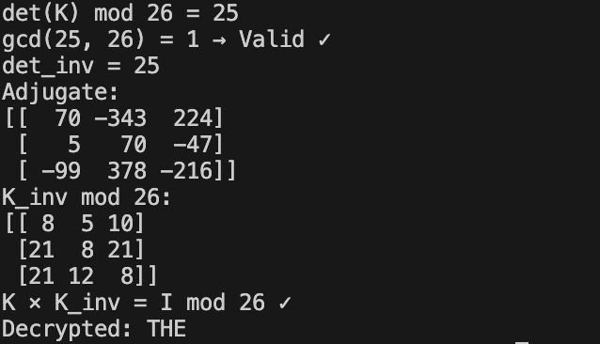
Bonus Question.
Keys Used in Dach Stage
Stage | Cipher | Key
1 | Affine Substitution | a=7, b=10
2 | Columnar Transposition | Column order = [2, 0, 1] (3 columns)
3 | Hill Cipher | $$K=\left(\begin{matrix}6 & 24 & 1 \\ 13 & 16 & 10 \\ 20 & 17 & 15\end{matrix}\right)$$
Mathematical Formulation
Stage 1: Affine Cipher
$$Encrypt:C≡7P+10 \left(mod 26\right)$$
$$Decrypt:P≡15 \left(C-10\right) \left(mod 26\right) (since 7^{-1}≡15 \left(mod 26\right))$$
Stage 2: Columnar Transposition
Write plaintext into rows of 3 columns, then read columns in the order defined by key [2, 0, 1] (i.e., read column 2 first, then column 0, then column 1). Decrypt by reversing the column reordering.
Stage 3: Hill Cipher
$$Encrypt:c≡K⋅p (mod 26)$$
$$Decrypt: p≡K^{-1}⋅c \left(mod 26\right),K^{-1}≡{\left(\det{K}\right)}^{-1}⋅adj \left(K\right) (mod 26)$$
Worked Example with Plaintext: “CRYPTOGRAPHY”
Stage 1: Affine Encryption $(f\left(x\right)=7x+10 mod 26)$:
Plaintext | C | R | Y | P | T | O | G | R | A | P | H | Y
P value | 2 | 17 | 24 | 15 | 19 | 14 | 6 | 17 | 0 | 15 | 7 | 24
mod 26 | 24 | 25 | 22 | 11 | 13 | 14 | 0 | 25 | 10 | 11 | 7 | 22
Cyphertext | Y | Z | W | L | N | E | A | Z | K | L | H | W
After stage 1: YZWLNEAZKLHW
Stage 2: Columnar Transposition (key = [2, 0, 1])
Input: YZWLNEAZKLHW (12 letters, 3 columns -> 4 rows, no padding needed)
Step 1: write into grid row by row
 | Col 0 | Col 1 | Col 2
Row 0 | Y | Z | W
Row 1 | L | N | E
Row 2 | A | Z | K
Row 3 | L | H | W
Step 2: read columns in key order [2, 0, 1], which means the column that gets rank 0 (read first) is col 1, rank 1 is col 2, rank 2 is col 3. So the output might be:
$$YZWLNEAZKLHW→ZNZHWEKWYLAL$$
After stage 2: ZNZHWEKWYLAL
Stage 3: Hill Cipher: $c=Kp mod 26$, split “ZNZHWEKWYLAL” into 4 blocks of 3:
$$Block 1:ZNZ, Block 2:HWE, Block 3:KWY, Block 4:LAL$$
Block 1: Z=25, N=13, Z=25
$$Row 1: 6(25)+24(13)+1(25)=150+312+25=487≡19=T$$
$$Row 2: 13(25)+16(13)+10(25)=325+208+250=783≡3=D$$
$$Row 3: 20(25)+17(13)+15(25)=500+221+375=1096≡4=E$$
Block 2: H=7, W=22, E=4
$$Row 1: 6(7)+24(22)+1(4)=42+528+4=574≡2=C$$
$$Row 2: 13(7)+16(22)+10(4)=91+352+40=483≡15=P$$
$$Row 3: 20(7)+17(22)+15(4)=140+374+60=574≡2=C$$
Block 3: K=10, W=22, Y=24
$$Row 1: 6(10)+24(22)+1(24)=60+528+24=612≡14=O$$
$$Row 2: 13(10)+16(22)+10(24)=130+352+240=722≡20=U$$
$$Row 3: 20(10)+17(22)+15(24)=200+374+360=934≡24=Y$$
Block 3: K=10, W=22, Y=24
$$Row 1: 6(11)+24(0)+1(11)=66+0+11=77≡25=Z$$
$$Row 2: 13(11)+16(0)+10(11)=143+0+110=253≡19=T$$
$$Row 3: 20(11)+17(0)+15(11)=220+0+165=385≡21=V$$
$$ZNZHWEKWYLAL→TDECPCOUYZTV$$
After stage 3: TDECPCOUYZTV, so the final Ciphertext is “TDECPCOUYZTV”
We could also check the result of implementing code below, for the code please check 112550081_bonus.py for further details:
