- Use window.open() to add the following functions
  - Click the button to open a link in new tab (in current window) (-10 points)
  - Click the button to open a link in new window (-10 points)
Location: home.js
(buttons are on the right corner of the top)


- Show the pop-up automatically after page load
Location: home.js
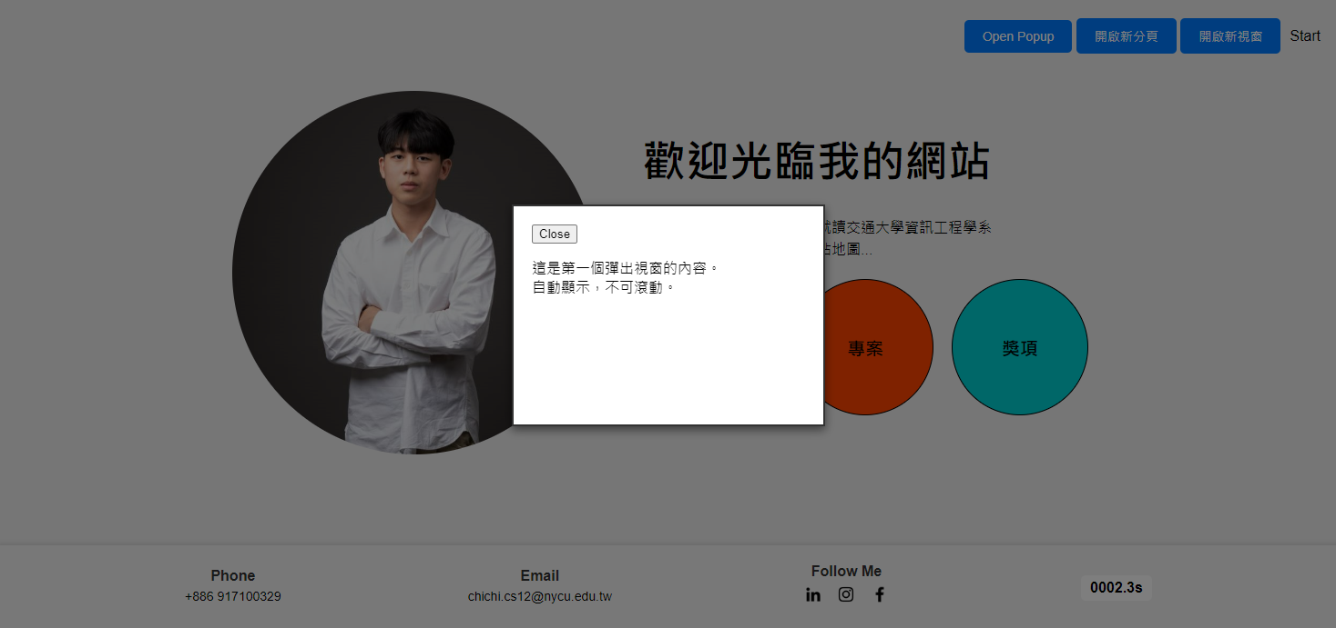
- Show the pop-up when the user clicks the button
Location: home.js
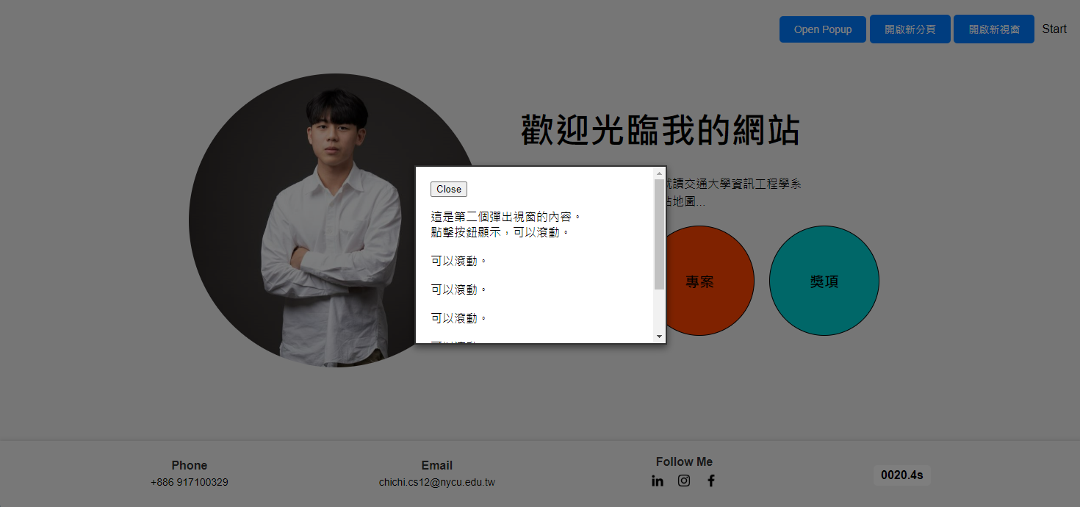

- Show the pop-up advertisement
- Show the browsed time after page load
Location: home.js
(ad and browsed are on the right corner of the bottom)


- You need to implement scroll detection with javascript on one of the page (-10 points)
  - Trigger some animations, events or images when browsing
Location: aboutme.js, project.js, award.js


- Design 5 different functions with JavaScript by yourself (each -10 points)
1. show the location of mouse
2. show the current time
3. Button for smooth scrolling to the top of the page
4. Random background color switching function
5. Day and night mode switch button
Location: project.js
