Use visual analytics to show uncertainty in the data. Compare the reliability of neighborhood reports. Which neighborhoods are providing reliable reports? Provide a rationale for your response.
Method:
1 Data processing:
The data is from the VAST MC1 dataset and contains infrastructure damage reports for multiple neighboring regions. Due to the large number of missing raw data, the preprocessing steps are as follows: for the medical data, only the data in regions 1, 3, 5, 6, 9, 11, and 16 are retained, and the medical data in the rest of the regions are set to NA. for the pipe network, electric power, roads and bridges, and building data, the plurality is directly used to fill in the data due to the small number of missing values and the availability of the data in all the regions. For seismic data, linear regression was used to predict the missing values, and new severity indicators were added to calculate the severity of the earthquake based on the weights of different items. All preprocessing codes were written in R language.
2 Visualization:
Heat map and line chart: using SVG and D3. JS library to draw heat maps and line diagrams,
Map and region selection (Canvas & JavaScript) : map an area using the HTML5 Canvas.
3 Front-end technology:
Use HTML/CSS to build the interface, including maps, legends, heat maps, line charts, and reliability score display areas to keep the interface clean and user-friendly. Use Event Handling in JavaScript as well.
Design:
The screenshot shows the sewer data for region one of the default option.
1 Map:
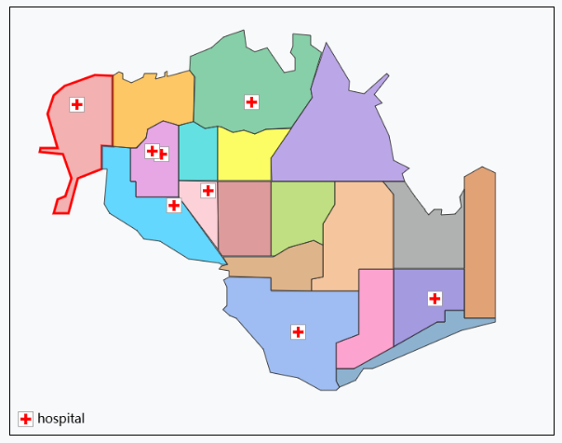
Figure 1
Figure 1 shows an area map rendered with HTML5 Canvas, where regions are defined by polygonal boundaries and filled with different colors. Region 1 is selected by default, and selected regions are outlined in red when clicked. The selection uses the ray-casting algorithm: a ray is cast from the click point, and if it intersects the polygon boundary an odd number of times, the point is inside; otherwise, it's outside.
2 Heat map:
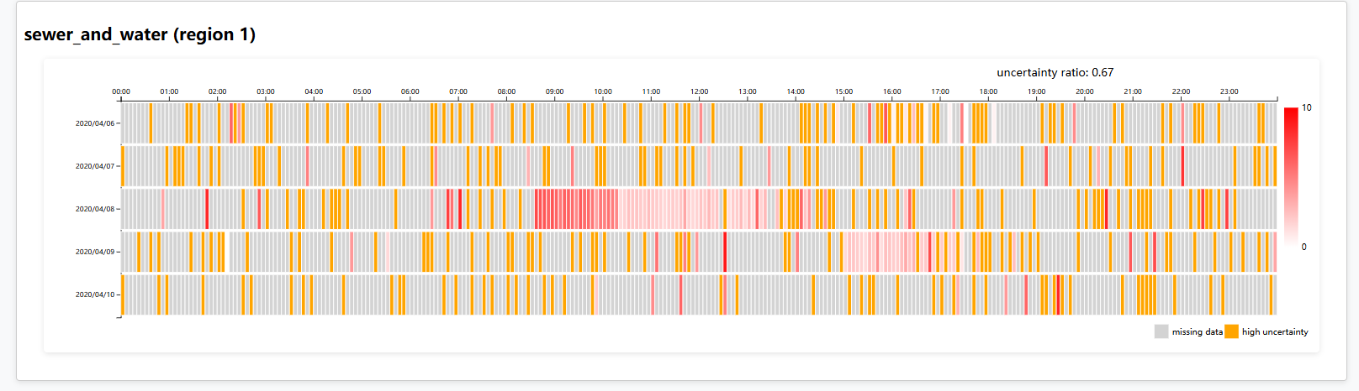
Figure 2
Drawn with SVG and D3.js, the heat map divides 24 hours into 5-minute intervals, with each cell representing data for a specific time. Colors indicate missing data (gray), uncertainty (orange), and data strength (white to red). "NA" values are marked as missing; entries with fewer than 2 data points are uncertain. The uncertainty ratio is the proportion of orange cells to total valid data.
3 Line chart:
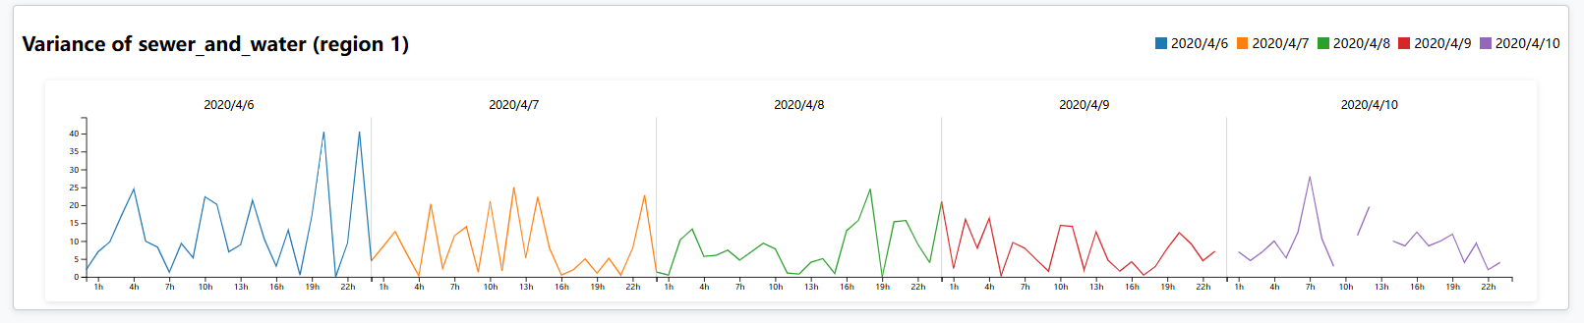
Figure 3
Also created with SVG and D3.js, the line chart shows hourly data trends per date, using variance to reflect data stability. Multiple lines help visualize fluctuations across different dates, with each date marked in the top-right legend.
4 Legend:
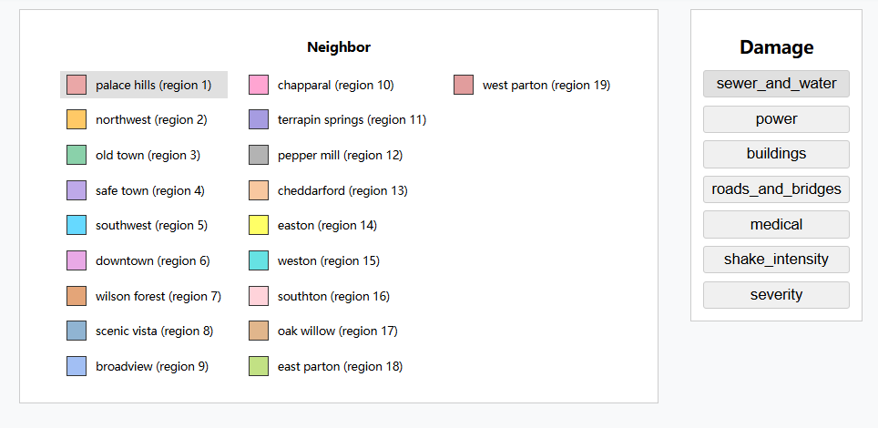
Figure 4
As shown in Figure 2, the legend updates automatically with the data. It functions as an independent module, decoupled from the map and data processing, and communicates via shared states and event notifications.
5 Reliability Score:
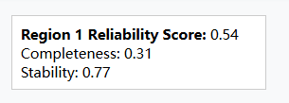
Figure 5
This project defines a Reliability Score based on two dimensions: data completeness and data stability.
Completeness reflects data missingness.
Completeness=1 − missingCount/T
Missing count is the missing data slot, and T is the total time slot.
Stability reflects how much the values fluctuate over time.
Stability=1 − Avg Variance / Max Variance
Avg Variance is the average of the variance and Max Variance is the maximum of the variance.
Reliability Score combines both with equal weights:
Reliability Score=0.5×Completeness+0.5×Stability
A score close to 1 indicates high completeness and stability (high reliability), while a low score suggests significant missing data or high fluctuations (low reliability).
6 Interaction:
Selected region is highlighted with red borders on the map and shaded in the legend. Clicking different areas or legend items updates the selection. Heat maps and line charts update interactively based on selected region and projects. Hovering over data points reveals details like date, time, and value, with yellow circles marking identical time points across dates in the line chart. To avoid excessive event triggering, an anti-shake mechanism ensures only the last action within a short interval is processed, improving performance and user experience.
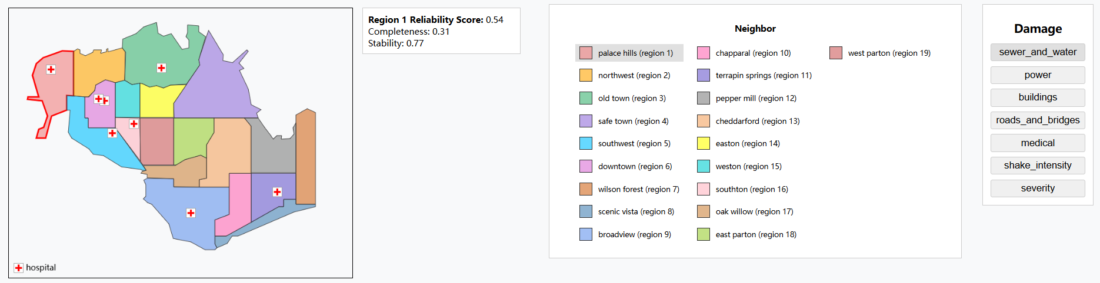
Figure 6
Figure 6 is a map of St. Himark, legend and reliability score.
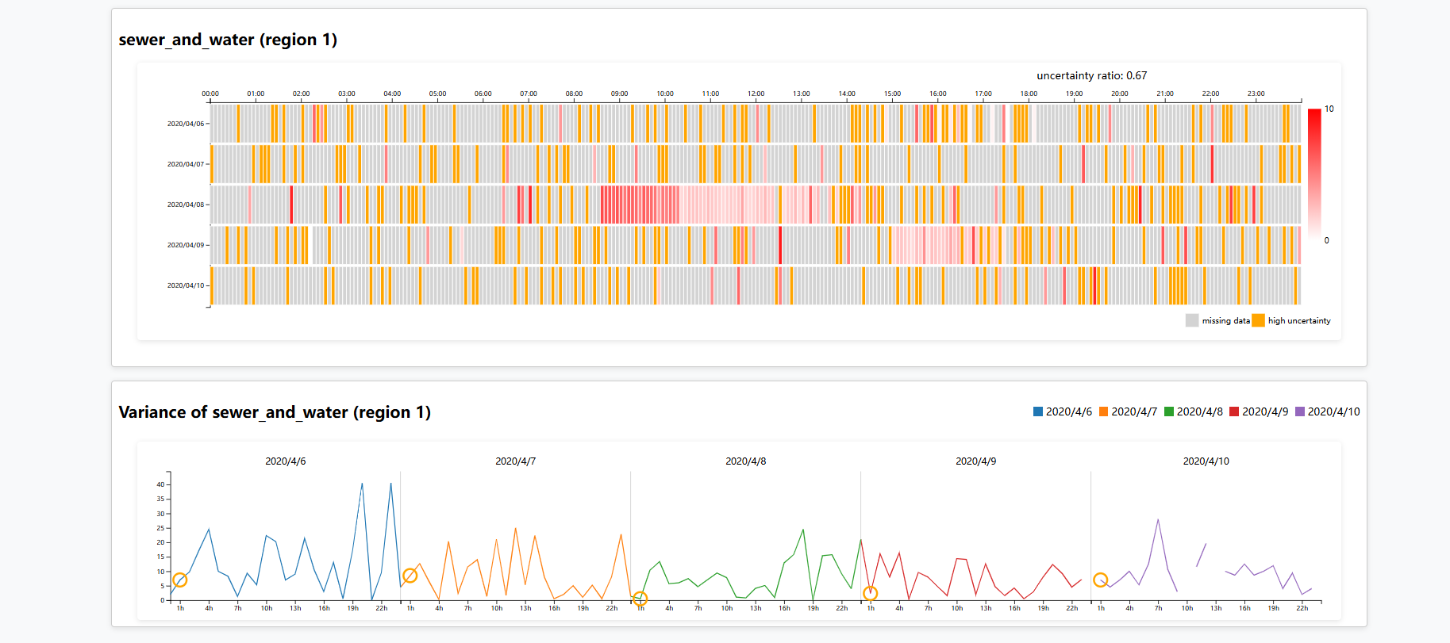
Figure 7
Figure 7 shows a heat map formed by the region 1 sewer_and_water data between April 6 and April 10 and a line graph formed by the variance of this data on an hourly basis.

Results:
Since severity is predicted from other indicators, severity data from different regions were selected to compare the viability scores.
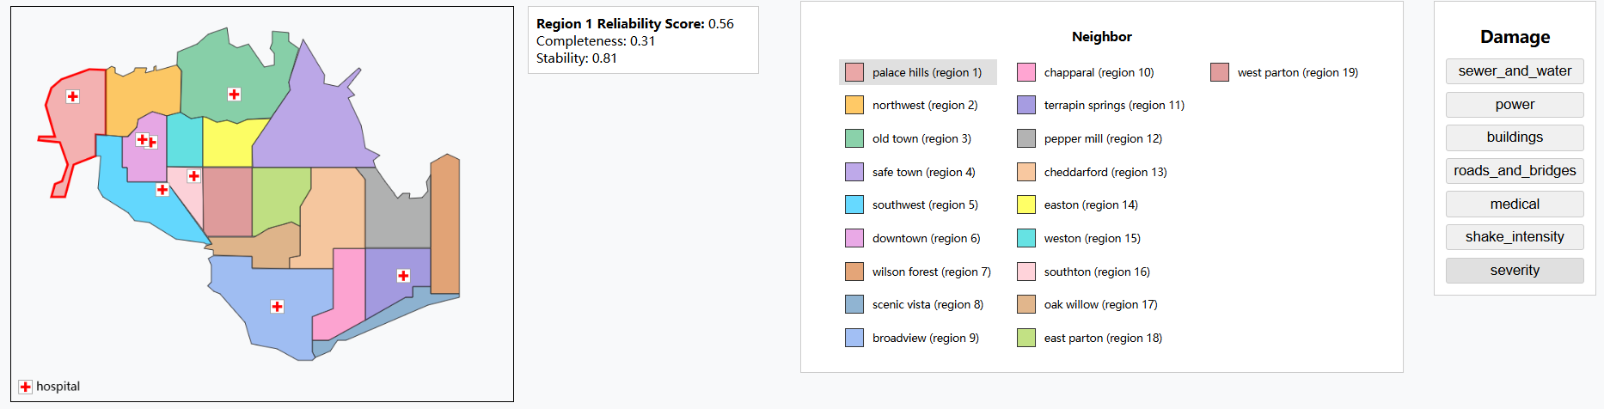
Figure 8
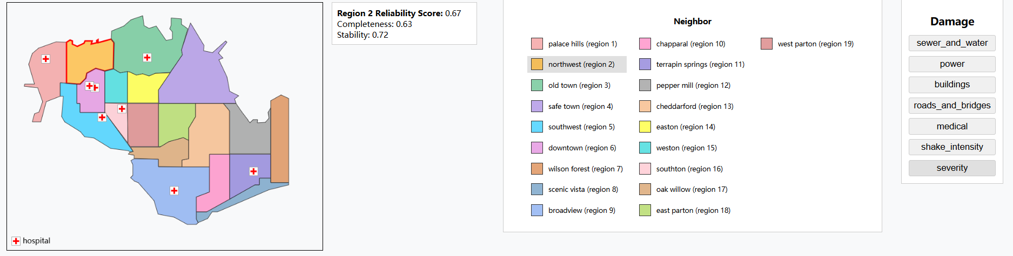Figure 9
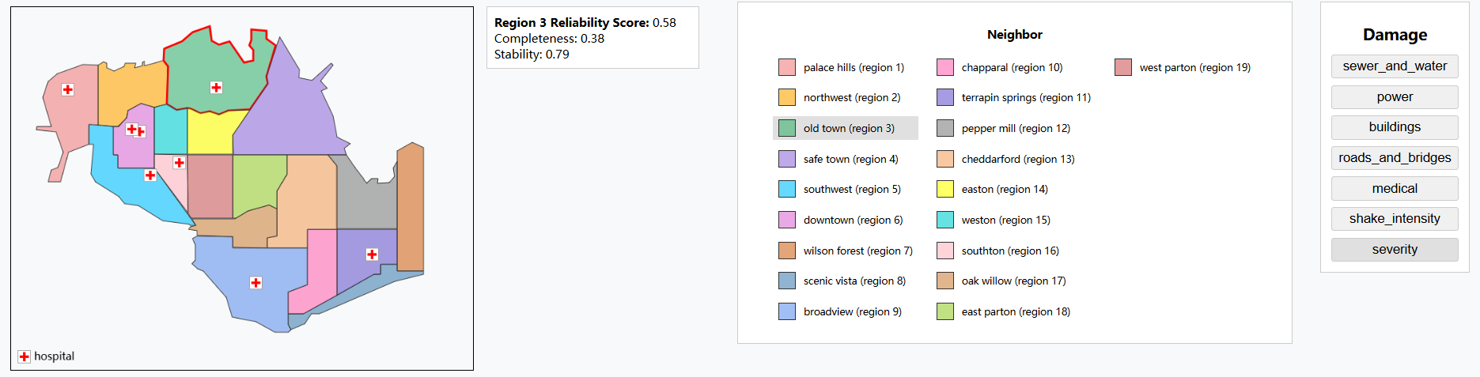
Figure 10
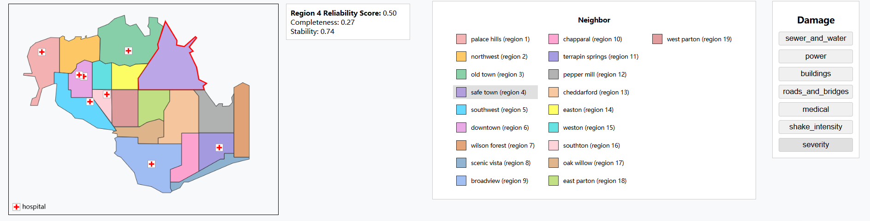
Figure 11
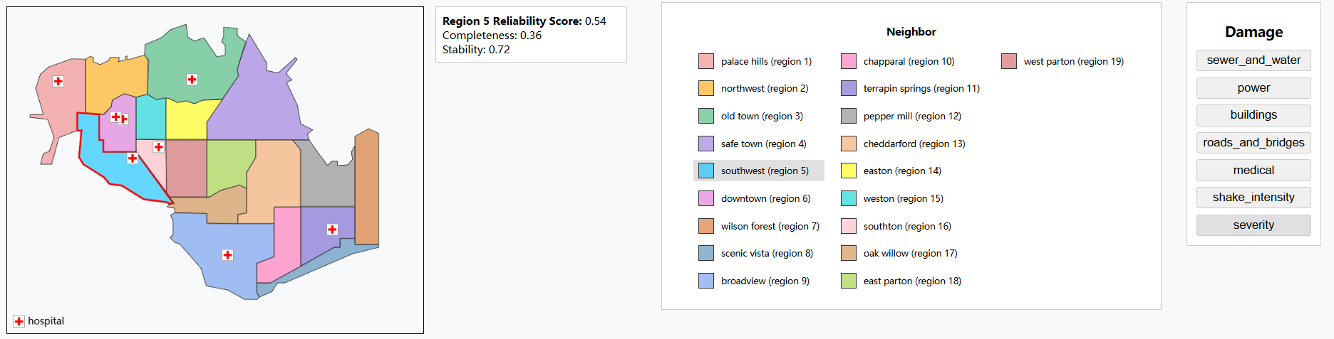
Figure 12
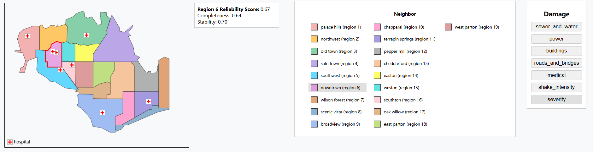
Figure 13
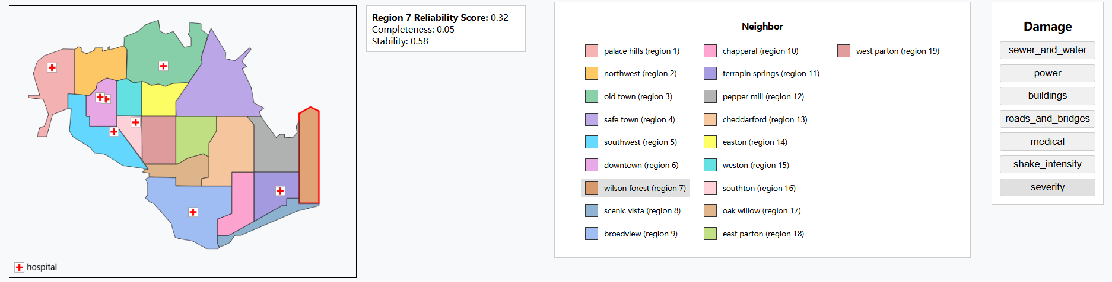
Figure 14
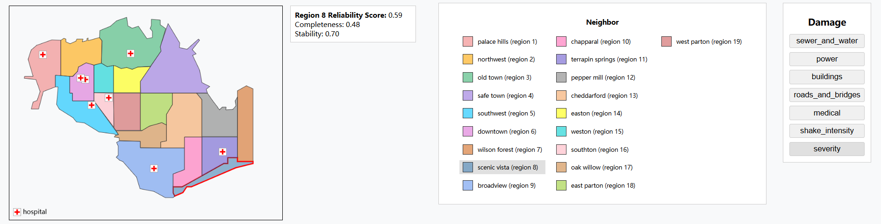
Figure 15
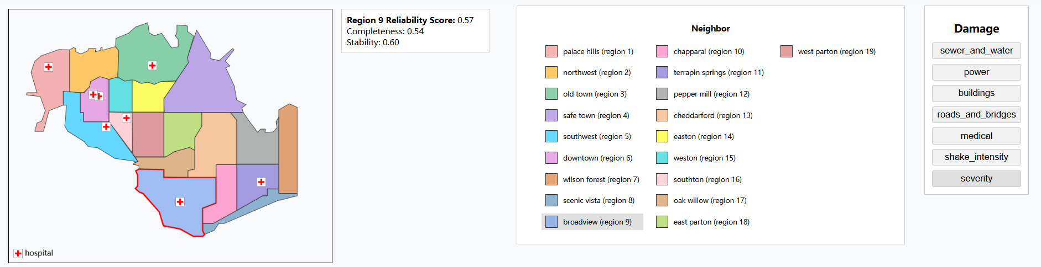
Figure 16
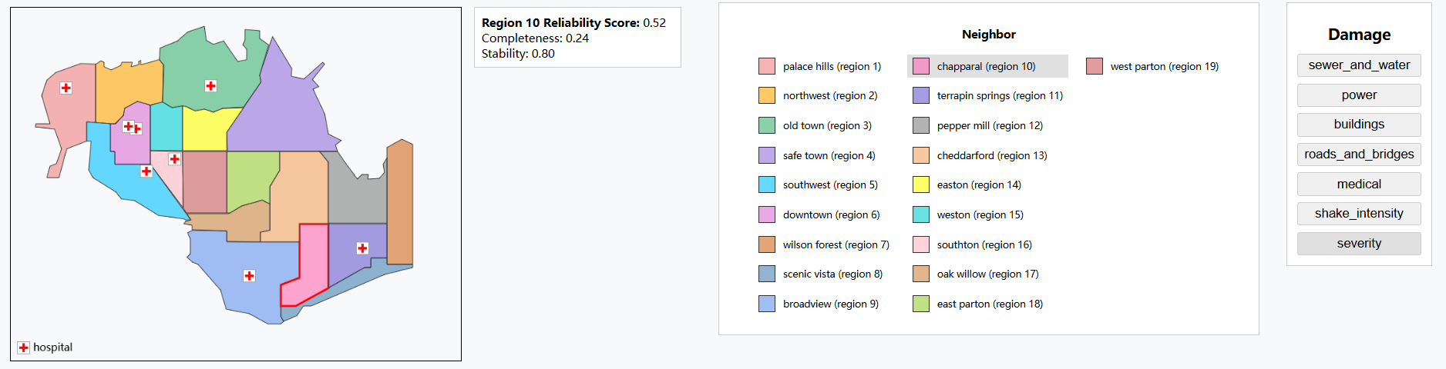
Figure 17
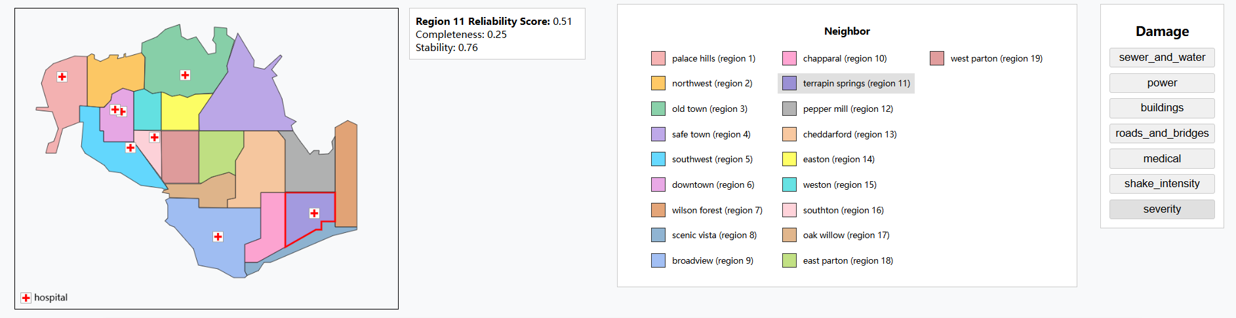
Figure 18
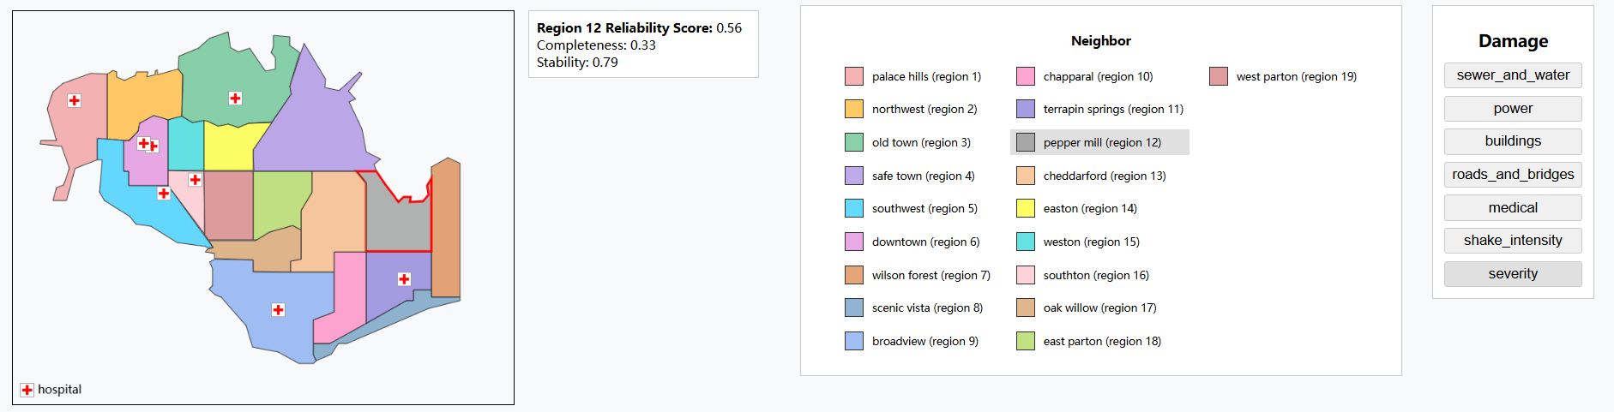
Figure 19
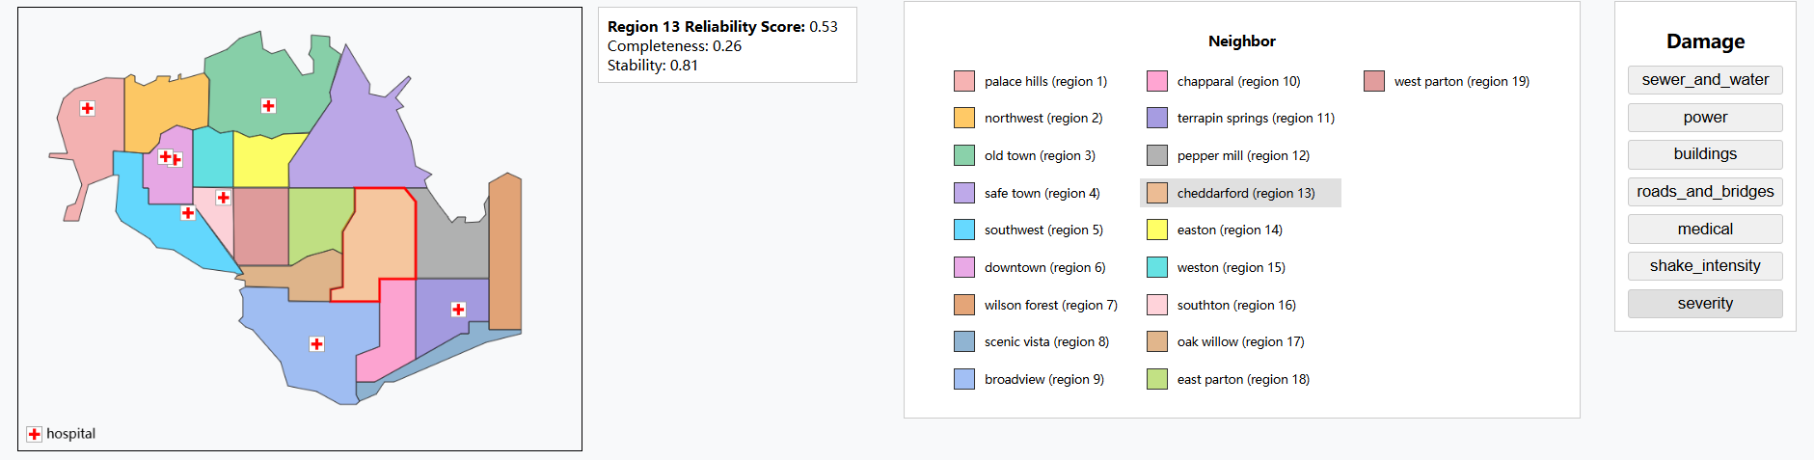
Figure 20
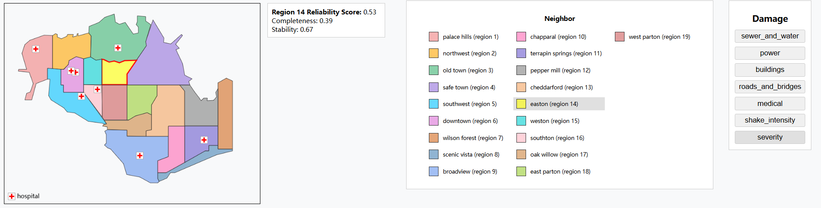
Figure 21
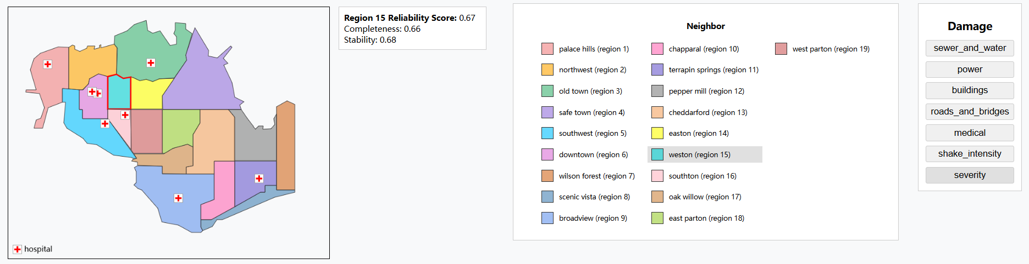Figure 22
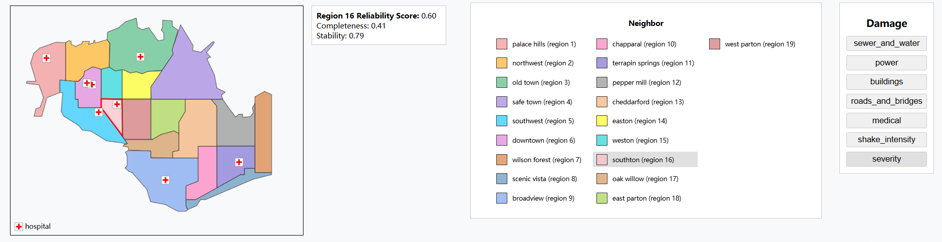
Figure 23
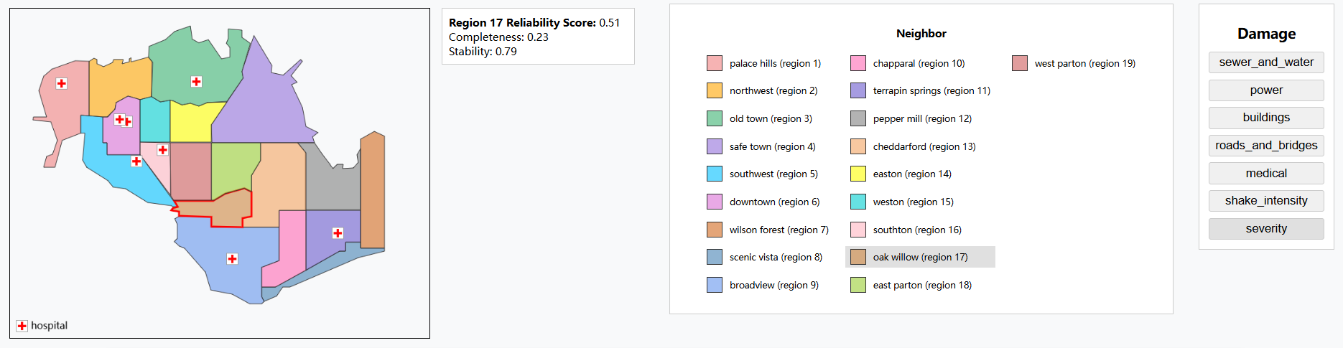
Figure 24
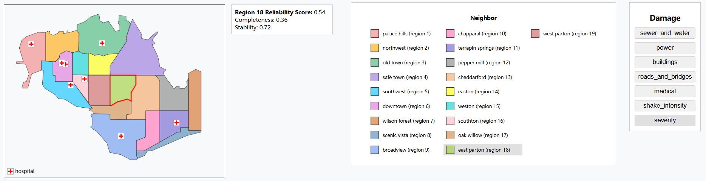
Figure 25
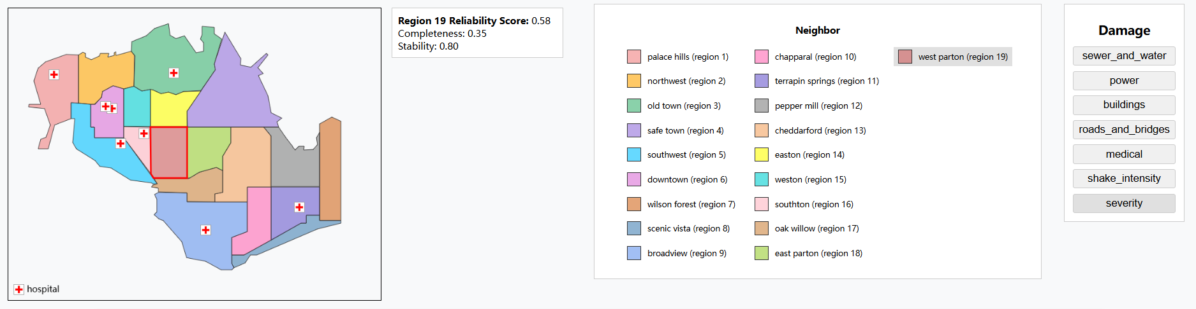
Figure 26
The above 19 screenshots illustrate severity-based reliability scores across all regions. Regions with scores ≤ 0.5, such as region 4 and 6, demonstrate poor reporting accuracy and are considered unreliable. In contrast, regions scoring above 0.6—like 2, 6, 15, and 16—exhibit strong data reliability and can support accurate reporting. Regions with scores between 0.5 and 0.6 fall into a moderate range, offering limited but generally acceptable reporting quality.

A further look at the heat map and line chart of the data distribution in regions of high reliability gives the following screenshot.
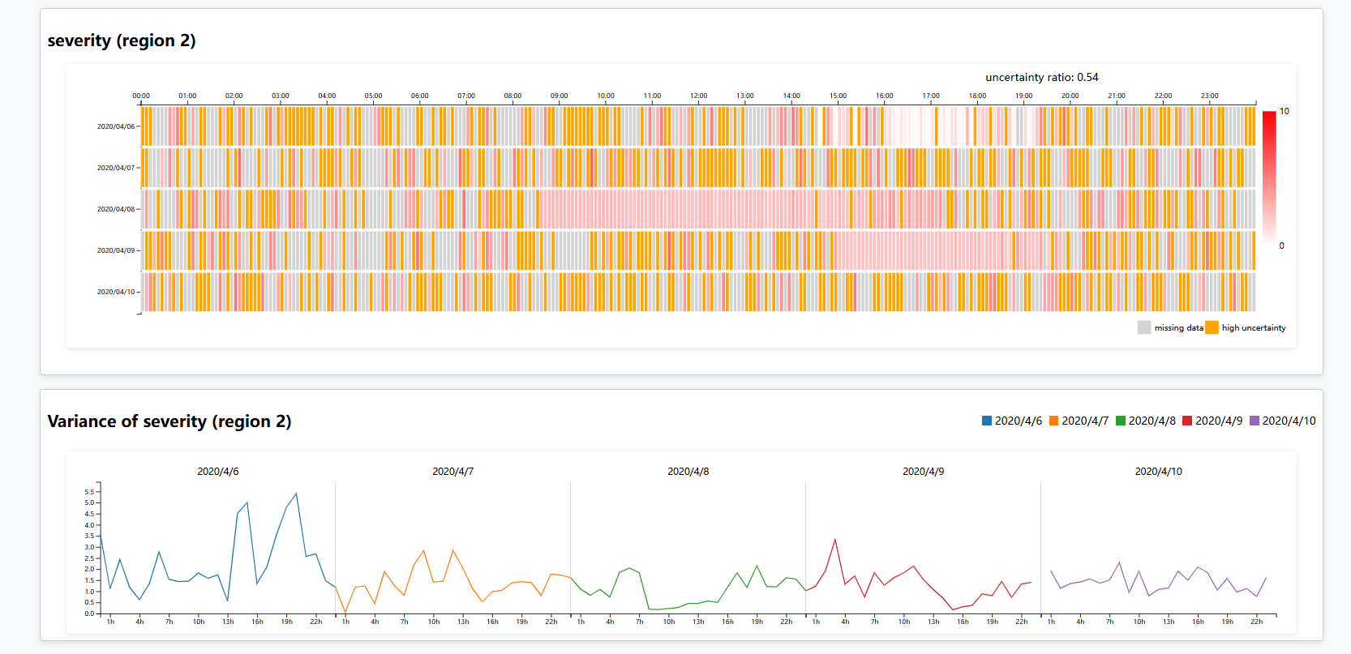
Figure 27
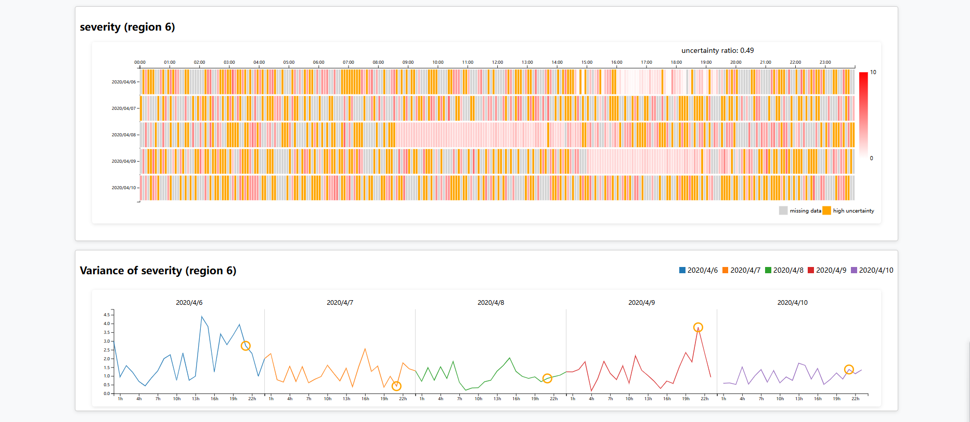
Figure 28
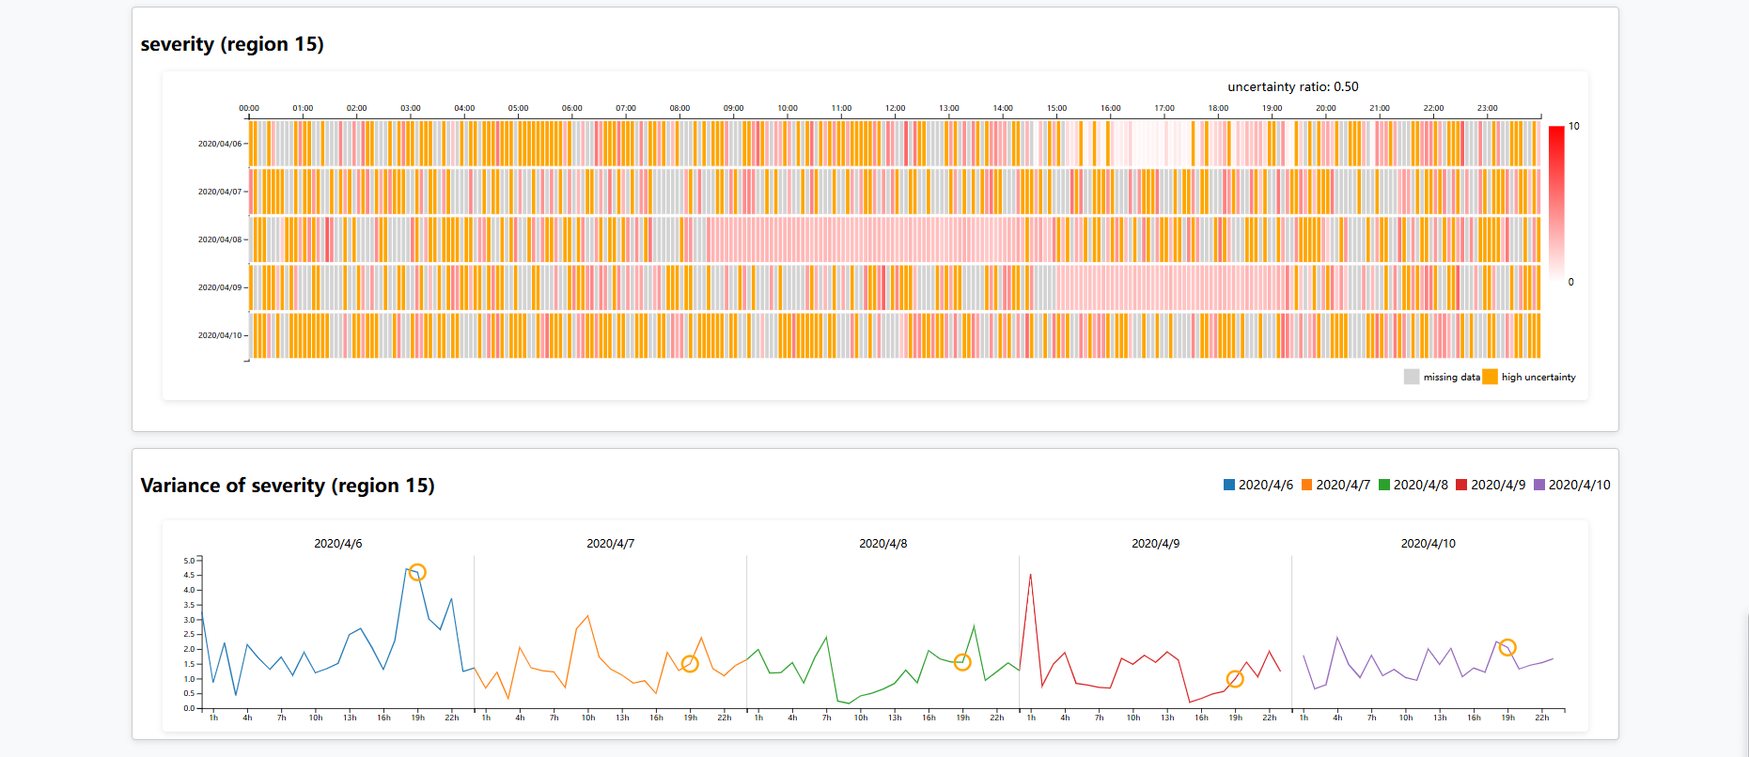
Figure 29
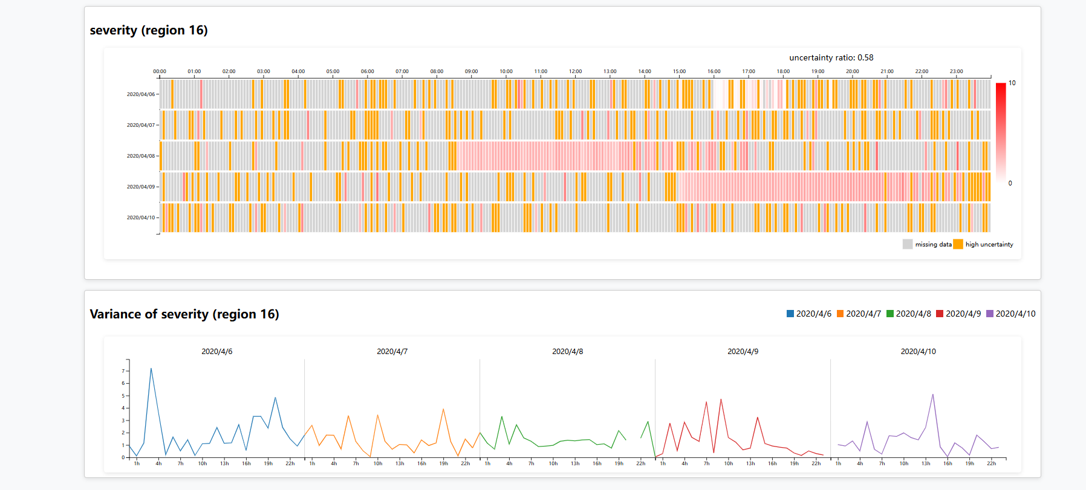
Figure 30
An analysis of the severity data in regions 2, 6, 15, and 16 from April 6 to April 10 shows high data coverage across nearly all time slots and relatively low variance. These observations support high Completeness and Stability scores, indicating strong overall Reliability in these regions.

Reflection:
Current Limitations:
Inconsistent visual styles and layouts across components (e.g., prompts and highlights) can affect user experience.
Data loading and computation are inefficient for large datasets; techniques like async processing, caching, or Web Workers need to be explored.
Future Work:
Enhance interactivity with smooth transitions, animations, and real-time data scrolling.
Use A/B testing and user behavior data to optimize layout and interaction logic.
Implement batch loading, caching, and async processing to improve performance with large data volumes.

