Packing List Include:
1 ×Load Cell Amplifier
1 ×User Manual
ATO Load Cell Amplifier with 6-digit LED display, output signal 4-20mA/ 0-10V/ RS485(Modbus-RTU)/ 4-20mA & RS485/ 0-10V & RS485. It can be used as a load cell indicator for reading the weight values.
There are 3 keys for parameter settings. Digital load cell amplifier can be calibrated on-line by its 3 keys. The setting parameters include zero, capacity, communication rate, division value, decimal digits, etc.
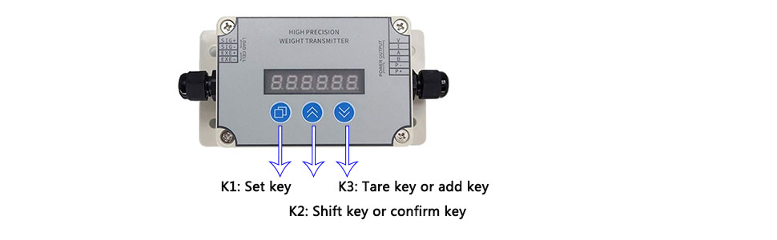
How to restore factory settings
When setting error, you can press K2 key to restore factory setting, free from maloperation.
Step 1: Power off → long press K2
Step 2: Power on → wait 2 seconds, then release K2
ATO Load Cell Amplifier Specification

Model | ATO-S-LCTR-DY610
Accuracy | ±0.2%FS ±1 byte
Input signal | 0~±20mV
Excitation voltage | DC 5V (for load cell)
Output signal * (optional) | DC 4-20mA,DC 0-10V, RS485 (Modbus-RTU), 4-20mA & RS485, 0-10V & RS485
Sampling rate | 60 times/s, 120 times/s
Power supply | DC 12-30V
Power consumption | ＜1W
Display | 6 digit red LED, -99999~999999
Readout units | kg, g, ton, and newtons
Protection class | IP65

ATO Load cell Amplifier wiring diagram :
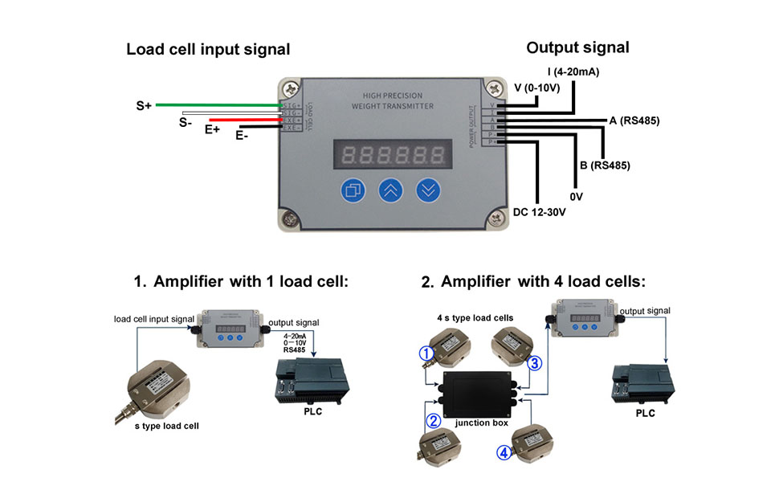
The shield of the load cell can be connected to the amplifier's E- terminal together.

