AOOP Homework 3

Problem 1: Design a class Resistor to solve the following problems:

1. Color bands are used to designate a resistor’s value and tolerance.
Compute the resistance of a resistor, given four color bands, where the fourth band represents the resistor’s tolerance.
2. Compute the total series resistance.
3. Compute the total parallel resistance.

Write three files for the class Resistor: ( Ref. lecture p4-50-p4-51)
(1). A file containing the class specification. ( resistor.h)
(2). A file containing the class implementation. ( resistor.cpp)
(3). A file to use and test the class Resistor.( test.cpp)

Class resistor need to provide the following function members:
(1). Default constructor.
(2). Constructors with parameters.
(3). Destructor.
(4). At least one input function to set the values of the color bands.
(5). At least one output function to write out the color bands.
(6). One function member to compute the resistance form the color bands .
(7). One function member to output the resistance.
(8). Define operator function member + to compute the total series resistor.
(串聯電阻).
(9). One operator function member || to compute the total parallel resistor.
(並聯電阻).
(10). You may design more function members from your considerations.
Note:
1.You may use enum (列舉型態) to define the color.
2. Please select at least one function member to provide function chaining.

Compiler usage ( select at least one just from the following list )
(1). Borland c++ 5.5.1.
(2). Borland C++ Builder. (BCB)
(3). Visual C++
(4). Dev C++

Problem 2:

Design a function “Integal” that uses the Trapezoidal Rule to approximate a definite integral: 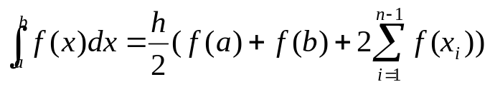 , where 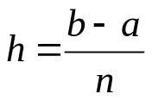 . Note that the interval [a,b] is divided into n subintervals. The function should have the following parameters: the interval’s endpoints a and b, and the number of subintervals n. As the number of subintervals increase, so will the accuracy of the approximation.

Create a program that uses this function to compute a voltage across capacitor at different values of time t. The capacitor voltage is give by the expression:
Find 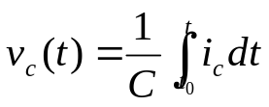 + 
Assume that the value of capacitance is C=0.1µF, and capacitor current is given by the expression:
Given 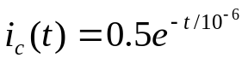

The user should input the time interval [,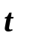], initial voltage , and number of subintervals n. The program should compute and display the values of capacitor voltage at different values of time within the specified intervals.

- This problem gives you an opportunity to practice: How to tune the number of subintervals n . You may input different values of n and observe the result.

- You may predict how large does the value of “n” be needed from the mathematic expression and use this value to execute the program.

- If the value of n is large, then the execution time will be longer. Please be patient to wait for the result.

- How to tune the input data to fit the requirement of the problem is an important technique in the simulation problem. You have the mathematic expression in problem2, but it is always no mathematic expression in the reality, complex problem.

- So please work hard and analysis problem2 then you may get some experiences from this problem.

- The derivation of Trapezoidal Rule

The Integration:
1. Using the Trapezoidal Rule:
The integral of the function f(x), evaluated from a to b, is expressed as
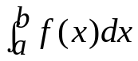 that represents the area under the function f(x) from x=a to x=b ,as
y

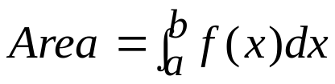
x
f(x)

a
b

Fig 1: Area under a curve
y
x
f(x)
y₁
y₂
y₃
y₄
y₅
a = x₁
x₂
x₃
x₄
x₅ = b

Fig 2: Spaced intervals
y
x
f(x)
y₁
y₂
y₃
y₄
y₅
a = x₁
x₂
x₃
x₄
X5 = b
A₁
A₂
A₃
A₄

h = x_{2 －} x₁
₌ x_{3 －} x_{2 = …}

Fig 1: Four trapezoids

The total area under the function f(x) from x₁ to x₅ is A₁＋A₂ ＋A₃＋A₄=
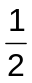× ( y_{1 ＋}y₂ ) × h＋× (y₂＋y₃) × h＋× (y₃＋y₄ )× h＋× ( y_{4 ＋}y₅ ) × h
＝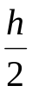× (y_{1 ＋}y₅ ) ＋（y₂＋y₃＋y₄）× h
＝＝× 〔(y_{1 ＋}y₅ ) ＋ 2 ×（y₂＋y₃＋y₄）〕
In general, Area = = 〔f(a) + f(b) + 2 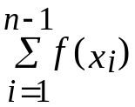 〕
where h = 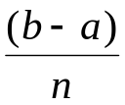, Note that the interval 〔a, b〕is divided into n subintervals

