LAB 4 Tuesday

2014/4

First, create a Frame (Frame A) with a button and a textfield.

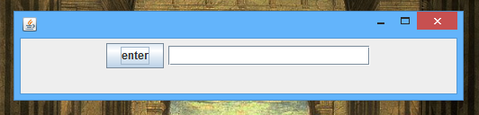

When user key in a number and click the enter button. Your program must new the other frame (Frame B) showing the corresponding picture and automatically Expand the boundary to the max.

The picture must draw on a Panel.





Then notice there are two button on the top of this Panel. When user click the button NEXT, your program must destroy the current Panel in the Frame B and create a new one adding to Frame B and showing the next picture.

And so on. You know how to handle button BACK.

**Requirement:**

● Two Frame, the first on contains a Button (Enter) and a Text Field, the second one contains a Panel.

● Second Frame’s Panel contain one picture and two button (NEXT & BACK).

● And it must automatically expand to the max size of your screen.

● You can’t just change the picture when clicking the button, you need to destroy the whole Panel from your frame.

● When the picture go to the end the next one is the first picture.

● Your Panel must implement the ActionListener. And handle the event in your Panel’s actionPerformed member.

**HINTS:**

There are some thing you may need.

Image image = new ImageIcon(fileName).getImage();

g.drawImage(image,0,0,getWidth(),getHeight(),null);

event.getSource()

And you may need to go to java document to check JFrame’s members.

And also check Frame’s member for **Extend** the Boundary!