ParkSmart: Milestone 2 Refined Prototype
Nicholas Palmgren | CSCI 4250 Human-Computer Interaction | Fall 2026
Runnable prototype: https://github.com/chickencell/ParkSmart/tree/main/m2-prototype (open index.html and click the screens)
Video demonstration: [paste YuJa link here]

The prototype
ParkSmart helps a student find an open parking lot near the building they are going to. The refined prototype is a clickable set of hand-drawn style screens: tapping a sketch moves to the next screen, the way paper screens are swapped in a paper-prototype test. Students can scan the campus map (lots colored green / yellow / red with open-spot counts), tap a lot for a quick preview, or pick a building to get the closest lots that still have space, check a lot's details, and hand off to their maps app for directions. Availability is simulated.

Design changes since Milestone 1
- Lot preview card. Tapping a map marker now opens a small card over the map (open spots, permit, walk time) instead of jumping to a new screen, so users can compare lots without losing the map.
- Recent buildings. Find a Building lists the last places searched, since students go to the same few buildings; picking from a list is easier than remembering and typing a name.
- “All lots full” screen. Milestone 1 had no answer when nothing nearby was open. Now the app says so plainly and suggests the closest lot that has space.
- Fill bars and “Updated 2 min ago.” Best Lots cards show a fill bar for quick comparison, and a timestamp tells users how fresh the numbers are.
- Back to map. Lot Info has a button to return home in one tap.

Usage scenarios (draft)
1. Running late for class. Maya commutes and has a 10:00 class in Science Hall. At 9:50 she pulls into campus, opens ParkSmart, taps Science Hall under Recent, and sees Lot A has 42 open spots and is a 4-minute walk. She taps Get Directions and parks without circling full lots.
2. Checking before leaving home. Jordan opens the Campus Map before leaving his apartment. Lot C is red (full), so he taps the green Lot A marker, sees 42 open spots in the preview card, and heads there.
3. Event night. Sam drives to a game at the Arena. The app shows that all lots near the Arena are full and suggests Lot A, a 9-minute walk, so Sam goes straight there instead of searching.

Prototype screens
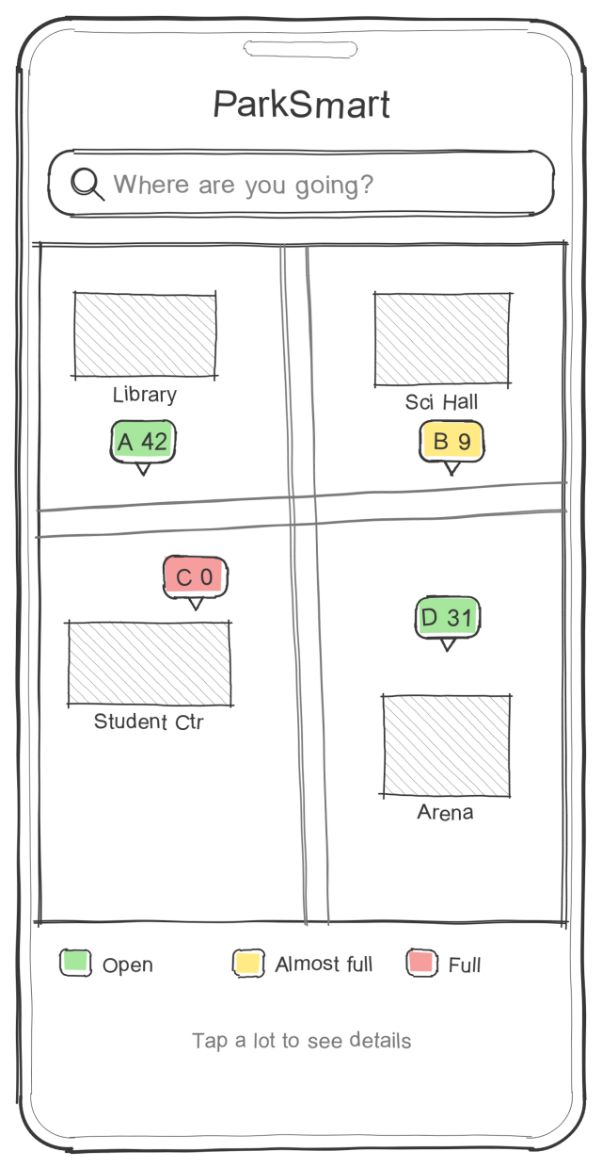  1. Campus Map | 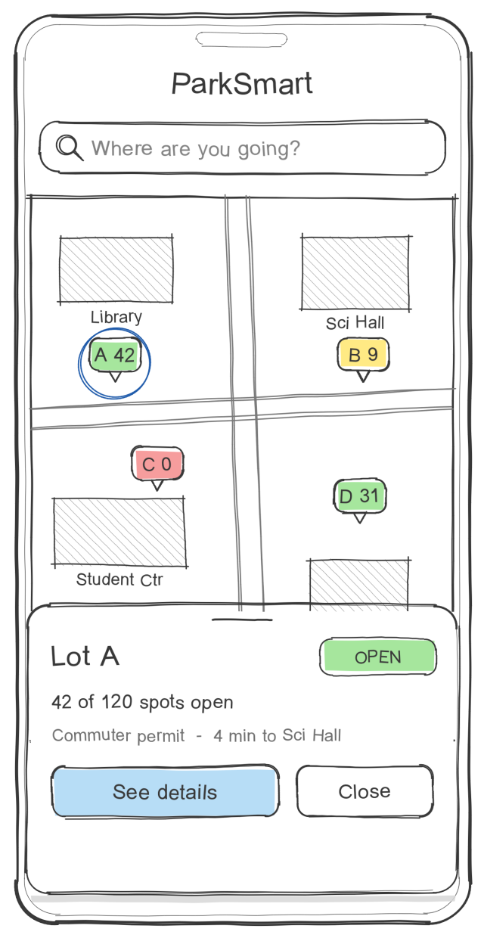  2. Lot preview (new) | 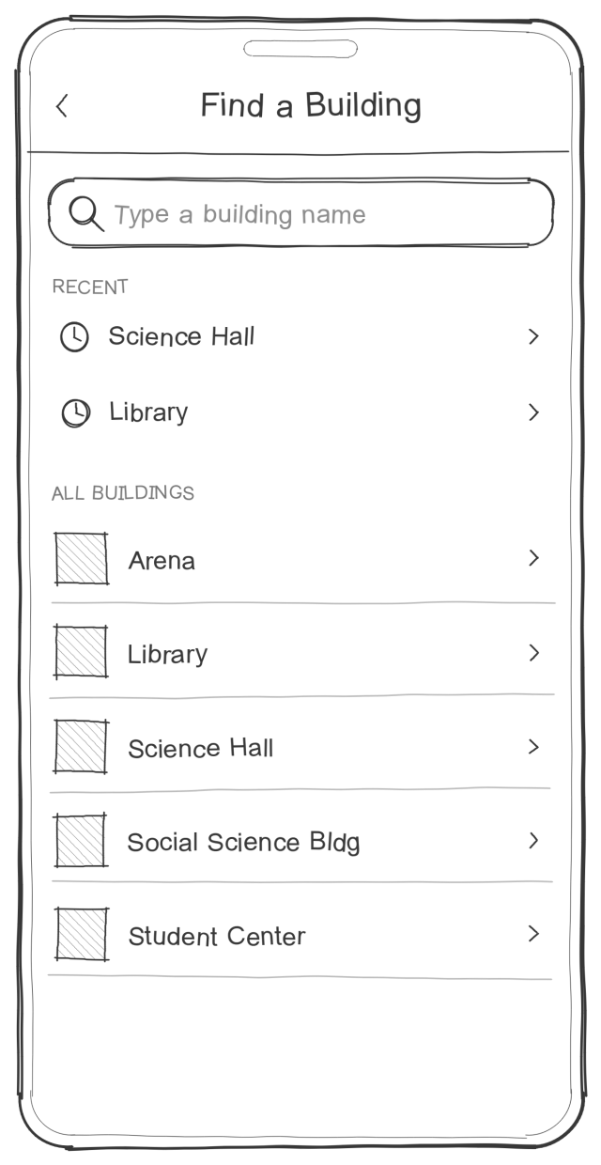  3. Find a Building
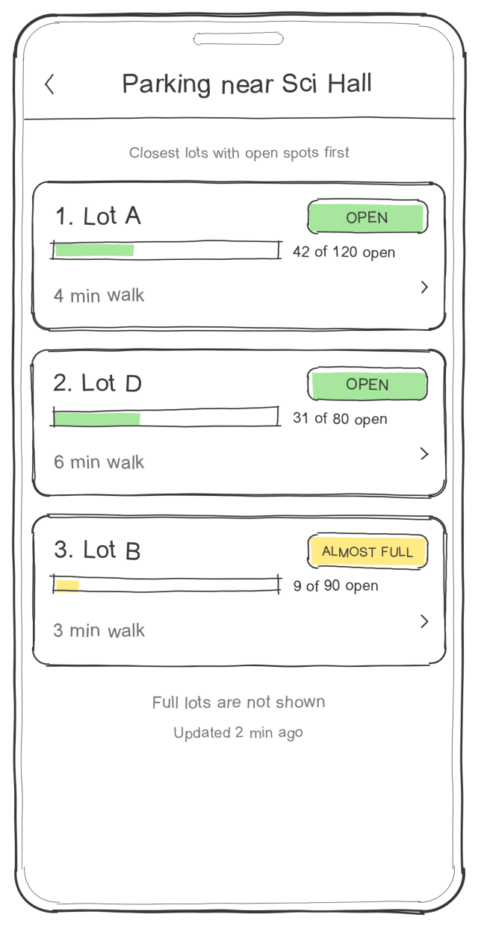  4. Best Lots | 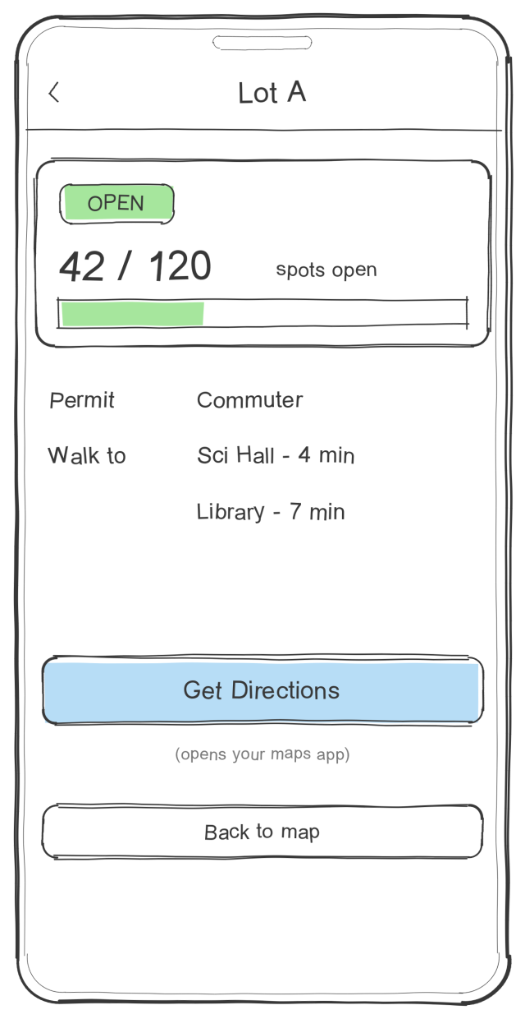  5. Lot Info | 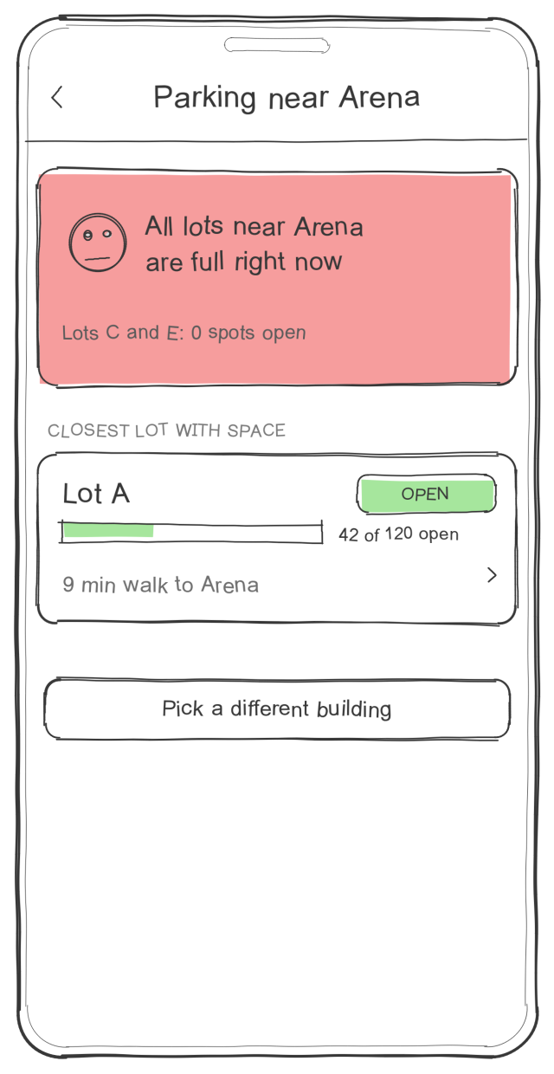  6. All lots full (new)
Paths through the prototype: Scenario 1: search bar → Science Hall → Lot A → Get Directions. Scenario 2: tap a lot marker → See details. Scenario 3: search bar → Arena → Lot A.
AI disclosure: I used Claude (Anthropic) to help draw the sketches, build the clickable prototype and draft this writeup.

