CHAPTER 2 CONSTANT-STRESS CREEP RIG DESIGN AND CALIBRATION
2.1 Introduction
This chapter details the design and calibration of a constant-stress creep rig constructed for use in this investigation to conduct high temperature constant-stress creep tests.
2.2 Overview of constant-stress creep testing
Creep testing machines take several forms depending on what is the primary target of investigation, which includes constant load, variable stress and constant-stress rigs. A small change in the level of stress can have a large effect on strain rate affecting both the overall creep rate and microstructure of the sample. With increasing strain, the cross-sectional area A of a test specimen decreases, which if tested in a constant-load creep rig, results in an increase in the instantaneous stress. With a load P, cross-sectional area A, the stress on the specimen will be σ = P/A. A constant-stress machine would allow the stress variable to be controlled by compensating for the decrease in the specimen’s cross-sectional area by decreasing the effective load applied on the specimen. This allows the basic creep mechanisms acting on the specimens tested to be isolated and analyzed.
The curve of the constant-stress cam is key to constructing a precise, operational constant-stress creep rig. In Figure 2.1, a schematic layout of the weight-transferring system is shown for a constant-stress creep test applications. For constant-load creep tests, the curved cam would be circular.
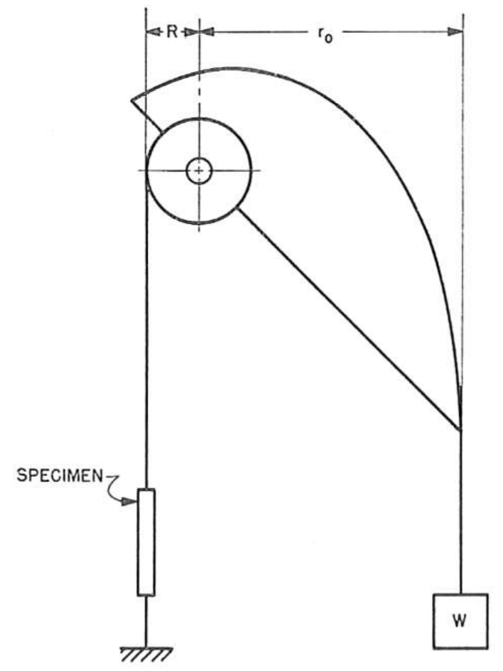
Figure 2.1: A schematic diagram detailing a weight-transferring system used for constant-stress creep tests. { | Garofalo, et al., 1962 | | |zu:2902168:5TKQ6V7D}
The curved profile of the constant-stress cam is analytically calculated using a system of parametric equations following the outline of an Andrade-Chalmers beam { | da C. Andrade, & Chalmers, 1932 | | |zu:2902168:SKTT22IB}. It is shown that the fixed Cartesian coordinates x and y of a constant-stress cam can be written in terms of constants and the angle θ (see Appendix I for derivation of equations (1) and (2)), where θ is the angle the cam makes with the horizontal as seen in Figure 2.2 from the paper by Garofalo et al (1962). In equations (1) and (2) L₀ is the initial specimen gauge length prior to creep, r₀ is the initial moment arm, R is the radius of the smaller load-transferring wheel. The Cartesian coordinates from which the profile of the cam can be traced for machining are determined by the values of constants a and b:
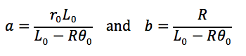
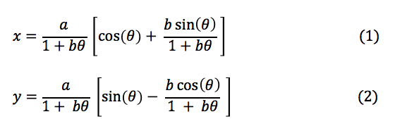
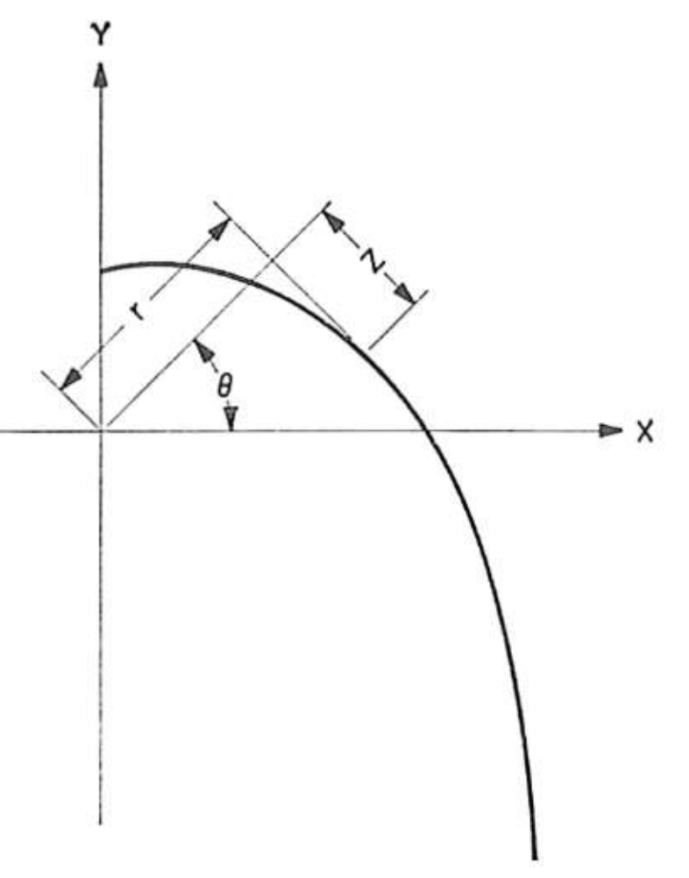
Figure 2.2: A diagram detailing the coordinate system used for the cam profile
For the purposes of this investigation, a constant-stress creep test rig was custom-designed, built and its operation validated based on the methods developed by Garofalo, Richmond and Domis (1962). The following section discusses the system’s dimensions, assembly, cam parameters, calibration and testing procedure.
2.3 Design of Creep Test Rig
A photograph of the full assembly of the creep rig is shown in Figure 2.3 with a sample specimen in tension and placed under a 35 MPa load.
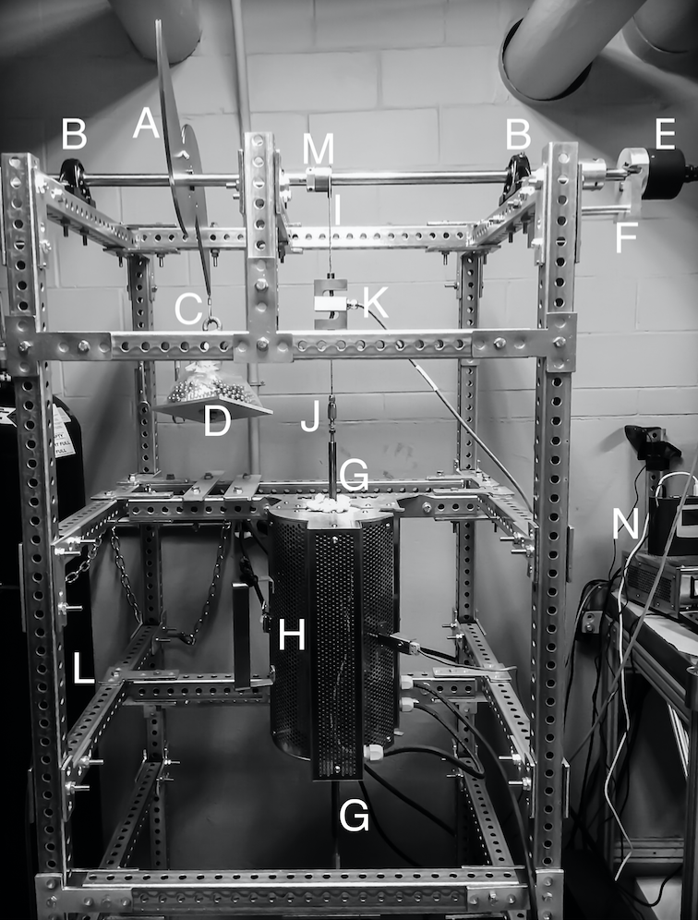
Figure 2.3: Photograph of the constant-stress creep machine with system components labeled matching the key
Key for Figure 2.3
A. Constant-stress cam
B. Bearing pillow block
C. Cable attached to load
D. Load weight on loading tray
E. Angular Displacement Transducer (ADT)
F. ADT support
G. Connecting rod
H. Mellen Furnace
I. Cable attached to specimen
J. Swageless Thread Terminal
K. Linear variable differential transformer (LVDT)
L. Steel Frame
M. Load-transferring wheel
N. Data Logger
* Letters in parentheses () indicate machine components as per Figure 2.3
2.3.1 Frame and Mounts
The metal frame (L) of the rig is made of 1.5-in galvanized steel perforated tubing for heavy duty telescoping framing and is bolted onto four base mounts to account for uneven floor surfaces. The metal frame additionally supports the Mellen Inc. SCR Split Series 120 V 1200 W Furnace (H) mounted vertically. The furnace utilizes clamshell-heating elements capable of 1250ºC in air. The temperature is measured with a centrally located K-type thermocouple and controlled by a Mellen Inc. PS105 programmable power control cabinet. Two heavy-duty ball bearing pillow blocks (B) are rigidly attached to the steel frame and support a 0.75-in diameter steel rod that acts as the cam and load-transferring wheel support shaft.
2.3.2 Constant-Stress Cam
As discussed in the previous section, the cam profile is dictated by the constants a and b. For a small load-transferring wheel with a radius of 0.75 inches, an initial specimen gauge length of 0.787 inches and a desired mechanical advantage of 8:1, the values of a = 6.00 in and b = 0.95 in. Using the derived equations (1) and (2) and the calculated values of a and b, the Cartesian coordinates of the cam’s profile in x and y can be calculated for a given angle θ as shown in Table 2.1.
Table 2.1 Coordinates for the constant-stress cam profile fabricated for use in this study, with a = 6.00 in and b = 0.95 in.
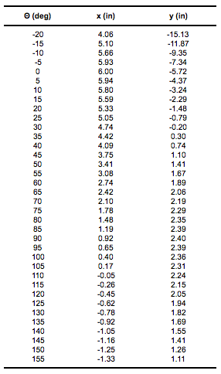

The constant-stress cam (A) and the load-transferring wheel (M) are mounted on the steel rod with a diametrical interference fit of 0.003-in, which facilitates free circular movement around the rod. The cam profile shown in Figure 2.1 is duplicated, inverted and attached to the original cam profile to balance the cam assembly when it’s threaded onto the support rod. The small radius load-transferring wheel is designed for an 8:1 mechanical advantage. Both the cam and the wheel are attached to the center support shaft with a collet and two set screws placed on opposing sides and screwed in to firmly secure the components and eliminate movement when the system is under load. The cam and the load-transferring wheel are fabricated from 1018 steel. Appendix II contains CAD drawings with specifications of the cam and load-transferring wheel.
2.3.3 Angular Discplacement Transducer
The TransTek Inc. Series 600 Model 0603-0000 Angular Displacement Transducer (ADT) with 100 mV/° output and maximum usable range of ±40° is attached (E) with a set screw to the end of the support shaft extending 1 inch past the pillow block and steel frame tubing. The ADT allows for measuring specimen elongation by tracking the angular displacement of the cam shaft as the sample lengthens throughout the duration of a creep test. More specifically, as the specimen creeps, the relative displacement of the two specimen grips is detected by the ADT. This angular displacement is translated into an electrical signal, which is then amplified
by the TransTek Inc. Series D100 Dual DC 12VDC Power Supply and sent by the readout wire to the Grant Instruments Ltd. SQ2010 Portable Universal Input Squirrel Data Logger (N) to monitor, measure and record the elongation of the specimen. The high accuracy ADT is capable of measuring an angular displacement of ±0.10 %, which translates to measuring a linear displacement of <0.001 in. The ADT is supported with an aluminum bolted frame (F) to eliminate any torque placed on the high-precision measurement equipment.
2.3.4 Cable and Load Alignment
Both the constant-stress cam and the load-transferring wheel have a 0.047-in radius milled groove on their outlines to create a track that allows for a 3/32-in wire cable to fit and wrap around with a snug fit. A wire 3/32-in cable (C) is attached to the constant-stress cam through a pinhole, shown in Figure 2.4, and swaged together with wire rope sleeves. The other end of the cable is swaged in the form of a loop and permits the attachment of a dead-weight load. The load is attached through the use of an 8-inch long metal hook threaded through the center of an aluminum 6x6-in square platform (D). The load is stacked on the platform. The material used for the applied load consists of steel 1/4-in diameter balls to aid in applying a variety of loads with precision.

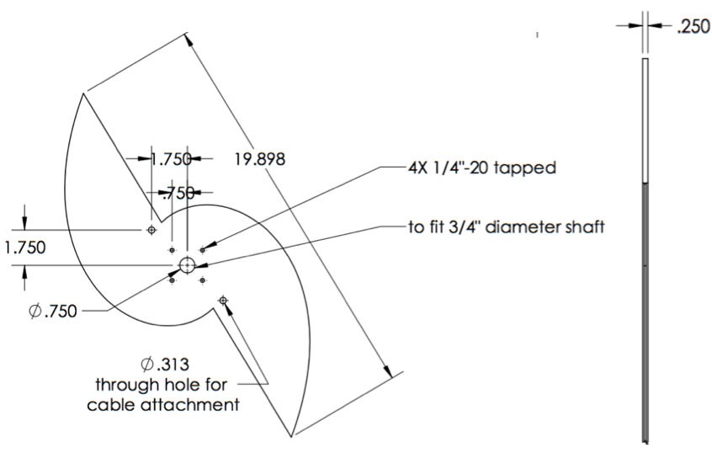
Figure 2.4: Design drawing of constant-stress cam
One end of a wire 3/32-in cable (I) is attached and swaged through a pinhole to the load-transferring wheel (M) on the opposite side that the cable is attached to the constant-stress cam. The other end of the cable drops vertically down to connect through two attachment openings in the vertically aligned Omega Engineering Inc. LC101-500: 500 lb S-beam load cell (K), which acts as the linear variable differential transformer (LVDT). The LVDT output wires are connected to the data logger (N) and Omega Engineering Inc. DP25B-S-A series Digital Panel Meter with a 4-digit LED display that aids in adjusting the cam placement when a load is applied by displaying the output in lbf units. A wire cable is attached through the bottom of the LVDT to a swageless thread terminal (J).
2.3.5 Specimen Grip Components
The thread terminal is screwed into the machined upper extension connecting rod (G). The extension rod is screwed into the upper male end of the machined specimen grips as shown in Figure 2.5. The specimen grips and connecting rods are fabricated from 718 Inconel to prevent elongation when heated in the furnace, and hold the specimen in a vertically aligned position. The lower specimen grips are similarly connected to an extension rod, a swageless thread terminal and a wire cable. Figure 2.5 shows a diagram of the details of the specimen grips. Appendix II contains CAD design drawings of the grip components, which includes the inner grips, collets, yolks, and rod connectors.
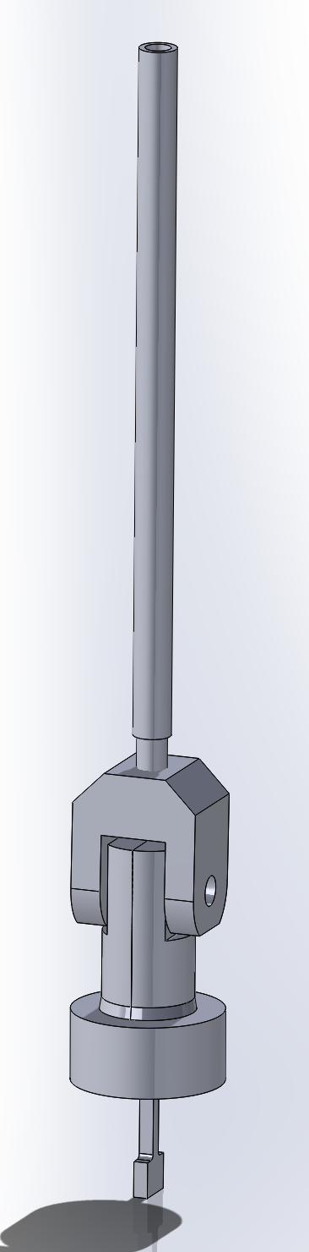
Figure 2.5: Diagram of specimen grips
2.3.6 Making Adjustments
Completing the linkage, the wire cable is vertically secured to the bottom crossbeam of the steel frame in a 1/4-in diameter slot to allow for lateral movement and adjustments of up to 2 inches when a load is applied to the system and the cable is placed under tension.
Of special note is the horizontal position mark that is inscribed on the constant-stress cam prior to the system assembly. The cam is designed to produce a constant-stress about this centerline as shown in Figure 2.6, which aids in proper adjusting and positioning of the cam during calibration testing such that the rig functions as intended (refer to Calibration Testing section 2.4.4).
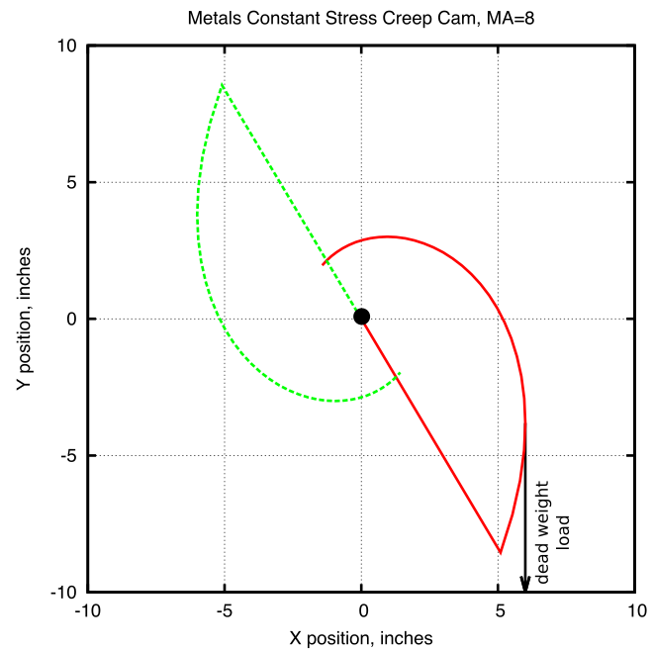
Figure 2.6: Plot of the constant-stress cam geometry. The cam’s centerline is centered on y = 0.
2.3.7 Data Logging
The Squirrel data logger receives amplified voltage readouts from the ADT and LVDT. The output is sampled at five-second intervals and then logged as an average of five samples. This logging rate allows for long term creep tests to be conducted by decreasing the amount of data logger memory used, while ensuring the data collected has appropriate resolution for detailed data analysis.

2.4 Testing and Verification
A range of tests were performed on the creep rig to verify that the system functioned as intended. The machine was calibrated for use with a load of 35 MPa, and a series of tests were conducted to prove that the load on the test sample would be reduced at the specified rate to produce a constant-stress.
2.4.1 Identifying the ADT Adjustment Factor
The Angular Displacement Transducer (ADT) output is a voltage, which is converted to an angular displacement in degrees. This rotational displacement value is used to calculate the elongation of the test specimen to a high degree of precision. The ADT displacement measurements required an adjustment factor to match the actual test specimen elongation.
To conduct the test and acquire the adjustment factor, a sample test specimen was placed in the system and the effective load was decreased in 5 MPa increments by mechanically simulating a displacement of the specimen, which was accomplished by unscrewing the upper connecting rod out of the upper specimen grip connector. The data logger was used to record the angular displacement recorded by the ADT, and a micrometer was used to measure and record the simulated linear displacement. The test was conducted three times and the data was averaged. Figure 2.7 shows the results of this calibration.
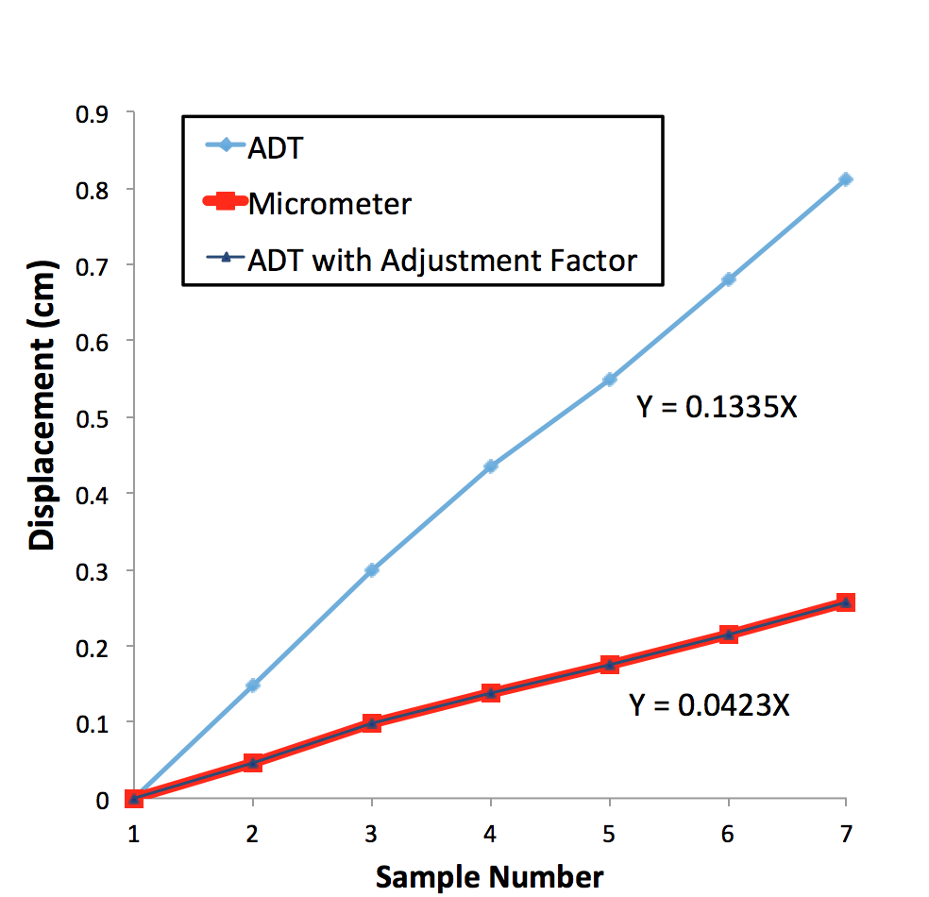
Figure 2.7: Plot of system displacement measurements taken with ADT, manually with a micrometer and the same ADT results plotted with an adjustment factor. Notice the adjusted ADT measurements match those taken with the micrometer.
When the ADT results were adjusted with a factor of 3.156, the displacement values were identical to those taken with the micrometer. This verified that the system recording displacement accurately measured and recorded specimen elongation.
2.4.2 Eliminating Creep Contributions From System Components
A test was performed to determine if the connecting components of the system, such as the connecting rods, cable and grips, would creep under an applied load and affect the test results by contributing to the overall creep measured.
A sample T-bone was fabricated from 718 Inconel and heat treated, which is the same material from which the specimen grips and connecting rods were fabricated. The sample was inserted into the specimen grips and the system put under a load of 35 MPa (the load used for subsequent testing in this investigation). The system was tested for a 24 h duration. An initial displacement was recorded by the ADT within the first few seconds of the system coming under load, which can be attributed to the elimination of slack in the system.
No creep of the system components was detected for the duration of the 24 h period. This demonstrated that the only contributing factor to subsequent tests’ resulting creep was attributed to elongation of the T-bone specimens and not to the creep of components of the system.
2.4.3 Furnace Temperature Profile
The furnace to heat the sample at a constant temperature was vertically aligned and therefore its temperature profile was measured to ensure that the temperature felt by the test specimen was indeed the temperature set point being measured by the K-type thermocouple in the furnace.
A second thermocouple was inserted along the inside length of the furnace and used to identify the location at which the measured temperature matched that being displayed as the set point on the furnace power control cabinet. This test was repeated three times and the results averaged with a final location determined to be 5.5 inches measured from the top of the furnace tube or 6.5 inches measured from the tube bottom exit. The system cables were adjusted accordingly to ensure that when under load, the test specimen would be located at the target height.
2.4.4 Calibration Testing
For a constant-stress test, the equation:
P/P₀ = L₀/L (1)
where P is the load and L is the length of the specimen, must be satisfied for any angle and for any initial load P₀ in order to satisfy the requirement that PL = constant. The creep rig was calibrated by comparing the theoretical predictions of equation (1) with experimental measurements of P and L.
Before beginning the calibration test, the cam was adjusted so the horizontal position mark inscribed on its side was level and at the intended zero mark. The furnace door was propped open to expose the specimen grips inside and a test specimen inserted. Steel balls with a total load 45 MPa were placed onto the loading tray. A zero reading was taken and recorded. The angle was increased in 5-degree increments, by mechanically simulating a displacement of the specimen, from 0 to 35 deg. For each interval, the load and linear displacement were recorded.
Figure 2.8 shows the calibration plot. The experimental values had an average variation of 0.36 percent compared to the theoretically predicted values from equation (1). This value was well within the bounds of literature values { | Garofalo, et al., 1962 | | |zu:2902168:5TKQ6V7D} confirming the rig was calibrated and operational for constant-stress testing.
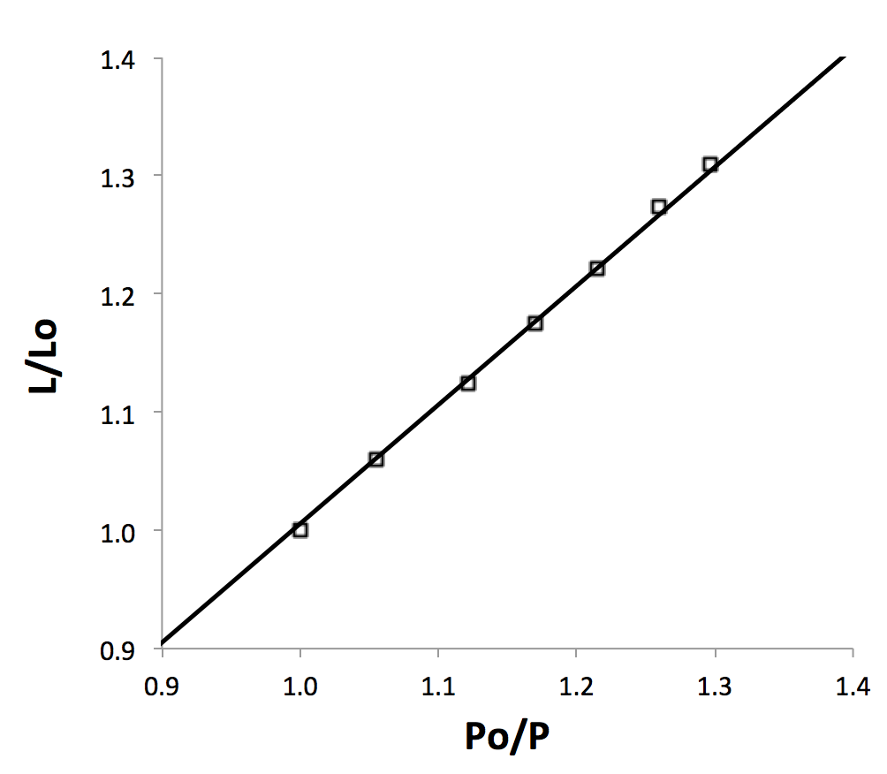
Figure 2.8: Load calibration of constant-stress cam

