________________________________________

Element Analyzed Theoretical (wt%) Analyzed (wt%) ________________________________________

Nickel 31.88 31.9
Chromium 18.83 18.98
Niobium 3.36 3.34
Aluminum 2.44 2.48
Carbon 0.00 0.02
Cobalt 0.00 0.01
Copper 0.00 <0.01
Manganese 0.00 <0.01
Molybdenum 0.00 0.01
Phosphorus 0.00 <0.005
Silicon 0.00 <0.01
Sulfur 0.00 <0.001
________________________________________

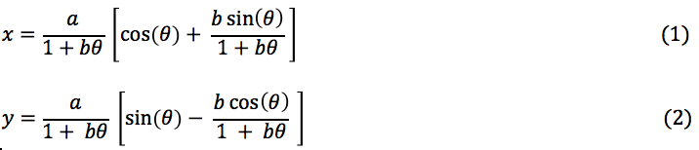

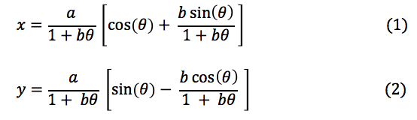

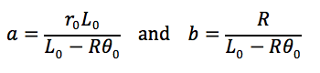
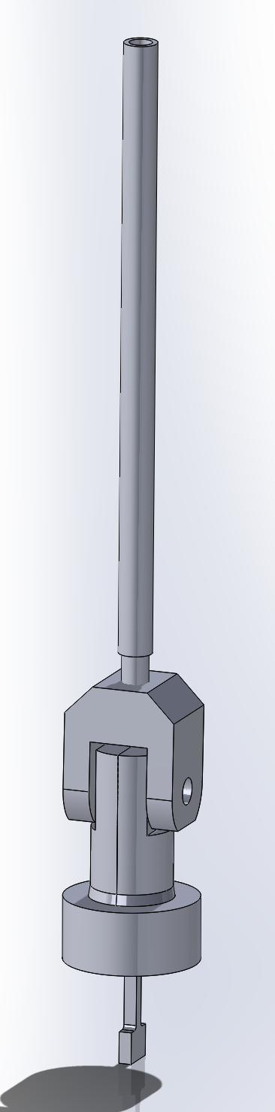





(A)

(B)

(C)

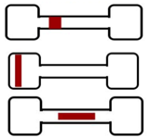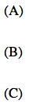
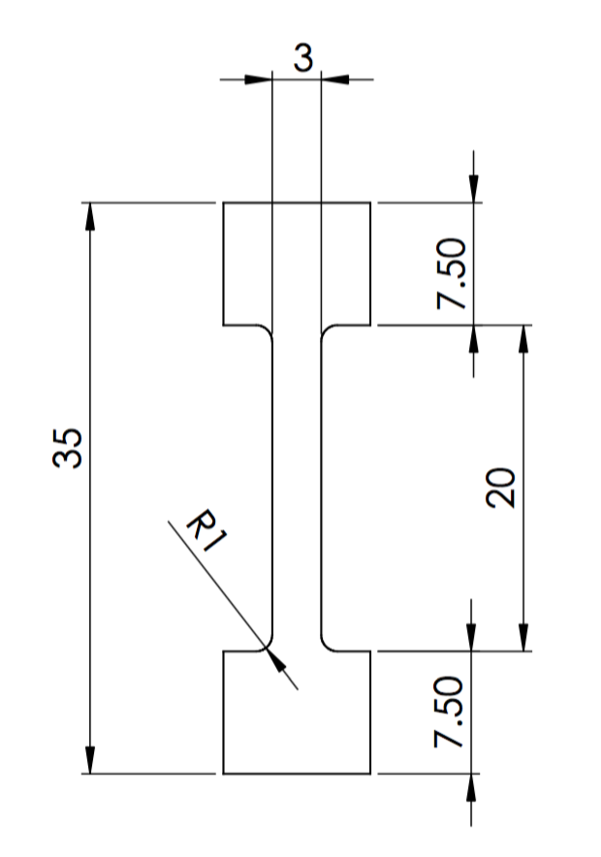
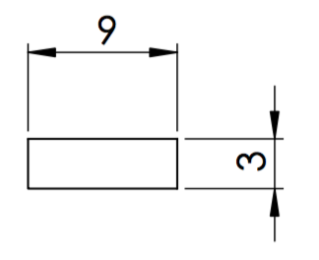

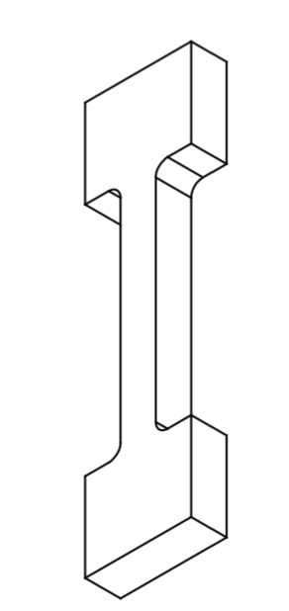
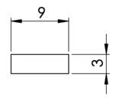

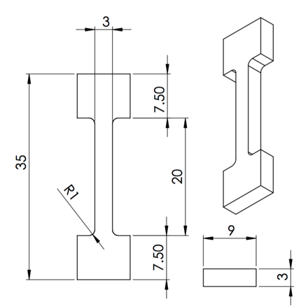

Tensile specimen

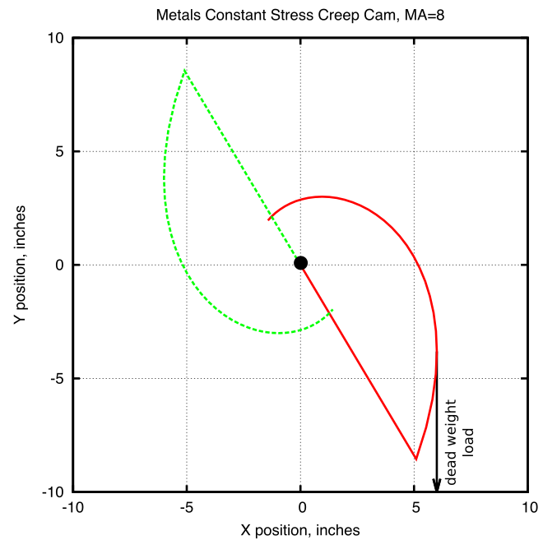
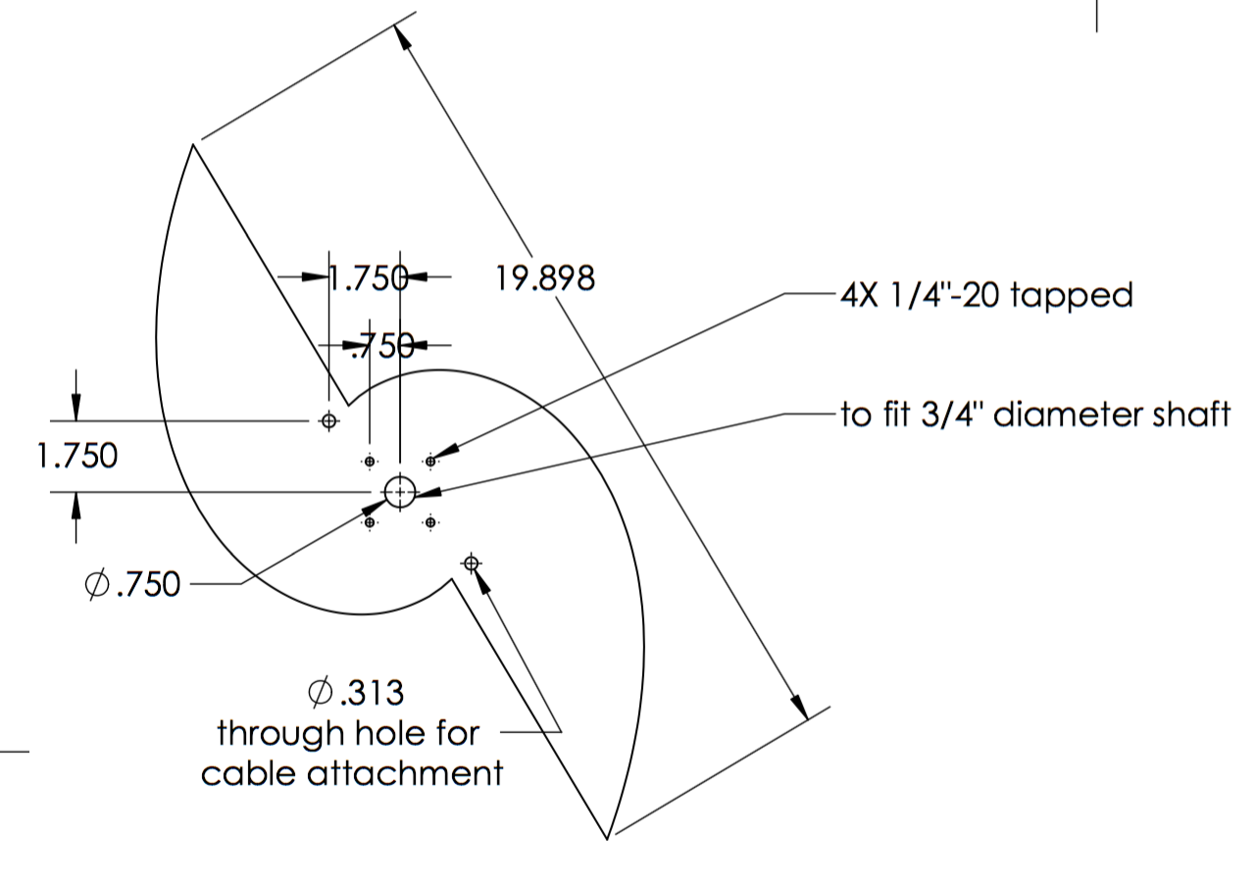

Element Analyzed | Theoretical (wt%) | Analyzed (wt%)
Nickel | 31.88 | 31.90
Chromium | 18.83 | 18.98
Niobium | 3.36 | 3.34
Aluminum | 2.44 | 2.48
Carbon | 0.00 | 0.02
Cobalt | 0.00 | 0.01
Copper | 0.00 | <0.01
Manganese | 0.00 | <0.01
Molybdenum | 0.00 | 0.01
Phosphorus | 0.00 | <0.005
Silicon | 0.00 | <0.01
Sulfur | 0.00 | <0.001  I

