CHAPTER 3 EXPERIMENTAL METHODS
3.1 Introduction
This chapter details materials preparation and processing methods, constant-stress creep testing procedures, tensile testing and materials characterization techniques involved in this work.
3.2 Materials Preparation
3.2.1 Materials Used
The alloy Fe-20Cr-30Ni-2Nb-5Al (at.%) was used for both the creep and strain-rate jump tests throughout this study. The alloy was provided by Mr. Michael Schmidt, Carpenter Technology Corporation (Wyomissing, PA). A split-cast vacuum induction melting heat was used to cast the alloy into 8 kg tapered ingots. The ingots were then press forged into rectangular bars with the following dimensions: 0.625” x 0.75’’ x 24’’. The chemical composition of the alloy was analyzed by LECO combustion analysis and X-ray Fluorescence. Table 2.1 compares the analyzed element compositions with the theoretically calculated weight percent ratios, demonstrating agreement between the predicted and actual chemical composition of the cast alloy.
Table 3.1 Chemical composition comparison of the Carpenter Technology alloy

3.2.2 Sample Machining
In preparation for both creep testing and strain-rate jump tests, the alloyed material was machine milled and then sectioned with a saw. The TRAK DPM SX3P bed mill with a 40 taper spindle and ProtoTRAK SMX control was used with zinc-coated carbide end mills to mill the specimens into the T-bone shapes necessary to insert into the specimen grips of the creep testing and strain-rate jump testing machines as shown in Figure 3.1. To ensure the accurate geometry of each T-bone, the specimen was sectioned using coolant with a Model 650 Low Speed Diamond Wheel Saw from South Bay Technology, Inc.
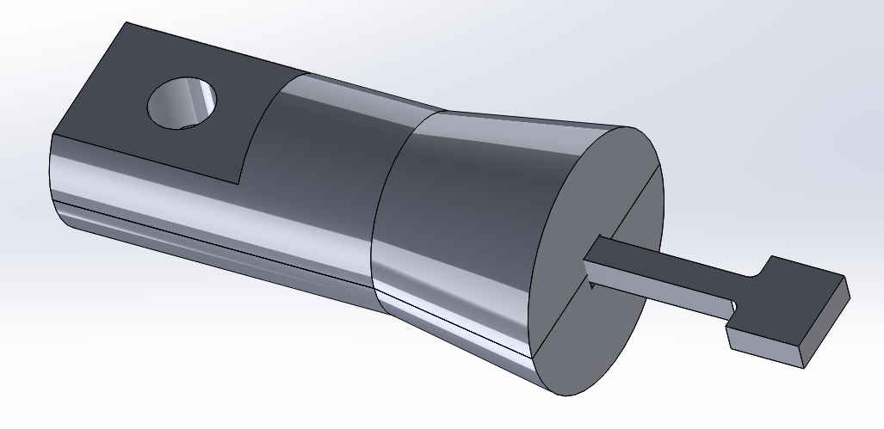
Figure 3.1: CAD file drawing of a T-bone specimen inserted into one side of the creep machine’s specimen grips.
3.2.3 Material Homogenization
Solutionizing anneals were necessary to homogenize the material for a uniform microstructure. For all tests in this study, the as-cast model alloy was homogenized for 24 h at 1250ºC in a vacuum and then water-quenched. This temperature and time was chosen with consideration to prior work with Fe-20Cr-30Ni-2Nb-5Al, where it was determined that a solutionized single phase γ-matrix could be consistently formed. This was confirmed with SEM images of the as-cast raw material and compared with the material after a heat treatment homogenization conducted at 1250ºC for 24 h.
All solutionizing heat treatments were conducted using a Thermo Scientific Type 54233 Lindberg Closed-Shell tube furnace. Specimens were placed on top of a piece of alumina and maneuvered to the center of the furnace tube with a rod. The furnace tube was then purged with argon and placed under a pressure of 0.01 MPa to maintain an oxygen-free environment and to prevent oxidation of the sample inside the furnace until the heat treatment was complete. Once the sample was sealed inside the furnace, the furnace was turned on and the temperature set to 1250ºC. When the solutionizing anneal was complete, the pressure seal was broken and the sample rapidly quenched in water with a substantially greater mass compared to the sample.
3.2.4 Annealing
All heat treatments of the samples after they were homogenized were conducted at 800ºC for a variety of time intervals of 0, 2.4, 24 or 240 h. Heat treatments were conducted in a Barnstead Thermolyne Type 47900 Furnace. Samples were placed inside an alumina crucible and then positioned at the center of the furnace for the duration of the heat treatment. At the completion of the heat treatment, the samples were quenched with water.
3.3 Materials Characterization
3.3.1 Scanning Electron Microscopy
In preparation for imaging with the scanning electron microscope (SEM), samples were compression mounted and polished on a turntable using successively finer silicon carbide abrasive paper up to 1200-grit, then with 0.3 µm followed by a finer 0.05 µm alumina powder dissolved in water. Samples were placed on a polishing vibrometer with a thin layer of diluted MasterMet Colloidal Silica Polishing Suspension solution for ~3 h to eliminate surface defects and achieve a mirror finish. After the polishing was complete, the samples were washed with a spray of distilled water, then methanol, followed by a light scrubbing with a cotton swab and detergent to eliminate any adhered alumina particles.
Samples were imaged using a Tescan Vega3 SEM outfitted with Bruker Quantax Energy-dispersive X-ray Spectroscopy (EDS) and electron backscatter diffraction (EBSD) detectors. Samples were imaged using back-scattered electrons (BSE) with a working distance of 10 mm and operating voltage of 15 keV.
3.3.2 Transmission Electron Microscopy
For thin-film TEM examination, material was prepared by sectioning discs from samples that were milled into the form of 3 mm diameter cylindrical rods. The specimens were ground and mechanically polished to a thickness of ~0.2 mm. They were electrolytically thinned in a polishing electrolyte solution consisting of 20% nitric acid and 10 % butoxyethanol in methanol in the temperature range of -20 to -25°C using the Struers TenuPol-5 apparatus with a voltage of 10 V and current of ~50 mA. After being electropolished, the samples were rinsed three times with ethanol.
The resulting samples were placed in a double-tilt holder with a capability of tilting 60° along two axes in order to adjust the specimen orientation during analysis. TEM investigations to characterize the microstructure of the material were performed using a Philips Tecnai F20 FEG-TEM under an accelerating voltage of 200 kV.
3.4 Constant-Stress Creep Testing
3.4.1 Sample Preparation
Following verification and calibration of the creep rig as described in section 2.4 of Chapter 2, creep test specimens were milled from the Fe-20Cr-30Ni-2Nb-5Al (at. %) model alloy to a 3 mm thickness, with a gauge length of 20 mm, width of 3mm and overall length of 35 mm as detailed in Figure 3.2. Each specimen was homogenized for 24 h at 1250ºC to produce a single phase material. Specimens were subsequently aged in air at 800ºC for 0, 2.4, 24 or 240 h.
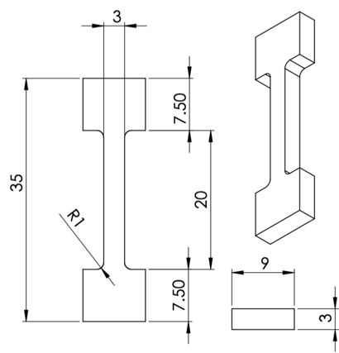
Figure 3.2: Dimensions of creep test specimen in millimeters.
Prior to conducting creep tests, one representative sample from each heat treatment procedure was mounted, polished and imaged using the SEM as detailed in section 3.3.1. These imaged samples provided a baseline for each heat treatment to compare to the specimen microstructures after they had undergone a creep test.
3.4.2 Creep Test Experimental Procedure
Test specimens were inserted into the high temperature specimen grips and the furnace door locked. Glass wool was placed over the top and bottom furnace openings to reduce air currents and increase temperature uniformity throughout the furnace. 4.015 kg were placed on the loading tray for a total load of 35 MPa, but not attached to the cam cable wire attachment loop. The cam was set so that the inscribed horizontal position mark was level and the furnace set to 760ºC. This temperature was chosen for all creep tests, because it matches the target application temperature for AFA stainless steels. Upon reaching the desired temperature, the weighted loading tray was hooked on the wire cable attachment loop and the system put into tension. When the loading tray stabilized within a few seconds, the data record button on the data logger would be pressed to begin data logging. Temperature was held constant in each test.
At 760ºC and under a 35 MPa load, it was established that the model alloy tested would enter the secondary creep regime approximately one hour after the specimen was put into tension by loading. It would remain at a steady state for at least a 1000 h duration (the longest duration tested). To capture a representative sample of the creep curve, the duration of each test was 500 h, with the exception of two shorter partial tests conducted to evaluate microstructural changes at stages on the creep curve.
Upon completion of a test, data recording would be terminated, the system unloaded and the furnace ramped down to room temperature. The test specimen would then be removed from the specimen grips and sectioned into three parts using a diamond saw as described in section 3.2.2. Figure 3.3 shows the locations of where the head, gauge and middle-long sections were located along the T-bone specimens. These three locations were chosen to explore any differences in precipitate directionality or observable microstructural differences between the three section.
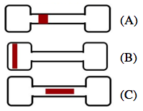
Figure 3.3: Diagram detailing the locations of sections taken for SEM microstructural analysis from crept T-bones. (A) Gauge (B) Head (C) Middle-long
Creep curves of strain percent over time were produced from the load and displacement data collected. Each crept sample was mounted, polished and imaged using scanning electron microscopy as detailed in section 3.3.1.
3.4.2 Creep Test Experiments Performed
Elevated temperature constant-stress creep tests were conducted for a duration of 500 h for each aging condition at 760ºC under a 35 MPa load. Each 500 h test was completed twice for each aging condition. Two partial constant-stress creep tests were conducted to evaluate the alloy’s microstructural changes as it crept over time. Similar test conditions as the full range 500 h creep tests were used for the partial tests. Two specimens were homogenized at 1250ºC but not aged. The first test was run for 3.5 h and the second test was stopped after a 300 h duration to get representative samples along the creep curve. Samples were mounted, polished and imaged on the SEM after the creep tests were complete and creep curves of strain percent over time were produced from the load and displacement data collected.
3.5 Tensile Tests
Flat T-bone test specimens approximately 1 mm thick, with a gauge length of 15 mm, and width of 2 mm were milled with the dimensions shown in Figure 3.4 from the Fe-20Cr-30Ni-2Nb-5Al model alloy as detailed in the materials preparation section 3.2.2. Each specimen was homogenized at 1250ºC for 24 h and then aged at 760ºC for 0, 2.4, 24 or 240 h. Specimens were polished on a turntable using successively finer silicon carbide abrasive paper up to 1200-grit, then with 0.3 µm alumina powder dissolved in water.
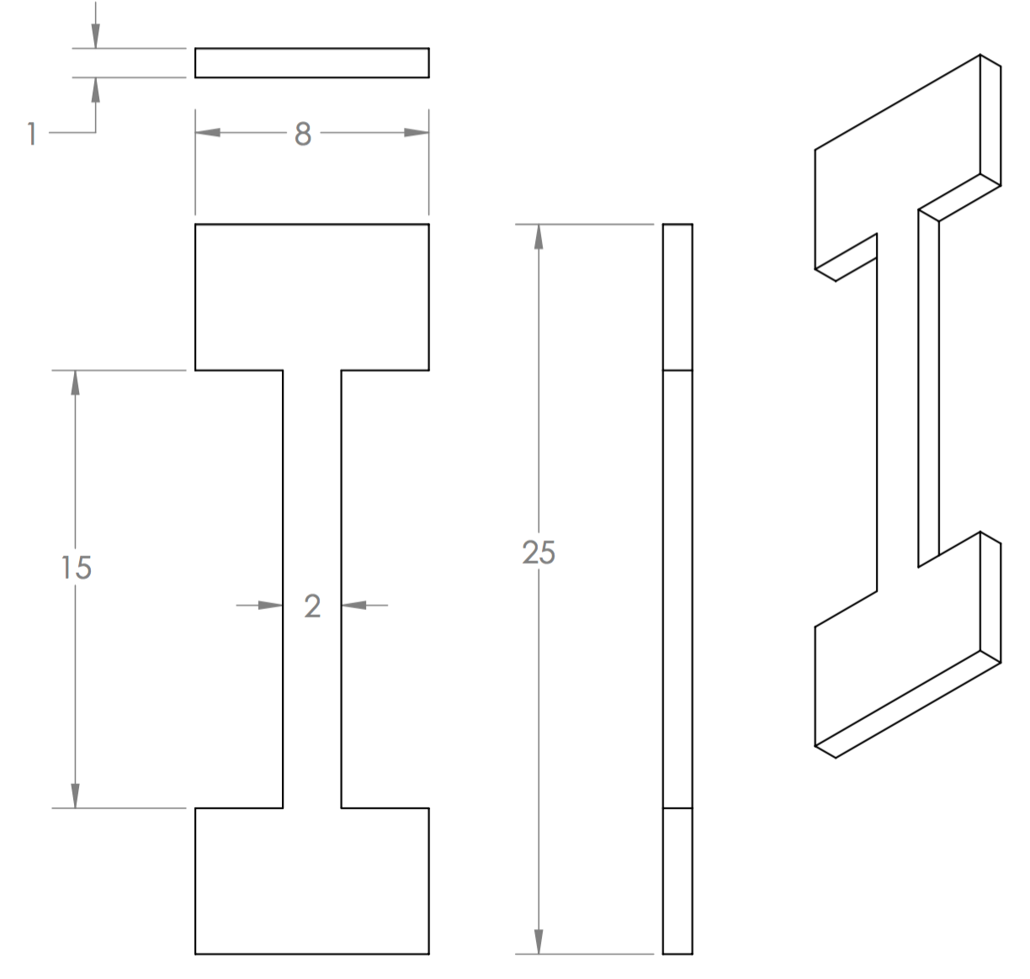
Figure 3.4: Dimensions of tensile test specimen in millimeters.
Samples were inserted into high-temperature specimen grips of the Instron 5690 tensile testing machine coupled with a MTS hydraulic testing machine. The metal frame of the Instron supports the Mellen Inc. SCR Split Series 120 V 1200 W Furnace mounted vertically. The furnace utilizes clamshell-heating elements capable of 1250ºC in air. The temperature was measured with a centrally located K-type thermocouple and controlled by a Mellen Inc. PS105 programmable power control cabinet.
Elevated temperature tensile tests were conducted at 760ºC with an applied preload force of 50 N. For all tests the initial strain rate was 5 x 10⁻⁴ s⁻¹, and up to five tensile tests were performed for each heat treatment protocol. To decrease the number of repeat tests that had to be performed, a soft mallet was used to secure the T-bones in the high temperature grips.
True strain (ɛ) and true stress (σ) were calculated from the load-displacement data and reported as true stress-strain curves. The yield strengths and ultimate tensile strengths were recorded. Percent elongation of the specimen was obtained by comparing the initial specimen gauge length and measuring the specimen gauge length after the tests were complete in an optical microscope. To examine the fracture surface, samples were prepared and imaged using scanning electron microscopy as detailed in section 3.3.1.

