CHAPTER 4 EFFECT OF HEAT TREATMENT CONDITIONS ON MECHANICAL PROPERTIES OF ALUMINA-FORMING AUSTENITIC STAINLESS STEELS

5.1 Strain Rate Jump Test Experimental
Strain rate jump tests were performed on the Instron 5690 tensile testing machine at 600 ºC and 700ºC on both as-received and TMT alloys. A preload force of 50 N was again applied on specimen before the strain rate jump tests were started. The initial strain rate for all strain rate jump tests was 5 × 10⁻⁵ s⁻¹.

5.2 Results and Discussion

Generally, the flow stress of alloys at elevated temperature is a function of the applied strain rate. The magnitude of the effect is expressed by the strain rate sensitivity m. Theoretically, it is possible to carry out a series tensile tests at various temperatures and strain rates. In practice, this is rarely done because of the limitations of time and the numbers of specimens required. Instead, strain rate jump tests can be performed using a single specimen. The strain rate is increased to a second level (approximately an order of magnitude) once a steady state flow stress is obtained.

Strain rate jump experiments were performed on as-received and TMT DAFA29 at 600ºC. The strain rate jump test results are shown in Figure 4.5a. The initial strain rate was 5 × 10⁻⁵ s⁻¹ with an order of magnitude increase for each jump. The flow stresses of both TMT alloys increased with the strain rate increases. But, the flow stress of as-received DAFA29 is relatively independent of strain rate at this temperature. It is insensitive to the strain rate change at 600ºC. It is worth noting the serrations that occurred on the as-received DAFA29 during testing at 600ºC. The serrated flow starts when the strain rate jumps from 5 × 10⁻⁵ s⁻¹ to 5 × 10⁻⁴ s⁻¹. It is thought to be related to dynamic strain aging in this material. We will further explain these serrations in the discussion section.
Strain rate jump tests were also performed at 700ºC which is the target application temperature for AFA stainless steels. The results of strain rate jump tests of as-received and TMT DAFA29 performed are shown in Figure 4.5b. The initial strain rate was 5 × 10⁻⁵ s⁻¹ with an order of magnitude increase for each jump. The flow stresses of all samples increased with the strain rate increasing. At the strain rate of 5 × 10⁻⁵ s⁻¹, the flow stress of as-received DAFA29 was 445 MPa which is almost twice that of TMT DAFA29 of 292 MPa. When the strain rate is jumped to 5 × 10⁻² s⁻¹, the flow stress of as-received DAFA29 was 829 MPa, which is less than that of TMT DAFA29 of 1080 MPa.
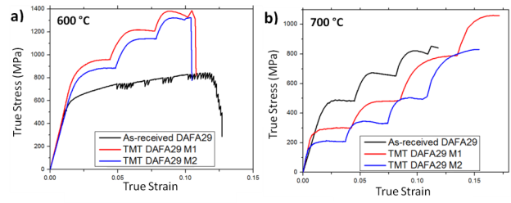
Figure 4.5 Strain rate jump tests of as-received and TMT DAFA29 (Method#1 and Method#2) at 600ºC (a) and 700ºC (b). Each strain rate jump is increased by an order of magnitude starting at an initial strain rate of 5 × 10⁻⁵ s⁻¹.

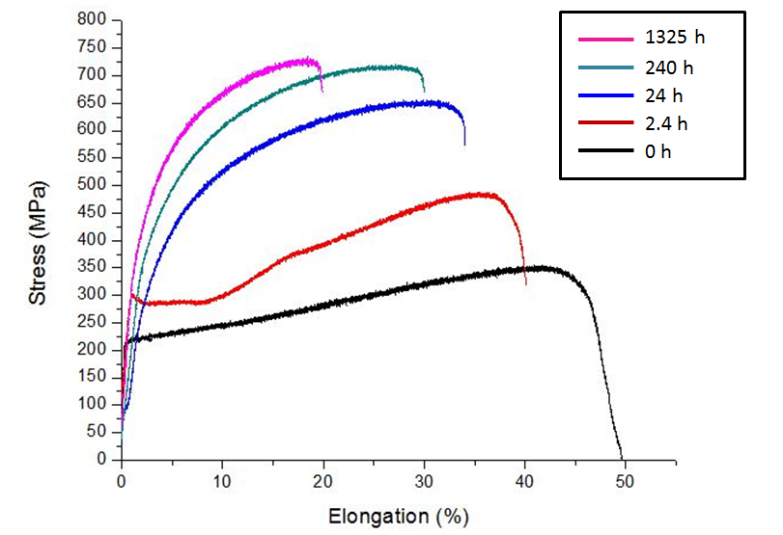
Figure 9. Representative tensile curves of Fe-20Cr-30Ni-2Nb-5Al (at. %) homogenized at 1523K for 24 h and subsequently aged at 1073K for the different times as indicated.

