CHAPTER 1 INTRODUCTION
1.1 Background
Increasing efficiency while decreasing the cost of operating advanced power plants has been an ongoing process. Energy efficiency gains in fossil energy conversion and combustion system applications also result in the added benefit of reducing CO₂ emissions, bolstering the motivation to pursue efficiency-increasing strategies { | Viswanathan, et al., 2004 | | |zu:2902168:SB3FI4HD}{ | Viswanathan, et al., 2006 | | |zu:2902168:5T7X6XNB}{ | Viswanathan, et al., 2008 | | |zu:2902168:VCJX2678}{ | Viswanathan, et al., 2005 | | |zu:2902168:M9KI53RT}. The efficiency of energy conversion applications is a strong function of steam temperature and pressure, thus increases in energy efficiency can be realized by elevating operating steam temperatures and pressures { | Viswanathan, & Bakker, 2001 | | |zu:2902168:7689KUZX}. An increase in operating temperatures from 600°C to 800°C results in an efficiency increase of more than 10%. Most current coal power plants in the U.S. operate at a maximum steam temperature of 538°C { | Holcomb, et al., 2004 | | |zu:2902168:EMP62P94}. Advanced ultrasupercritical steam boilers and turbines for power plants offer the promise of higher efficiencies and lower emissions, which are goals of the U.S. Department of Energy’s Advanced Power Systems Initiatives. Efforts are currently underway to enable advanced power plants to function at temperatures greater than 700°C { | Shingledecker, 2014 | | |zu:2902168:KDTUXTSZ}. Specifically, the U.S. Department of Energy has set a goal to develop materials technology needed for the construction of the critical components of coal-fired boilers and turbines that are capable of operating with steam at temperatures of 760°C and pressures of 35 MPa, which can reduce emissions, including CO₂, by 20% or greater compared to today’s U.S. power plant fleet { | Viswanathan, et al., no date | | |zu:2902168:VVZ3S4WD}{ | Shingledecker, & Wright, 2006 | | |zu:2902168:HG83A7D8}{ | Shingledecker, 2014 | | |zu:2902168:KDTUXTSZ}.
An important contributor to realizing these higher steam temperatures and pressures is the material composition of the power plants' industrial gas turbine components, super heater tubes and boilers { | Yamamoto, et al., 2007 | | |zu:2902168:85ZQGZD8}. Currently, many energy production and chemical processing plants operate at temperatures below 600°C due to the poor performance of martensitic and ferritic steel alloys at higher temperatures { | Viswanathan, & Bakker, 2000 | | |zu:2902168:PE3VWWHP}. To withstand the high temperature and pressure demands of energy applications, metal alloys must have the necessary material properties to withstand such conditions. These properties include the materials' high-temperature long term creep strength, oxidation and corrosion resistance and strength. Aggressive environments, where metal components are exposed to water vapor, sulfur and carbon species, are a prime target for new materials being developed { | Yamamoto, et al., 2007 | | |zu:2902168:4MNWSE4J}.
Nickel-based superalloys and austenitic alloys with high nickel concentrations perform well and have the necessary creep strength and oxidation and corrosion resistance to withstand such conditions, but are prohibitively expensive and not economically viable except for use in specialized applications due to the high levels of nickel and nickel’s cost { | Viswanathan, et al., 2008 | | |zu:2902168:VCJX2678}{ | Viswanathan, et al., 2005 | | |zu:2902168:M9KI53RT}. Thus, other alloys are now being researched and developed that can withstand the demands of such energy conversion and combustion systems as well as to decrease reliance on costly nickel-based alloys. However, in order for an alternative to be viable, it must have the strength, long-term creep resistance and oxidation resistance close to or exceeding that of nickel-based alloys. One promising class of alloys that are low in cost and potentially capable of withstanding the rigors placed on the materials by high temperature energy applications are alumina-forming austenitic stainless steels (AFAs) { | Yamamoto, et al., 2007 | | |zu:2902168:85ZQGZD8}{ | Brady, et al., 2007 | | |zu:2902168:CQH9PX4J}{ | Brady, et al., 2008 | | |zu:2902168:VU6Q4EDM}{ | Pint, et al., 2007 | | |zu:2902168:9NXG7NJ2}{ | Brady, et al., 2009 | | |zu:2902168:SZSS7FI6}{ | Yamamoto, et al., 2009 | | |zu:2902168:UK5QSMTK}{ | Brady, et al., 2014 | | |zu:2902168:PD5B4ZPG}{ | Yamamoto, et al., 2013 | | |zu:2902168:37HVMBC9}. However, more investigation is needed into the oxidation and corrosion resistance as well as the creep strength in order for this class of steels to be widely used as an alternative to nickel-based alloys.
1.2 Alumina-Forming Austenitic Stainless Steels
Extensive efforts are underway to improve the high-temperature strength, corrosion and oxidation resistance, and long-term creep resistance of AFAs, ideally at lower cost compared with currently used materials. Researchers at Oak Ridge National Laboratory have developed a new family of AFAs in the last few years that have yielded promising results for use with elevated temperatures above 700°C in aggressive environments { | Brady, et al., 2014 | | |zu:2902168:USZ8XMC2}{ | Yamamoto, et al., 2007 | | |zu:2902168:UQXIIP8N}{ | Brady, et al., 2008 | | |zu:2902168:PB5FB5Z3}{ | Yamamoto, et al., 2008 | | |zu:2902168:X76SQJXR}{ | Yamamoto, et al., 2011 | | |zu:2902168:UJ9EJWHK}. These new AFAs being developed have a composition range of Fe-(12-35)Ni-(12-15)Cr-(2.5-4)Al-(0.6–3)Nb (wt %), and include alloying additions such as Al, Cr, Mn and Ni to maintain a single phase austenitic matrix microstructure { | Brady, et al., 2014 | | |zu:2902168:USZ8XMC2}.
The alumina (Al₂O₃) layer that forms in AFAs at temperatures between 600-900°C, acts as a protective barrier and increases the oxidation and corrosion resistance of the material. Austenitic steels without sufficient additions of aluminum use chromia (Cr₂O₃) scales as a protective layer, but in environments with high concentrations of water vapor and other oxidizing agents, the chromia scales perform poorly. Relatively small amounts of aluminum additions to austenitic steels have the ability to form the protective alumina surface layer. It’s been shown that these alumina scale formations remain stable at operating temperatures from 650-800°C, with the necessary oxidation resistance in environments with water vapor present, making AFAs the preferred choice for use in low-cost, high-temperature structural materials { | Kofstad, & Bredesen, 1992 | | |zu:2902168:JCTUIGD6}{ | Pint, et al., 2006 | | |zu:2902168:U89A5P53}{ | Pint, et al., 2004 | | |zu:2902168:9KQPSD4R}{ | Yamamoto, et al., 2007 | | |zu:2902168:85ZQGZD8}{ | Brady, et al., 2010 | | |zu:2902168:H6UIDG3Q}{ | Yamamoto, et al., 2006 | | |zu:2902168:9BTPENSB}{ | Brady, et al., 2007 | | |zu:2902168:CQH9PX4J}. Ferritic FeCrAl alloys have excellent oxidation and corrosion resistance at elevated temperatures, however at temperatures greater than 600°C their creep resistance does not meet expectations set by nickel-based alloys, a property that is attributed to their open body-centered-cubic (b.c.c) structure { | Brady, et al., 2014 | | |zu:2902168:USZ8XMC2}.
Precipitates play a large role in determining the mechanical properties of an alloy. Both the type of precipitate and their distribution have an effect on an alloy’s strength and creep resistance. Precipitate nucleation occurs due to the strain energy being lowered { | Cahn, 1957 | | |zu:2902168:R27TI7KH}. Precipitates nucleate preferentially on grain boundaries due to a larger strain energy reduction compared with precipitation occurring on dislocations, which has a higher activation energy { | Porter, et al., 2009 | | |zu:2902168:2MM6WBDJ}. The type, size, distribution and volume fraction all have an effect on the alloy’s properties. The effect of various precipitates and their phases on creep strength in AFAs with a variety of alloying elements is still being explored to identify the optimum combination of alloys and precipitates for their use at elevated temperatures in the 600°C to 800°C range. Small changes in alloy composition and precipitate phases often result in a wide variation of creep strengths { | Viswanathan, & Bakker, 2001 | | |zu:2902168:7689KUZX}{ | Yamamoto, et al., 2013 | | |zu:2902168:37HVMBC9}{ | Chen, et al., 2014 | | |zu:2902168:GDI3FBC2}.
1.3 AFA precipitates
In the past, AFAs have primarily used MC carbides (with the metal primarily being niobium) or γ’-Ni₃Al for their strength { | Brady, et al., 2008 | | |zu:2902168:4UVJT7ZI}{ | Yamamoto, et al., 2007 | | |zu:2902168:UQXIIP8N}. Particles that are ~10 nm in size are effective at increasing creep strength by pinning dislocations in the f.c.c. austenitic matrix. However at elevated temperatures above 800°C, the carbide precipitates coarsen and dissolve { | Pint, et al., 2009 | | |zu:2902168:CVM8HWFW}, making them unsuitable for strengthening purposes in elevated temperature applications. Newer grades of AFAs being developed have an austenitic face-centered-cubic matrix instead of a b.c.c matrix, and their elevated temperature creep resistance and strength is achieved through not only the existing MC carbides and γ’-Ni₃Al (L1₂) precipitates, but also Fe₂Nb Laves phase and NiAl-type B2 precipitates { | Sourmail, 2001 | | |zu:2902168:UJ3U2B4C}{ | Abe, et al., 2007 | | |zu:2902168:M5BVQK2E}{ | Brady, et al., 2014 | | |zu:2902168:USZ8XMC2}{ | Stott, et al., 1995 | | |zu:2902168:HEWBBS3B}{ | Yamamoto, et al., 2007 | | |zu:2902168:85ZQGZD8}.
In various Ni-based and Fe-based superalloys, the L1₂-ordered γ’-Ni₃Al precipitates are used for their strengthening effects of improving high-temperature mechanical properties { | Yamamoto, et al., 2013 | | |zu:2902168:37HVMBC9}{ | Reed, 2008 | | |zu:2902168:MZ64JXCN}. The f.c.c. structure of Ni₃Al can be seen in Figure 1.1. In a 2008 study, superior creep resistance in the the AFA alloy Fe-20Cr-30Ni-2Nb-5Al (at%) compared to the base alloy was attributed to the formation of a dense dispersion of 30 nm in diameter spherical Ni₃Al precipitates observed in creep-rupture samples tested at 750°C under a 100 MPa load { | Yamamoto, et al., 2008 | | |zu:2902168:P4GIA9HS}. Although present at 750°C, Ni₃Al precipitates were not found in Fe-20Cr-30Ni-2Nb-5Al (at%) at 800°C, negating the precipitates’ strengthening effects at high temperatures exceeding 800°C { | Trotter, et al., 2014 | | |zu:2902168:5KGJFBG9}. The presence of Ni₃Al precipitates in the temperature range between 750°C-800°C in the AFA Fe-20Cr-30Ni-2Nb-5Al (at%) alloy has not been evaluated.
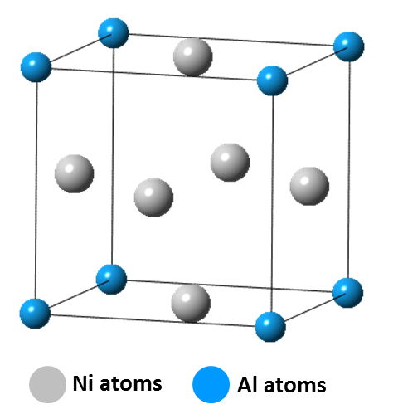
Figure 1.1: Diagram of the L1₂-ordered γ’-Ni₃Al precipitate crystal structure.
Intermetallic precipitates have the potential to be used as strengtheners in AFA alloys to further improve their creep resistance. The formation of Fe₂Nb Laves phase precipitates along grain boundaries in ferritic steels results in a decrease in the alloys’ toughness and yield strength { | Kato, et al., 2010 | | |zu:2902168:V73NJ84H}. In contrast, creep strengthening has been achieved in AFAs { | Liu, et al., 2000 | | |zu:2902168:7QWGA24G}{ | Yamamoto, et al., 2007 | | |zu:2902168:UQXIIP8N}. For example the AFA alloy Fe-20Cr-30Ni-2Nb-5Al (at%) demonstrates good ductility and strength, even with extensive intermetallic formation of Fe₂Nb Laves phase precipitates along the grain boundaries { | Trotter, & Baker, 2015 | | |zu:2902168:25396B3B}. It has been shown that in Fe-20Cr-(25–35)Ni-2Nb (at.%) alloys, fine dispersions of strengthening Fe₂Nb Laves phase can form within the austenitic iron matrix { | Cao, & Kennedy, 2001 | | |zu:2902168:CW3SMDBS}. The use of Fe₂Nb Laves phase particles has shown thermal stability up to its melting point of 1640°C in the Fe-Nb system over a prolonged duration { | Massalski, et al., 1904 | | |zu:2902168:25HIHA5G} and exists in equilibrium with f.c.c. γ-Fe above 955°C in the Fe-Cr-Ni base steel { | Villars, et al., 1995 | | |zu:2902168:Z63677GQ}, making it a good candidate for strengthening AFAs at elevated temperatures.
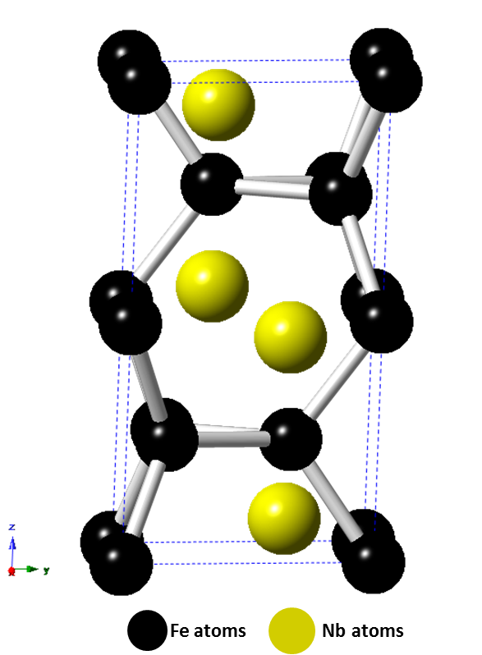
Figure 1.2: Diagram of the hexagonal C14 Fe₂Nb Laves phase structure.
Prior work with the intermetallic Laves phase Fe₂Nb has shown that the strengthening effect of the precipitate is dependent on whether it precipitates on grain boundaries or in the austenitic matrix, and in what volume fractions and particle size it appears in the alloy { | Yamamoto, et al., 2008 | | |zu:2902168:P4GIA9HS}. See Figure 1.2 for a diagram depicting the hexagonal C14 Fe₂Nb Laves phase structure. As the Laves phase particles increase in density and size, the brittle properties of the precipitate cause the material to lose its strength and creep resistance. Thus, a fine particle dispersion diameter of <100 nm is recommended to match the creep strength exhibited by AFAs strengthened with MC carbides and prevent failure of the material { | Yamamoto, et al., 2008 | | |zu:2902168:P4GIA9HS}. This decrease in the precipitate size and increase of the precipitate volume fraction in the austenitic matrix, allows for dislocations to be pinned leading to an increase in the alloy’s creep strength. It has recently been shown by Tarigan et al. that in Fe-20Cr-30Ni-2Nb (at.%), the alloy’s long-term creep resistance increased with an increasing area fraction of Laves phase precipitated on the grain boundary. It was also noted that dislocations that piled up near Laves phase grain boundaries were effective at suppressing local deformation by inhibiting the motion of dislocations and thereby increasing the long-term creep strength of the alloy { | Tarigan, et al., 2011 | | |zu:2902168:G78CMASC}{ | Tarigan, et al., 2012 | | |zu:2902168:RB6XSGVQ}. This creep-strengthening mechanism was coined “grain boundary precipitation strengthening mechanism” by Tarigan et al.
Yamamoto et al found that in addition to Fe₂Nb Laves phase forming, after heat treating at 750°C, dense and fine B2-type NiAl precipitates formed in the γ-Fe matrix and on the grain boundaries { | Yamamoto, et al., 2011 | | |zu:2902168:UJ9EJWHK}. The B2-type NiAl phase particles were dark in contrast and between 300 nm to 1 μm in size. The Fe₂Nb Laves phase particles appeared spherical with a bright contrast in the matrix and less than 500 nm in size. See Figure 1.3 for an example of precipitate contrast in Fe-20Cr-30Ni-2Nb-5Al (at. %). At elevated temperatures, B2-type NiAl precipitates play an important role in providing corrosion and oxidation resistance by acting as an aluminum reservoir for formation of the alumina protective layer { | Brady, et al., 2008 | | |zu:2902168:HBC2NU6I}. They are not effective in improving the high-temperature tensile strength at temperatures greater than 400°C { | Satyanarayana, et al., 2001 | | |zu:2902168:I7ZM2B32}{ | Satyanarayana, et al., 2002 | | |zu:2902168:CX4DKZC5}, however it’s been posited that B2-type NiAl precipitates improve creep resistance by affecting the climb of dislocations in the matrix or the precipitate’s resistance to dislocation slicing { | Yamamoto, et al., 2011 | | |zu:2902168:UJ9EJWHK}.
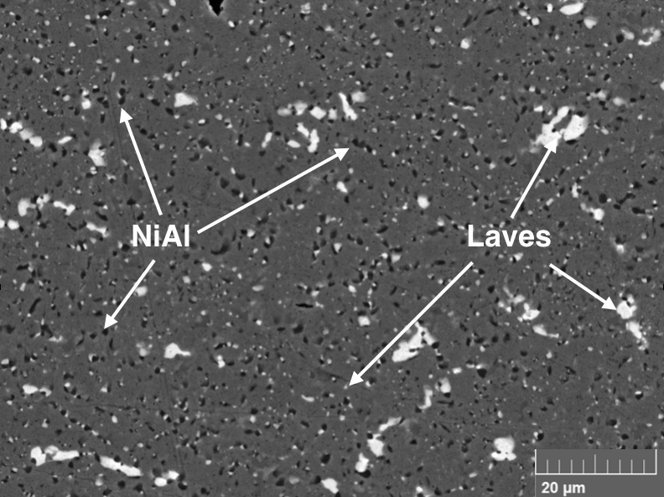
Figure 1.3: Backscattered electron images showing Fe₂Nb Laves phase (light contrast) and B2-type NiAl phase (dark contrast) precipitates in the matrix of Fe-20Cr-30Ni-2Nb-5Al (at. %) homogenized at 1250°C and heat-treated at 800°C for 240 h.
In order to better predict which precipitates are most beneficial for increasing AFA high temperature creep strength, further tests and characterization needs to be performed to form a better understanding of the complex interactions between the presence of various precipitates and phases and their effect on the alloys’ creep properties.
1.4 Outline of Research Project
The purpose of this thesis is to investigate the high-temperature strengthening mechanisms in alumina-forming austenitic stainless steels, specifically the high temperature constant-stress creep and mechanical properties of the model alloy Fe-20Cr-30Ni-2Nb-5Al (at. %) at different aging conditions.
The investigation proceeded as follows:
1) A constant-stress creep apparatus was designed, built and its operation validated
2) Samples were prepared form the model alloy and aged for time intervals of 0, 2.4, 24 or 240 h at 800°C
3) Constant-stress creep tests were conducted at elevated temperatures of 760°C
4) Secondary electron imaging was used to examine the microstructure of the samples prior to and after the completion of creep testing
5) Elevated temperature tensile tests were conducted on aged samples at 760°C
Chapter 2 focuses on the design, construction and testing of the constant-stress creep rig used in this investigation.
Chapter 3 covers materials preparation, testing procedures and materials characterization techniques.
Chapter 4 details the effect of aging time on the microstructural evolution and high temperature constant-stress creep and tensile behavior of the model alloy. The observed microstructural changes and precipitate evolution prior to and after creep tests were conducted, are analyzed and discussed. Additionally, the observed differences of the mechanical properties of the alloy at different aging conditions is explored.
In Chapter 5 and 6, the conclusions of this research project are summarized and suggestions are made for future work.

