

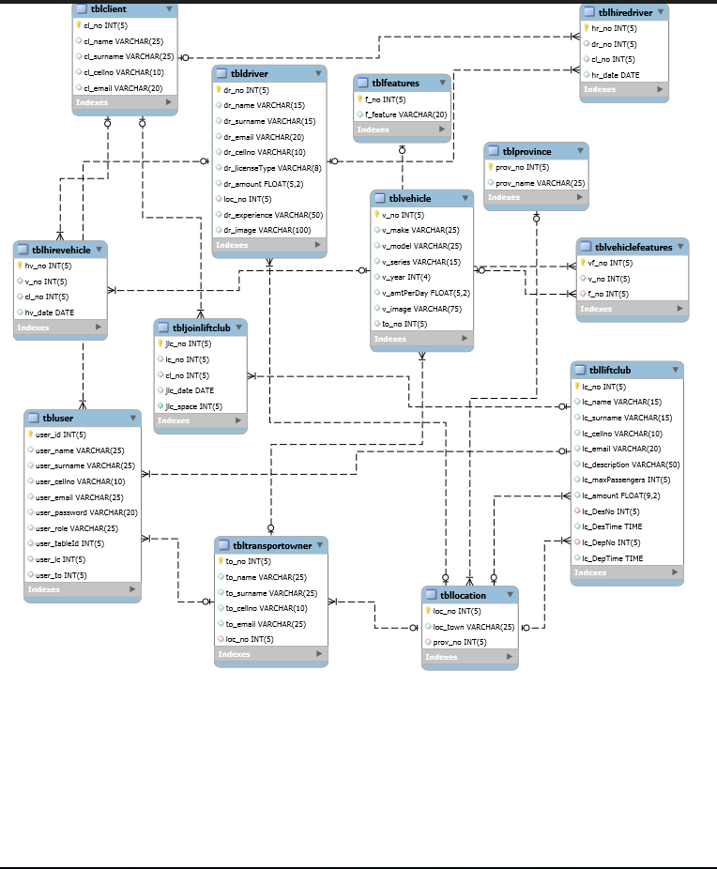

|  |  |
| --- | --- |
| Use Case name: | Add driver |
| Scenario: | Driver creates an account(profile) |
| Triggering Event: | Driver enters data |
| Brief Use Case Description | Driver enters personal information as well as experience and type of license obtained, additionally adding a daily rate for driving. |
| Actor(s): | Driver |
| Related Use Cases: | N/A |
| Stakeholders: |  |
| Pre-condition: | The driver is logged into the system |
| Post-condition: | The driver profile has been created |
| Flow of activities: | |  |  | | --- | --- | | Actor | System | | 1.Driver clicks on add button  2. Driver enter details  3. Driver clicks on submit button | 1.1Displays add form  3.1 Confirm data has been captured  3.2 Displays message | |  |  | |  |  | |  |  | |  |  | |  |  | |
| Exception Condition | Invalid details |

|  |  |
| --- | --- |
| Use Case name: | Update driver profile |
| Scenario: | Driver request to change his details |
| Triggering Event: | Driver update personal details |
| Brief Use Case Description | Enables the driver to edit their details, by confirming that they have an existing profile first. |
| Actor(s): | Driver |
| Related Use Cases: | N/A |
| Stakeholders: |  |
| Pre-condition: | The driver’s profile must exist |
| Post-condition: | The driver profile is updated |
| Flow of activities: | |  |  | | --- | --- | | Actor | System | | 1. Driver clicks on login button 2. Driver enters login details 3. Driver selects edit button 4. Driver clicks on update link 5. Driver updates information 6. Driver clicks on save | 1.1Display login page  2.1 Confirm credentials Validation  3.1 Displays update link with details  4.1 Displays update driver form  6.1 Displays confirmation message | |  |  | |  |  | |  |  | |
| Exception Condition | 1.Invalid login credentials  2.Invalid updated details |

|  |  |
| --- | --- |
| Use Case name: | View driver |
| Scenario: | Driver receives notification from clients |
| Triggering Event: | Driver receives notification from clients |
| Brief Use Case Description | The driver receives request from interested client |
| Actor(s): | Driver |
| Related Use Cases: | Driver Report |
| Stakeholders: |  |
| Pre-condition: | Driver receive an email(must have an email account) |
| Post-condition: | The driver is notified |
| Flow of activities: | |  |  | | --- | --- | | Actor | System | | 1. Driver clicks on login button 2. Driver enters login credentials 3. Clicks on View my clients 4. View appointments | 1.1Displays login page  2.1Confirm credentials validation  3.2 Shows client appointments | |  |  | |  |  | |  |  | |  |  | |  |  | |
| Exception Condition | 1.Invalid login credentials |

|  |  |
| --- | --- |
| Use Case name: | Delete driver profile |
| Scenario: | Driver delete his/her profile |
| Triggering Event: | Driver delete personal details |
| Brief Use Case Description | Driver wishes to no longer be a driver ,thus removing the driver from the system. |
| Actor(s): | Driver |
| Related Use Cases: | N/A |
| Stakeholders: |  |
| Pre-condition: | The driver must have an account and must be logged in(must exist) |
| Post-condition: | The driver profile is deleted |
| Flow of activities: | |  |  | | --- | --- | | Actor | System | | 1. Driver clicks on login button  2.Driver enters login credentials  3.Driver select “ delete” button    3.Confirm delete personal details | * 1. Displays login page   2.1 Confirm credentials validation  3.1 Displays driver details to delete  3.1Show profile deleted | |  |  | |  |  | |  |  | |  |  | |  |  | |
| Exception Condition | 1.Invalid login credentials |
|  |  |

|  |  |
| --- | --- |
| Use Case name: | Add lift club |
| Scenario: | Lift club admin create an account(profile) |
| Triggering Event: | Lift club admin capture personal information |
| Brief Use Case Description | Persons with a vehicle travelling to a specific location can set up a profile by filling in personal details as well as amount per person and time departure. |
| Actor(s): | Lift club admin |
| Related Use Cases: | N/A |
| Stakeholders: |  |
| Pre-condition: | The lift club admin is logged into the system |
| Post-condition: | The lift club admin profile has been created |
| Flow of activities: | |  |  | | --- | --- | | Actor | System | | 1. Lift club admin  1. lift club admin enter personal details | 1.1Capture data  1.2 Confirm data has been captured | |  |  | |  |  | |  |  | |  |  | |  |  | |
| Exception Condition | 1.Invalid details |

|  |  |
| --- | --- |
| Use Case name: | Update lift club |
| Scenario: | Update lift club admin details |
| Triggering Event: | Update lift club admin update personal details |
| Brief Use Case Description | Lift club admin is able to update personal details |
| Actor(s): | Lift club |
| Related Use Cases: | N/A |
| Stakeholders: |  |
| Pre-condition: | The Lift club admin must have an account and must be logged in(must exist |
| Post-condition: | Lift club admin profile updated |
| Flow of activities: | |  |  | | --- | --- | | Actor | System | | 1. Lift club admin login  2. Lift club admin select “ update profile” button  3. Lift club update personal details | 1.1Display login page  2.1Confirm credentials Validation  2.2Displays updated details  3.1Confirm update | |  |  | |  |  | |  |  | |
| Exception Condition | 1. Invalid login credentials |

|  |  |
| --- | --- |
| Use Case name: | Receive notification |
| Scenario: | Receive driver notification |
| Triggering Event: | Lift club admin receives notification |
| Brief Use Case Description | The driver receives request from interested client |
| Actor(s): | Lift club admin |
| Related Use Cases: | Lift club Report |
| Stakeholders: |  |
| Pre-condition: | Lift club admin receive an email(must have an email account) |
| Post-condition: | Lift club admin notified |
| Flow of activities: | |  |  | | --- | --- | | Actor | System | | 1. Lift club admin login  2.View appointments | 1.1Displays login page  2.1Confirm credentials validation  2.2 Show client appointments | |  |  | |  |  | |  |  | |
| Exception Condition | 1.Invalid details |

|  |  |
| --- | --- |
| Use Case name: | Delete lift club |
| Scenario: | Lift club admin remove the lift club |
| Triggering Event: | Lift club admin remove the lift club |
| Brief Use Case Description | After the maximum capacity of passengers have been met,lift club should be removed from available lift clubs. |
| Actor(s): | Lift club admin |
| Related Use Cases: | N/A |
| Stakeholders: |  |
| Pre-condition: | Lift club must exist |
| Post-condition: | Lift club deleted |
| Flow of activities: | |  |  | | --- | --- | | Actor | System | | 1.Lift club admin login  2. Lift club admin select “ delete profile” button  3. Lift club admin delete personal details | * 1. Display login page   2.1Validate  2.2 Confirm delete  3.1Redirect to home page | |  |  | |  |  | |  |  | |  |  | |  |  | |
| Exception Condition | 1.Invalid details |

|  |  |
| --- | --- |
| Use Case name: | View driver |
| Scenario: | Client create an account(profile) |
| Triggering Event: | Client capture personal information |
| Brief Use Case Description | Potential persons wishing to take advantage of any services rendered by the web application, will have to provide their personal information which will be captured by the client. |
| Actor(s): | Client |
| Related Use Cases: | N/A |
| Stakeholders: |  |
| Pre-condition: | The client is logged into the system |
| Post-condition: | The client profile has been created |
| Flow of activities: | |  |  | | --- | --- | | Actor | System | | 1.Client enter personal details | 1.1Capture data  1.2 Confirm data has been captured | |  |  | |  |  | |  |  | |
| Exception Condition | 1.Invalid details |

|  |  |
| --- | --- |
| Use Case name: | View lift club |
| Scenario: |  |
| Triggering Event: | Client update personal details |
| Brief Use Case Description | Existing client wishing to make any changes to their personal details |
| Actor(s): | Client |
| Related Use Cases: | N/A |
| Stakeholders: |  |
| Pre-condition: | The client’s profile must exist |
| Post-condition: | The client profile is updated |
| Flow of activities: | |  |  | | --- | --- | | Actor | System | | 1.Client login  2.Client select “ update profile” button  3.Edit appointment | 1.1Display login page  2.1Confirm credentials Validation  2.2Displays updated details  3.1Confirm updated appointment | |  |  | |  |  | |  |  | |  |  | |  |  | |
| Exception Condition | 1.Invalid login credentials  2.Invalid updated details |

|  |  |
| --- | --- |
| Use Case name: | View vehicle |
| Scenario: | Client delete personal details |
| Triggering Event: | Client delete personal details |
| Brief Use Case Description | Client who no longer wants to use the web application services , would be able to terminate their accounts |
| Actor(s): | Client |
| Related Use Cases: | N/A |
| Stakeholders: |  |
| Pre-condition: | The client must have an account and must be logged in(must exist) |
| Post-condition: | The client profile is deleted |
| Flow of activities: | |  |  | | --- | --- | | Actor | System | | 1.Client login  2. Client select “ delete profile” button  3. Client delete personal details | * 1. Display login page   2.1Validate  2.2 Confirm delete  3.1Redirect to home page | |  |  | |  |  | |  |  | |  |  | |  |  | |
| Exception Condition | 1.Invalid login credentials |

|  |  |
| --- | --- |
| Use Case name: | Join lift club |
| Scenario: | View registered or available drivers |
| Triggering Event: | Client view driver information |
| Brief Use Case Description | Clients interested in hiring a driver can view a list of registered drivers,filtering to suit clients’s needs. |
| Actor(s): | Client |
| Related Use Cases: | N/A |
| Stakeholders: | Capture client data |
| Pre-condition: | The client must have an account and must be logged in(must exist) |
| Post-condition: | The client is able to view the available drivers |
| Flow of activities: | |  |  | | --- | --- | | Actor | System | | 1.View available drivers  2. Client hire driver | 1.1Display available drivers  2.1Validate credentials  2.2Notify driver | |  |  | |  |  | |  |  | |
| Exception Condition | 1. Invalid login credentials |
| Use Case name: | View vehicle |
| Scenario: | View vehicles information |
| Triggering Event: | Client view available vehicles |
| Brief Use Case Description | Interested clients who wishes to hire a vehicle are able to view from a list of vehicles , to suit their needs. |
| Actor(s): | Client |
| Related Use Cases: | Capture client data |
| Stakeholders: |  |
| Pre-condition: | The client must have an account and must be logged in(must exist) |
| Post-condition: | The client is able to view the available vehicles |
| Flow of activities: | |  |  | | --- | --- | | Actor | System | | 1.View available vehicles  2. Client hire vehicle | 1.1Display available vehicles  2.1Validate credentials  2.2Notify transport owner | |  |  | |  |  | |  |  | |
| Exception Condition | 1. Invalid login credential |

|  |  |
| --- | --- |
| Use Case name: | Send Notification |
| Scenario: | Client views the lift club |
| Triggering Event: | Client views the lift club |
| Brief Use Case Description | Client going to a particular location can view other people also going to that location |
| Actor(s): | Client |
| Related Use Cases: | N/A |
| Stakeholders: |  |
| Pre-condition: | Client profile must exist |
| Post-condition: | The client is able to view the available lift clubs |
| Flow of activities: | |  |  | | --- | --- | | Actor | System | | 1.client login  2.View lift club | 1.1 Display login page  1.2 Confirm credentials validation  2.1 Show available lift clubs | |  |  | |  |  | |  |  | |  |  | |  |  | |
| Exception Condition |  |







**CRUD MATRIX**

|  |  |  |  |  |  |  |
| --- | --- | --- | --- | --- | --- | --- |
|  |  | **ENTITIES** |  |  |  |  |
|  | **USE CASE** | **Driver** | **Lift Club** | **Transport** | **Client** |  |
|  | Add driver | **C** |  |  |  |  |
|  | Update profile | **U** |  |  |  |  |
|  | View notification | **R** |  |  |  |  |
|  | Delete Driver | **D** |  |  |  |  |
|  | Add vehicle |  | C |  |  |  |
|  | Update vehicle |  | U |  |  |  |
|  | Receive notification |  | R |  |  |  |
|  | Delete vehicle |  | D |  |  |  |
|  | Add liftclub |  |  | C |  |  |
|  | Update liftclub |  |  | U |  |  |
|  | view notification |  |  | R |  |  |
|  | Delete lift club |  |  | D |  |  |
|  | View driver |  |  |  | **R** |  |
|  | View vehicle |  |  |  | **R** |  |
|  | Join liftclub |  |  |  | **C** |  |
|  | Send notification |  |  |  | **R** |  |
|  |  |  |  |  |  |  |
|  | **C = Create , R = Read , U = Update , D = Delete** |  |  |  |  |  |

**PROJECT NAME : Transportation Management System**

**Test Case Template**

|  |  |
| --- | --- |
| **Test Case ID:** TC_AT_4 | **Test Designed by:** <Ndivhuho> |
| **Test Priority (Low/Medium/High):** Med | **Test Designed date:** <16/08/2018> |
| **Module Name:**ListVehicle | **Test Executed by:** <Dr Strydom> |
| **Test Title: Enter Vehicle and Owner information as well as select features** | **Test Execution date:** <17/08/2018> |
| **Description**: Advertise Vehicles |  |

|  |
| --- |
| **Pre-conditions:** User Enter Appropriate data  **Dependencies:** |
|  |

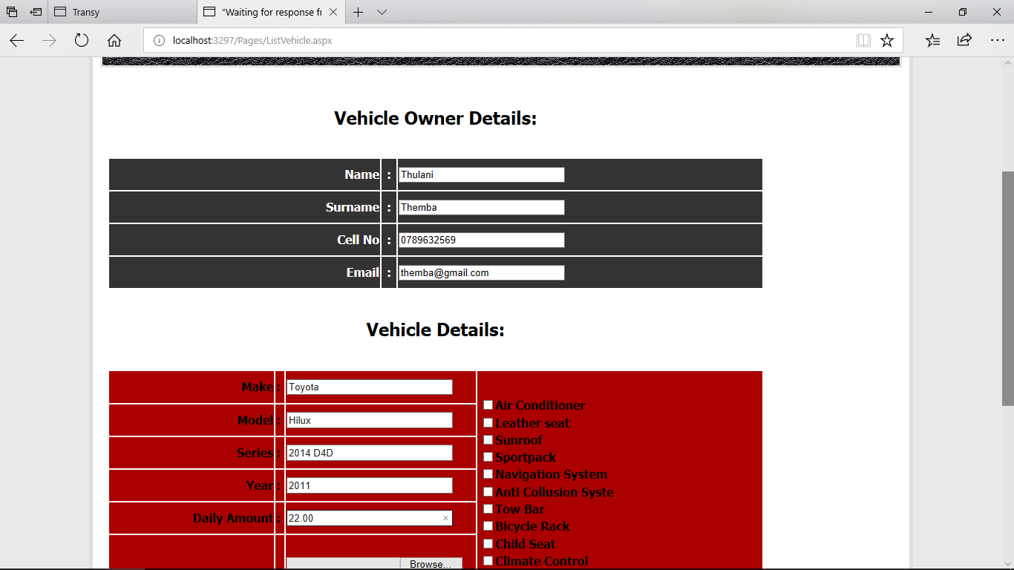

|  |  |  |  |  |  |
| --- | --- | --- | --- | --- | --- |
| **Step** | **Test Steps** | **Test Data** | **Expected Result** | **Actual Result** | **Status** |
| **1** | **Client Navigates to Add Vehicle** | **Add Vehicle** | **Click on Add Transport** | **Navigate to page** |  |
| **2** | **Client Enters data** | **Name:**  **Surname: etc** | **Click on Add** | **Click Save Data** |  |
| **3** | **Response** | **Data Captured** | **Response Display** | **Return Message** |  |

|  |
| --- |
| **Post-conditions:**  Data Saved to database and user notified of successful entering of data |

**PROJECT NAME : Transportation Management System**

**Test Case Template**

|  |  |
| --- | --- |
| **Test Case ID:** TC_HD_1 | **Test Designed by:** <Judith> |
| **Test Priority (Low/Medium/High):** Med | **Test Designed date:** <16/08/2018> |
| **Module Name**: Hire Driver | **Test Executed by:** <Dr Strydom> |
| **Test Title:** Request to hire Driver | **Test Execution date:** <17/08/2018> |
| **Description**: Client Views Drivers and Enters information to contact driver |  |

|  |
| --- |
| **Pre-conditions:** Selecting of a driver |

|  |  |  |  |  |  |
| --- | --- | --- | --- | --- | --- |
| **Step** | **Test Steps** | **Test Data** | **Expected Result** | **Actual Result** | **Status** |
| **1** | **Request to View Drivers** | **View Drivers** | **Click Hire Driver** | **List Of Drivers** |  |
| **2** | **Click On Contact Driver** | **Bill Gate**  **Code 10** | **Drivers Details** | **Bill Gates**  **Code 10** |  |
| **3** | **Client Navigates to Contact Driver** |  | **Driver Clicked on** | **Navigate to page** |  |
| **4** | **Client Enters data** | **Name:**  **Surname: etc** | **Click on Add** | **Click Save Data** |  |
| **5** | **Response** | **Data Captured** | **Response Display** | **Return Message** |  |

**Select Driver:**

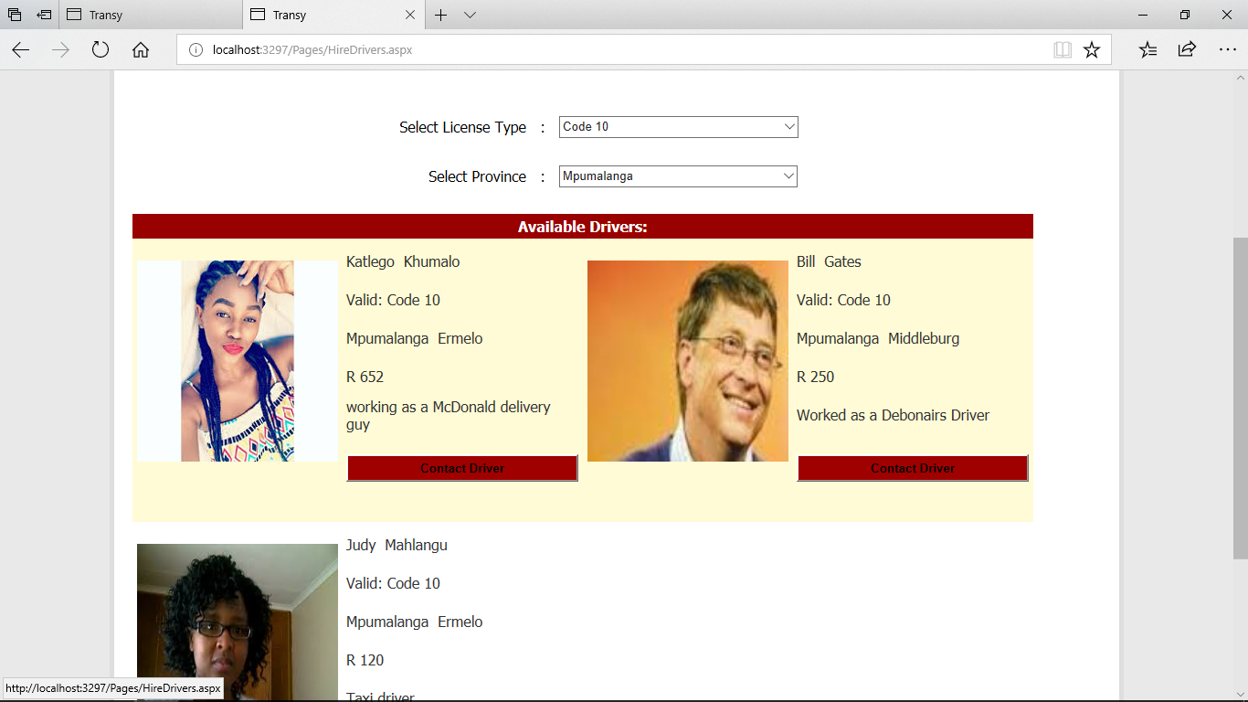

**Contact Driver:**

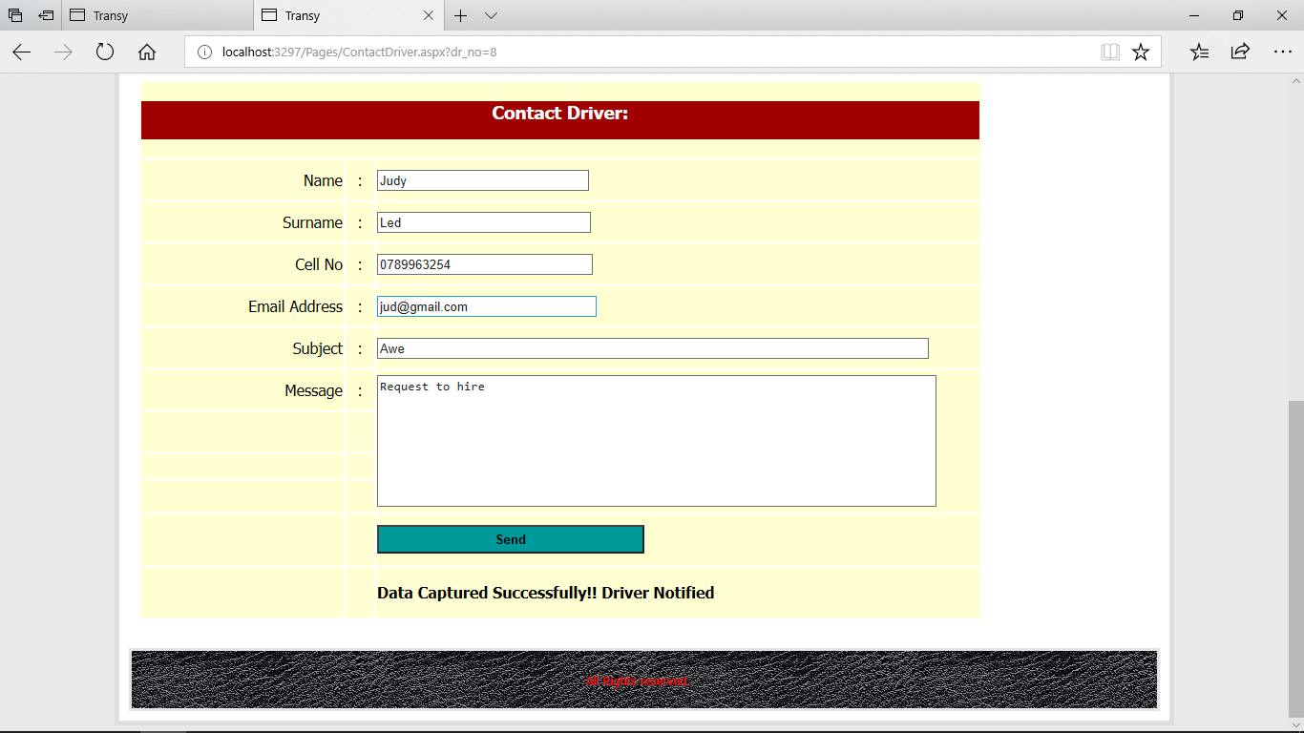

|  |  |
| --- | --- |
|  |  |
|  |  |
|  |  |

|  |
| --- |
| **Post-conditions:**  Confirm Data Captured and Email Client |

**PROJECT NAME : Transportation Management System**

**Test Case Template**

|  |  |
| --- | --- |
| **Test Case ID:** TC_HV_2 | **Test Designed by:** <Katlego> |
| **Test Priority (Low/Medium/High):** Med | **Test Designed date:** <16/08/2018> |
| **Module Name:** Hire Vehicle | **Test Executed by:** <Dr Strydom> |
| **Test Title:** Request to hire vehicle | **Test Execution date:** <17/08/2018> |
| **Description**: List of available Vehicles for Renting |  |

|  |
| --- |
| **Pre-conditions:** Client must select vehicle |

|  |  |  |  |  |  |
| --- | --- | --- | --- | --- | --- |
| **Step** | **Test Steps** | **Test Data** | **Expected Result** | **Actual Result** | **Status** |
| **1** | **Request to View Vehicles** | **View Vehicles** | **Click View Vehicle** | **List Of Vehicles** |  |
| **2** | **Click On Contact Owner** | **Vehicle Details** | **Vehicle Details** | **BMW**  **E90** |  |
| **3** | **Client Navigates to Contact Owner** | **Owner Details** | **Contact Owner Clicked on** | **Navigate to page** |  |
| **4** | **Client Enters data** | **Name:**  **Surname: etc** | **Click on Add** | **Click Save Data** |  |
| **5** | **Response** | **Data Captured** | **Response Display** | **Return Message** |  |
|  |  |  |  |  |  |

**SELECT VEHICLE:**

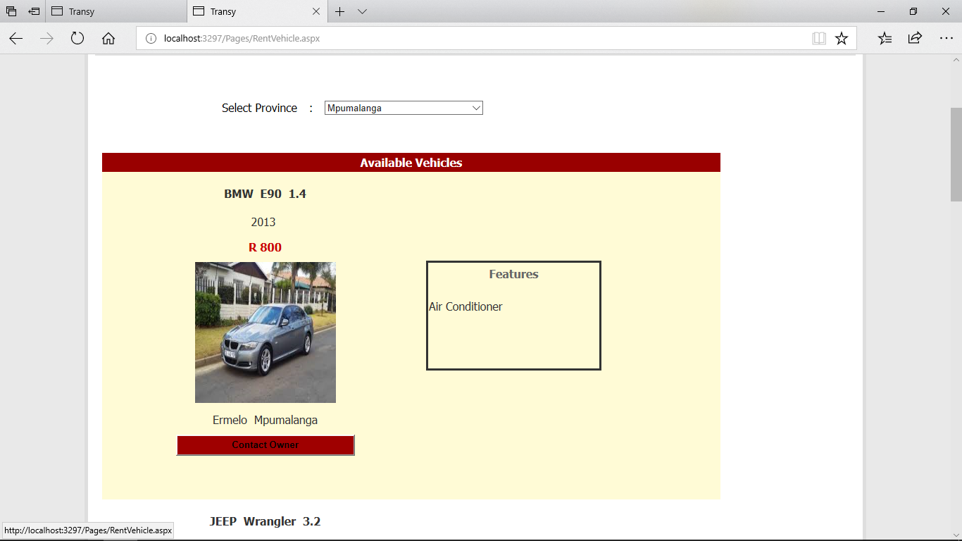

**Notify Owner:**

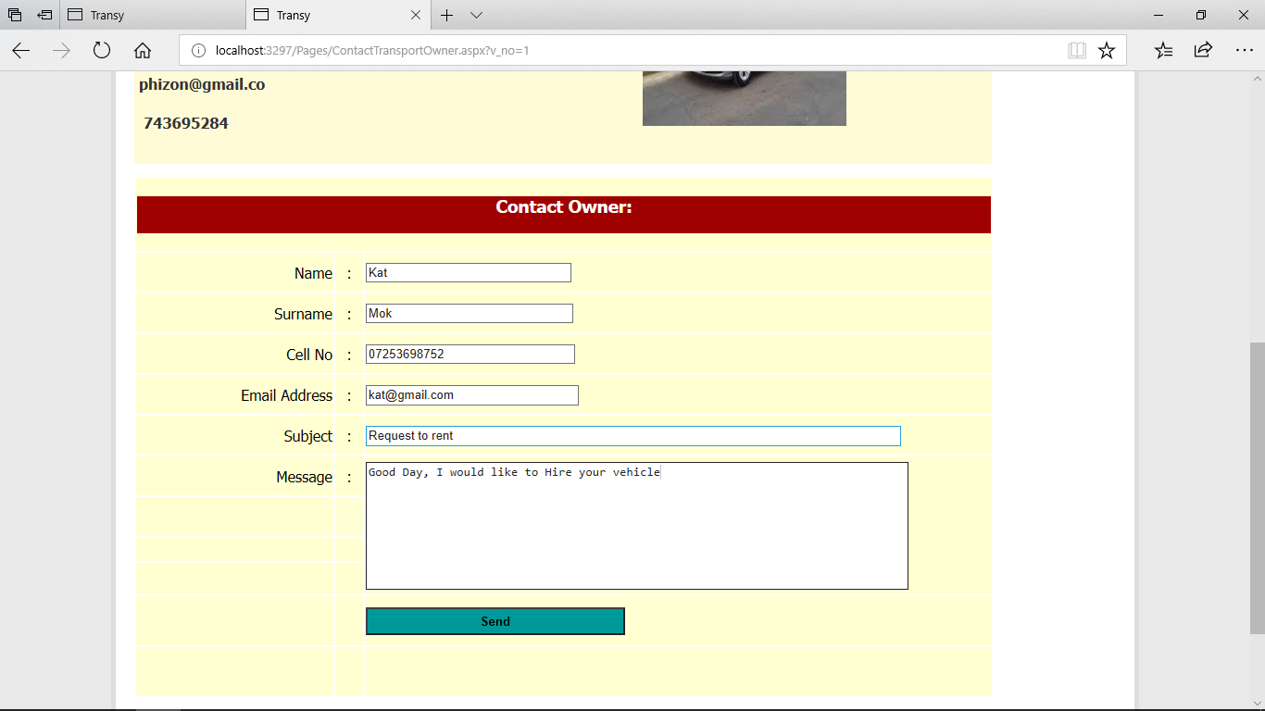

|  |
| --- |
| **Post-conditions:**  Confirm Entering of data and notify owner |

**PROJECT NAME : Transportation Management System**

**Test Case Template**

|  |  |
| --- | --- |
| **Test Case ID:** TC_JLC_3 | **Test Designed by:** <Faizel> |
| **Test Priority (Low/Medium/High):** Med | **Test Designed date:** <16/08/2018> |
| **Module Name:** Join Lift Club | **Test Executed by:** <Dr Strydom> |
| **Test Title:** Join Lift Club | **Test Execution date:** <17/08/2018> |
| **Description**: Client Views and Contact lift club ower |  |

|  |
| --- |
| **Pre-conditions:** Client Wishes to View Available Lift Clubs  **Dependencies:** Locations |

|  |  |  |  |  |  |
| --- | --- | --- | --- | --- | --- |
| **Step** | **Test Steps** | **Test Data** | **Expected Result** | **Actual Result** | **Status** |
| **1** | **Request to View Lift Clubs** |  | **Click on View Lift Clubs** | **List Of Available Lift Clubs** |  |
| **2** | **Click Contact Lift Club** | **Lift Club Admin Details** | **Lift Clubs** | **BMW**  **E90** |  |
| **3** | **Client Navigates to Contact Lift Club** |  | **Click Contact Lift Club** | **Navigate to page** |  |
| **4** | **Client Enters data** | **Name:**  **Surname: etc** | **Click on Add** | **Click Save Data** |  |
| **5** | **Response** | **Data Captured** | **Response Display** | **Return Message** |  |
|  |  |  |  |  |  |

**View Available Lift Clubs:**

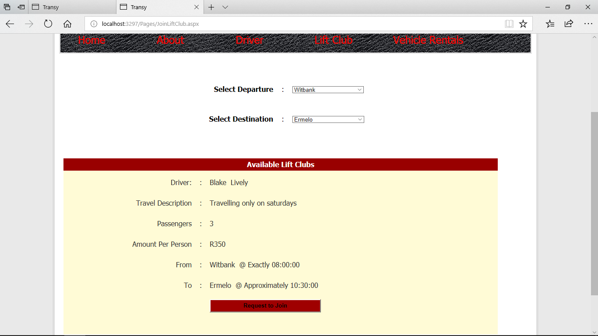

**Contact Lift Club Driver:**

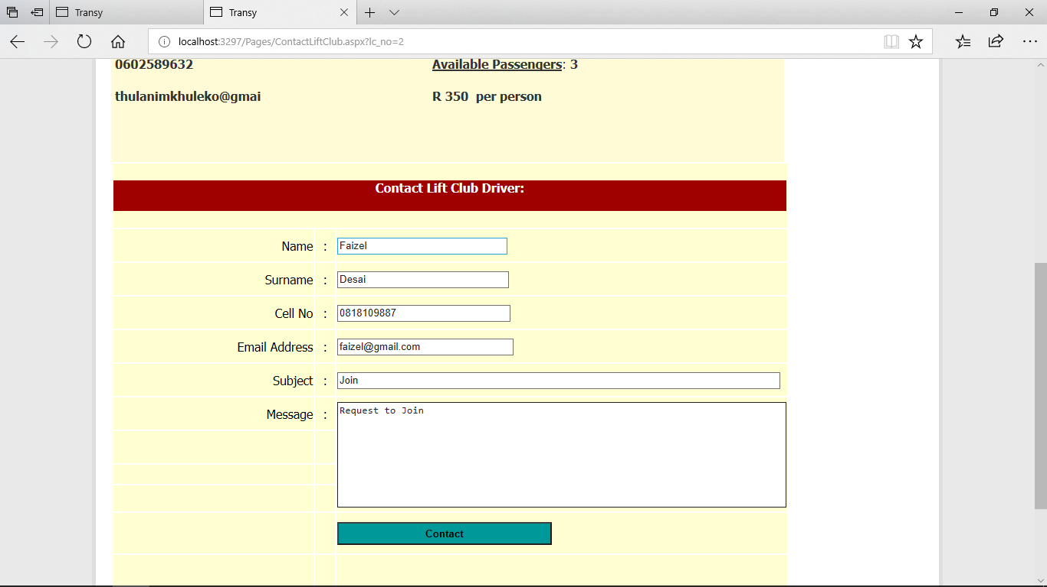

|  |
| --- |
| **Post-conditions:**  User is validated with database and successfully login to account. The account session details are logged in database.  The vehicle is hired by the client. |

|  |  |
| --- | --- |
|  |  |
|  |  |
|  |  |

|  |  |
| --- | --- |
|  |  |
|  |  |
|  |  |

|  |  |
| --- | --- |
|  |  |
|  |  |
|  |  |























/*

SQLyog Community Edition- MySQL GUI v5.22a

Host - 5.1.30-community : Database - transy

*********************************************************************

Server version : 5.1.30-community

*/

/*!40101 SET NAMES utf8 */;

/*!40101 SET SQL_MODE=''*/;

create database if not exists `transy`;

USE `transy`;

/*!40014 SET @OLD_FOREIGN_KEY_CHECKS=@@FOREIGN_KEY_CHECKS, FOREIGN_KEY_CHECKS=0 */;

/*!40101 SET @OLD_SQL_MODE=@@SQL_MODE, SQL_MODE='NO_AUTO_VALUE_ON_ZERO' */;

/*Table structure for table `photos` */

DROP TABLE IF EXISTS `photos`;

CREATE TABLE `photos` (

`id` int(11) NOT NULL AUTO_INCREMENT,

`location` varchar(100) NOT NULL,

`caption` varchar(100) NOT NULL,

PRIMARY KEY (`id`)

) ENGINE=MyISAM AUTO_INCREMENT=5 DEFAULT CHARSET=latin1;

/*Data for the table `photos` */

insert into `photos`(`id`,`location`,`caption`) values (3,'photos/the_joker_cartoon.jpg','caption'),(4,'photos/220px-Dark_Knight.jpg','batman');

/*Table structure for table `tblclient` */

DROP TABLE IF EXISTS `tblclient`;

CREATE TABLE `tblclient` (

`cl_no` int(5) unsigned zerofill NOT NULL AUTO_INCREMENT,

`cl_name` varchar(25) DEFAULT NULL,

`cl_surname` varchar(25) DEFAULT NULL,

`cl_cellno` varchar(10) DEFAULT NULL,

`cl_email` varchar(20) DEFAULT NULL,

`user_id` int(5) DEFAULT NULL,

`cl_date` date DEFAULT NULL,

PRIMARY KEY (`cl_no`)

) ENGINE=InnoDB AUTO_INCREMENT=43 DEFAULT CHARSET=latin1;

/*Data for the table `tblclient` */

insert into `tblclient`(`cl_no`,`cl_name`,`cl_surname`,`cl_cellno`,`cl_email`,`user_id`,`cl_date`) values (00001,'Hendry','Tompson','0741234569','hentom@gmail.com',39,'2018-11-23'),(00002,'Bongane','Simelane','0718529631','bonsim@gmail.com',NULL,'2018-11-13'),(00003,'Keith','Krugel','0826598745','keikru@gmail.com',NULL,'2018-11-22'),(00004,'Zakhele','Sithole','0600032582','zaksit@gmail.com',NULL,'2018-11-23'),(00005,'Michelle','Bower','0728513698','micbow@gmail.com',NULL,'2018-11-29'),(00006,'Mabuyi','Mokoena','0831478523','mabmok@gmail.com',NULL,'2018-11-23'),(00007,'Sarah','Nell','0762144911','sarnel@gmail.com',NULL,'2018-11-13'),(00008,'Ike','Nomazulu','0762434951','ikenom@gmail.com',NULL,'2018-11-29'),(00009,'Mike','Stevens','0734567398','mikste@gmail.com',NULL,'2018-11-22'),(00010,'Zake','Wallens','0762144914','zakwal@gmail.com',NULL,'2018-11-28'),(00011,'John','Themba','0832576895','johthe@gmail.com',NULL,'2018-11-23'),(00012,'Sizwe','Khumalo','0762344658','sizkhu@gmail.com',NULL,'2018-11-13'),(00013,'Sandile','Shabangu','0634586798','sansha@gmail.com',NULL,'2018-11-22'),(00014,'Michael','Nkosi','0762144923','micnko@gmail.com',NULL,'2018-11-28'),(00015,'Faizel','Naidoo','0723475968','fainai@gmail.com',NULL,'2018-11-29'),(00016,'Zake','Phillips','0713473468','zakphi@gmail.com',NULL,'2018-11-22'),(00017,'Mike','Skosana','0723445954','miksko@gmail.com',NULL,'2018-11-23'),(00018,'Keisha','Ledimo','0733471258','keiled@gmail.com',NULL,'2018-11-13'),(00019,'Lebo','Mokoena','0723473457','lebmok@gmail.com',NULL,'2018-11-22'),(00020,'Lasaros','Gumani','0765423467','lasgum@gmail.com',NULL,'2018-11-29'),(00021,'Precious','Mgidi','0723475876','premgi@gmail.com',NULL,'2018-11-13'),(00022,'John','Sefako','0632749576','johsef@gmail.com',NULL,'2018-11-22'),(00023,'Jooseph','Maroga','0723475945','joomar@gmail.com',NULL,'2018-11-23'),(00024,'Zaka','Simelani','0824566979','zaksim@gmail.com',NULL,'2018-11-13'),(00025,'Rayah','Malatji','0637685943','raymal@gmail.com',NULL,'2018-11-29'),(00026,'Andrew','Nkamoni','0745768493','andnka@gmail.com',NULL,'2018-11-23'),(00027,'Andris','Mokwana','0834756983','andmok@gmail.com',NULL,'2018-11-28'),(00028,'Andy','Lebese','0714759674','andleb@gmail.com',NULL,'2018-11-13'),(00029,'Given','Sithole','0606583645','givsit@gmail.com',NULL,'2018-11-22'),(00030,'Sphe','Lebepe','0795564354','sphleb@gmail.com',NULL,'2018-11-28'),(00032,'Mike','Khumalo','0721548914','xse@gmail.com',NULL,'2018-11-29'),(00033,'Kat','Mokwena','0765973125','kat@gmail.com',33,'2018-11-13'),(00042,'jack','mabu','0125896312','jack@gmail.com',38,'2018-11-23');

/*Table structure for table `tbldriver` */

DROP TABLE IF EXISTS `tbldriver`;

CREATE TABLE `tbldriver` (

`dr_no` int(5) unsigned zerofill NOT NULL AUTO_INCREMENT,

`dr_name` varchar(15) DEFAULT NULL,

`dr_surname` varchar(15) DEFAULT NULL,

`dr_email` varchar(20) DEFAULT NULL,

`dr_cellno` varchar(10) DEFAULT NULL,

`dr_licenseType` varchar(8) DEFAULT NULL,

`dr_amount` float(5,2) DEFAULT NULL,

`loc_no` int(5) unsigned DEFAULT NULL,

`dr_experience` varchar(50) DEFAULT NULL,

`dr_image` varchar(100) DEFAULT NULL,

`cl_no` int(5) DEFAULT NULL,

PRIMARY KEY (`dr_no`),

KEY `FK_tbldriver` (`loc_no`),

CONSTRAINT `FK_tbldriver` FOREIGN KEY (`loc_no`) REFERENCES `tbllocation` (`loc_no`)

) ENGINE=InnoDB AUTO_INCREMENT=73 DEFAULT CHARSET=latin1;

/*Data for the table `tbldriver` */

insert into `tbldriver`(`dr_no`,`dr_name`,`dr_surname`,`dr_email`,`dr_cellno`,`dr_licenseType`,`dr_amount`,`loc_no`,`dr_experience`,`dr_image`,`cl_no`) values (00000,'Will','Dannahh','wildan@gmail.com','0727838986','Code 8',652.00,1,'Bus Driver','',NULL),(00001,'Peter','Mahlangu','petmah@gmail.com','0712589362','Code 10',120.00,1,'Trucks','Images/Drivers/clive.jpg',NULL),(00002,'Xolani','Ngamone','xolsim@gmail.com','0826985123','Code 14',300.00,1,'Delivery driver','Images/Drivers/judy.jpg',NULL),(00003,'Clive','Lebepe','clileb@gmail.com','0745698125','Code 8',150.00,1,'Bus driver','Images/Drivers/junior.jpg',NULL),(00004,'Junior','Tlou','juntlo@gmail.com','0836589125','Code 8',220.00,1,'Uber driver','Images/Drivers/katlego.jpg',NULL),(00005,'Phillip','Simelane','phisim@gmail.com','0731258478','Code 8',420.00,1,'Delivery driver','Images/Drivers/phillip.jpg',NULL),(00072,'mpho','lebepe','mpho@gmail.com','0826985124','Code 10',350.00,1,'5 years','./Images/Drivers/TUTbrandScreenSave.png',NULL);

/*Table structure for table `tblfeatures` */

DROP TABLE IF EXISTS `tblfeatures`;

CREATE TABLE `tblfeatures` (

`f_no` int(5) unsigned zerofill NOT NULL AUTO_INCREMENT,

`f_feature` varchar(20) DEFAULT NULL,

PRIMARY KEY (`f_no`)

) ENGINE=InnoDB AUTO_INCREMENT=11 DEFAULT CHARSET=latin1;

/*Data for the table `tblfeatures` */

insert into `tblfeatures`(`f_no`,`f_feature`) values (00001,'pdc'),(00002,'Leather seat'),(00003,'Sunroof'),(00004,'Sportpack'),(00005,'Navigation System'),(00006,'Anti Collusion Syste'),(00007,'Refridgerator'),(00008,'Remote keyless entry'),(00009,'Anti-locks brakes'),(00010,'Electronic stability');

/*Table structure for table `tblhiredriver` */

DROP TABLE IF EXISTS `tblhiredriver`;

CREATE TABLE `tblhiredriver` (

`hr_no` int(5) unsigned zerofill NOT NULL AUTO_INCREMENT,

`dr_no` int(5) unsigned DEFAULT NULL,

`cl_no` int(5) unsigned DEFAULT NULL,

`hr_date` date DEFAULT NULL,

PRIMARY KEY (`hr_no`),

KEY `FK_tblhiredriver` (`dr_no`),

KEY `FK_tbldriverClient` (`cl_no`),

CONSTRAINT `FK_tbldriverClient` FOREIGN KEY (`cl_no`) REFERENCES `tblclient` (`cl_no`),

CONSTRAINT `FK_tblhiredriver` FOREIGN KEY (`dr_no`) REFERENCES `tbldriver` (`dr_no`)

) ENGINE=InnoDB AUTO_INCREMENT=21 DEFAULT CHARSET=latin1;

/*Data for the table `tblhiredriver` */

insert into `tblhiredriver`(`hr_no`,`dr_no`,`cl_no`,`hr_date`) values (00001,1,1,'2018-06-01'),(00002,2,2,'2018-06-02'),(00003,3,3,'2018-07-01'),(00004,4,4,'2018-06-03'),(00005,5,5,'2018-07-04'),(00010,1,10,'2018-07-15'),(00019,3,1,'2018-11-26'),(00020,3,42,'2018-11-26');

/*Table structure for table `tblhirevehicle` */

DROP TABLE IF EXISTS `tblhirevehicle`;

CREATE TABLE `tblhirevehicle` (

`hv_no` int(5) unsigned zerofill NOT NULL AUTO_INCREMENT,

`v_no` int(5) unsigned DEFAULT NULL,

`cl_no` int(5) unsigned DEFAULT NULL,

`hv_date` date DEFAULT NULL,

PRIMARY KEY (`hv_no`),

KEY `FK_tblhirevehicle` (`v_no`),

KEY `FK_tblhirevehcle` (`cl_no`),

CONSTRAINT `FK_tblhirevehcle` FOREIGN KEY (`cl_no`) REFERENCES `tblclient` (`cl_no`),

CONSTRAINT `FK_tblhirevehicle` FOREIGN KEY (`v_no`) REFERENCES `tblvehicle` (`v_no`)

) ENGINE=InnoDB AUTO_INCREMENT=11 DEFAULT CHARSET=latin1;

/*Data for the table `tblhirevehicle` */

insert into `tblhirevehicle`(`hv_no`,`v_no`,`cl_no`,`hv_date`) values (00001,1,11,'2018-06-02'),(00002,2,12,'2018-07-01'),(00003,3,13,'2018-06-29'),(00004,4,14,'2018-06-10'),(00005,5,15,'2018-07-03'),(00006,6,16,'2018-06-01'),(00007,7,17,'2018-07-20'),(00008,1,18,'2018-07-01'),(00009,4,19,'2018-06-11'),(00010,3,20,'2018-07-14');

/*Table structure for table `tbljoinliftclub` */

DROP TABLE IF EXISTS `tbljoinliftclub`;

CREATE TABLE `tbljoinliftclub` (

`jlc_no` int(5) unsigned zerofill NOT NULL AUTO_INCREMENT,

`lc_no` int(5) unsigned DEFAULT NULL,

`cl_no` int(5) unsigned DEFAULT NULL,

`jlc_date` date DEFAULT NULL,

`jlc_space` int(5) NOT NULL,

PRIMARY KEY (`jlc_no`),

KEY `FK_tbljoinliftclub` (`cl_no`),

KEY `FK_tbljoinlifclub` (`lc_no`),

CONSTRAINT `FK_tbljoinlifclub` FOREIGN KEY (`lc_no`) REFERENCES `tblliftclub` (`lc_no`),

CONSTRAINT `FK_tbljoinliftclub` FOREIGN KEY (`cl_no`) REFERENCES `tblclient` (`cl_no`)

) ENGINE=InnoDB AUTO_INCREMENT=13 DEFAULT CHARSET=latin1;

/*Data for the table `tbljoinliftclub` */

insert into `tbljoinliftclub`(`jlc_no`,`lc_no`,`cl_no`,`jlc_date`,`jlc_space`) values (00004,3,21,'2018-06-25',1),(00005,4,22,'2018-07-21',2),(00006,5,23,'2018-06-22',3),(00007,7,24,'2018-06-06',2),(00008,5,25,'2018-07-04',1),(00009,4,26,'2018-06-05',3),(00010,3,27,'2018-07-06',2),(00011,9,32,'2018-08-15',0),(00012,9,32,'2018-08-15',0);

/*Table structure for table `tblliftclub` */

DROP TABLE IF EXISTS `tblliftclub`;

CREATE TABLE `tblliftclub` (

`lc_no` int(5) unsigned zerofill NOT NULL AUTO_INCREMENT,

`lc_name` varchar(15) DEFAULT NULL,

`lc_surname` varchar(15) DEFAULT NULL,

`lc_cellno` varchar(10) DEFAULT NULL,

`lc_email` varchar(20) DEFAULT NULL,

`lc_description` varchar(50) DEFAULT NULL,

`lc_maxPassengers` int(5) DEFAULT NULL,

`lc_amount` float(9,2) DEFAULT NULL,

`lc_DesNo` int(5) unsigned DEFAULT NULL,

`lc_DesTime` time DEFAULT NULL,

`lc_DepNo` int(5) unsigned DEFAULT NULL,

`lc_DepTime` time DEFAULT NULL,

`lc_date` date DEFAULT NULL,

PRIMARY KEY (`lc_no`),

KEY `FK_tblliftclub` (`lc_DesNo`),

KEY `FK_tblliftclub1` (`lc_DepNo`),

CONSTRAINT `FK_tblliftclub` FOREIGN KEY (`lc_DesNo`) REFERENCES `tbllocation` (`loc_no`),

CONSTRAINT `FK_tblliftclub1` FOREIGN KEY (`lc_DepNo`) REFERENCES `tbllocation` (`loc_no`)

) ENGINE=InnoDB AUTO_INCREMENT=16 DEFAULT CHARSET=latin1;

/*Data for the table `tblliftclub` */

insert into `tblliftclub`(`lc_no`,`lc_name`,`lc_surname`,`lc_cellno`,`lc_email`,`lc_description`,`lc_maxPassengers`,`lc_amount`,`lc_DesNo`,`lc_DesTime`,`lc_DepNo`,`lc_DepTime`,`lc_date`) values (00001,'Mariah','Maake','0742589365','marmaa@gmail.com','Travelling 6 days a week, back and forth',4,120.00,1,'08:00:00',2,'06:30:00','2018-11-23'),(00002,'Martin','Scott','0602589632','marsco@gmail.com','Travelling only on saturdays',3,350.00,3,'10:30:00',4,'08:00:00','2018-11-24'),(00003,'Carlos','Meyer','0762465322','carmey@gmail.com','Travelling on mondays and Thursdays',3,450.00,5,'11:00:00',6,'10:00:00','2018-11-26'),(00004,'Koos','Botha','0835214789','koobot@gmail.com','Travelling on weekdays',4,620.00,7,'04:30:00',1,'04:00:00','2018-11-29'),(00005,'Jacob','Nelson','0822952864','jacnel@gmail.com','Travelling all week',2,240.00,5,'08:00:00',1,'07:00:00','2018-11-29'),(00006,'Paul','Eksteen','0794561258','paueks@gmail.com','Travelling only on wednesdays',3,280.00,5,'18:00:00',1,'14:00:00','2018-11-28'),(00007,'Dorothy','Jacobs','0836541236','dorjac@gmail.com','Travelling on weekends only',4,160.00,5,'17:00:00',1,'13:00:00','2018-11-21'),(00008,'Dee','Masha','0726541287','deemas@gmail.com','Travelling on weekdays',2,150.00,5,'11:00:00',1,'13:00:00','2018-11-27'),(00009,'Vee','Cele','0836751236','veecel@gmail.com','Everyday',4,200.00,5,'15:00:00',1,'16:00:00','2018-11-22'),(00010,'Judy','Ladwaba','0736541267','judlad@gmail.com','Travelling all week',3,210.00,5,'15:30:00',1,'18:00:00','2018-11-20');

/*Table structure for table `tbllocation` */

DROP TABLE IF EXISTS `tbllocation`;

CREATE TABLE `tbllocation` (

`loc_no` int(5) unsigned zerofill NOT NULL AUTO_INCREMENT,

`loc_town` varchar(25) DEFAULT NULL,

`prov_no` int(5) unsigned DEFAULT NULL,

PRIMARY KEY (`loc_no`),

KEY `FK_tbllocation` (`prov_no`),

CONSTRAINT `FK_tbllocation` FOREIGN KEY (`prov_no`) REFERENCES `tblprovince` (`prov_no`)

) ENGINE=InnoDB AUTO_INCREMENT=49 DEFAULT CHARSET=latin1 ROW_FORMAT=DYNAMIC;

/*Data for the table `tbllocation` */

insert into `tbllocation`(`loc_no`,`loc_town`,`prov_no`) values (00001,'Ermelo',1),(00002,'Witbank',1),(00003,'Benoni',1),(00004,'Barberton',1),(00005,'Ranburg',20),(00006,'Polokwane',19),(00007,'Bela-Bela',19),(00009,'Springbok',17),(00010,'East London',16),(00011,'Grahamstown',16),(00012,'Rustenburg',21),(00013,'Newcastle',15),(00014,'Richards Bay',15),(00015,'Ballito',15),(00016,'Pretoria',20),(00017,'Johannesburg',20),(00018,'Centurion',20),(00019,'Wonderboom',20),(00020,'Mthatha',16),(00021,'Graaff Reinet',16),(00022,'Jeffreys Bay',16),(00023,'Middelburg',1),(00024,'Kimberly',17),(00025,'Upington',17),(00026,'Kuruman',17),(00027,'Colesburg',17),(00028,'Bloemfontein',18),(00029,'Parys ',18),(00030,'Ficksburg',18),(00031,'Clarens',18),(00032,'Bethlehem',18),(00033,'Tzaneen',19),(00034,'Burgersfort',19),(00035,'Lephalale',19),(00036,'Hoedspruit',19),(00037,'Mahikeng',21),(00038,'Klerksdrop',21),(00039,'Brits',21),(00040,'Zeerust',21),(00041,'Cape Town',14),(00042,'Darling',14),(00043,'Paarl',14),(00044,'Overberg',14),(00045,'Montagu',14),(00046,'Dundee',15),(00047,'Lady Smith',15),(00048,'Pinetown',15);

/*Table structure for table `tblprovince` */

DROP TABLE IF EXISTS `tblprovince`;

CREATE TABLE `tblprovince` (

`prov_no` int(5) unsigned zerofill NOT NULL AUTO_INCREMENT,

`prov_name` varchar(25) DEFAULT NULL,

PRIMARY KEY (`prov_no`)

) ENGINE=InnoDB AUTO_INCREMENT=22 DEFAULT CHARSET=latin1;

/*Data for the table `tblprovince` */

insert into `tblprovince`(`prov_no`,`prov_name`) values (00001,'Mpumalanga'),(00014,'Western Cape'),(00015,'Kwazulu Natal'),(00016,'Eastern Cape'),(00017,'Northern Cape'),(00018,'Free State'),(00019,'Limpopo'),(00020,'Gauteng'),(00021,'North West');

/*Table structure for table `tbltransportowner` */

DROP TABLE IF EXISTS `tbltransportowner`;

CREATE TABLE `tbltransportowner` (

`to_no` int(5) unsigned zerofill NOT NULL AUTO_INCREMENT,

`to_name` varchar(25) DEFAULT NULL,

`to_surname` varchar(25) DEFAULT NULL,

`to_cellno` varchar(10) DEFAULT NULL,

`to_email` varchar(25) DEFAULT NULL,

`loc_no` int(5) unsigned DEFAULT NULL,

PRIMARY KEY (`to_no`),

KEY `FK_tbltransportowner` (`loc_no`),

CONSTRAINT `FK_tbltransportowner` FOREIGN KEY (`loc_no`) REFERENCES `tbllocation` (`loc_no`)

) ENGINE=InnoDB AUTO_INCREMENT=15 DEFAULT CHARSET=latin1;

/*Data for the table `tbltransportowner` */

insert into `tbltransportowner`(`to_no`,`to_name`,`to_surname`,`to_cellno`,`to_email`,`loc_no`) values (00001,'Phiwe','Zondo','0743695284','phizon@gmail.com',1),(00002,'Mike','Sibiya','0829632123','miksib@gmail.com',1),(00003,'Fihliwe','Zungu','0836985214','fihzun@gmail.com',1),(00004,'Ndaba','Ndaba','0793625147','ndanda@gmail.com',2),(00005,'Sulat','fourie','0628964123','salfou@gmail.com',3),(00006,'Emmy','Van der walt','0712589632','emmvan@gmail.com',4),(00007,'Margaret','Burger','0732589741','marbur@gmail.com',6),(00008,'Mike','Smith','0732889756','miksmi@gmail.com',15),(00009,'John','Wallen','0736589776','johwal@gmail.com',14),(00010,'Simon','Wale','0714569741','simwal@gmail.com',13),(00013,'Peter','Maret','0735489775','petmar@gmail.com',10);

/*Table structure for table `tbluser` */

DROP TABLE IF EXISTS `tbluser`;

CREATE TABLE `tbluser` (

`user_id` int(5) unsigned zerofill NOT NULL AUTO_INCREMENT,

`user_name` varchar(25) DEFAULT NULL,

`user_surname` varchar(25) DEFAULT NULL,

`user_cellno` varchar(10) DEFAULT NULL,

`user_email` varchar(25) DEFAULT NULL,

`user_password` varchar(50) DEFAULT NULL,

`user_role` varchar(25) DEFAULT NULL,

`user_tableId` int(5) unsigned DEFAULT NULL,

`user_lc` int(5) unsigned DEFAULT NULL,

`user_to` int(5) unsigned DEFAULT NULL,

`temp_var` varchar(25) DEFAULT NULL,

`user_address` varchar(50) DEFAULT NULL,

PRIMARY KEY (`user_id`),

KEY `FK_tbluser` (`user_tableId`),

KEY `FK_LiftClub` (`user_lc`),

KEY `FK_Transport` (`user_to`),

CONSTRAINT `FK_Driver` FOREIGN KEY (`user_tableId`) REFERENCES `tbldriver` (`dr_no`),

CONSTRAINT `FK_LiftClub` FOREIGN KEY (`user_lc`) REFERENCES `tblliftclub` (`lc_no`),

CONSTRAINT `FK_Transport` FOREIGN KEY (`user_to`) REFERENCES `tbltransportowner` (`to_no`)

) ENGINE=InnoDB AUTO_INCREMENT=40 DEFAULT CHARSET=latin1;

/*Data for the table `tbluser` */

insert into `tbluser`(`user_id`,`user_name`,`user_surname`,`user_cellno`,`user_email`,`user_password`,`user_role`,`user_tableId`,`user_lc`,`user_to`,`temp_var`,`user_address`) values (00001,'Will','Danah','0727838986','wildan@gmail.com','wildan00','Driver',1,NULL,NULL,'wildan00',NULL),(00002,'Xolani','Ngamone','0826985123','xolsim@gmail.com','xolsim02','Driver',2,NULL,NULL,NULL,NULL),(00003,'Clive','Lebepe','0745698125','clileb@gmail.com','clileb03','Driver',3,NULL,NULL,'clileb03',''),(00004,'Junior','Tlou','0836589125','juntlo@gmail.com','juntlo04','Driver',4,NULL,NULL,NULL,NULL),(00005,'Phillip','Simelane','0731258478','phisim@gmail.com','phisim05','Driver',5,NULL,NULL,NULL,NULL),(00011,'Mariah','Maake','0742589365','marmaa@gmail.com','marmaa11','Lift Club',NULL,1,NULL,'marmaa11',NULL),(00012,'Martin','Scott','0602589632','marsco@gmail.com','marsco12','Lift Club',NULL,2,NULL,NULL,NULL),(00013,'Carlos','Meyer','0762465322','carmey@gmail.com','carmey13','Lift Club',NULL,3,NULL,NULL,NULL),(00014,'Koos','Botha','0835214789','koobot@gmail.com','koobot14','Lift Club',NULL,4,NULL,NULL,NULL),(00015,'Jacob','Nelson','0822952864','jacnel@gmail.com','jacnel15','Lift Club',NULL,5,NULL,NULL,NULL),(00016,'Paul','Eksteen','0794561258','paueks@gmail.com','paueks16','Lift Club',NULL,6,NULL,NULL,NULL),(00017,'Dorothy','Jacobs','0836541236','dorjac@gmail.com','dorjac17','Lift Club',NULL,7,NULL,NULL,NULL),(00018,'Dee','Masha','0726541287','deemas@gmail.com','deemas18','Lift Club',NULL,8,NULL,NULL,NULL),(00019,'Vee','Cele','0836751236','veecel@gmail.com','veecel19','Lift Club',NULL,9,NULL,NULL,NULL),(00020,'Judy','Ladwaba','0736541267','judlad@gmail.com','judlad20','Lift Club',NULL,10,NULL,NULL,NULL),(00021,'Phiwe','Zondo','0743695284','phizon@gmail.com','phizon21','Transport',NULL,NULL,1,NULL,NULL),(00022,'Mike','Sibiya','0829632123','miksib@gmail.com','miksib22','Transport',NULL,NULL,2,NULL,NULL),(00023,'Fihliwe','Zungu','0836985214','fihzun@gmail.com','fihzun23','Transport',NULL,NULL,3,NULL,NULL),(00024,'Ndaba','Ndaba','0793625147','ndanda@gmail.com','ndanda24','Transport',NULL,NULL,4,NULL,NULL),(00025,'Salut','Fourie','0628964123','salfou@gmail.com','salfou25','Transport',NULL,NULL,5,NULL,NULL),(00026,'Emmy','Van der walt','0712589632','emmvan@gmail.com','emmvan26','Transport',NULL,NULL,6,NULL,NULL),(00027,'Margaret','Burger','0732589741','marbur@gmail.com','marbur27','Transport',NULL,NULL,7,'marbur27',NULL),(00028,'Mike','Smith','0732889756','miksmi@gmail.com','miksmi28','Transport',NULL,NULL,8,NULL,NULL),(00029,'John','Wallen','0736589776','johwal@gmail.com','johwal29','Transport',NULL,NULL,9,NULL,NULL),(00030,'Simon','Wale','0714569741','simwal@gmail.com','simwal30','Transport',NULL,NULL,10,NULL,NULL),(00031,'Peter','Maret','0735489775','petmar@gmail.com','petmar31','Transport',NULL,NULL,13,NULL,NULL),(00032,'kat','mokwena','0765973125','kat@gmail.com','kat123','Client',NULL,NULL,NULL,'kat123',NULL),(00033,'Peter','Mahlangu','0712589362','petmah@gmail.com','pet123','Driver',NULL,NULL,NULL,'pet123',NULL),(00038,'jack','mabu','0125896312','jack@gmail.com','jack123','Client',NULL,NULL,NULL,'jack123','fio;hjkj '),(00039,'Hendry','Tompson','0741234569','hentom@gmail.com','hend123','Client',NULL,NULL,NULL,'hend123','jkdfghgfb ');

/*Table structure for table `tblvehicle` */

DROP TABLE IF EXISTS `tblvehicle`;

CREATE TABLE `tblvehicle` (

`v_no` int(5) unsigned zerofill NOT NULL AUTO_INCREMENT,

`v_make` varchar(25) DEFAULT NULL,

`v_model` varchar(25) DEFAULT NULL,

`v_series` varchar(15) DEFAULT NULL,

`v_year` int(4) DEFAULT NULL,

`v_amtPerDay` float(5,2) DEFAULT NULL,

`v_image` varchar(75) DEFAULT NULL,

`to_no` int(5) unsigned DEFAULT NULL,

PRIMARY KEY (`v_no`),

KEY `FK_tblvehicle` (`to_no`),

CONSTRAINT `FK_tblvehicle` FOREIGN KEY (`to_no`) REFERENCES `tbltransportowner` (`to_no`)

) ENGINE=InnoDB AUTO_INCREMENT=9 DEFAULT CHARSET=latin1;

/*Data for the table `tblvehicle` */

insert into `tblvehicle`(`v_no`,`v_make`,`v_model`,`v_series`,`v_year`,`v_amtPerDay`,`v_image`,`to_no`) values (00001,'BMW','E90','1.4',2013,130.00,'Images/Vehicles/e90.jpg',1),(00002,'Jeep','Wrangler','1.6',2018,250.00,'Images/Vehicles/jeep.jpg',1),(00003,'Mercedes','Gclass','1.8',2018,360.00,'Images/Vehicles/gclass.jpg',3),(00004,'Volkswag','Polo','2.6',2017,140.00,'Images/Vehicles/polo.jpg',4),(00005,'Ferrari','Spider','3.4',2016,550.00,'Images/Vehicles/spider.jpg',5),(00006,'BMW','325is','2.5',2017,360.00,'Images/Vehicles/is.jpg',6),(00007,'Range Ro','Sport','2.9',2017,410.00,'Images/Vehicles/fort.jpg',7);

/*Table structure for table `tblvehiclefeatures` */

DROP TABLE IF EXISTS `tblvehiclefeatures`;

CREATE TABLE `tblvehiclefeatures` (

`vf_no` int(5) unsigned zerofill NOT NULL AUTO_INCREMENT,

`v_no` int(5) unsigned DEFAULT NULL,

`f_no` int(5) unsigned DEFAULT NULL,

PRIMARY KEY (`vf_no`),

KEY `FK_tblvehiclefeatures` (`f_no`),

KEY `FK_tblvehiclefe` (`v_no`),

CONSTRAINT `FK_tblvehiclefe` FOREIGN KEY (`v_no`) REFERENCES `tblvehicle` (`v_no`),

CONSTRAINT `FK_tblvehiclefeatures` FOREIGN KEY (`f_no`) REFERENCES `tblfeatures` (`f_no`)

) ENGINE=InnoDB AUTO_INCREMENT=15 DEFAULT CHARSET=latin1;

/*Data for the table `tblvehiclefeatures` */

insert into `tblvehiclefeatures`(`vf_no`,`v_no`,`f_no`) values (00001,1,1),(00002,2,2),(00003,3,3),(00004,4,4),(00005,5,5),(00006,6,6),(00007,7,7),(00008,1,3),(00009,1,5),(00010,1,7),(00011,7,6),(00012,7,9);

/* Procedure structure for procedure `AddVehicle` */

/*!50003 DROP PROCEDURE IF EXISTS `AddVehicle` */;

DELIMITER $$

/*!50003 CREATE DEFINER=`root`@`localhost` PROCEDURE `AddVehicle`(

IN p_email varchar(25),

IN o_loc int,

IN o_make varchar(25),

IN o_model varchar(25),

IN o_series varchar(15),

IN o_year int,

IN o_amt float(9, 2),

IN v_image varchar(75)

)

BEGIN

DECLARE o_name varchar(25);

DECLARE o_surname varchar(25);

DECLARE o_cellno varchar(10);

DECLARE o_email varchar(50);

DECLARE p_to_no int;

DECLARE p_usr int;

SELECT user_name, user_surname, user_cellno, user_email

INTO o_name, o_surname, o_cellno, o_email

FROM tbluser

WHERE user_email = p_email;

INSERT INTO tbltransportowner(to_name, to_surname, to_cellno, to_email, loc_no)

VALUES (o_name,o_surname, o_cellno,o_email, o_loc);

SELECT MAX(to_no) INTO p_to_no

FROM tbltransportowner;

INSERT INTO tblvehicle (v_make, v_model, v_series, v_year, v_amtPerDay, v_image, to_no)

VALUES (o_make, o_model, o_series, o_year, o_amt, v_image, p_to_no);

SELECT MAX(to_no) INTO p_usr FROM tbltransportowner;

UPDATE tbluser SET user_lc = p_usr WHERE user_email = p_email;

END */$$

DELIMITER ;

/* Procedure structure for procedure `DelDriver` */

/*!50003 DROP PROCEDURE IF EXISTS `DelDriver` */;

DELIMITER $$

/*!50003 CREATE DEFINER=`root`@`localhost` PROCEDURE `DelDriver`(

IN p_drNo int

)

BEGIN

DELETE FROM tbluser WHERE user_tableId = p_drNo;

DELETE FROM tblhiredriver WHERE dr_no = p_drNo;

DELETE FROM tbldriver WHERE dr_no = p_drNo;

END */$$

DELIMITER ;

/* Procedure structure for procedure `DriverBecome` */

/*!50003 DROP PROCEDURE IF EXISTS `DriverBecome` */;

DELIMITER $$

/*!50003 CREATE DEFINER=`root`@`localhost` PROCEDURE `DriverBecome`(

IN p_userID varchar(25),

IN p_dr_licenseType varchar(8),

IN p_dr_amount float(5, 2),

IN p_loc int,

IN p_experience varchar(50),

IN p_image varchar(100)

)

BEGIN

DECLARE p_name varchar(25);

DECLARE p_surname varchar(25);

DECLARE p_cellno varchar(10);

DECLARE p_email varchar(25);

DECLARE p_drId int;

SELECT user_name, user_surname, user_cellno, user_email

INTO p_name, p_surname, p_cellno, p_email

FROM tbluser

WHERE user_email = p_userID;

INSERT INTO tbldriver (dr_name, dr_surname, dr_email, dr_cellno, dr_licenseType, dr_amount, loc_no, dr_experience, dr_image)

VALUES (p_name, p_surname, p_email, p_cellno, p_dr_licenseType, p_dr_amount, p_loc, p_experience, p_image);

SELECT MAX(dr_no) INTO p_drId FROM tbldriver;

UPDATE tbluser SET user_tableId = p_drId WHERE user_email = p_userID;

END */$$

DELIMITER ;

/* Procedure structure for procedure `hiredriver` */

/*!50003 DROP PROCEDURE IF EXISTS `hiredriver` */;

DELIMITER $$

/*!50003 CREATE DEFINER=`root`@`localhost` PROCEDURE `hiredriver`(

IN p_name VARCHAR(25),

IN p_surname VARCHAR(25),

IN p_cell VARCHAR(10),

IN p_email VARCHAR(50),

IN p_drNo int

)

BEGIN

DECLARE p_cl_no int;

INSERT INTO tblclient (cl_name, cl_surname, cl_cellno, cl_email)

VALUES(p_name,p_surname , p_cell, p_email);

SELECT MAX(cl_no) FROM tblclient INTO p_cl_no;

INSERT INTO tblhiredriver (dr_no, cl_no, hr_date)

VALUES(p_drNo, p_cl_no, SYSDATE());

END */$$

DELIMITER ;

/* Procedure structure for procedure `HireTransport` */

/*!50003 DROP PROCEDURE IF EXISTS `HireTransport` */;

DELIMITER $$

/*!50003 CREATE DEFINER=`root`@`localhost` PROCEDURE `HireTransport`(

IN t_name VARCHAR(25),

IN t_surname VARCHAR(25),

IN t_cellno VARCHAR(10),

IN t_email VARCHAR(50),

IN t_vno INT(5),

IN t_date DATE

)

BEGIN

DECLARE t_clNo INT(5);

INSERT INTO tblclient (cl_name, cl_surname, cl_cellno, cl_email)

VALUES(t_name,t_surname , t_cellno, t_email);

SELECT MAX(cl_No) INTO t_clNo

FROM tblclient;

INSERT INTO tblhirevehicle (v_no, cl_no, hv_date)

VALUES(t_vno, t_clNo, t_date);

END */$$

DELIMITER ;

/* Procedure structure for procedure `JoinLiftClub` */

/*!50003 DROP PROCEDURE IF EXISTS `JoinLiftClub` */;

DELIMITER $$

/*!50003 CREATE DEFINER=`root`@`localhost` PROCEDURE `JoinLiftClub`(

IN j_name VARCHAR(25),

IN j_surname VARCHAR(25),

IN j_cellno VARCHAR(10),

IN j_email varchar(50),

IN l_no INT(5),

IN j_date date

)

BEGIN

DECLARE c_no INT(5);

INSERT INTO tblclient (cl_name, cl_surname, cl_cellno, cl_email)

VALUES(j_name,j_surname , j_cellno, j_email);

SELECT MAX(cl_no) INTO c_no

FROM tblclient;

INSERT INTO tbljoinliftclub (lc_no, cl_no, jlc_date)

VALUES(l_no, c_no, j_date);

END */$$

DELIMITER ;

/* Procedure structure for procedure `LCAdd` */

/*!50003 DROP PROCEDURE IF EXISTS `LCAdd` */;

DELIMITER $$

/*!50003 CREATE DEFINER=`root`@`localhost` PROCEDURE `LCAdd`(

IN p_user_email varchar(25),

IN p_lc_description varchar(50),

IN p_lc_maxPassengers int,

IN p_lc_amount float(5, 2),

IN p_lc_DesNo int,

IN p_lc_DesTime time,

IN p_lc_DepNo int,

IN p_lc_DepTime time

)

BEGIN

DECLARE p_name varchar(25);

DECLARE p_surname varchar(25);

DECLARE p_cellno varchar(10);

DECLARE p_email varchar(25);

DECLARE p_lc int;

SELECT user_name, user_surname, user_cellno, user_email

INTO p_name, p_surname, p_cellno, p_email

FROM tbluser

WHERE user_email = p_user_email;

INSERT INTO tblliftclub (lc_name, lc_surname, lc_cellno, lc_email, lc_description, lc_maxPassengers, lc_amount, lc_DesNo, lc_DesTime, lc_DepNo, lc_DepTime)

VALUES (p_name, p_surname, p_cellno, p_email, p_lc_description, p_lc_maxPassengers, p_lc_amount, p_lc_DesNo, p_lc_DesTime,p_lc_DepNo,p_lc_DepTime);

SELECT MAX(lc_no) INTO p_lc FROM tblliftclub;

UPDATE tbluser SET user_lc = p_lc WHERE user_email = p_user_email;

END */$$

DELIMITER ;

/*!40101 SET SQL_MODE=@OLD_SQL_MODE */;

/*!40014 SET FOREIGN_KEY_CHECKS=@OLD_FOREIGN_KEY_CHECKS */;