

Intro To Computer Science Report

Mainstream Music Throughout The World

Pauline Chicoye

12/23/2019

# **Introduction**

**In my Introduction to Computer Science class, the last assignment will be about databases, ethics, and teamwork. As you may know, we are constantly surrounded by music and since the year is coming to an end, I will be creating a report on streaming music for 2019.**

## Tables & Chart

**Most Monthly Listened Artists of 2019**

|  |  |  |  |  |
| --- | --- | --- | --- | --- |
| **Rank** | **Artist** | **Monthly Listeners (Millions)** |  | **Genre** |
| **1** | **Ed Sheeran** | **63.2** |  | **Folk Pop** |
| **2** | **Post Malone** | **57.4** |  | **R&B/Trap Rap/Pop Rap** |
| **3** | **Camila Cabello** | **55.9** |  | **Pop/R&B** |
| **4** | **J. Balvin** | **55** |  | **Reggaeton** |
| **5** | **Ariana Grande** | **55** |  | **Pop/R&B** |
| **6** | **Khalid** | **54.2** |  | **R&B** |
| **7** | **Justin Bieber** | **52.6** |  | **Teen Pop/R&B** |
| **8** | **Billie Eilish** | **52.3** |  | **Art Pop** |
| **9** | **Maroon 5** | **50.3** |  | **Soft Rock/Neo-Pop** |
| **10** | **Shawn Mendes** | **47.5** |  | **Teen Pop/Pop** |

**Most Listened Songs in Quebec of 2019**

|  |  |  |  |  |
| --- | --- | --- | --- | --- |
| **Rank** | **Artist** |  | **Song** | **Genre** |
| **1** | **Billy Ray Cyrus/Lil Nas X** |  | **Old Town Road** | **Rap** |
| **2** | **Camila Cabello/Shawn Mendes** |  | **Senorita** | **Pop** |
| **3** | **Lewis Capaldi** |  | **Someone You Loved** | **Soft Pop** |

**Most Listened Artists in Quebec in 2019**

|  |  |
| --- | --- |
| **Rank** | **Artist** |
| **1** | **Post Malone** |
| **2** | **Khalid** |
| **3** | **Drake** |

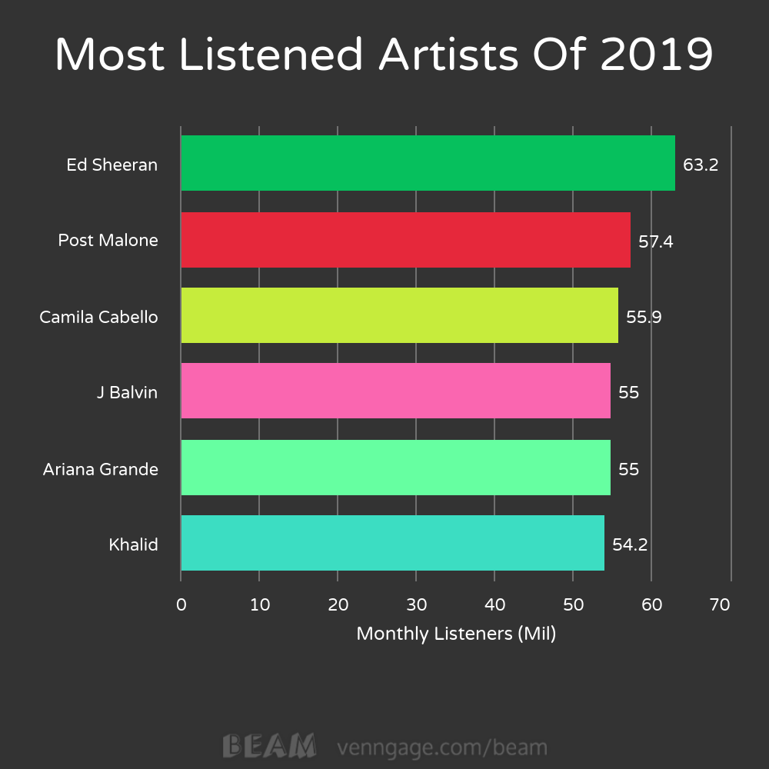

The Interpretation/Conclusion

**After analyzing the tables and charts of streaming music in 2019, I have noticed that the most popular genre of music among music listeners is pop. This explains why Ed Sheeran was the most monthly listened artist of this year with about 63.2 million listeners. As we see in the first chart, pop artists are the ones that rank very high, followed by R&B and rap music. I believe this is due to the fact that most pop music is catchy and very easily listened to. I also believe that pop music can be enjoyed by all. From youngsters to the elderly, a “pop-py” rhythm is somewhat timeless. While, rock, rap, and country can be the opposite. In order to analyze even more in-depth the databases, I researched the most popular song and artists in Quebec (Table 1 & 2). And as we see, the top three songs and artists are mainly pop produced. Although the most popular song in Quebec may be a rap song, the beat and lyrics are fairly simple and upbeat. Thus, having many characteristics of a pop song. For you to understand, here is a sample of this song:** [**https://ca.video.search.yahoo.com/search/video?fr=mcafee&p=old+time+road#id=0&vid=8420f7986642b619990228c5e9efd56d&action=click**](https://ca.video.search.yahoo.com/search/video?fr=mcafee&p=old+time+road#id=0&vid=8420f7986642b619990228c5e9efd56d&action=click)

**As you may know, the pop genre is named after the word “popular”, and that explains why it is so deeply listened to. Pop music also has different types of subcategories, like soft pop, art-pop, and etc, this is why it can be pleased by everyone. I believe that in the future years, pop music will remain the most listened to genre, but it differs from generation to generation. For further explanations, at the beginning of the 2000s pop music relied on an electric and dancing beat just like many of the artist’s songs Britney Spears. But right now, I have realized that pop music relies on a mix of soothing and rap music. This just shows how far we have come in music and how we are constantly evolving as a species.**

Ethical Argument

**After my research on mainstream music, I have chosen an ethical issue related to this topic. : Is mainstream music a bad influence on the younger generation?**

**Paramedic Methodology :**

**Who are the stakeholders in this situation?**

**The young generation & the music industry.**

**What does each stakeholder have to gain or lose?**

**The young generation: The obligation of “growing up” quicker, meaning to lose their innocence faster due to the topics discussed in mainstream music. Due to social media, the radio and etc the youth are exposed to profanity and suggestive themes. Sadly, it is almost impossible to avoid this, since technology surrounds everyone, especially kids, because of apps like Tik Tok, Instagram, and etc.**

**The music industry : It has nothing to lose, because it does not affect them in any bad way possible. In fact, there is only gain for them : the possibility of gaining money and recognition on platforms. So, even if mainstream music might be offensive to the youth, the music artists will still due as they please,**

**What duties and responsibilities are important?**

**The duty/responsibility of the music industry is to make money.**

**The responsibility of the youngsters is to enjoy their childhood the more they can.**

**Decision:**

**Sadly, most mainstream music has profanity and the suggestive themes I mentioned earlier. Meaning, it is quite inevitable for youngsters to avoid these themes. Sadly, provocation sells and that's the reality, what is left to do is for the parents of this youth is to try to supervise the music they listen to.**

ER Diagram

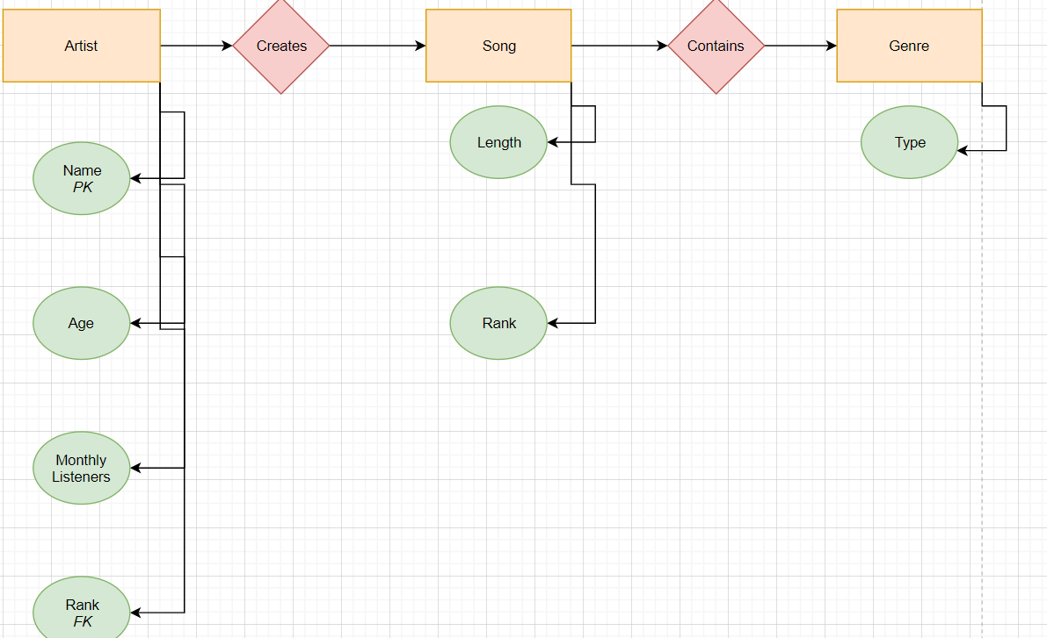

References

[**https://en.wikipedia.org/wiki/List_of_most-streamed_artists_on_Spotify**](https://en.wikipedia.org/wiki/List_of_most-streamed_artists_on_Spotify)

[**https://dailyhive.com/vancouver/most-streamed-spotify-songs-artists-canada-2019**](https://dailyhive.com/vancouver/most-streamed-spotify-songs-artists-canada-2019)

[**https://www.draw.io/#Hchiclyp%2FAssigment3%2Fmaster%2FDiagram.drawio**](https://www.draw.io/#Hchiclyp%2FAssigment3%2Fmaster%2FDiagram.drawio)

[**https://en.wikipedia.org/wiki/Foreign_key**](https://en.wikipedia.org/wiki/Foreign_key)

[**https://en.wikipedia.org/wiki/Primary_key**](https://en.wikipedia.org/wiki/Primary_key)