It would be a pleasure to have the company of

Prof. Plum

at 11010 Memory Lane on the evening of

April 1st

at 7 o'clock

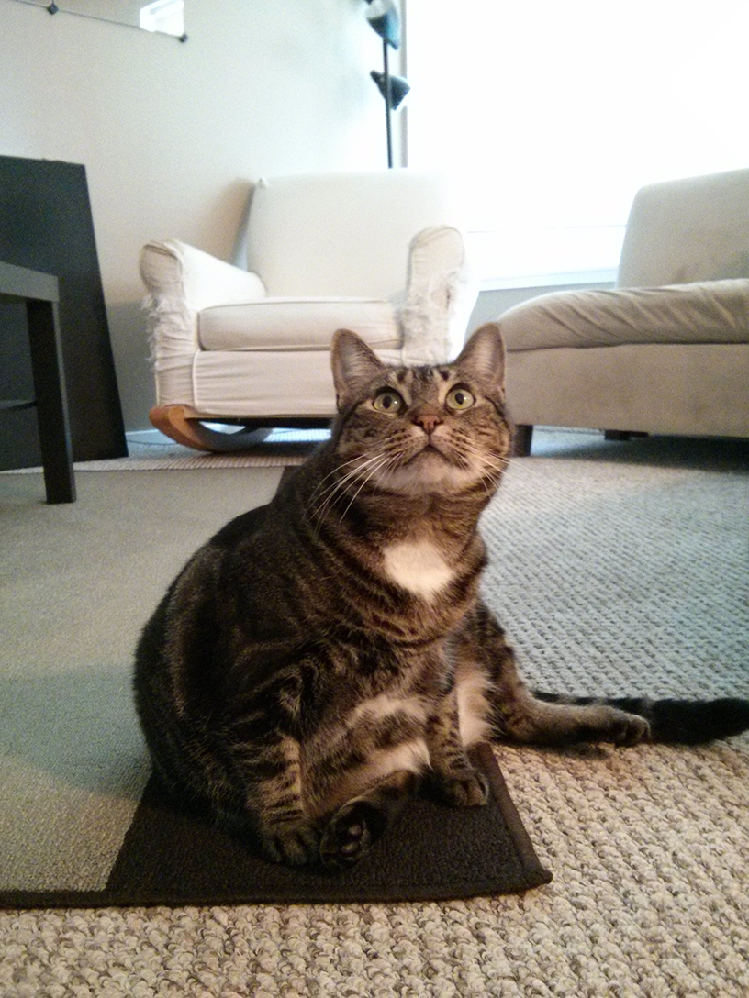

It would be a pleasure to have the company of

Miss Scarlet

at 11010 Memory Lane on the evening of

April 1st

at 7 o'clock



It would be a pleasure to have the company of

Col. Mustard

at 11010 Memory Lane on the evening of

April 1st

at 7 o'clock



It would be a pleasure to have the company of

Al Sweigart

at 11010 Memory Lane on the evening of

April 1st

at 7 o'clock



It would be a pleasure to have the company of

Robocop

at 11010 Memory Lane on the evening of

April 1st

at 7 o'clock

