CPE301 – SPRING 2019

Design Assignment 3A

Student Name: Francisco Mata Carlos

Student #: 1012593607

Student Email: matacarl@unlv.nevada.edu

Primary Github address: https://github.com/chicosisco/da_sub.git

Directory: repository/cpe301/DesignAssignments/DA3A

1. **COMPONENTS LIST AND CONNECTION BLOCK DIAGRAM w/ PINS**

The components used for this assignment are the next:

1. Atmega328p Xplained Mini
2. Atmel Studio 7
3. FTDI chip

**Block diagram with pins used in the Atmega328P**

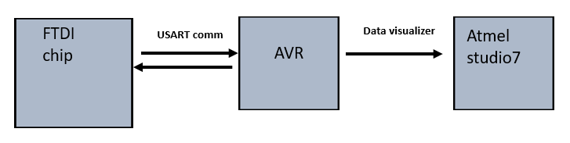

1. **INITIAL/MODIFIED/DEVELOPED CODE OF TASK 1/A**

**Task 1_A**

**1. Write a C AVR program that will display a string, random integer and floating point values on the serial terminal every 1 sec. Use a timer with interrupt for the 1 sec delay. Use a FTDI chip for serial to USB conversion**

/*

* DA3A.c

*

* Created: 3/28/2019 2:24:27 AM

* Author : Francisco Mata carlos

*/

#define *F_CPU* 16000000UL

#include <avr/io.h>

#include <util/delay.h>

#include <avr/interrupt.h>

#include <stdio.h>

#define BAUDRATE 9600

#define BAUD_PRESCALLER (((*F_CPU* / (BAUDRATE * 16UL)))-1)

//Function declarations

volatile int Count;

void USART_init( unsigned int ubrr );

void USART_TX_string(char *data);

char outs[30];

int x_num; //creates variable for random number

float due_date; //creates variable for decimal point

char str[] = "July_4th_1776"; //creates string

char empty[] = " "; //creates space

int main(void)

{

Count = 0;

TIMSK0 |= (1<<TOIE0); //sets interrupt when overflow occurs

sei (); //set global overflow

TCCR0A = 0; //normal mode

TCCR0B |= (1<<CS02)|(1<<CS00); //prescaler = 1024

USART_init(BAUD_PRESCALLER); //baud prescaler

USART_TX_string("connection_successful\r\n"); //prints the word connection successful when connected and running

while (1);

}

// USART (RS-232)

void USART_init( unsigned int ubrr ){

UBRR0H = (unsigned char)(ubrr>>8);

UBRR0L = (unsigned char)ubrr;

UCSR0B = (1 << TXEN0);

UCSR0C = (3 << UCSZ00);

}

//sending string to TEH RS-232

void USART_TX_string(char *data) {

while (*data != '\0') {

while (!(UCSR0A & (1<<UDRE0)));

UDR0 = *data;

data++;

}

}

ISR (TIMER0_OVF_vect){ //timer0 overflow interrupt call

while (Count < 61){

if ((TIFR0 & 0x01) == 1){ //checks for overflow flag

TIFR0 = 0X01; //reset overflow

Count++;

}

}

if (Count > 60){

USART_TX_string(str); //prints string

USART_TX_string(empty); //prints space

x_num = *rand*(); // random number

due_date = 327.19; //creates floating value; due date of assignment

*snprintf*(outs, sizeof(outs), "%3d\r\n", x_num);

USART_TX_string(outs);

USART_TX_string(empty);

*sprintf*(outs, "%f", due_date);

USART_TX_string(outs);

USART_TX_string(empty);

Count = 0;

}

}

1. **DEVELOPED MODIFIED CODE OF TASK 2/A from TASK 1/A**

Same as above

1. **SCREENSHOTS OF EACH TASK OUTPUT (ATMEL STUDIO OUTPUT)**

**Task 1_A C code**

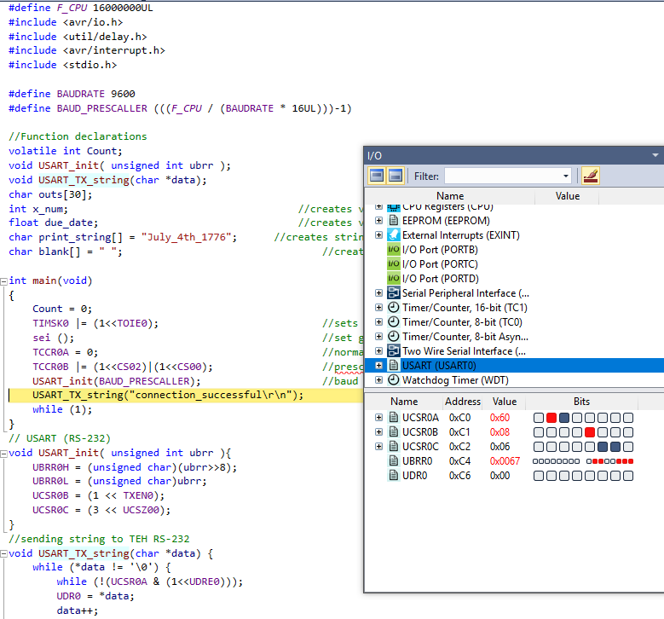

1. **SCREENSHOT OF EACH DEMO (BOARD SETUP)**

**Task 1**

**Photo below shows the set up**

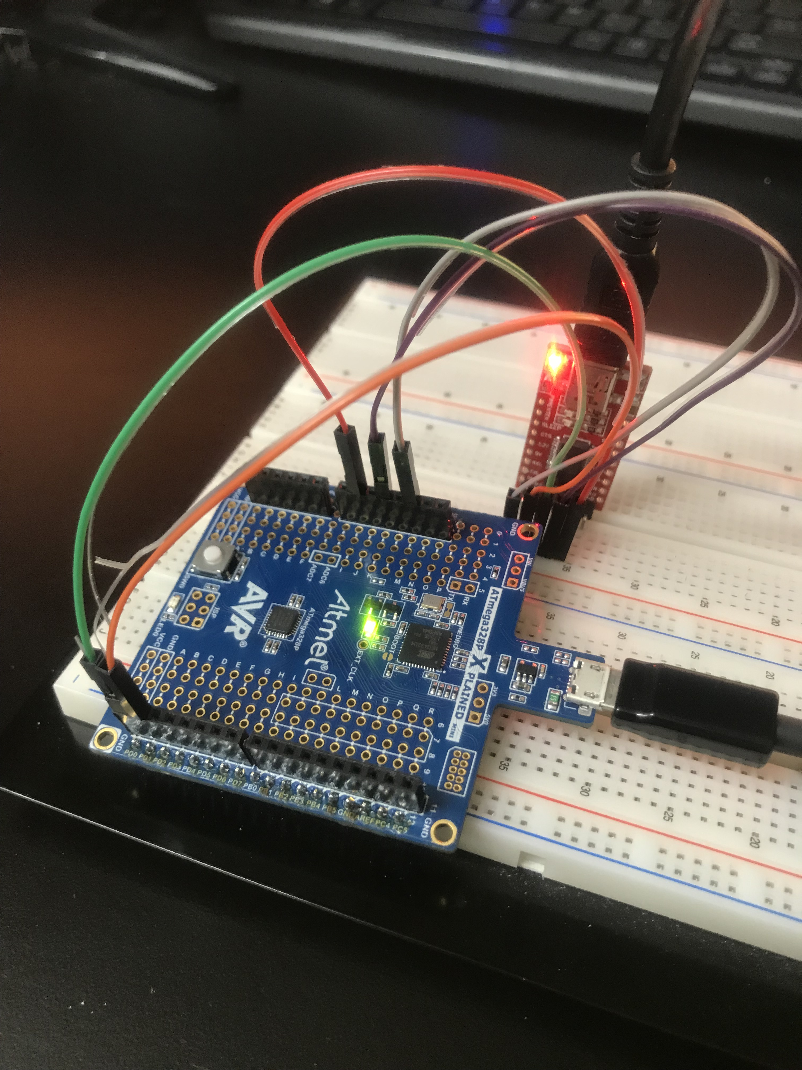

1. **VIDEO LINKS OF EACH DEMO**

DA3A

<https://youtu.be/vQLKcaiOqFk>

1. **GITHUB LINK OF THIS DA**

**Student Academic Misconduct Policy**

<http://studentconduct.unlv.edu/misconduct/policy.html>

“This assignment submission is my own, original work”.

Francisco Mata Carlos