Group Project Documentation   
Advanced Cross-Platform Application Programming with .NET

*Coffee Shop Management*

**Prepared by Group6**

***Tang Chi Cuong***

***Nguyen Quang Dung***

***Tran Khai Minh Khoi***

**Ho Chi Minh City, 2022**

**Table of Contents**

**1.** **Project Introduction 1**

1.1 Product Perspective 1

1.2 User Classes and Characteristics 1

**2.** **Database Design 1**

**3.** **System Architecture 1**

**4.** **Implementation 2**

4.1. Deployment Considerations 2

4.2. Screenshots and explanations 2

**5.** **References 3**

# Project Introduction

## Product Perspective

This is a web application for users to manage their coffee shop. Owner can manage the shop’s staffs, products, storage and bills,

This application will ease the manual documentation for the shop owner, reduce staffs’ work as well as consistently store and share information between staffs and shop owner.

## User Classes and Characteristics

* This project will have 2 main user classes:
* Shop’s owner
* Shop’s employee
* Each user class will be able to perform some functions, and there will be functions that are automatically executed by the system when the requirements are met. And there will be general functions that can be performed by both the owner and the employee.
* Functions for shop’s owner:
* The owner can create and edit an employee’s account information
* The owner can create and edit a product’s information
* The owner can create and edit a voucher’s information
* The owner can create and edit a category’s information
* The owner can create and edit a supplier’s information
* The owner can view the invoice after ordering products from the supplier
* The owner can order ingredients from the supplier
* The owner can view all bills’ detail and sort them by date/ total price
* Admin can see the notifications from the staff
* Staffs can create notifications and view their notifications

**Business Rules**

* Products, Categories, Staffs, Suppliers shall not be deleted from the database. To delete them, only change their status to False
* Only Staffs can Create and Edit bills of their own, Admin can only view bills
* Vouchers can only be used when it is not expired and usage count is greater or equal to 1
* Staff email and username must be unique

# Database Design

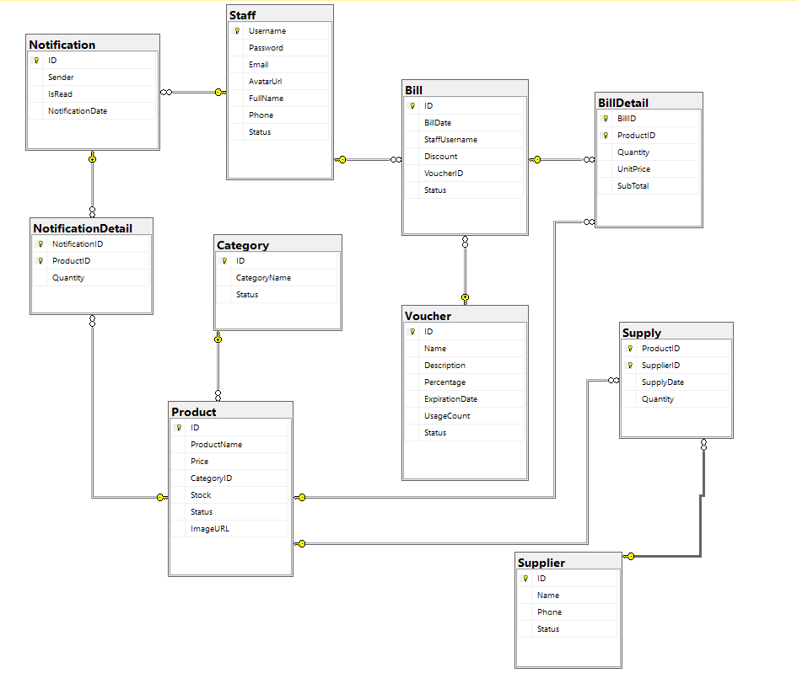

**Entity Relationship Diagram**

# System Architecture

* The 3-layer architecture is used in this application
* Data objects layer contains entity classes and Database context class
* Data access layer contains Repositories to access database
* Web layer to present data for the clients

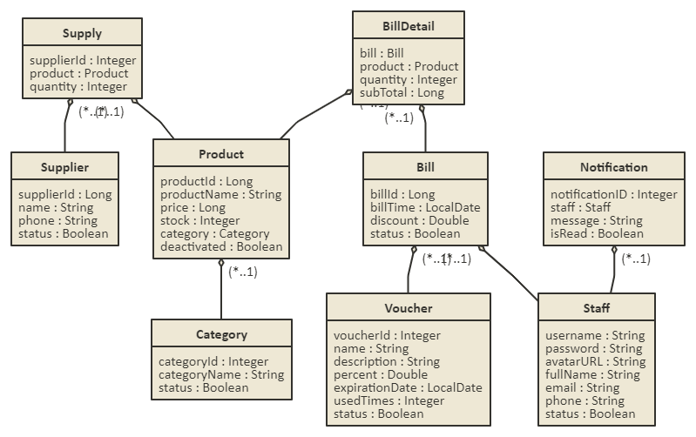

**Class diagram**

# Implementation

## Deployment Considerations

The application will be deployed on a web server, we have to make sure that server works 90% of the time. Users have to be able to connect to the internet in order to use the application.