Group Project Documentation   
Building Cross-Platform Back-End Application With .NET

***OnlyFunds***

**Prepared by Group 6**

***Tăng Chí Cường***

***Nguyễn Quang Dũng***

***Trần Khải Minh Khôi***

***Trần Phạm Kim Sơn***

**Ho Chi Minh City, 2022**

Table of Contents

1. Project Introduction 1

1.1 Product Perspective 1

1.2 User Classes and Characteristics 1

2. Database Design 3

3. System Architecture 3

4. Implementation 4

4.1. Deployment Considerations 4

4.2. Screenshots and explanations 5

**Revision History**

|  |  |  |  |
| --- | --- | --- | --- |
| **Name** | **Date** | **Reason For Changes** | **Version** |
| Chi Cuong | 20 May 2022 | Initial draft | 1.0 draft 1 |
| Quang Dung | 31 May 2022 | Updates | 1.0 |
| Chi Cuong | 16 July 2022 | Add more business rules; architecture design diagram; login screen, register screen and home page screenshots | 1.1 |
|  |  |  |  |

# Project Introduction

## Product Perspective

* OnlyFunds aims to create a platform where creators from various backgrounds can demonstrate and present their works to others. By doing so, they can receive feedback, comment or even earn from them using a donation system. Furthermore, people can utilize this product to find colleagues, other people with the same interests or just simply looking for ideas to create one for their own.
* Technologies used:
* React, React Redux and Rematch for Front-end.
* ASP .Net 6 and Entity Framework for Back-end
* Imgur API for images and videos hosting
* Microsoft SQL Server 18 for storing the database.

## User Classes and Characteristics

* **User**:
  + Manage own posts/comments/profile
  + Like posts/comments
  + Bookmark posts
  + Donate to other users
  + Follow other users
  + Report users/posts/comments
* **Admin**:
  + Manage list of users
  + Ban users
  + Manage posts/comments
  + Manage categories
  + Manage list of reports
* **Business Rules:**
  + Admin is not allowed to update/change inappropriate contents, they shall only be able to remove or lock it.
  + Donation should be processed by a trusted 3rd party API such as PayPal or MasterCard. OnlyFunds role will only act as a middleman for this payment.
  + All users must be authenticated in order to have access to all system’s functions.
  + Created/Updated Post/Comment’s creator/updater must be the currently logged in user
  + A user can’t report to the same user/comment/post multiple times unless the report is resolved.
  + A user can’t like the same post/comment more than once.
  + If a post requires donation to view, only users who have donated have accessed to that post.
  + Users don’t have access to the system if their accounts are banned.
* **Context diagram**:

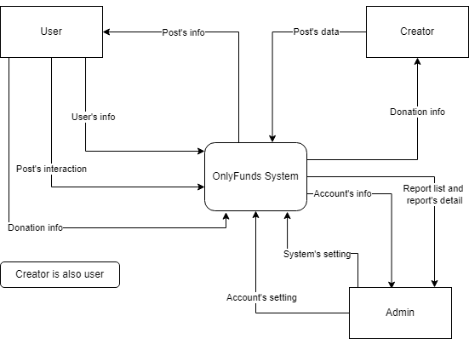

# Database Design

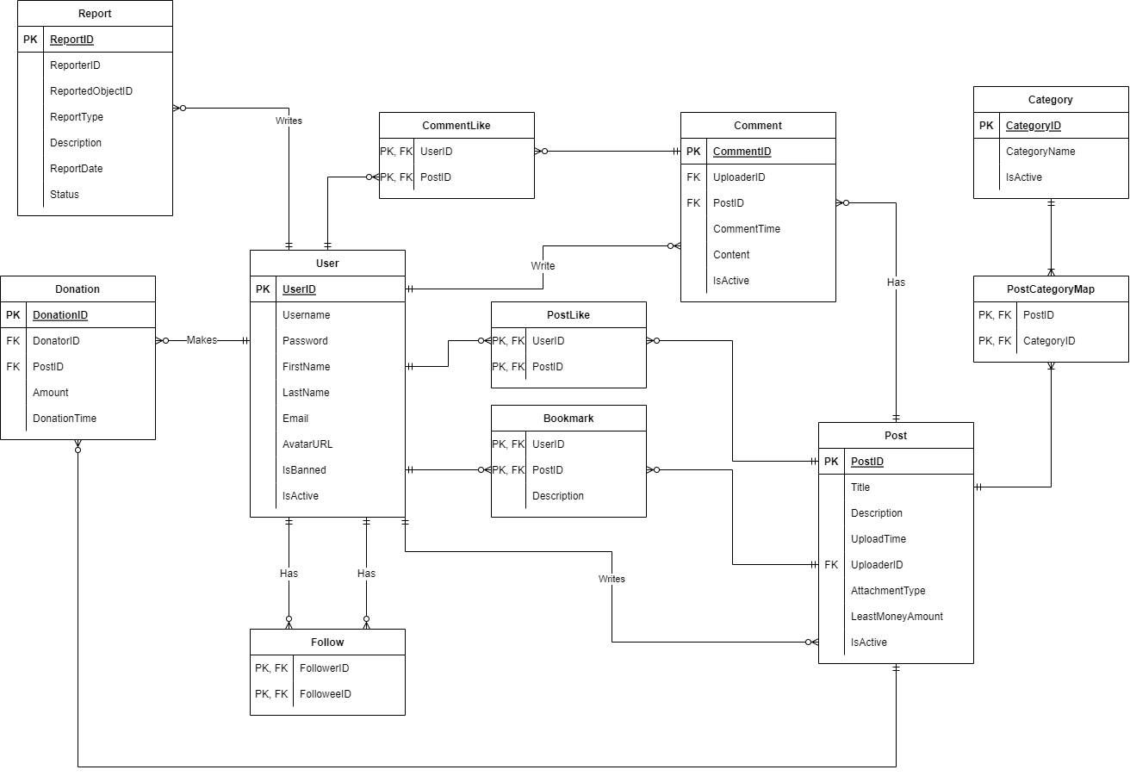

# System Architecture

* Data for the product will be stored on SQL Server. Password shall be hashed with SHA-256 before being stored inside this database. Images and videos will be hosted on the Imgur website and the URL to the content will be saved in the SQL database as a string.
* The final product will have 2 separate projects, one for the back-end part and one for the front-end part of the website. The first project will use React version 18 along with some libraries to create a user-friendly UI. This project will also act as a middleman to carry the requests from the users and call the API from the back-end to process it, then creates a response from the back-end project and displays them properly to the users. The second project will utilize the .NET 5 framework to create an API project to communicate with the database and other 3rd party sides.

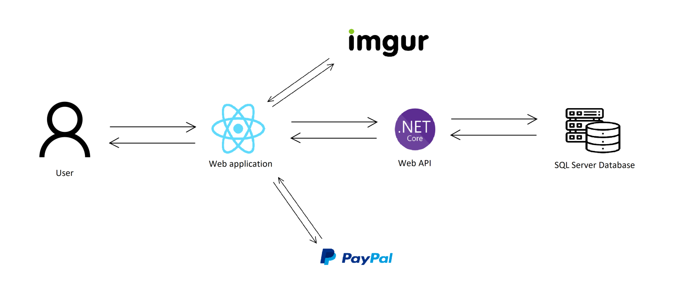

Architecture Diagram

# Implementation

## Deployment Considerations

* Deployed as a web appliction, no special skills or hardware is needed to operate and use this product, but it is advised people should have a stable internet connection to ensure the best experience when interacting with the website. Admin should create their own community standard before running the website so that inappropriate contents created by users will be done swiftly and smoothly.

## Screenshots and explanations

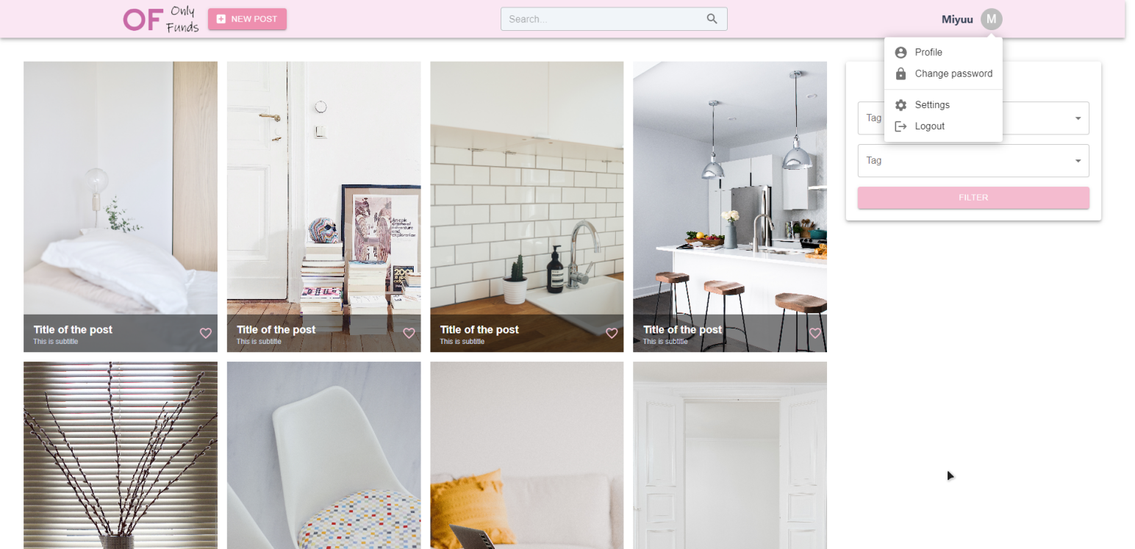

Home Screen

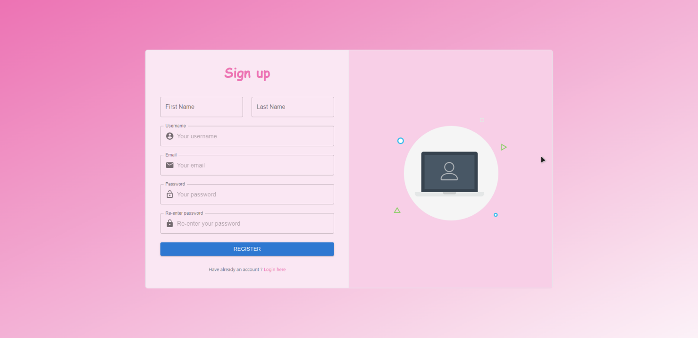

Register Screen

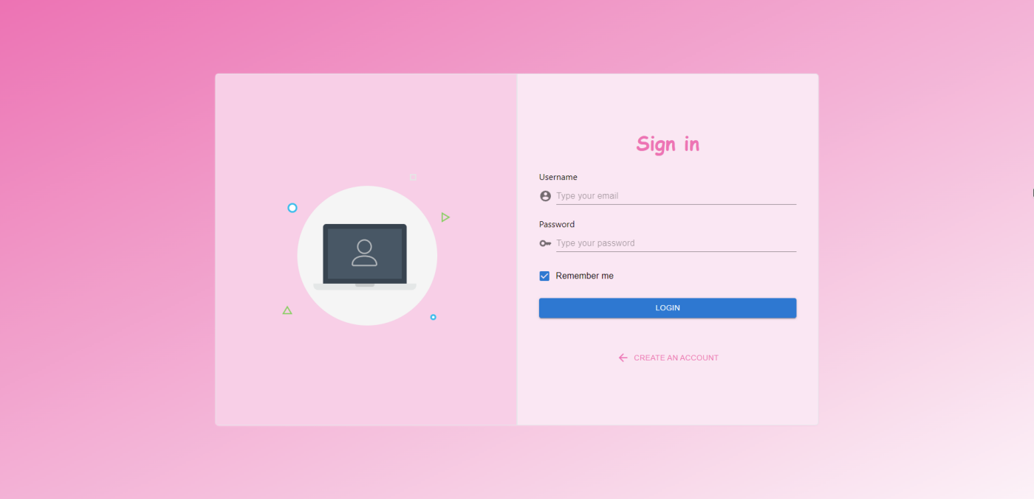

Sign in Screen