Coding challenge 1

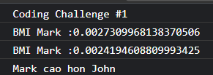

Coding challenge 2

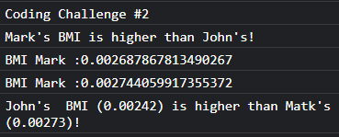

Coding challenge 3

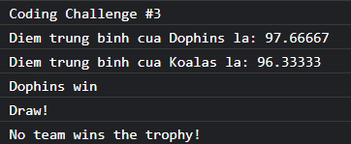

Coding challenge 4



Coding challenge 5

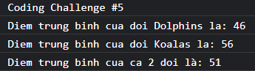

Coding challenge 6

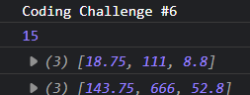

Coding challenge 7

