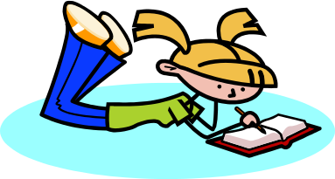Should Young Learners be taught Grammar?

Give your opinion. Write a number between 1 and 5
1 = I strongly disagree 5 = I strongly agree

Some writers say that:… | I think
1 It is clearly pointless for the teacher to attempt to teach children about grammar. Children do not have the mental capacity to understand these abstract ideas. Children learn by using patterns rather than logic.

2 We should not underestimate children’s learning abilities or intelligence. Teaching is taken more slowly but this does not mean that young learners do not have the capacity to conceptualize.

3 The knowledge underlying fluent use of language is not grammar in the sense of abstract rules or structures but a huge collection of memories of previously experienced utterances.

4 There is no good evidence for the view that language can only be acquired during communicative activity, and that grammatical study decoupled from communication does not result in acquisition.

5 Fortunately, nowadays with the emphasis on a communicative approach and a wealth of interesting resources, teaching grammar does not necessarily mean endless conjugation of verbs or grammar translation.

6 It is sometimes beneficial to the students to make a comparison to the first language in the presentation stage. This is particularly true in the case of more problematic grammatical structures which students are not able to transfer to their own language.

7 Young learners who have no grammar awareness before secondary level meet with problems, because they have not been equipped for the task of dealing with abstract language concepts.

Joanne Collie mail@jmacollie.co.uk and Hans Mol connexxions@bigpond.com
19.04.07

