# 第一单元

Classification with logistic regression

利用逻辑回归进行分类

1. Which is an example of a classification task? C
2. Based on a patient's blood pressure, determine how much blood pressure medication (a dosage measured in milligrams) the patient should be prescribed.
3. Based on a patient's age and blood pressure, determine how much blood pressure medication (measured in milligrams) the patient should be prescribed.
4. Based on the size of each tumor, determine if each tumor is malignant (cancerous) or not.

1. Recall the sigmoid function is $g(z)=\frac{1}{1+e^{−z}}$

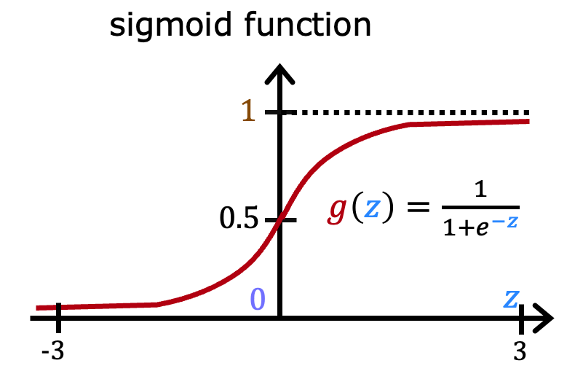

If z is a large positive number, then: B

1. $g(z)$ will be near 0.5
2. $g(z)$ is near one (1)
3. $g(z)$ will be near zero (0)
4. $g(z)$ is near negative one (-1)

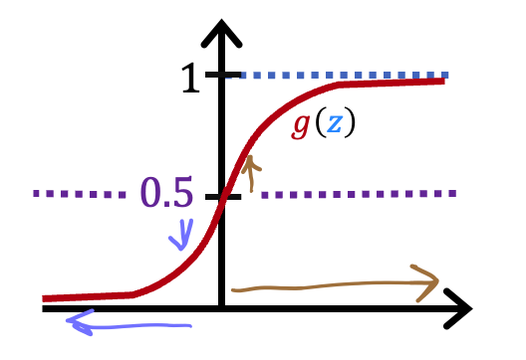

A cat photo classification model predicts 1 if it's a cat, and 0 if it's not a cat. For a particular photograph, the logistic regression model outputs $g(z)$ (a number between 0 and 1). Which of these would be a reasonable criteria to decide whether to predict if it’s a cat? D

1. Predict it is a cat if $g(z)$ < 0.7
2. Predict it is a cat if $g(z)$ < 0.5
3. Predict it is a cat if $g(z)$ = 0.5
4. Predict it is a cat if $g(z)$ >= 0.5
5. True/False? No matter what features you use (including if you use polynomial features), the decision boundary learned by logistic regression will be a linear decision boundary. A
6. True
7. False

# 第二单元

Cost function for logistic regression

逻辑回归的代价函数

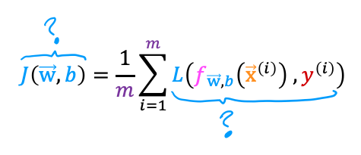

In this lecture series, "cost" and "loss" have distinct meanings. Which one applies to a single training example? A

1. Loss
2. Cost
3. Both Loss and Cost
4. Neither Loss nor Cost

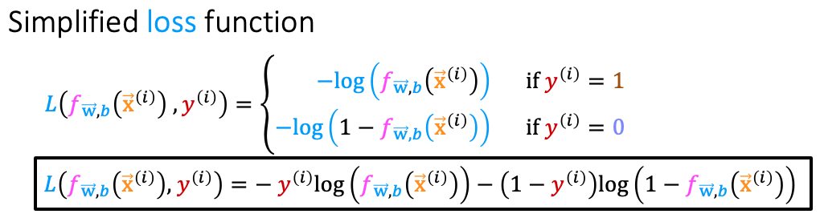

For the simplified loss function, if the label $y^{(i)}=0$，then what does this expression simplify to? C

$log⁡(1−f_{\vec{w},b}(x^{(i)}))+log(1−f_{\vec{w},b}(x^{(i)}))$

$log⁡(f_{\vec{w},b}(x^{(i)})$

$−log⁡(1−f_{\vec{w},b}(x^{(i)}))$

$−log⁡(1−f_{\vec{w},b}(x^{(i)}))−log(1−f_{\vec{w},b}(x^{(i)}))$

# 第三单元

Gradient descent for logistic regression

逻辑回归的梯度下降

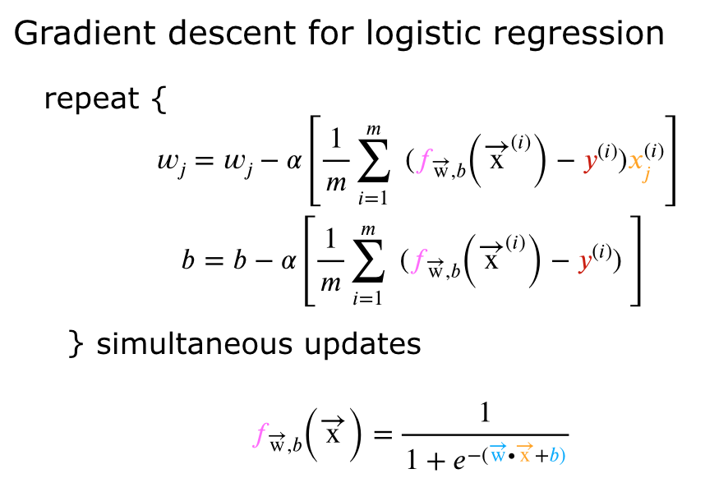

Which of the following two statements is a more accurate statement about gradient descent for logistic regression? B

1. The update steps are identical to the update steps for linear regression.
2. The update steps look like the update steps for linear regression, but the definition of $f_{\vec{w},b}(x^{(i)})$ is different.

# 第四单元

The problem of overfitting

过拟合问题

1. Which of the following can address overfitting? A
2. Apply regularization
3. Select a subset of the more relevant features.
4. Remove a random set of training examples
5. Collect more training data
6. You fit logistic regression with polynomial features to a dataset, and your model looks like this.

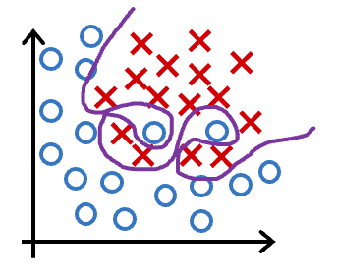

What would you conclude? (Pick one) C

1. The model has high bias (underfit). Thus, adding data is likely to help
2. The model has high bias (underfit). Thus, adding data is, by itself, unlikely to help much.
3. The model has high variance (overfit). Thus, adding data is, by itself, unlikely to help much.
4. The model has high variance (overfit). Thus, adding data is likely to help

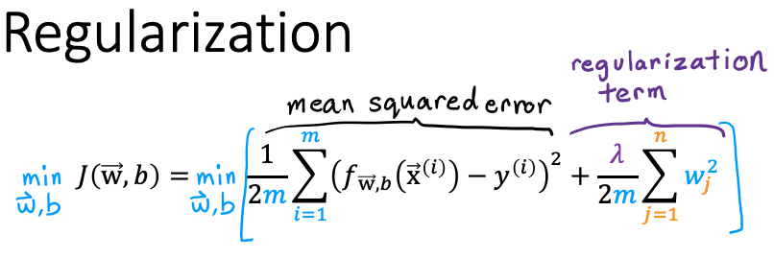  
Suppose you have a regularized linear regression model.  If you increase the regularization parameter $\begin{aligned}λ\end{aligned}$, what do you expect to happen to the parameters $w_{1},w_{2},...,w_{n}$？ A

1. This will reduce the size of the parameters $w_{1},w_{2},...,w_{n}$
2. This will increase the size of the parameters $w_{1},w_{2},...,w_{n}$