# 第一单元

Neural networks intuition

神经网络的直观了解

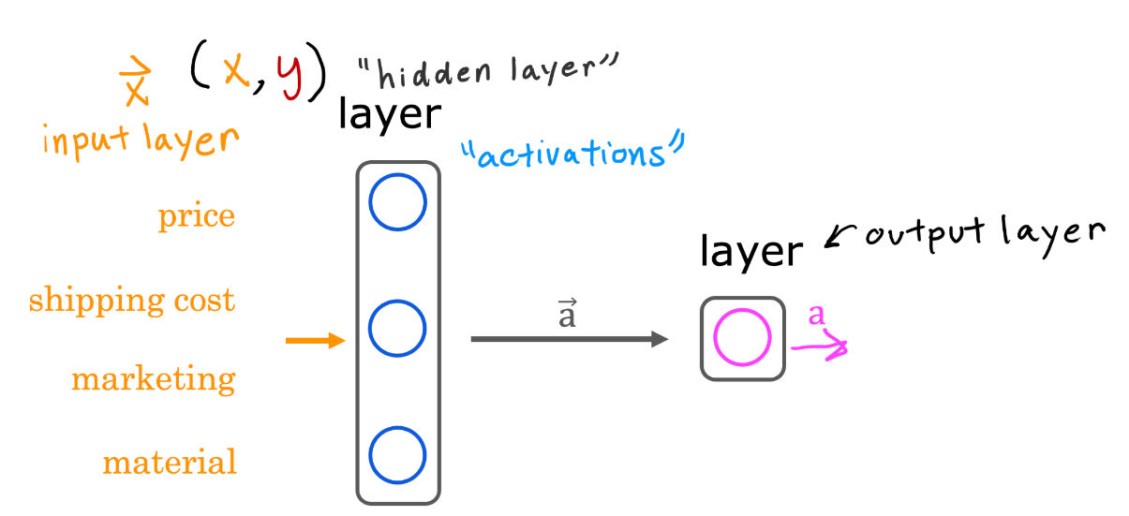

Which of these are terms used to refer to components of an artificial neural network? (hint: three of these are correct) B C D

1. axon
2. neurons
3. activation function
4. layers
5. True/False? Neural networks take inspiration from, but do not very accurately mimic, how neurons in a biological brain learn. A
6. True
7. False

# 第二单元

Neural network model

神经网络模型

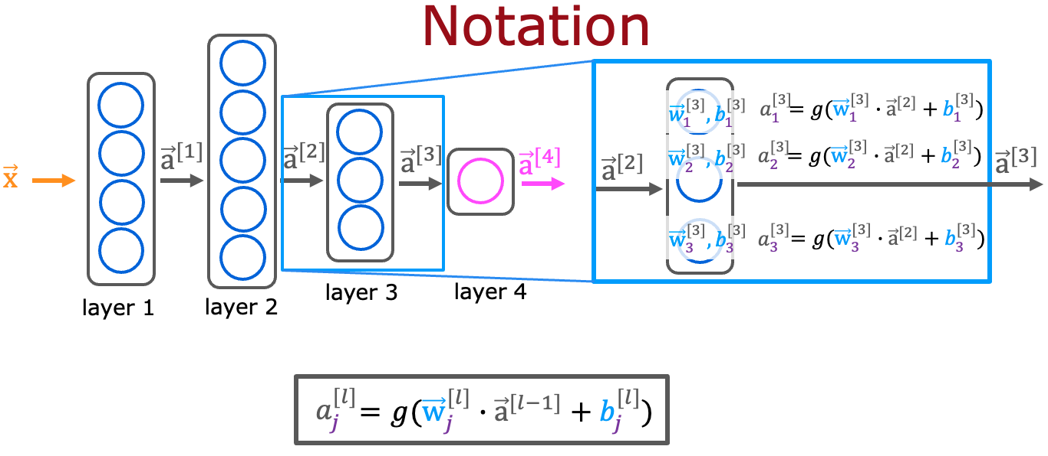

For a neural network, what is the expression for calculating the activation of the third neuron in layer 2? Note, this is different from the question that you saw in the lecture video. A

$a_{3}^{[2]}=g({\vec{w}}_{3}^{[2]}⋅{\vec{a}}^{[1]}+b_{3}^{[2]})$

$a_{3}^{[2]}=g({\vec{w}}_{2}^{[3]}⋅{\vec{a}}^{[2]}+b_{2}^{[3]})$

1. 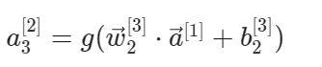

$a_{3}^{[2]}=g({\vec{w}}_{3}^{[2]}⋅{\vec{a}}^{[2]}+b_{3}^{[2]})$

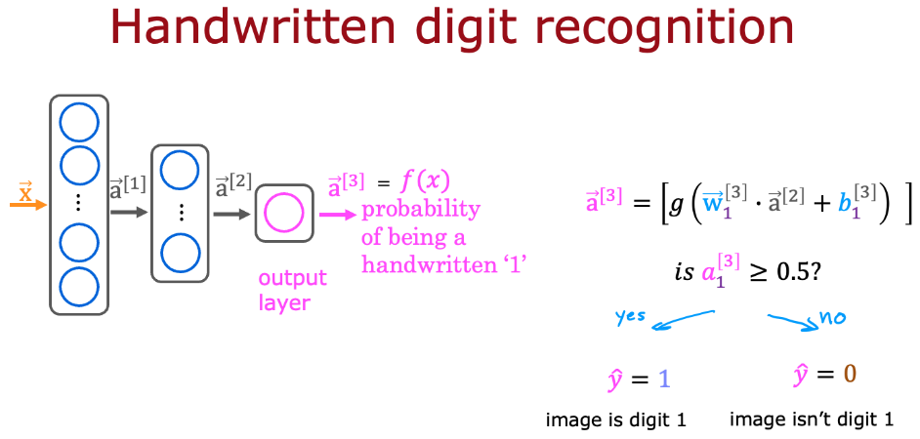

For the handwriting recognition task discussed in lecture, what is the output $a_{1}^{[3]}$？ B

1. A number that is either exactly 0 or 1, comprising the network’s prediction
2. The estimated probability that the input image is of a number 1, a number that ranges from 0 to 1.
3. A vector of several numbers that take values between 0 and 1
4. A vector of several numbers, each of which is either exactly 0 or 1

# 第三单元

TensorFlow implementation

TensorFlow 的实现

1. For the the following code:

model = Sequential([

Dense(units=25, activation="sigmoid"),

Dense(units=15, activation="sigmoid"),

Dense(units=10, activation="sigmoid"),

Dense(units=1, activation="sigmoid")])

This code will define a neural network with how many layers? C

1. 5
2. 3
3. 4
4. 25

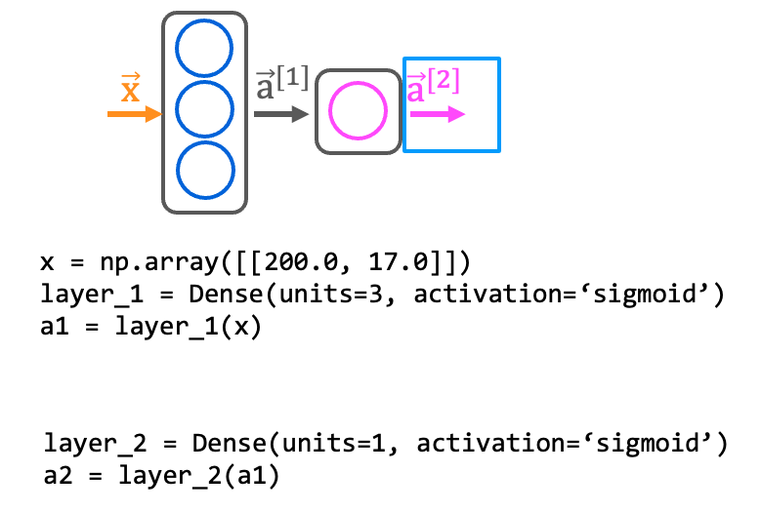

How do you define the second layer of a neural network that has 4 neurons and a sigmoid activation? B

1. Dense(layer=2, units=4, activation = ‘sigmoid’)
2. Dense(units=4, activation=‘sigmoid’)
3. Dense(units=[4], activation=[‘sigmoid’])
4. Dense(units=4)

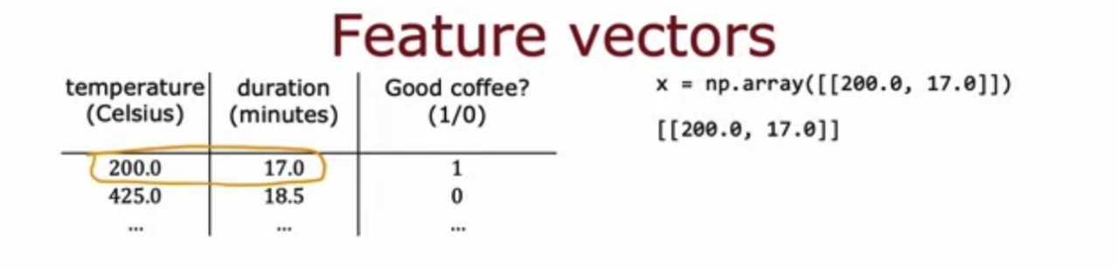

If the input features are temperature (in Celsius) and duration (in minutes), how do you write the code for the first feature vector x shown above? B

1. x = np.array([[200.0],[17.0]])
2. x = np.array([[200.0, 17.0]])
3. x = np.array([[‘200.0’, ’17.0’]])
4. x = np.array([[200.0 + 17.0]])

# 第四单元

Neural network implementation in Python

用 Python 实现神经网络

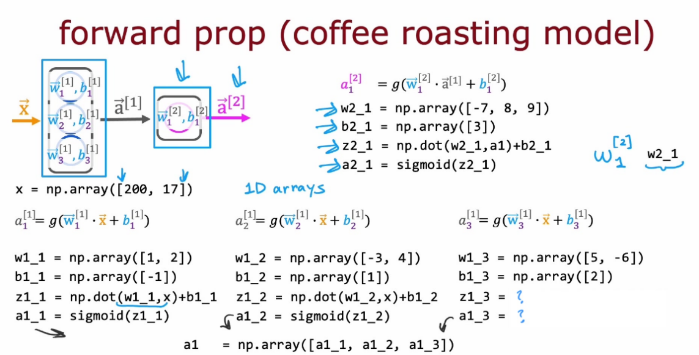

According to the lecture, how do you calculate the activation of the third neuron in the first layer using NumPy? C

1. z1_3 =w1_3 * x + b

a1_3 = sigmoid(z1_3)

1. layer_1 = Dense(units=3, activation='sigmoid')

a_1 = layer_1(x)

1. z1_3 = np.dot(w1_3, x) + b1_3

a1_3 = sigmoid(z1_3)

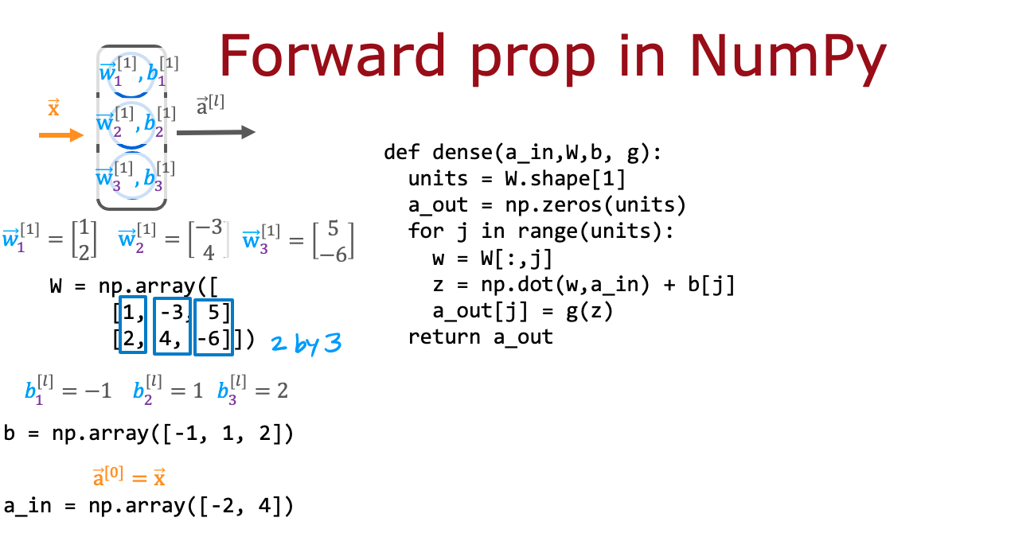

According to the lecture, when coding up the numpy array W, where would you place the w parameters for each neuron? B

1. In the columns of W.
2. In the rows of W



For the code above in the "dense" function that defines a single layer of neurons, how many times does the code go through the "for loop"? Note that W has 2 rows and 3 columns. C

1. 6 times
2. 2 times
3. 3 times
4. 5 times