Enterprise-Wide AI Agent Use Case Taxonomy
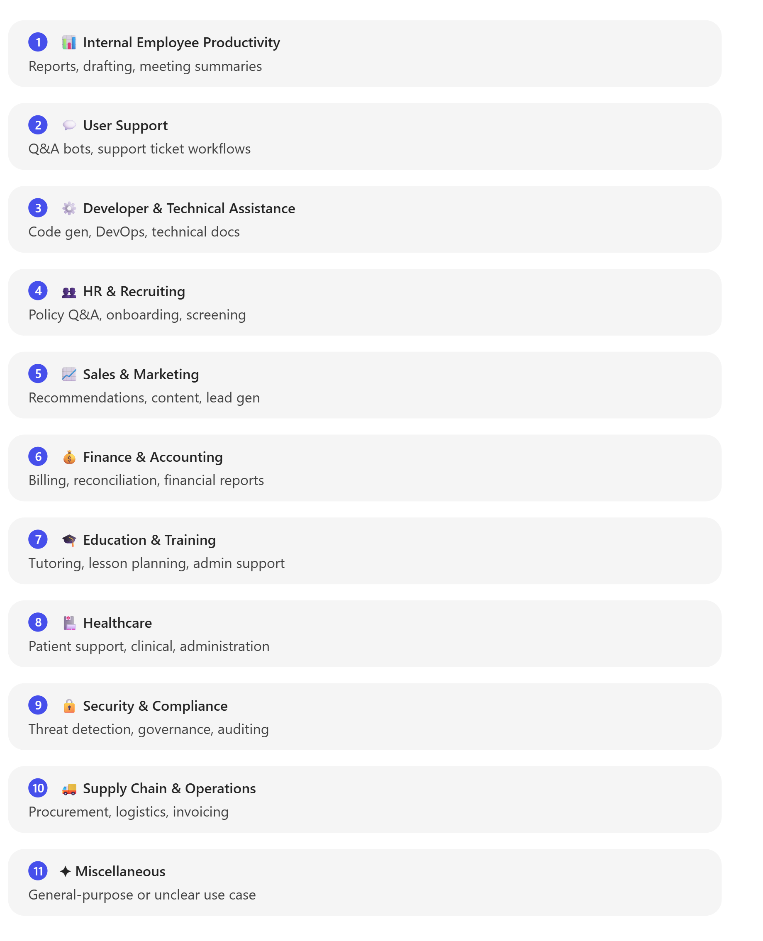

Overview
This taxonomy defines 11 top-level (L1) categories and 27 L2 sub-types for classifying AI agent use cases across an enterprise. The categories were defined by the MCS User Research team, built from real customer studies and surveys. The purpose is to provide a shared language that enables consistent comparison across tenants, industries, and time periods — serving early intake, triage, portfolio reporting, and high-level prioritization.
Every agent use case should be mapped to one L1 category and one L2 sub-type in this framework. It functions as a field playbook for use case conversations: when a customer describes what they are trying to do, the taxonomy locates it and connects it to comparable data.
The taxonomy is mutually exclusive at the L1 level — each use case receives exactly one primary category based on its dominant business purpose. Optional secondary tags (described at the end) can be layered on top without creating hierarchy complexity.

Full L1 → L2 Taxonomy Reference
The complete mapping of 11 L1 categories to 27 L2 sub-types is reproduced below:
# | L1 Category | L2 Sub-Types
01 | Internal Employee Productivity | Report & Data Analysis · Writing & Drafting · Meeting Summarization
02 | User Support | Question Answer Bot · Automated Support Workflows
03 | Developer & Technical Assistance | DevOps Automation · Code Generation · Technical Documentation
04 | HR & Recruiting | HR Policy & Q&A · HR Automation Workflows · Screening & Interviewing
05 | Sales & Marketing | Personalization & Recommendations · Marketing Content Creation · Lead Generation & Qualification
06 | Finance & Accounting | Reconciliation & Billing · Financial Report Generation
07 | Education & Training | Content Creation & Lesson Planning · Student Learning Support · Admin & Teacher Support
08 | Healthcare | Patient Support · Clinical Support & Monitoring · Healthcare Administration
09 | Security & Compliance | Threat Detection & Response · Governance & Auditing
10 | Supply Chain & Operations | Production & Procurement · Logistics & Invoicing
11 | Miscellaneous | Miscellaneous
Within each L1 category, the L2 sub-types capture the specific workflow the agent performs. For example, HR splits into Policy Q&A, Automation Workflows, and Screening — three distinct use cases with different automation potential and different buyer personas. This two-level structure moves classification from "what's the category" to "what's the exact motion".

Real-World Usage Distribution
Platform consumption data provides empirical context for category prioritization. In a classified cohort of 30,600 agents across 1,991 tenants generating 79M credits (28-day window ending March 31), agent intent categorizations were assigned using LLM-based classification of agent instructions.
Key concentration findings:
- Internal Employee Productivity and User Support together account for ~67% of consumption and ~62% of agent count — these are the foundational, validated use cases at scale.
- The top 5 L1 categories (out of 11, including Miscellaneous) account for ~88% of total credits and ~76% of agent count.
- At L2, Question Answer Bot leads on both dimensions: 18.5M credits (25% of consumption) and 5,474 agents (19% of count), reflecting broad distributed usage rather than a single large deployment. Report & Data Analysis is the second most common agent type by count at 5,344 agents.
Autonomous consumption multiplier by L1 category (median credits for autonomous agents ÷ median credits for non-autonomous agents in the same scenario):
L1 Category | Non-Autonomous (median) | Autonomous (median) | Multiplier
Supply Chain & Operations | 44 | 248 | 5.6×
Developer & Tech Assistance | 39 | 193 | 4.9×
Internal Employee Productivity | 31 | 129 | 4.2×
Security & Compliance | 30 | 123 | 4.1×
Healthcare | 34 | 143 | 4.1×
Finance & Accounting | 33 | 115 | 3.5×
User Support | 39 | 135 | 3.4×
Education & Training | 26 | 52 | 2.0×
HR & Recruiting | 46 | 85 | 1.8×
Sales & Marketing | 34 | 43 | 1.3×
Every L1 category shows a positive multiplier — no scenario where going autonomous reduces consumption. The highest-multiplier categories share a common characteristic: structured, repetitive, multi-step workflows where an autonomous agent replaces a human decision loop rather than just answering a question.
Tradeoff note: High multiplier categories (Supply Chain, Developer, Security) represent the largest consumption upside when deploying autonomous agents, but they also tend to involve more complex integrations and governance requirements. Categories with lower multipliers (HR, Sales & Marketing) may be easier to deploy as non-autonomous assistive agents — the right choice depends on the balance of value vs. complexity for each use case.

Category Definitions, Examples & Assignment Guidance

1. Internal Employee Productivity
Definition: Agents that assist employees in general knowledge work and productivity tasks — boosting efficiency in day-to-day internal workflows across roles. Not tied to a single corporate function; they span departments to help with routine cognitive tasks.
L2 Sub-Types:
- Report & Data Analysis — Aggregating data and generating reports, dashboards, or analytical summaries
- Writing & Drafting — Creating documents, emails, presentations, or other written outputs
- Meeting Summarization — Condensing meeting transcripts, extracting action items, and creating follow-up notes
Typical Examples: An agent that summarizes internal reports and meeting transcripts to help employees prepare status updates; an agent that drafts executive briefings from multiple internal data sources; a data analysis assistant that generates quarterly performance dashboards from Excel data.
When to Assign: Use this category if the agent's primary goal is to help employees get work done faster or better without being specific to one business domain. If the agent's function is broadly applicable (summarizing content, scheduling, writing, searching internal data) and intended for internal users across various teams, it belongs here. Do not use this category for use cases focused on a specific department's core processes (e.g., HR policy Q&A, financial reconciliation) — those belong in the respective functional category.

2. User Support
Definition: Agents dedicated to answering questions, resolving issues, or providing guidance to end-users — whether external customers or internal employees in a helpdesk scenario. The focus is on interactive Q&A, troubleshooting, and ticket handling in support contexts.
L2 Sub-Types:
- Question Answer Bot — Self-service Q&A that retrieves answers from knowledge bases, FAQs, or documentation
- Automated Support Workflows — Agents that handle ticket triage, routing, escalation, or multi-step resolution flows
Typical Examples: A customer service chatbot answering product questions and troubleshooting common issues; an IT helpdesk agent walking employees through software setup; an automatic ticket triage and routing system that categorizes and assigns incoming support requests.
When to Assign: Choose User Support if the core function is providing help or information in response to user inquiries or support tickets. This includes autonomous Tier-1 support bots, knowledge base Q&A agents, and service desk assistants. Distinguish from other categories: If the agent is chiefly engaged in Q&A or guiding users through problem resolution, it fits here. However, if the agent's function is deeply tied to a specific domain (e.g., an HR-only policy bot), consider classifying it under that domain for better alignment with business owners.

3. Developer & Technical Assistance
Definition: Agents that help with software development, IT operations, or other technical tasks, serving technical users (developers, engineers, IT professionals) by automating or streamlining coding, debugging, infrastructure management, and similar workflows.
L2 Sub-Types:
- DevOps Automation — CI/CD pipelines, infrastructure management, and deployment automation
- Code Generation — Writing, debugging, reviewing, and refactoring code
- Technical Documentation — API docs, architecture diagrams, and system specifications
Typical Examples: A code review assistant that suggests improvements or identifies errors; a DevOps bot managing build deployments or monitoring infrastructure; an agent that generates technical design documents or API reference documentation.
When to Assign: Use this category if the use case is for developers or IT staff, or involves automating technical processes. The key is that the agent facilitates technical work or provides technical knowledge (coding, software troubleshooting, infrastructure tasks). If an agent is more about general user support (non-technical Q&A) or business data analysis (without a coding focus), consider User Support or Internal Employee Productivity instead.

4. HR & Recruiting
Definition: Agents that automate or assist with human resources processes or employee management tasks — supporting HR personnel or all employees in areas like onboarding, HR policy information, and talent recruitment.
L2 Sub-Types:
- HR Policy & Q&A — Questions about company policies, benefits, time-off, and workplace guidelines
- HR Automation Workflows — Leave requests, onboarding, offboarding, payroll inquiries
- Screening & Interviewing — Candidate screening, interview scheduling, and resume review
Typical Examples: An HR virtual assistant answering employee questions on policies, benefits, or time-off; agents processing leave requests or expense approvals; recruiting agents that screen resumes, schedule interviews, or rank applicants.
When to Assign: Choose this category if an agent's functionality is primarily in the HR domain — managing people-related processes or information. This covers both employee-facing HR assistants and HR staff productivity agents. If the agent is simply providing generic Q&A support not specifically related to HR content, consider User Support instead. If it's an internal knowledge or productivity tool used by all employees beyond HR topics, Internal Employee Productivity may be a better fit.
Autonomous multiplier context: HR & Recruiting shows a 1.8× autonomous multiplier, suggesting that many HR use cases (particularly HR Policy & Q&A, which shows a 0.7× sub-1 multiplier at L2) are better served by conversational, non-autonomous formats rather than fully autonomous agents.

5. Sales & Marketing
Definition: Agents that support sales, business development, and marketing functions — helping drive revenue and customer engagement through lead management, personalized outreach, content creation, and market intelligence.
L2 Sub-Types:
- Personalization & Recommendations — Tailored product suggestions, customer segmentation, and personalized outreach
- Marketing Content Creation — Generating marketing copy, campaign materials, and brand content
- Lead Generation & Qualification — Scoring leads, qualifying prospects, and managing pipeline
Typical Examples: A lead qualification agent scoring incoming prospects and suggesting next steps for sales reps; an agent personalizing marketing emails or product recommendations; a market research assistant analyzing customer feedback or competitor data.
When to Assign: Use this category if the agent's main purpose is to boost sales processes or marketing efforts — customer outreach, lead management, sales enablement, campaign optimization, content marketing, or market analysis. If a use case focuses on direct customer service or support after a sale, classify it under User Support. The distinction: Sales & Marketing agents work to attract, engage, or convert customers and drive revenue, rather than troubleshooting issues or answering post-sale support questions.
Autonomous multiplier context: Sales & Marketing shows the lowest autonomous multiplier at 1.3×, and the Personalization & Recommendations L2 sub-type shows a 0.5× sub-1 multiplier. This indicates that many sales and marketing use cases work effectively as non-autonomous, conversational agents rather than fully autonomous ones.

6. Finance & Accounting
Definition: Agents that handle financial operations, accounting tasks, or related administrative finance functions — automating calculations, data entry, compliance checks, and financial analyses to improve efficiency and accuracy in finance departments.
L2 Sub-Types:
- Reconciliation & Billing — Invoice processing, payment matching, billing automation, and account reconciliation
- Financial Report Generation — Producing financial statements, dashboards, budget forecasts, and compliance reports
Typical Examples: An agent that automates invoice processing and payment matching for accounts payable; expense report auditing bots that flag policy violations; financial planning assistants that generate budget forecasts and pull data from multiple systems; agents for fraud detection monitoring transactions for anomalies.
When to Assign: Classify a use case as Finance & Accounting if it deals with money management, financial transactions, record-keeping, or fiscal analysis — bookkeeping, billing, financial compliance, budgeting, procurement approvals, or risk assessment in finance. If the agent's primary function is managing financial data (invoices, budgets, expenses) or ensuring compliance with financial controls, it belongs here. A sales forecasting agent might fit better under Sales & Marketing if the intent is revenue planning rather than financial operations.
Autonomous multiplier context: Finance & Accounting shows a 3.5× multiplier overall, with Reconciliation & Billing at 6.5× — one of the highest L2 multipliers, indicating that autonomous agents in billing and reconciliation workflows generate significantly more value than non-autonomous alternatives.

7. Education & Training
Definition: Agents that assist with learning, knowledge dissemination, or skill development — designed for educational institutions or corporate training environments, focusing on teaching, tutoring, or training facilitation.
L2 Sub-Types:
- Content Creation & Lesson Planning — Generating curricula, learning materials, quizzes, and lesson plans
- Student Learning Support — Tutoring, answering questions on course material, and personalized learning paths
- Admin & Teacher Support — Administrative tasks for educators and institutions
Typical Examples: A tutoring chatbot helping users learn new topics by answering questions and providing explanations; an agent generating training materials (quizzes, flashcards, lesson plans) for instructors; a virtual coach providing personalized learning paths.
When to Assign: Use Education & Training for use cases where the primary goal is facilitating learning or knowledge transfer — applicable in schools, universities, or enterprise training and development programs. If the agent is more about general internal knowledge search or productivity without a structured learning curriculum, consider Internal Employee Productivity. The distinguishing factor is a focus on structured educational content, teaching interactions, or training processes.

8. Healthcare
Definition: Agents focused on medical, clinical, or healthcare operational use cases — typically appearing in healthcare organizations (hospitals, clinics) or departments dealing with health services. They assist with patient interactions, medical data analysis, or healthcare administrative tasks.
L2 Sub-Types:
- Patient Support — Patient inquiries, appointment scheduling, and health information
- Clinical Support & Monitoring — Clinical decision support, symptom checking, and provider guidance
- Healthcare Administration — Medical billing, insurance processing, and healthcare operations
Typical Examples: A patient self-service agent answering health-related FAQs or scheduling appointments; a clinical support agent helping professionals with symptom checking or treatment guideline suggestions; an agent automating healthcare billing or insurance claims processing.
When to Assign: Assign to Healthcare if the use case is explicitly aimed at health or medical contexts — patient care, clinical operations, or health administration. This category is reserved for health-specific agent tasks that wouldn't normally appear in a non-health industry. If the use case is in a healthcare setting but is essentially a generic function (e.g., an HR agent at a hospital's HR department), use the functional category (HR & Recruiting) instead.
Consumption context: Healthcare ranks 3rd in consumption (12.3%) but has only 374 agents (1.9% of the cohort). This asymmetry reflects that 93.6% of all Healthcare consumption comes from a single autonomous agent — demonstrating what one fully autonomous agent can achieve, rather than broad category adoption. Clinical Support & Monitoring shows an 8.9× autonomous multiplier, the highest of any L2 sub-type.

9. Security & Compliance
Definition: Agents that handle security monitoring, compliance enforcement, and risk management tasks — safeguarding the organization's assets, data, and processes by detecting threats, ensuring policy compliance, or automating governance.
L2 Sub-Types:
- Threat Detection & Response — Monitoring for cybersecurity threats, anomalous activity, and security incidents
- Governance & Auditing — Reviewing activity logs, enforcing policies, and automating compliance checks
Typical Examples: A cybersecurity agent monitoring network traffic and alerting on threats or anomalies; an agent automating compliance checks by scanning documents against regulatory requirements; an internal audit assistant reviewing activity logs for policy violations; a data privacy agent classifying and protecting sensitive information.
When to Assign: Use Security & Compliance if a use case's primary purpose is risk control, security operations, or compliance auditing — enforcing security policies, detecting fraud or data leaks, monitoring for regulatory compliance, or automating audits. Cases that focus on security incident support (like an IT helpdesk answering security questions) might fall under User Support if they are Q&A oriented. But if the agent's core function is actively monitoring or enforcing security/compliance (often autonomously), choose this category.
Autonomous multiplier context: Threat Detection & Response shows a 7.2× autonomous multiplier — the second highest L2 sub-type — confirming that security monitoring is a strong candidate for fully autonomous agent deployment.

10. Supply Chain & Operations
Definition: Agents addressing operational, logistical, or supply chain management tasks — optimizing or automating the backbone of business operations from procurement and inventory management to manufacturing, logistics, and delivery.
L2 Sub-Types:
- Production & Procurement — Manufacturing process automation, procurement workflows, purchase orders, and supplier management
- Logistics & Invoicing — Shipment tracking, route optimization, delivery coordination, and operational invoicing
Typical Examples: An agent managing inventory optimization by automatically reordering stock when levels run low; a procurement assistant processing purchase orders or supplier onboarding; a production scheduling agent allocating resources and timelines; a logistics coordination bot monitoring shipments and routes.
When to Assign: Assign to Supply Chain & Operations if the use case is fundamentally about physical operations, process optimization, or supply chain management — manufacturing automation, logistics and shipping, fleet management, inventory and warehouse management, procurement and vendor management, or quality control automation. If a use case is more service-oriented or internal support (like IT operations), ensure it truly deals with operations of the business. Choose this category for agents serving to enhance efficiency, accuracy, and responsiveness in production, delivery, or operational planning.
Autonomous multiplier context: Supply Chain & Operations has the highest L1 autonomous multiplier at 5.6×, with L2 sub-types Production & Procurement at 5.8× and Logistics & Invoicing at 4.6× — making this category the strongest candidate for autonomous agent deployment. The structured, repetitive, high-frequency nature of operational workflows is where autonomous agents add the most value.

11. Miscellaneous
Definition: A catch-all for use cases that do not clearly fit into the other 10 top-level categories. These may be highly specialized, novel, or multi-domain agent scenarios that are worth tracking but too unique to categorize at the top level.
Typical Examples: Experimental or very domain-specific agents not in mainstream business functions; general-purpose agents whose value proposition is still being clarified; trial scenarios or exploratory agents awaiting clearer definition.
When to Assign: Use Miscellaneous sparingly. Apply it only when a use case truly defies classification under the first 10 categories. Before choosing Miscellaneous, check if the use case's main objective aligns with an established category. If it touches several domains, determine the dominant primary purpose. Treat this category as a temporary holding place — ideally, use cases placed here are refined or reclassified into a primary category as more information becomes available. Miscellaneous provides less value for portfolio reporting, so minimise its use.
Usage note: In the classified cohort, Miscellaneous accounted for 1,816 agents (5.9%) and 4.4M credits (5.6%), and was excluded from intent analysis results.

Complementary View: Agent Capability Taxonomy
In addition to the intent-based taxonomy above, a complementary capability-based taxonomy organizes AI agents by what they do technically, rather than which business function they serve. This taxonomy groups capabilities into broad parent categories with specific functional sub-capabilities: [Agent Arch...Categories | Word]
Capability Category | Example Sub-Capabilities
Data Acquisition & Integration | Extract data from sources, integrate multiple data sources, query databases and knowledge bases, data validation, file upload
Data Analysis & Insights | Compute and analyse metrics, generate visualisations
For example, a market research agent pulling product data from a CRM and ERP to compile a unified inventory report would be classified as Data Acquisition & Integration in the capability view, but as Sales & Marketing (or Internal Employee Productivity) in the intent view. [Agent Arch...Categories | Word]
When to use which view: The intent taxonomy (the 11 L1 categories above) is the primary classification for intake, triage, and portfolio reporting — it tells you which business problem the agent solves. The capability taxonomy is useful for technical planning and platform architecture — it tells you what technical capabilities the agent needs. Both can be applied to the same use case simultaneously without conflict.

Optional Secondary Tagging Dimensions
In addition to the primary L1 category, tag each use case with secondary dimensions to aid triage and prioritisation. These tags cut across all categories to highlight key attributes without creating a deeper hierarchy.
Secondary Dimension | Values | Description | Triage Value
User Audience | Internal · External | Internal: agents used by employees (e.g., HR assistant, internal IT bot). External: agents interacting with customers or partners (e.g., customer-facing support chatbot). | Separates employee-facing vs. customer-facing solutions; external agents typically carry higher compliance and quality requirements.
Initiation Style | Reactive · Proactive | Reactive: agents that act in response to user requests or specific triggers (wait for input). Proactive: agents that initiate actions or recommendations on their own based on context or events (e.g., monitoring metrics and alerting on anomalies). | Proactive agents signal higher complexity and the need for careful design to ensure relevance and avoid user disruption.
Level of Autonomy | Assistive · Autonomous | Assistive: agents that support a human decision-maker — providing suggestions, drafts, or information for human review. Autonomous: agents with authority to act end-to-end with minimal human intervention, automating entire workflows. | Autonomous agents deliver more value through full automation but involve more risk and governance complexity. Platform data shows autonomous agents generate 1.3× to 5.6× more consumption than non-autonomous agents in the same scenario.
Usage example: A use case classified as "User Support" (primary) and tagged External, Reactive, Assistive indicates a customer-facing Q&A bot that responds when asked and requires human review for final actions. A "Finance & Accounting" agent tagged Internal, Proactive, Autonomous indicates a back-office automation that runs on its own schedule and completes transactions without human intervention.

Assignment Decision Rules — Quick Reference
When assigning a use case to a primary category, apply these rules in order:
- Identify the dominant business purpose. What is the agent fundamentally doing for the business? Classify by the primary outcome, not the technology used.
- Function-specific beats general. If a use case clearly serves a specific department's core process (HR, Finance, Security, etc.), assign it to that functional category — even if it also involves Q&A or productivity features. Internal Employee Productivity and User Support are intended for use cases that are broadly applicable rather than department-specific.
- Distinguish support from function. If an agent provides Q&A or issue resolution as its primary mode, it is User Support. If the same Q&A is narrowly scoped to one domain (HR policies only, clinical guidelines only), consider the domain category for better business alignment.
- Industry-specific categories (Healthcare) are reserved for domain-specific tasks. A hospital's scheduling agent for patients is Healthcare; the same hospital's internal HR assistant is HR & Recruiting. Industry context alone does not determine the category — the agent's functional purpose does.
- When in doubt, choose the category whose L2 sub-types best describe the agent's workflow. The L2 sub-types provide the specificity needed to resolve borderline cases.
- Use Miscellaneous as a last resort. Always attempt to classify into one of the first 10 categories before resorting to Miscellaneous. If you must use it, plan to reclassify as the use case is refined.

Summary
This taxonomy provides a concise, mutually exclusive, research-backed classification for AI agent use cases at the enterprise level. Its 11 L1 categories and 27 L2 sub-types are grounded in real customer studies and surveys conducted by the MCS User Research team, and validated against production consumption data spanning 30,600 classified agents across 1,991 tenants. Combined with optional secondary tags for user audience, initiation style, and autonomy level, the framework supports consistent evaluation and comparison of diverse AI agent projects. Assign each new use case a primary L1 category based on what the agent fundamentally does for the business, then layer on secondary tags as needed to inform triage, governance, and prioritisation decisions.

Industry Classification Guidance
Purpose
The Industry field is used to indicate the primary vertical or market context in which the agentic use case applies. This can also be mapped to the Customer industry if the customer name is known and identifiable.
This helps users understand where the use case is most commonly applicable, not where it is technically deployable.

Selection Rules
When assigning an Industry:
- Select one primary industry only
- Choose the industry that best represents the business context, not the technology
- If the use case is broadly applicable across multiple industries, select Cross-Industry / Horizontal
- Do not infer industry from department or function alone

Industry Options (Canonical List)
The agent must select one of the following values:
- Cross-Industry / Horizontal
- Financial Services
- Healthcare & Life Sciences
- Retail & Consumer Goods
- Manufacturing
- Energy & Utilities
- Telecommunications & Media
- Technology & Software
- Public Sector
- Transportation & Logistics
- Travel & Hospitality
- Professional Services
- Real Estate & Construction
- Non-Profit

