AAKASH JAISWAL

RA1911003010289

E1 – SECTION

AI lab – EXPERIMENT 1 – TOY PROBLEM

**AIM**

To implement a 2 player Tic Tac Toe toy problem.

**PROCEDURE**

* Prepare all the functions you need to make the game.
* Prepare the 3x3 matrix and assign X and O to user and computer.
* Arrange spaces and symbols between matrix to avoid confusion and for

better look.

* Prompt user for the turn if he wants to go first or second.
* Scan the input from the user and map it on the matrix.
* Display the computers chosen grid, computer selects the grid where

there is maximum possibility to win.

* Compute the result, if all the 3 adjacent grid have same symbol, out

put the result

* Or Else give output- ‘the match is drawn’.
* Prompt the user if he wants to play again and if yes repeat the program
* Or Else exit the code

**PROGRAM/CODE:**

#include <iostream>

using namespace std;

char matrix[10] = {'0','1','2','3','4','5','6','7','8','9'};

int checkwin(){

if (matrix[1] == matrix[2] && matrix[2] == matrix[3])

return 1;

else if (matrix[4] == matrix[5] && matrix[5] == matrix[6])

return 1;

else if (matrix[7] == matrix[8] && matrix[8] == matrix[9])

return 1;

else if (matrix[1] == matrix[4] && matrix[4] == matrix[7])

return 1;

else if (matrix[2] == matrix[5] && matrix[5] == matrix[8])

return 1;

else if (matrix[3] == matrix[6] && matrix[6] == matrix[9])

return 1;

else if (matrix[1] == matrix[5] && matrix[5] == matrix[9])

return 1;

else if (matrix[3] == matrix[5] && matrix[5] == matrix[7])

return 1;

else if (matrix[1] != '1' && matrix[2] != '2' && matrix[3] != '3' && matrix[4] != '4' && matrix[5] != '5' && matrix[6] != '6' && matrix[7] != '7' && matrix[8] != '8' && matrix[9] != '9')

return 0;

else

return -1;

}

void board(){

system("cls");

cout << "\n\n\tTic Tac Toe\n";

cout<<"-------------------------\n";

cout << "Player 1 (X) - Player 2 (O)" << endl << endl;

cout << endl;

cout << " | | " << endl;

cout << " " << matrix[1] << " | " << matrix[2] << " | " << matrix[3] << endl;

cout << "_____|_____|_____" << endl;

cout << " | | " << endl;

cout << " " << matrix[4] << " | " << matrix[5] << " | " << matrix[6] << endl;

cout << "_____|_____|_____" << endl;

cout << " | | " << endl;

cout << " " << matrix[7] << " | " << matrix[8] << " | " << matrix[9] << endl;

cout << " | | " << endl << endl;

}

int main(){

int player = 1,i,choice;

char mark;

do

{

board();

player=(player%2)?1:2;

cout << "Player " << player << ", enter a number: ";

cin >> choice;

mark=(player == 1) ? 'X' : 'O';

if (choice == 1 && matrix[1] == '1')

matrix[1] = mark;

else if (choice == 2 && matrix[2] == '2')

matrix[2] = mark;

else if (choice == 3 && matrix[3] == '3')

matrix[3] = mark;

else if (choice == 4 && matrix[4] == '4')

matrix[4] = mark;

else if (choice == 5 && matrix[5] == '5')

matrix[5] = mark;

else if (choice == 6 && matrix[6] == '6')

matrix[6] = mark;

else if (choice == 7 && matrix[7] == '7')

matrix[7] = mark;

else if (choice == 8 && matrix[8] == '8')

matrix[8] = mark;

else if (choice == 9 && matrix[9] == '9')

matrix[9] = mark;

else

{

cout<<"Invalid move ";

player--;

cin.ignore();

cin.get();

}

i=checkwin();

player++;

}while(i==-1);

board();

if(i==1)

cout<<"==> \aPlayer "<<--player<<" win ";

else

cout<<"==> \aGame draw";

cin.ignore();

cin.get();

return 0;

}

**OUTPUT:**

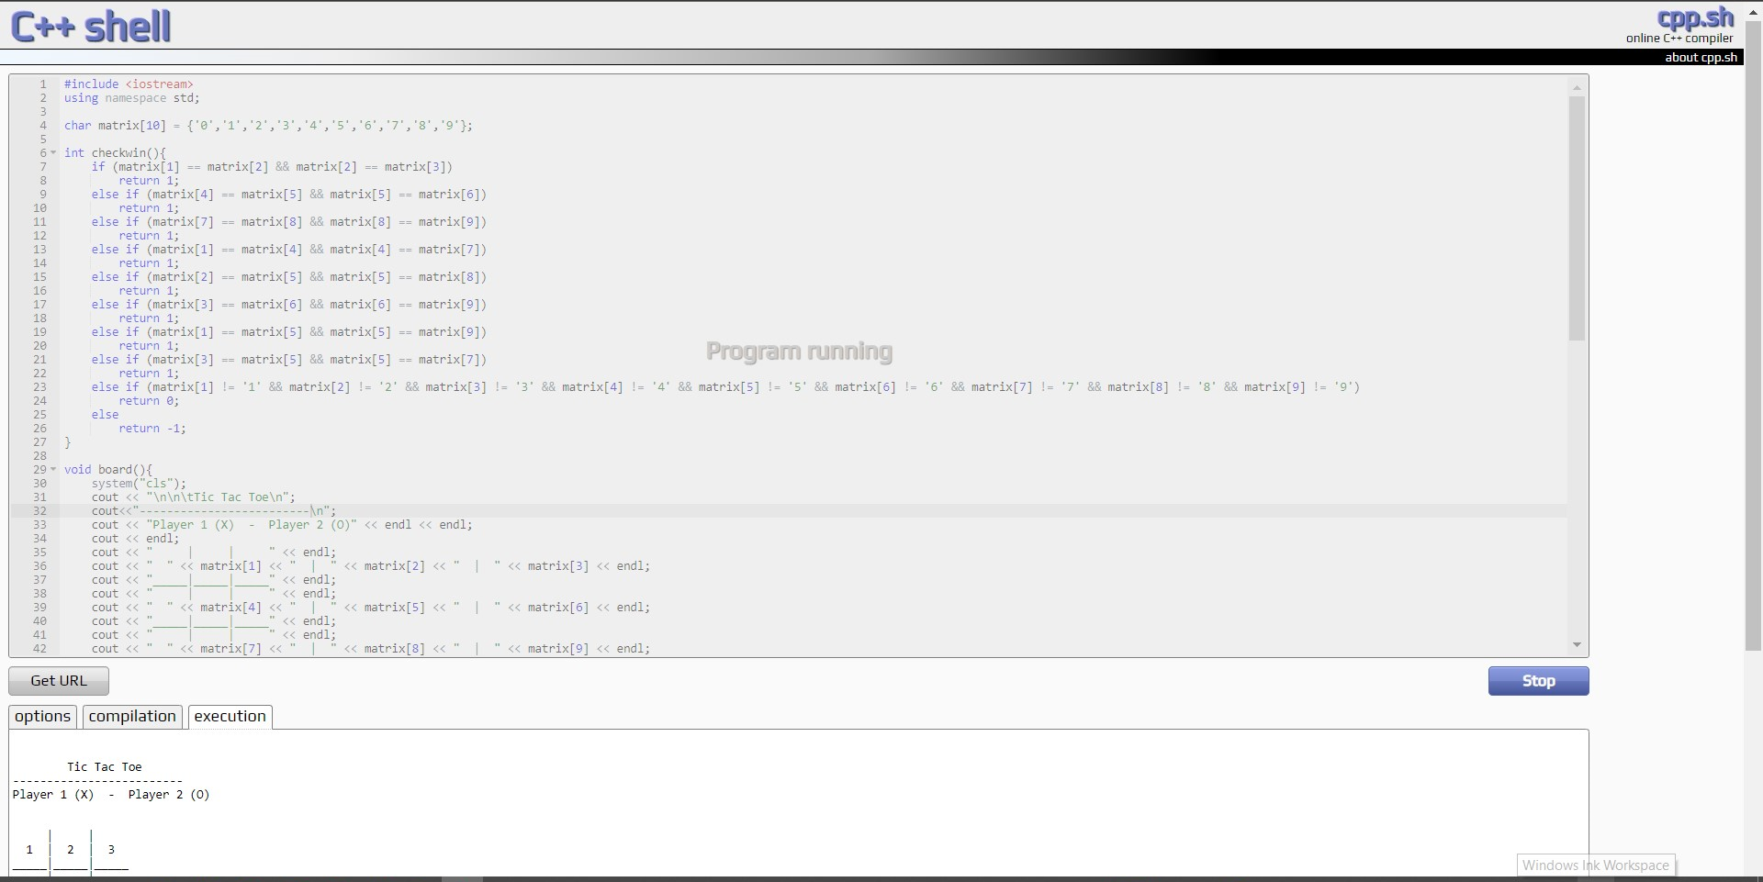

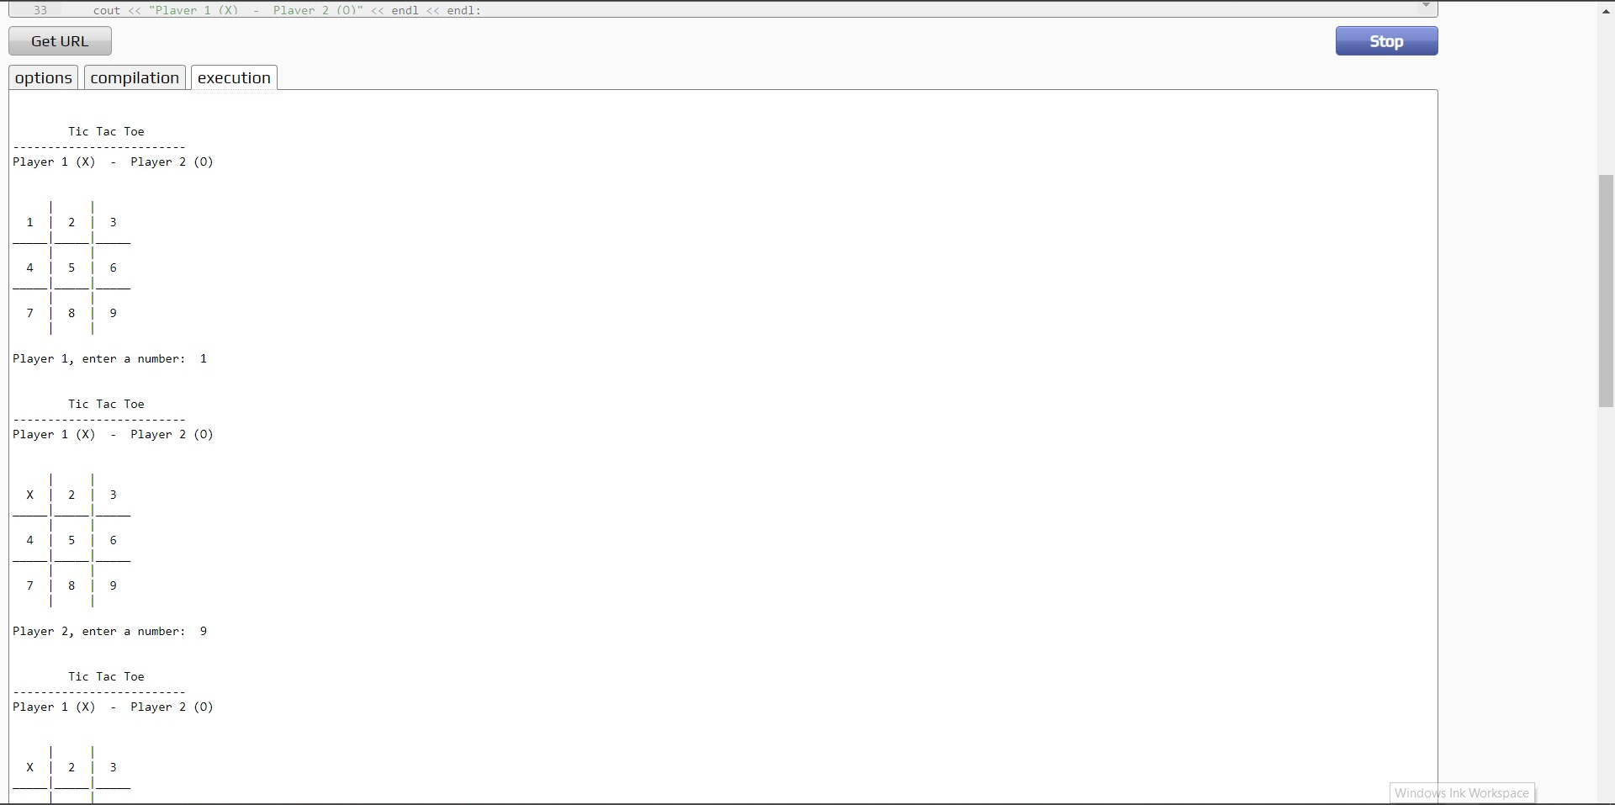

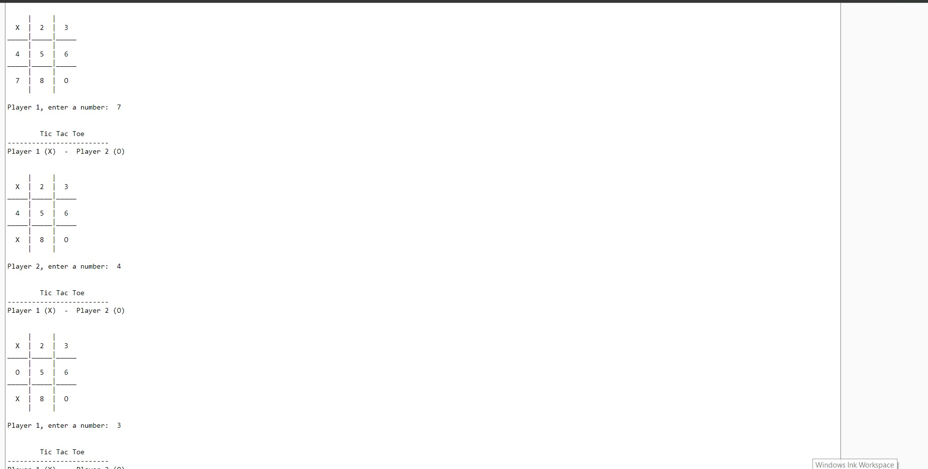

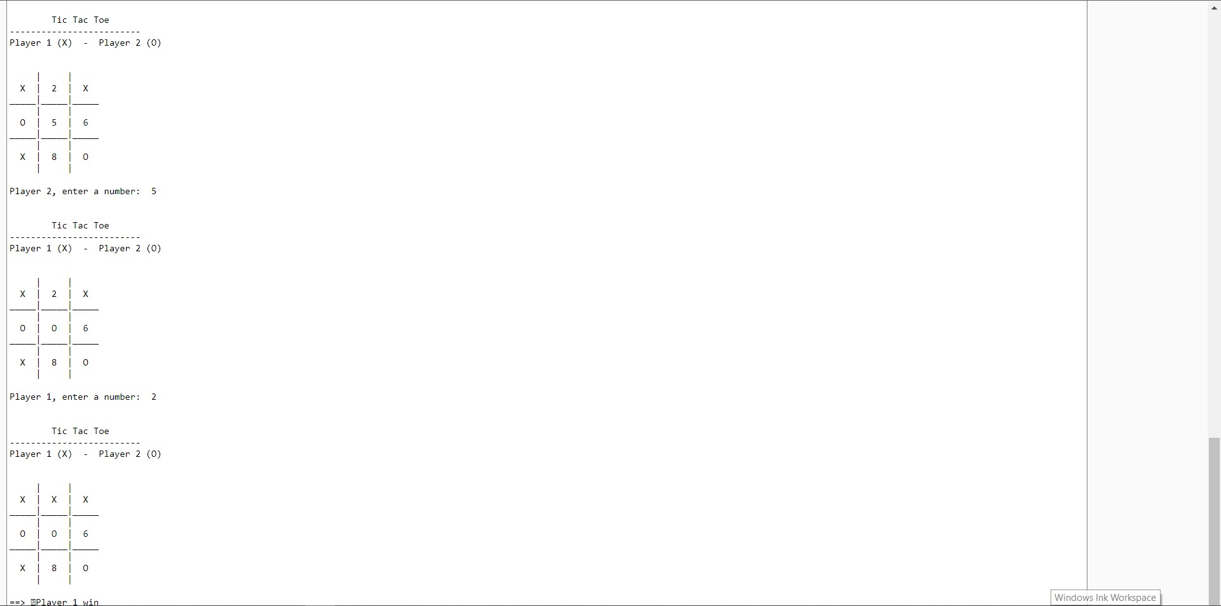

**RESULT:**

Two player Tic Tac Toe toy problem was successfully implemented.