# CONTROLLED ENVIRONMENT AGRICULTURE USING IOT AND AI

**A Project Report**

***submitted by***

**M.Chidambaram Pillai 312315205032**

**G.Ramesh 312315205126**

***in partial fulfillment for the award of the degree***

# Of

**BACHELOR OF TECHNOLOGY**

***in***

# INFORMATION TECHNOLOGY



**ST. JOSEPH’S COLLEGE OF ENGINEERING, CHENNAI 600119 ANNA UNIVERSITY: CHENNAI 600 025**

**MARCH 2019**

**ANNA UNIVERSITY: CHENNAI 600 025**



**BONAFIDE CERTIFICATE**

Certified that this project report “**CONTROLLED ENVIRONMENT AGRICULTURE USING IOT AND AI”** is the bonafide work of **M.CHIDAMBARAM PILLAI (312315205032) and G.RAMESH**

**(312315205126)** who carried out the project work under my supervision, for the partial fulfillment of the requirements for the award of the degree of Bachelor of Technology in Information Technology.

# SIGNATURE SIGNATURE

Dr. V. Muthulakshmi M.E., Ph.D., Mr. J. Suresh M.E.,Ph.D., Associate professor Assistant professor **HEAD OF THE DEPARTMENT SUPERVISOR**

# LAB AFFAIRS

Department of Department of

Information Technology Information Technology

St. Joseph’s College of Engineering St. Joseph’s College of Engineering Old Mamallapuram Road Old Mamallapuram Road

Chennai-600 119 Chennai-600 119 Submitted for the Viva-Voce held on

# (INTERNAL EXAMINAR) (EXTERNAL EXAMINAR)

**CERTIFICATE OF EVALUATION**

**College Name** : St.Joseph’s College of Engineering

**Branch &Semester** : Information Technology(VIII)

|  |  |  |  |
| --- | --- | --- | --- |
| **S.NO** | **NAME OF THE**  **STUDENTS** | **TITLE OF THE**  **PROJECT** | **NAME OF THE SUPERVISOR WITH**  **DESIGNATION** |
| 1 | M.Chidambaram | Controlled | Mr.Suresh M.E .,Ph.D., |
|  | Pillai | Environment  Agriculture |  |
|  |  | using IOT and |  |
|  |  | AI |  |
| 2 | G.Ramesh |  |  |

The report of the project work submitted by the above students in partial fulfillment for the award of Bachelor of Technology degree in Information Technology of Anna University were evaluated and confirmed to be reports of the work done by the above students.

# (INTERNAL EXAMINAR) (EXTERNAL EXAMINAR)

**ACKNOWLEDGEMENT**

The contentment and elation that accompany the successful completion of any work be incomplete without mentioning the people who made it possible.

We express our gratitude in thanking our Chairman **Dr. B. Babu Manoharan M.A., M.B.A., Ph.D.,** our respected Managing Director **Mrs. B. Jessie Priya M.Com.,** our respected Director **Mr. B. Shashi Sekar M.Sc.,** our respected Principal **Dr. Vaddi Seshagiri Rao M.E., M.B.A., Ph.D** for having encouraged us to do our under graduation in Information Technology in this esteemed college.

We express our sincere thanks and most heartfelt sense of gratitude to our eminent Head of the Department **Dr. V. Muthulakshmi M.E., Ph.D.,** for having extended her helping hand at all times.

It is with deep sense of gratitude that we acknowledge our indebtedness to our supervisor **Mr.Suresh M. E.,Ph.D.,** a perfectionist for his expert guidance and connoisseur suggestion.

Last but not the least, we thank our family members and friends who have been the greatest source of support to us.

# ABSTRACT

Agriculture is the heart of India's economic activity and our experience during the last 60 years has demonstrated the strong relationship between agricultural growth and economic wealth. The present agricultural system is a mix of outstanding achievements and missed opportunities in India. If India want to become powerful economically in the world, our agricultural productivity should be equal to those countries, which are currently rated as economic power of the world. We need a new and emerging technology which can improve continuously the productivity, profitability, quality of our major farming systems. One such technology used in India is the greenhouse technology. Although it is centuries old, it is new to India. In India, dependence on agricultural productivity and geographical conditions contribute majors to underdevelopment and poverty. These can be achieved by alternative new and latest technology of farming such as hydroponics. The goal of this project is to design and construct a hydroponic system which is fully automatic and remotely accessible that can be integrated into the agricultural curriculum while introducing business skills.

# LIST OF FIGURES

**FIGURE NO NAME OF THE FIGURE PAGE NO**

* 1. The Python Interpreter 22
  2. Architecture Diagram 24
  3. Use case Diagram 26
  4. Class Diagram 27

5.1 Monitoring 29

5.2 Remote Control 30

**LIST OF ABBREVIATIONS**

|  |  |
| --- | --- |
| **ACRONYM** | **EXPLANATION** |
| CEA | Controlled Environment Agriculture | |
| IOT | Internet Of Things | |
| pH  LED  DBMS  RDBMS  SQL | Pouvoir Hydrogene  Light Emitting Diode  Database Management System  Relational Database Management System  Structured Query Language | |
|  |  |
|  |  |

**CHAPTER 1**

**INTRODUCTION**

* 1. **INTERNET OF THINGS**

The main idea of hydroponics is to use a controlled-environment agriculture (CEA) technology, where all environmental factors can be controlled. Therefore, an automatic system, which consists of the Internet of Thing [IoT] is implemented in providing the controlled environment for the hydroponics. The main purpose of the project is to build a system to monitor the temperature, pH, humidity, and to control water content through the web browser on the laptop, mobile phone and other handheld and compact devices. A temperature sensor, humidity sensor, pH sensor, EC sensor is used to detect the moisture, temperature, pH level, EC level so that the plant can be consecutively monitored and controlled in an efficient manner. The signals are continuously sent to the Raspberry-pi. Then, the data is stored eventually in the Raspberry-pi IDE software and simultaneously sent to the web browser through the Wi-Fi that is connected to the internet router. The user can monitor their plant through the web browser that allows them to read the status of the plant and can control remotely. After the development of the web browser, monitoring of the hydroponics has been so helpful and the growth of the plant can be supervised from time to time without having the operator at the event.

# MACHINE LEARNING

Machine learning is the scientific study of algorithms and statistical models that computer systems use to effectively perform a specific task without using explicit instructions, relying on patterns and inference instead. It is seen as a subset of artificial intelligence. Machine learning algorithms build a mathematical model of sample data, known as "training data", in order to make predictions or decisions

without being explicitly programmed to perform the task. Machine learning algorithms are used in a wide variety of applications, such as email filtering, detection of network intruders, and computer vision, where it is infeasible to develop an algorithm of specific instructions for performing the task. Machine learning is closely related to computational statistics, which focuses on making predictions using computers. The study of mathematical optimization delivers methods, theory and application domains to the field of machine learning. Data mining is a field of study within machine learning, and focuses on exploratory data analysis through unsupervised learning. In its application across business problems, machine learning is also referred to as predictive analytics.

# SYSTEM OVERVIEW

The innovation is simple in-store hydroponic farming. Hydroponic farms with perfect temperature, lighting, water and nutrient supply are setup inside the grocery store or supermarket. Customers can then harvest the produce right into their baskets.

By moving the plants indoor, we eliminate dependence on the weather. Instead, we are able to control the climate inside the container, creating the absolutely ideal artificial growing environment as well as nurturing the well-being of our plants. Using hydroponics and a closed loop system, we are also able to reduce our water usage by up to 90 percent, deploy our product in any geographic location and, perhaps most importantly, use of any pesticides or herbicides can be avoided throughout the entire growing process.

Light is an essential product in plant growth and development. As producers in most ecosystems, plants rely heavily on some sort of light source. Plants respond to the quality, quantity, and direction of light. Light is required in photosynthesis,

plant’s process of creating food and energy. The sun is the greatest light source for outdoor plants. However, substitute lighting can support the growth of plants indoor. So LED light is used to provide nearly all the benefits of sunlight. Most importantly, the wavelengths of light are calculated so that a plant grow well.

Plants require a suitable temperature and humidity for their growth. So, the control is managed with the help of two fans, one fogger and one cooling system. For sensing the temperature and humidity of the surrounding AM2301(Temperature & humidity sensor) is used. The temperature and humidity is sensed and the data in given to Raspberry pi. Usually, due to the LED light temperature increases humidity decreases. When temperature is above the required value the surrounding has to be cooled down, so the cooling system is switched ON. When humidity is below the required value the temperature has to be increased, so the fogger is switched ON. Both the fan’s cooling system and LED light are controlled with help of a relay.

Forthwith, deep water culture method is used because in-store hydroponics could be made efficient. A tray has been designed to regulate water supply and to hold the plants.

A submersible water pump is used to circulate water and a relay is used to control the pump. Periodically every 30 minutes it is switched ON.

A tub acts as a reservoir and if the water containing nutrient solution is exposed to direct sunlight it produces algae. So, it is with black which would be a very good idea for algae control. Nutrients and pH up & down solutions are added accordingly using a dc motor and dc motor is controlled using a relay. A pH and EC sensors is used to monitor the levels of nutrients in the water tank and added accordingly to the requirement.

Camera is placed to take pictures on regular intervals which are being used to store the data about the plants along with the raspberry pi

Using Iot temperature, humidity, pH levels, Nutrition levels can be monitored. Product will manage the following:

* + - Nutrient solution
    - Electrical conductivity
    - Acidity
    - Temperature
    - Relative humidity
    - Temperature
    - Water Pump

# SCOPE OF THE PROJECT

People have to be helped to grow and eat sustainable, organic, and hyperlocal food. A movement towards trust and ownership in the food system, will enlighten the future where people source most of their food from local farmers, from outside in their garden, and from inside their home. Monitoring and controlling plants from web interface takes place through Raspberry-pi.

# CHAPTER 2 LITERATURE SURVEY

1. **Karishma Rahman, Amitabha Chakrabarty, ”Agricultural production output prediction using Supervised Machine Learning techniques”, 1st International Conference on Next Generation Computing Applications (NextComp), 2017.**

Farmers usually plan the cultivation process based on the previous experiences. Due to the lack of precise knowledge about cultivation, cultivating undesirable crops occurs. To help the farmers take decisions that can make farming more efficient and profitable, the research tries to establish an intelligent information prediction analysis on farming in Bangladesh. However, this way of farming has still at the initial stage. The research suggests area based beneficial crop rank before the cultivation process. It indicates the crops that are cost effective for cultivation for a particular area of land. To achieve these results, we are considering six major crops which are Aus rice, Aman rice, Boro rice, Potato, Jute and Wheat. The prediction has been based on analyzing a static set of data using Supervised Machine Learning techniques. This static dataset contains previous years' data taken from the Yearbook of Agricultural Statistics and Bangladesh Agricultural Research Council of those crops according to the area. The research has an intent to use Decision Tree Learning-ID3 (Iterative Dichotomiser 3) and K-Nearest Neighbours Regression algorithms.

# Ankita Patil, Akshay Naik, Mayur Beldar, Sachin Deshpande, "Smart Farming using Arduino and Data Mining", International Conference on Computing for Sustainable Global Development (INDIACom), 2016.

The current scenario in India depicts a steady decrease of agriculture contribution to the Indian GDP. The current erratic weather condition and crop loss

had been the main reasons for decrease in agriculture. New technologies and advanced fertilizers have not penetrated through the corners of India where majority of the farmers reside. A concept for smart farming which utilizes wireless sensor web technology for moisture detection in the soil in conjunction with a smart phone application has been introduced, which plays a vital role in helping farmers. Arduino based automatic plant watering system and android application which would help to control Arduino via internet has been introduced. Also, the android application provides farmers with agricultural related information such as costs of seeds, moisture level required, type of soil needed, weather forecast, fertilizers and pesticides to be used.

# Narayut Putjaika, Sasimanee Phusae, Anupong Chen-Im, Phond Phunchongharn, Khajonpong Akkarajitsakup, "A Control System in an Intelligent Farming by using Arduino Technology", Fifth ICT International Student Project Conference (ICT-ISPC), 2016.

“Internet of Things” (IoT) is a technology that allows things to communicate and connect with each other. The patterns and processes in both industry and agriculture towards higher efficiency would be changed. Particularly, agriculture is an important foundation of Thai economy. Consequently,an intelligent farming system (IF) to improve the production process in planting has been proposed. An intelligent farming system composes of two main parts which are a sensor system and a control system. The control part which had been watering and roofing systems of an outdoor farm based on the statistical data sensed from the sensor systems (including temperature, humidity, moisture and light intensity) has been focused. Since the sensed data would not be always accurate due to noises, Kalman filtering has been applied to smooth the data before using as an input in decision making process. Not only sensed data but also weather data would be considered making more efficient.

A decision tree model has generated to predict the weather condition. Then, a set of decision rules based on both the sensed data and the predicted weather condition has been developed to automatically make a decision on whether watering and roofing system should be on or off. Moreover, functions for users to manually control the watering and roofing systems would be provided via our mobile application.

**[4] Vijendra Sahare, Preet Jain " Automated Hydroponic System using Psoc4 Prototyping Kit to Deliver Nutrients Solution Directly to Roots of Plants on Time Basis" Dept. of ECE, SVITS College, Indore, MP, India,2015.**

Hydroponics is a method of growing plants using mineral Nutrients solutions in water without soil. Hydroponics not only save water but also save land. Automated Hydroponic systems that automatically deliver nutrients solution into water in every week for tomato plants has been represented. The mix of water and nutrient solution has been continuously circulated throw the water pump. Automated hydroponic system supply water and mix of nutrient solution directly to the roots of plants continuously. System used less water and fertilizer as compared to the soil system. Main parts of Automated System were PSoC4 CY8CKIT-049-42xx Prototyping kit, LCD, nutrient pump, water pump and relay.

# [5] Nattapol Kaewmard, Saiyan Saiyod, "Sensor Data Collection and Irrigation Control on Vegetable Crop Using Smart Phone and Wireless Sensor Networks for Smart Farm", 2014 IEEE Conference on Wireless Sensors, 2014.

Feeding of the world in the 21st century is the biggest challenge, especially for smart farm business. The smart farm has used agriculture automation system instead of traditional agriculture. Traditional agricultural methods employed by the

local people had been highly sustainable, although the inclusive of all cost has not been cheap. Their research goal has provided a long term sustainable solution for automation of agriculture. Agriculture automation has several methods to get the data from vegetable crop like sensor for environmental measurement. Therefore, a portable measurement technology had been developed including soil moisture sensor, air humidity sensor and air temperature sensor. Moreover, irrigation system using wireless sensor network has installed these sensors, with the purpose for collecting the environment data and controlling the irrigation system via smart phone. The purpose of the experiment has to find better ways of controlling an irrigation system with automatic system and manual control by smart phone. In order to control an irrigation system, the communication methodology of the wireless sensor network had been developed for collected environment data and sending control command to turn on/off irrigation system. Controlling the irrigation system and water near the vegetable roots had been successful. The automation of the irrigation system has been useful for farm business which attempted to make it comfortable than using traditional agriculture by using smart phone for monitoring and controlling the system. Accordingly, in the long-term has reduced cost as well. The experimental result shows that the accuracy of sending and receiving command control for irrigation system has been 96 percent and accuracy of environment collection has been 98 percent.

[6**] Carlos A.P.camara “Automated system developed to control pH**

**and concentration of nutrient solution evaluated in hydrophonic lettuce”, Department of Chemistry, State University of Londrina,Brazil,2012.**

Lettuce is one of the most widely consumed leaf vegetables. In hydroponic the growth depends upon the composition of nutrient solution. Due to its nutrient absorption, the conductivity of the nutrients and pH suffer continuous variations.

The development of a system completely managed by a lab-made software has been described. The system monitors the conductivity and pH throughout 24 hours during the whole cycle of production. Also, allows adjust automatically any variation, through solenoid valves which dispense solutions of acid/base or nutrient. The efficiency of the proposed instrumentation has been evaluated by simultaneously cultivation of same kind of lettuce (Vanda) in two different ways, hydroponics in greenhouse controlled with the developed devices, and grown conventionally in soil, adopted as referential. Agronomic and chemical parameters of commercial interest has been analyzed for both crop, attesting the precocity in harvest (64 against 71 days) with reduced labor, better control and higher productivity, especially in fresh and dry matter of aerial parts, presenting 267.56 and 13.33 g plant−1 respectively, using the developed system. The data sequence regarding the concentration of nutrients for the automated hydroponic system has similar to those obtained by the mentioned researchers, as follows: K > N > Ca > P > Mg > S > Fe > Zn > Mn > Cu. This similarity highlights the efficiency of controlling the parameters of conductivity and pH in the instrumental system applied to hydroponics, offering the producer an effective and viable alternative in the production of lettuce.

**[7]. O. V. Avercheva, “Growth and photosynthesis” cabbage plants under light-emitting diode-based light source", Russia journal of plant pysiology, Volume 56, Issue 1, pp 14–21, January,2009. "Growth and photosynthesis of Chinese**

The growth and the content of sugar, protein, and photosynthetic pigments, as well as chlorophyll fluorescence parameters has been compared in 15-17 and 27-day-old Chinese cabbage (*Brassica chinensis*L.) plants grown under a high-pressure sodium (HPS) lamps or a light source built on the basis of red (650 nm) and blue (470 nm) light-emitting diodes (LEDs) with a red to blue photon ratio of 7:1. One group of plants has been grown at a photosynthetic photon flux (PPF) level of specific values.

When grown at the normal PPF level, the plants grown under LEDs didn’t differ from plants grown under HPS lamps in shoot fresh weight, but they showed a lower root fresh and dry weights and the lower content of total sugar and sugar reserves in the leaves. No differences in the pigment content and photosystem II quantum yield were found; however, a higher Chlorophyllratio in plants grown under LEDs indicates a different proportion of functional complexes in thylakoid membranes. The response to low light conditions has mostly the same in plants grown under HPS lamps and LEDs; however, LED plants showed a lower growth rate and a higher non photochemical fluorescence quenching. In the case of the altered PPF level during growth, the plant photosynthetic apparatus adapted to new conditions of illumination within three days. Plants grown under HPS lamps at a constant normal PPF level and those transferred to the normal PPF level on the 12th day, on the 27th day didn’t differ in shoot fresh weight, but in plants grown under LEDs, the differences had been considerable. Their results show that LED-based light sources can be used for plant growing. At the same time, some specific properties of plant photosynthesis and growth under these conditions of illumination had been found.

# [8]. Dimitrios Savvas “Hydroponics: A modern technology supporting the application of integrated crop management in greenhouse ”, Department of Floriculture and Landscape Architecture, Faculty of Agricultural Technology,Greece,2003.

Commercial hydroponics is a modern technology involving plant growth on inert media in place of the natural soil, in order to uncouple the performance of the

crop from problems associated with the ground, such as soil-borne diseases, nonarable soil, poor physical properties, etc. Various non-toxic porous materials has used as plant growth substrates, including rockwool, perlite, pumice, expanded clay, various volcanic materials, polyurethane foam, coir dust, etc. A balanced distribution of small and larger pores has been required in a substrate to ensure adequate availability of water to the plants without to affect the supply of oxygen to the roots. Hydroponics has no adverse effect on the quality of fruits and flowers produced in such systems. In contrast, the complete control of nutrition via the nutrient solution may enable an enhancement of product quality, particularly in vegetable crops, such as tomato, melon, and lettuce. The switching over from the soil to hydroponics results in a decreased application of pesticides and other toxic agrochemicals, which has necessary in soil-grown crops to disinfect the soil and to control soil-borne pathogens. Moreover, the recycling of the excess nutrient solution that drains off after each watering application may contribute to a considerable reduction of nitrate and phosphate leaching to surface and groundwater resources. To restrict costs and increase profitability, hydroponics has been increasingly based on automation of nutrient and water supply. Future developments in hydroponics were mainly focused on further automation of the nutrient solution management, particularly in closed systems in which the excess nutrient solution would be recycled, as well as on a complete standardization of the substrate analysis in order to obtain more reliable results and to facilitate their interpretation.

# CHAPTER 3

**SYSTEM ANALYSIS**

* 1. **EXISTING SYSTEM**

In existing system, the soil based systems take longer to grow and mature. Growing food slowly and naturally creates a system that encourages biodiversity. The existing system has generously sized, hexagonal pots, allowing plenty of room for your plants to develop a good root base. Every agricultural base needs a soil medium which needs lot of oxygen, nutrition and enzymes. This needs gradual maintenance of the agricultural land with plenty of nutrition and water. This also occupies lot of area and the complete spread of nutrition are hard

# DISADVANTAGES OF THE EXISTING SYSTEM

* + - * This agricultural system depends on the fertilization content. There may not be a micronutrient a plant in the soil requires or may need lot of micronutrient in the soil. Also, pH is altered upon fertilization so plants and soil microorganisms existing in the soil could react conversely to the change.
      * Actually traditional agricultural medium includes topsoil erodes first. As the

nutrient-rich topsoil erodes, the soil that becomes exposed is less likely to contain enough nutrients to sustain plant life.

* + - * Agricultural areas relying on nutrients on growth, fertilizer is mandatory to

add the essential nutrients such as nitrogen, phosphorus and potassium to the soil to a larger extent.

# PROPOSED SYSTEM

In hydroponics farming system the water is circulated. Thus, it achieves 20 times less water consumption than the traditional soil culture. It works by automatically getting the complete nutrient mixture and water to the roots without drowning the plant. Plants get everything they need all the time, so they do not waste growing a lot of roots or searching the nutrients. In addition to growing better food, monitoring the effects of variables like pH, EC temperature and humidity using predictive analytics and thereby developing the perfect crop has been done. Data like temperature, humidity, water level, presence of pH and ECC from sensors are sent to Cloud IOT.

# ADVANTAGES OF PROPOSED SYSTEM

* + - * Machines can produce natural, fresh and non-polluted plant. It is easy to install and maintain.
      * Because all that plants need is provided and maintained in a system, you can grow in your small apartment, or the spare bedrooms as long as you have some spaces. Plants' roots usually expand and spread out in search for foods, and oxygen in the soil. This is not the case in Hydroponics, where the roots are sunk in a tank full of oxygenated nutrient solution and directly contact with vital minerals. This means you can grow your plants much closer, and consequently huge space savings.
      * The advantages of the Hydroponics against traditional farming is concentrated around; no soil, no weeds, no herbicides, few pests, precise control nutrients, farming will be done in all extreme weather conditions cold and hot.

# REQUIREMENTS SPECIFICATION

* + 1. **HARDWARE REQUIREMENTS**
       - Raspberry pi 3
       - LED light(50v)
       - Fans(12v)
       - Cooling system(12v)
       - Submersible motor(12v)
       - 8 Channel relay
       - Fogger(24v)

# SOFTWARE REQUIREMENTS

Operating System : Raspberry Pi.

Languages used : Python.

Tools : Rodeo, Excel, Beebotte Cloud Platform.

# LANGUAGE SPECIFICATION 3.4.1. Python

**Overview**

Python is a general-purpose interpreted, interactive, object-oriented, and high-level programming language. It was created by Guido van Rossum during 1985- 1990. Like Perl, Python source code is also available under the GNU General Public License (GPL). Python is a high-level, interpreted, interactive and

object-oriented scripting language. Python is designed to be highly readable. It uses English keywords frequently where as other languages use punctuation, and it has fewer syntactical constructions than other languages.

# Working of Python

Pythonis an object oriented programming language like Java. Python is called an interpreted language. Python uses code modules that are interchangeable instead of a single long list of instructions that was standard for functional programming languages. The standard implementation of python is called “cpython”. It is the default and widely used implementation of the Python. Python doesn’t convert its code into machine code, something that hardware can understand. It actually converts it into something called byte code. So within python, compilation happens, but it’s just not into a machine language. It is into byte code and this byte code can’t be understood by CPU. So we need actually an interpreter called the python virtual machine. The python virtual machine executes the byte codes.

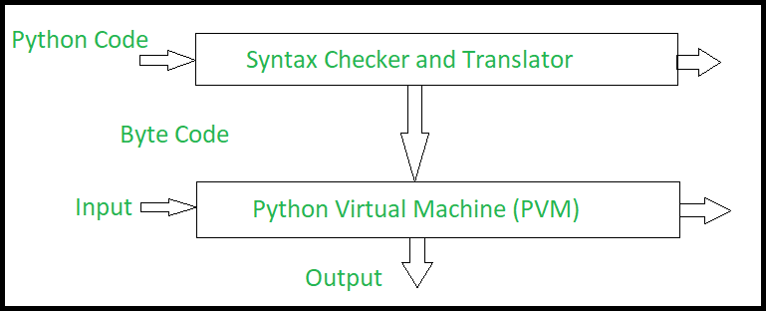

# Fig 3.1 The Python Interpreter

* + 1. **Rodeo**

It is an IDE that has been built especially for data science/Machine Learning in Python and you can also very simply think of it as a light weight alternative to the IPython Notebook. Rodeo is also known as the RStudio clone as uses the Ace Editor as its under lying layer, just the same as what powers RStudio but the difference that comes is that Rodeo is browser-based and apart from this it offers the same functionalities and features offered by its counter as well.Some of the other features it provides include a clean code, as the Rodeo text editor comes with auto-complete, syntax highlighting and Ipython support so that the users can now write better codes even faster. Not to forget, its plus point that allows its users to find whatever is needed, as Rodeo’s visual file navigator, point and click directories and package search make it easier for the users to find exactly what they are looking for.Rodeo is a native Python IDE that can be of help to its users in quickly get some idea about data structures without having to write any additional lines of code hence reducing the time required and also has some basic package management and plotting views.Rodeo also includes in it Integrated Tutorials that will help all its users to get started with learning python adding to its advantage even more. In addition to all of this that we just got to know of, this very IDE also comes with cheat sheets that help in referencing helpers material very quickly.

# Beebotte Cloud Platform

Beebotte has a Publish/Subscribe model based on channels and resources offering bidirectional data communication between your connected clients or devices. A data model featuring persistent and transient messages gives you the power to decide which data to retain. A comprehensive authentication mechanism allows you to control access to your resources. In addition, [presence](https://beebotte.com/docs/presence) events let you know who is connected.Beebotte has a REST API to let backend (server) applications read, write and publish data while a Websocketsjavascript client library makes it ready for Web and HTML5 applications. In addition, Beebotte supports MQTTmaking the platform suited for embedded devices and sensors.Beebotte REST API [libraries](https://beebotte.com/libs) are available in many programming languages to help you get started, while a JavaScript client library (using Web sockets) makes it ready for integration in web applications. These documentation pages along with the [tutorials](https://beebotte.com/tutorials) and [demos](https://beebotte.com/demos) help you get started. If you have further questions or inquiries, don't hesitate to drop us an email (contact@beebotte.com), we will be glad to help you or hear what you think about Beebotte.

Connecting anything and everything in real-time using a rich API supporting REST, Web Sockets and MQTT.Designed to empower Internet of Things and real-time communicating applications.Beebotte brings you a platform as a service connecting thousands of objects and delivering millions of messages. One platform suited for diverse applications like instant messaging, dashboards, online gaming and score boards, domotics, Internet of Things and reporting. Seamless scalability to meet your growing demands. Redundant architecture hosted with Amazon's AWS for high availability

# CHAPTER 4 SYSTEM DESIGN

* 1. **SYSTEM ARCHITECTURE**

Implementation is the stage of the project when the theoretical design is turned into a working system. Thus it can be considered to be the most critical in achieving a successful new system and in giving the user, confidence that the new system will work and be effective.

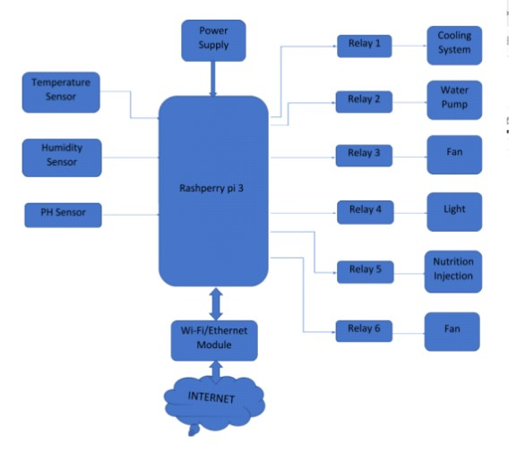

# Figure 4.1 Architecture of proposed system

The above diagram denotes the overall system architecture of the proposed system. The major component is the raspberry pi which is connected to main sensors which provide main readings from temperature sensor, humidity sensor and pH sensor. The raspberry pi board is connected to a relay system which is connected to additional devices like cooling system, water pump, fan, light, nutrition injection, and fan which provides nutrition and life-like condition to the leaf system. Thus, plants convert carbon dioxide, water and light into sugars and oxygen through a process called photosynthesis. The photosynthesis process requires that the plant has access to certain minerals, especially nitrogen, phosphorus and potassium. These nutrients can be naturally occurring in soil and are found in most commercial fertilizers. Notice that the soil itself is not required for plant growth: the plant simply needs the minerals from the soil. This is the basic premise behind hydroponics -- all the elements required for plant growth are the same as with traditional soil-based gardening. Hydroponics simply takes away the soil requirements.

# USECASE DIAGRAM

Most known diagram type of the behavioral UML diagrams, is use case diagram gives a graphic view of the actors involved in a system, different functions needed by those actors and how these different functions are interacted. It’s a great starting point for any project discussion because you can easily identify the main actors involved and the main processes of system.

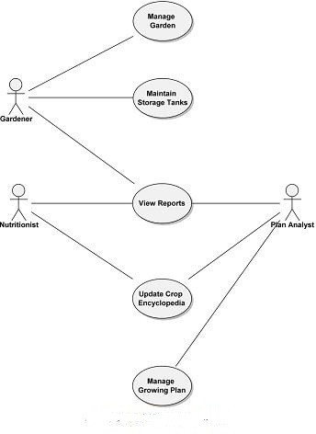

# Fig 4.2 Use case diagram

* 1. **CLASS DIAGRAM**

A class diagram is a type of diagram and part of a unified modeling language (UML) that defines and provides the overview and structure of a system in terms of classes, attributes and methods, and the relationships between different classes.It is used to illustrate and create a functional diagram of the system classes and serves as a system development resource within the software development life cycle.

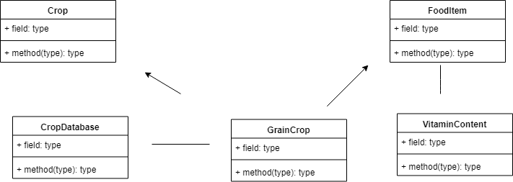

# Fig 4.3 Class diagram

**CHAPTER 5**

**SYSTEM IMPLEMENNTATION**

* 1. **MODULES**

1.Monitoring

2.Remote control

3.Interfacing python with excel

4.Predictive analytics

# Monitoring

This system is built for monitoring the crop field with the help of sensors (light, humidity, temperature, soil moisture, etc.) and automating the irrigation system.One can monitor the field conditions from anywhere. IoT-based smart farming is highly efficient when compared with the conventional approach.

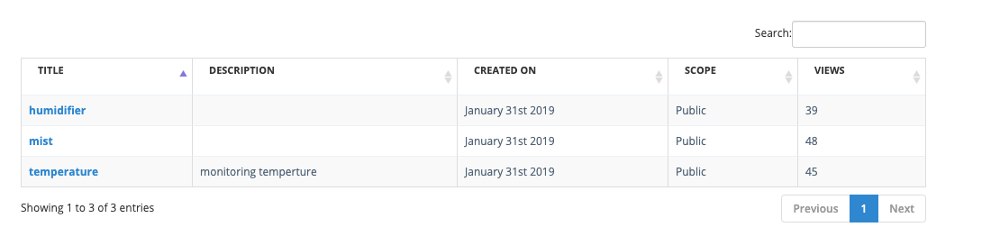

**Fig 5.1 Monitoring**

# Remote Control

Using bebotee cloud platform one can interact with their devices from anywhere and control them remotely which helps the crop to grow effectively even though it is automated.



**Fig 5.2 Remote Control**

# Interfacing Python with Excel

A CSV file (Comma Separated Values file) is a type of plain text file that uses specific structuring to arrange tabular data which is used as training model in machine learning.The modules are coded to generate the data sequentially in the spreadsheet for analytics.Once the data is generated we can use it analytics.

* + 1. **Predictive Analytics**

By learning from historical and future data based on measured variables, management and outcomes of decisions can more readily be made that can greatly impact efficiencies and processes.The data collected from cloud platform is often used in machine learning model to improve the plant growth.

# CHAPTER 6

**CONCLUSION AND FUTURE ENHANCEMENT**

* 1. **CONCLUSION**

Finally, plant production value grows higher without any damages to the ecosystem and self-sufficiency can be in agriculture produces using modern farming methods.

# FUTURE ENHANCEMENT

Hydroponic farming is as popular in india as it is on the moon. Most of the time, farms are owned by individuals hovering around the poverty line who work on the farm as well. Their lack of knowledge, lack of investment and lack of willingness to move out of their comfort zone all influence the unpopularity of hydroponics here. Most farmers are in rural areas and do not even know that something like hydroponics exists. They usually live on a crop to crop basis  - borrowing from private moneylenders to source the raw materials and nutrients required, and paying them back when the sales come in. Prices are so low and margins are so slim that to even contemplate the investment in hydroponics would be hard for them.There are plenty of farms owned by wealthy individuals; most of these range anywhere from 30 acres to thousands - and they are likely already very profitable due to the sheer area under cultivation, so the owners/investors see no reason to change something that works and has been working for many years. Needless to say, the cost for setting up hydroponics across hundreds of acres would not be cheap.

# APPENDIX 1 SAMPLE CODE

**Watertank.py**

import RPi.GPIO as GPIO import time

import Adafruit_DHT

from time import gmtime,strftime GPIO.setmode(GPIO.BOARD)

GPIO.setup(40, GPIO.OUT) #relay9-Water solenoid try:

while 1:

s=0

while s<3602:

if s in range(0, 300): GPIO.output (40,GPIO.LOW)

print(s) s+=1

print("water on")

time.sleep(1)#

elif s in range(300,3600) : #LED_LIGHT GPIO.output (40,GPIO.HIGH)

s+=1

print(s) print("water off") time.sleep(1)

if s == 10: s=0 break

except KeyboardInterrupt: print("Keyboard interrupt")

finally:

print("clean up") GPIO.cleanup()

# Led.py

import RPi.GPIO as GPIO import time

import Adafruit_DHT

from time import gmtime,strftime GPIO.setmode(GPIO.BOARD)

GPIO.setup(16, GPIO.OUT) #relay1-LED light

try:

while 1:

s=0

while s<86401: if s==86400:

s=0

if s>57600:

GPIO.output (16,GPIO.HIGH)

print(s) s+=1

print("led off")

time.sleep(1)

else : #LED_LIGHT GPIO.output (16,GPIO.LOW)

print(s) s+=1

print("led on") time.sleep(1)

except KeyboardInterrupt: print("Keyboard interrupt")

finally:

print("clean up") GPIO.cleanup()

# Humidity.py

import RPi.GPIO as GPIO import time

import Adafruit_DHT

from time import gmtime,strftime

GPIO.setmode(GPIO.BOARD)

GPIO.setup(11, GPIO.OUT) #relay9-Water solenoid try:

while 1:

s=0

while s<2702:

if s in range(0, 300):

GPIO.output (11,GPIO.LOW)

print(s) s+=1

print("mist on") time.sleep(1)#

elif s in range(300,2700) : #LED_LIGHT

GPIO.output (11,GPIO.HIGH) s+=1

print(s) print("mist off") time.sleep(1)

if s == 10: s=0 break

except KeyboardInterrupt: print("Keyboard interrupt")

finally:

print("clean up") GPIO.cleanup()

# Fan1.py

import RPi.GPIO as GPIO import time

import Adafruit_DHT

from time import gmtime,strftime GPIO.setmode(GPIO.BOARD)

GPIO.setup(11, GPIO.OUT) #relay7-Fan 1 try:

while 1:

f1=0

while f1<901: if f1==900:

f1=0

if f1>10: GPIO.output(11,GPIO.HIGH) f1+=1

print(f1) print("fAN OFF")

else: #FAN1(ATMOSPHERE)

GPIO.output(11,GPIO.LOW) f1+=1

print(f1) print("FAN ON")

time.sleep(1) except KeyboardInterrupt:

print("Keyboard interrupt")

finally:

print("clean up") GPIO.cleanup()

# Fan2.py

import RPi.GPIO as GPIO import time

import Adafruit_DHT

from time import gmtime,strftime GPIO.setmode(GPIO.BOARD)

GPIO.setup(13, GPIO.OUT) #relay7-Fan 1 try:

while 1:

f1=0

while f1<61: if f1==60:

f1=0

if f1>30: GPIO.output(13,GPIO.HIGH) f1+=1

print(f1) print("fAN2 OFF")

else: #FAN1(ATMOSPHERE) GPIO.output(13,GPIO.LOW)

f1+=1

print(f1) print("FAN2 ON")

time.sleep(1) except KeyboardInterrupt:

print("Keyboard interrupt")

finally:

print("clean up") GPIO.cleanup()

# Cooling.py

import RPi.GPIO as GPIO import time

import Adafruit_DHT

from time import gmtime,strftim GPIO.setmode(GPIO.BOARD)

GPIO.setup(12, GPIO.OUT) #relay9-Water solenoid try:

while 1:

s=0

while s<1802:

if s in range(0, 900):

GPIO.output (12,GPIO.LOW)

print(s) s+=1

print("coolling on") time.sleep(1)#

elif s in range(300,1800) : #LED_LIGHT

GPIO.output (12,GPIO.HIGH) s+=1

print(s) print("coolling off") time.sleep(1)

if s == 10: s=0 break

except KeyboardInterrupt: print("Keyboard interrupt")

finally:

print("clean up") GPIO.cleanup()

**LogisticsRegression.py**

import numpy as np

import matplotlib.pyplot as plt

import pandas as pd

# Importing the dataset

dataset = pd.read_csv('Social_Network_Ads.csv')

X = dataset.iloc[:, [2, 3]].values

y = dataset.iloc[:, 4].values

# Splitting the dataset into the Training set and Test set

from sklearn.cross_validation import train_test_split

X_train, X_test, y_train, y_test = train_test_split(X, y, test_size = 0.25, random_state = 0)

# Feature Scaling

from sklearn.preprocessing import StandardScaler

sc = StandardScaler()

X_train = sc.fit_transform(X_train)

X_test = sc.transform(X_test)

# Fitting Logistic Regression to the Training set

from sklearn.linear_model import LogisticRegression

classifier = LogisticRegression(random_state = 0)

classifier.fit(X_train, y_train)

# Predicting the Test set results

y_pred = classifier.predict(X_test)

# Making the Confusion Matrix

from sklearn.metrics import confusion_matrix

cm = confusion_matrix(y_test, y_pred)

# Visualising the Training set results

from matplotlib.colors import ListedColormap

X_set, y_set = X_train, y_train

X1, X2 = np.meshgrid(np.arange(start = X_set[:, 0].min() - 1, stop = X_set[:, 0].max() + 1, step = 0.01),

np.arange(start = X_set[:, 1].min() - 1, stop = X_set[:, 1].max() + 1, step = 0.01))

plt.contourf(X1, X2, classifier.predict(np.array([X1.ravel(), X2.ravel()]).T).reshape(X1.shape),

alpha = 0.75, cmap = ListedColormap(('red', 'green')))

plt.xlim(X1.min(), X1.max())

plt.ylim(X2.min(), X2.max())

for i, j in enumerate(np.unique(y_set)):

plt.scatter(X_set[y_set == j, 0], X_set[y_set == j, 1],

c = ListedColormap(('red', 'green'))(i), label = j)

plt.title('Logistic Regression (Training set)')

plt.xlabel('Age')

plt.ylabel('Estimated Salary')

plt.legend()

plt.show()

# Visualising the Test set results

from matplotlib.colors import ListedColormap

X_set, y_set = X_test, y_test

X1, X2 = np.meshgrid(np.arange(start = X_set[:, 0].min() - 1, stop = X_set[:, 0].max() + 1, step = 0.01),

np.arange(start = X_set[:, 1].min() - 1, stop = X_set[:, 1].max() + 1, step = 0.01))

plt.contourf(X1, X2, classifier.predict(np.array([X1.ravel(), X2.ravel()]).T).reshape(X1.shape),

alpha = 0.75, cmap = ListedColormap(('red', 'green')))

plt.xlim(X1.min(), X1.max())

plt.ylim(X2.min(), X2.max())

for i, j in enumerate(np.unique(y_set)):

plt.scatter(X_set[y_set == j, 0], X_set[y_set == j, 1],

c = ListedColormap(('red', 'green'))(i), label = j)

plt.title('Logistic Regression (Test set)')

plt.xlabel('Age')

plt.ylabel('Estimated Salary')

plt.legend()

plt.show()

# APPENDIX 2 SCREENSHOTS

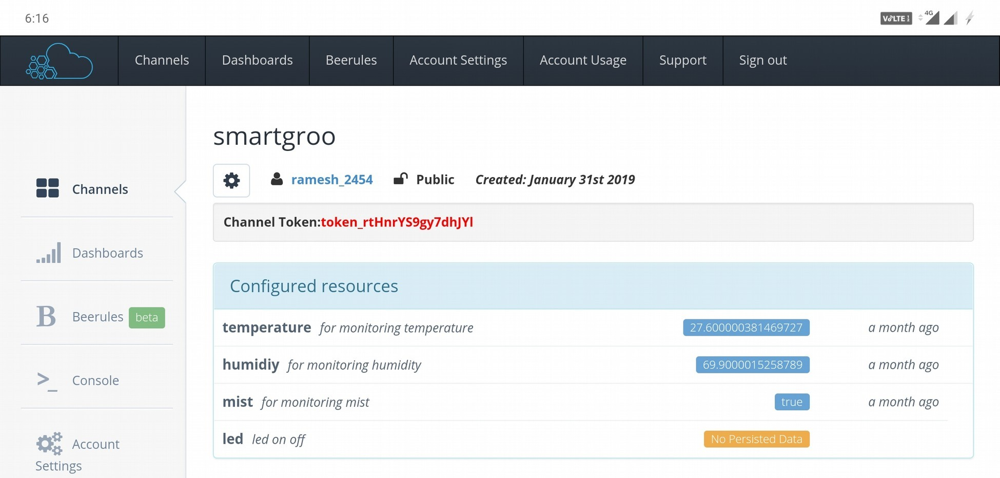

**Fig1.1**

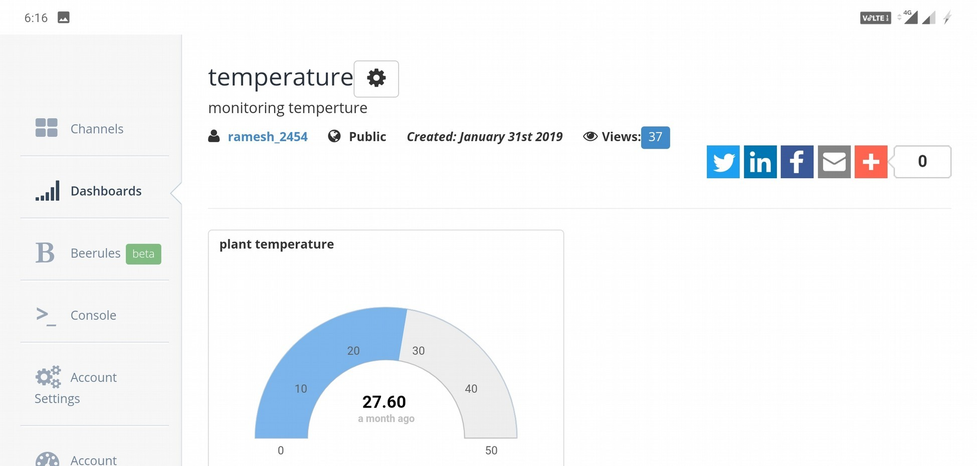

**Fig1.2**

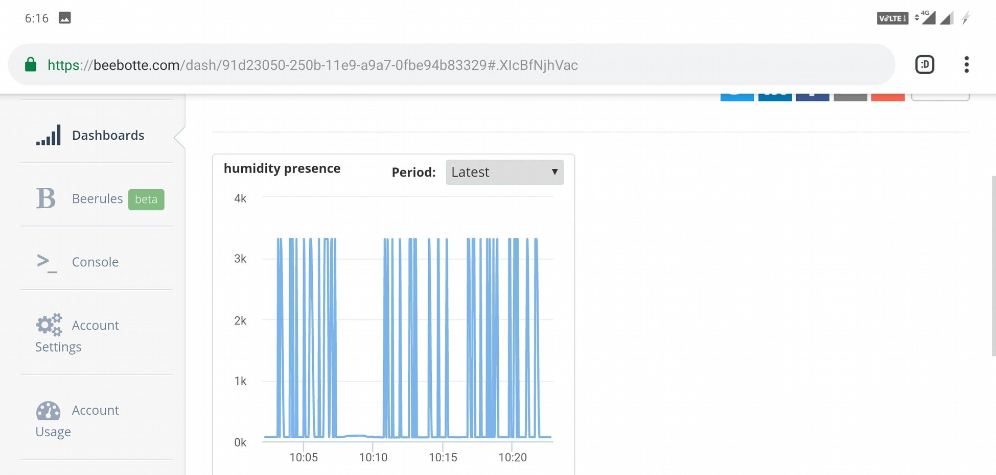

**Fig1.3**

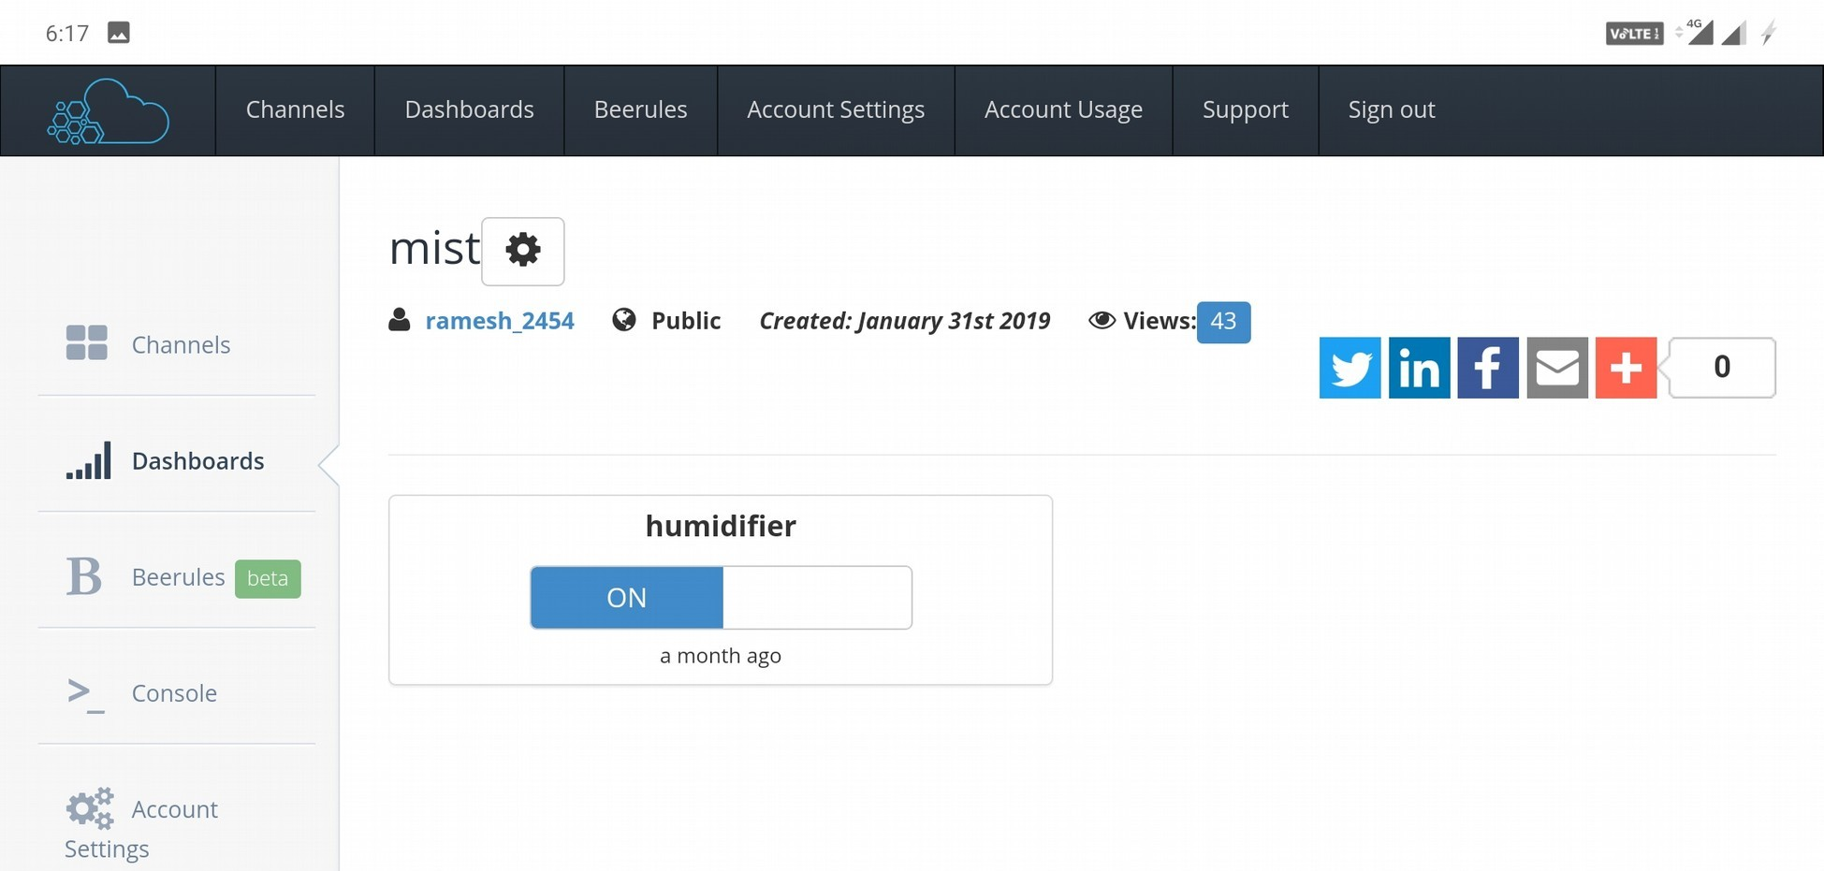

**Fig1.4**

**REFERENCES**

1. dos Santos, J. D.; et al. (2013). "Development of a vinasse nutritive solution for hydroponics". Journal of Environmental Management.
2. Douglas, J. S. (1975). Hydroponics (5th ed.). Bombay: Oxford UP. pp. 1–3. [3]Dunn, H. H. (October 1929). "Plant "Pills" Grow Bumper Crops". Popular Science Monthly: 29–30.
3. Thiyagarajan, G.; Umadevi, R.; Ramesh, K. (Jan 2007). "Hydroponics" . Science Tech Entrepreneur. Archived from the original on December 29, 2009 – via Wayback Machine.
4. Turner, Bambi (Oct 20, 2008). "How Hydroponics Works". HowStuffWorks. InfoSpace Holdings LLC. Retrieved May 29, 2012.
5. "Biography of W.A. Setchell". The University and Jepson Herbaria, University of California. Archived from the original on October 15, 2015. Retrieved Nov 21, 2018.
6. Adelman, Jacob (Nov 21, 2008). "Urban growers go high-tech to feed city dwellers". Newsvine. The Associated Press. Archived from the original on 2009- 05-03. Retrieved Nov 21, 2018.
7. Wood, Laura (Dec 6, 2017). "Global Hydroponics Market Report 2017-2023: Market is expected to grow from $226.45 million in 2016 to reach $724.87 million by 2023 - Research and Markets". Business Wire. Berkshire Hathaway. Retrieved Apr 1, 2018.
8. "What are the fundamentals of setting up an NFT system?". Practical Hydroponics & Greenhouses. Casper Publications (148). Oct 2014. Archived from the original on 2017-09-04. Retrieved 2017-05-16 – via Wayback Machine.
9. ["DIY Fogponics"](https://www.gardenculturemagazine.com/diy-fogponics/). Garden Culture Magazine. Jan 1, 2016. Retrieved Mar 15, 2017.[permanent dead link]
10. What is Hydroculture?". Greens Hydroponics. Retrieved Nov 22, 2018.
11. Barbosa, G.; Gadelha, F.; Kublik, N.; et al. (2015). "Comparison of Land, Water, and Energy Requirements of Lettuce Grown Using Hydroponic vs. Conventional Agricultural Methods". Int. J. Environ. Res. Public Health. MDPI. **12** (6): 6879–6891. [doi](https://en.wikipedia.org/wiki/Digital_object_identifier):[10.3390/ijerph120606879](https://doi.org/10.3390%2Fijerph120606879).
12. "Flood and Drain or Ebb and Flow". [www.makehydroponics.com.](http://www.makehydroponics.com/) Archived from the original on 2013-02-17. Retrieved 2013-05-17.
13. Douglas, James Sholto (1975). Hydroponics: The Bengal System (5th ed.). New Dehli: Oxford University Press. p. 10. [ISBN](https://en.wikipedia.org/wiki/International_Standard_Book_Number) 9780195605662.
14. "Deep Water Culture". GroWell Hydroponics & Plant Lighting. Archived from the original on April 13, 2010.
15. Sky Green (Jun 17, 2016). "Commercial Vertical Farming Initiatives" (PDF). MVO Netherland. Retrieved Nov 22, 2018.
16. "Growstones ideal alternative to perlite, parboiled rice hulls". (e) Science News. Dec 14, 2011. Retrieved Nov 22, 2018.
17. "GrowStone Products MSDS" (PDF). Growstone, LLC. Dec 22, 2011. Retrieved Nov 22, 2018.
18. Wallheimer, Brian (Oct 25, 2010). "Rice hulls a sustainable drainage option for greenhouse growers". Purdue University. Retrieved Aug 30, 2012.
19. "An Intro Into Sand Culture Hydroponics". The FVSU Greenhouse Project. Jun 13, 2014. Retrieved Nov 22, 2018.
20. Böhme, M.; Schevchenko, J.; Pinker, I.; Herfort, S. (Jan 2008). "Cucumber grown in sheepwool slabs treated with biostimulator compared to other organic and mineral substrates". Acta Horticulturae. **779**: 299–306. [doi](https://en.wikipedia.org/wiki/Digital_object_identifier):10.17660/actahortic.2008.779.36. [ISSN](https://en.wikipedia.org/wiki/International_Standard_Serial_Number) [0567-7572](https://www.worldcat.org/issn/0567-7572).
21. Tom Alexander; Don Parker (1994). The Best of Growing Edge. New Moon Publishing, Inc. [ISBN](https://en.wikipedia.org/wiki/International_Standard_Book_Number) 978-0-944557-01-3.
22. Parker, Rick (2009). Plant & Soil Science: Fundamentals & Applications. Cengage Learning. Retrieved 22 *January 2019.*