**CHAPTER 1**

**INTRODUCTION**

**1.1 INTERNET OF THINGS**

The main idea of hydroponics is to use a controlled-environment agriculture (CEA) technology, where all environmental factors can be controlled. Therefore, in this project, an automatic system, which consists of the Internet of Thing [IoT] is implemented in providing the controlled environment for the hydroponics. The main purpose of this project is to build a system to monitor the temperature ,pH , humidity, and to control water content through the web browser on the laptop, mobile phone and other handheld and compact devices. In this project, a temperature sensor, humidity sensor , pH sensor, EC sensor is used to detect the moisture , temperature ,pH level , EC level so that the plant can be consecutively monitored and controlled in a efficient manner. The signals are continuously sent to the Raspberry-pi. Then, the data is stored eventually in the Raspberry-pi IDE software and simultaneously sent to the web browser through the Wi-fi that is connected to the internet router. The user can monitor their plant through the web browser that allows them to read the status of the plant and can control remotely. With this development, the monitoring of the hydroponics has been so helpful and the growth of the plant can be supervised from time to time without having the operator at the event.

**1.2 MACHINE LEARNING**

Machine learning is the scientific study of algorithms and statistical models that computer systems use to effectively perform a specific task without using explicit instructions, relying on patterns and inference instead. It is seen as a subset of artificial intelligence. Machine learning algorithms build a mathematical model of sample data, known as "training data", in order to make predictions or decisions without being explicitly programmed to perform the task. Machine learning algorithms are used in a wide variety of applications, such as email filtering, detection of network intruders, and computer vision, where it is infeasible to develop an algorithm of specific instructions for performing the task. Machine learning is closely related to computational statistics, which focuses on making predictions using computers. The study of mathematical optimization delivers methods, theory and application domains to the field of machine learning. Data mining is a field of study within machine learning, and focuses on exploratory data analysis through unsupervised learning. In its application across business problems, machine learning is also referred to as predictive analytics.

**1.2 SYSTEM OVERVIEW**

The innovation is simple-instore hydroponic farming. Hydroponic farms with perfect temperature, lighting, water and nutrient supply are setup by our team inside the grocery store or supermarket. Customers can then harvest the produce right into their baskets.By moving our plants indoors, we eliminate our dependence on the weather. Instead, we are able to control the climate inside the container, creating the absolutely ideal artificial growing environment as well as nurturing the well being of our plants. Using hydroponics and a closed loop system, we are also able to reduce our water usage by up to 90 percent,deploy our product in any geographic location and, perhaps most importantly, we do not need to use any pesticides or herbicides throughout the entire growing process.Plants require a suitable temperature and humidity for their growth. So we are control them with the help of two fans ,one fogger and one cooling system.For sensing the temperature and humidity of the surrounding we use AM2301(Temperature&humidity sensor).The temperature and humidity is sensed and the data in given to Raspberry pi.Usually, due to the LED light temperature increases humidity decreases.When temperature is above the required value we need to cool down the surrounding, so the cooling system is switched ON.When humidity is below the required value we need to increase it, so the fogger is switched ON.Both the fans ,cooling system and LED light are controlled with help of a relay.

Using Iot temperature, humidity, PH levels,Nutrition levels can be monitored.

Our product will managing the following:

* Nutrient solution
* Electrical conductivity
* Acidity
* Temperature
* Relative humidity
* Temperature
* Water Pump
  1. **SCOPE OF THE PROJECT**

We want to help more people grow and eat sustainable, organic, and hyperlocal food.We believe that our can spark a movement towards trust and ownership in our food system, and we envision a future where people source most of their food from local farmers, from outside in their garden, and from inside their home.Monitor and control your plants from web interface through Raspberry-pi. That's how we are committing to change the future of food.

**CHAPTER 2**

**LITERATURE SURVEY**

# **[1] Karishma Rahman,Amitabha chakrabarty,”Agricultural production output prediction using Supervised Machine Learning techniques”, 1st International Conference on Next Generation Computing Applications (NextComp), 2017.**

Farmers usually plan the cultivation process based on their previous experiences. Due to the lack of precise knowledge about cultivation, they end up cultivating undesirable crops. To help the farmers take decisions that can make their farming more efficient and profitable, the research tries to establish an intelligent information prediction analysis on farming in Bangladesh. However, this way of farming here is still at the initial stage. The research suggests area based beneficial crop rank before the cultivation process. It indicates the crops that are cost effective for cultivation for a particular area of land.

**[2] Ankita Patil, Akshay Naik, Mayur Beldar, Sachin Deshpande, "Smart Farming using Arduino and Data Mining", International Conference on Computing for Sustainable Global Development (INDIACom), 2016.**

The current scenario in India depicts a steady decrease of agriculture contribution to the Indian GDP. The reasons for this condition are mainly - the current erratic weather condition and crop loss. New technologies and advanced fertilizers have not penetrated through the corners of India where majority of the farmers reside. Through this paper, we introduce a concept for smart farming which utilizes wireless sensor web technology for moisture detection in the soil in conjunction with a smart phone application which plays a vital role in helping farmers. We introduce Arduino based automatic plant watering system and android application which will help to control Arduino via internet.

**[3]Narayut Putjaika, Sasimanee Phusae, Anupong Chen-Im, Phond Phunchongharn, Khajonpong Akkarajitsakup, "A Control System in an Intelligent Farming by using Arduino Technology", Fifth ICT International Student Project Conference (ICT-ISPC), 2016.**

“Internet of Things” (IoT) is a technology that allows things to communicate and connect with each other. This will change the patterns and processes in both industry and agriculture towards higher efficiency. Particularly, agriculture is an important foundation of Thai economy. Consequently, we propose an intelligent farming system (IF) to improve the production process in planting. IF composes of two main parts which are a sensor system and a control system. In this paper, we focus on the control part which are watering and roofing systems of an outdoor farm based on the statistical data sensed from the sensor systems (including temperature, humidity, moisture and light intensity sensors) Since the sensed data would not be always accurate due to noises,

**[4] Vijendra Sahare, Preet Jain " Automated Hydroponic System using**

**Psoc4 Prototyping Kit to Deliver Nutrients Solution Directly to**

**Roots of Plants on Time Basis" Dept. of ECE, SVITS College,**

**Indore, MP, India,2015.**

Hydroponics is method of growing plants using mineral Nutrients solutions in Water without soil. Hydroponics not only save water but also save land. This paper represents Automated Hydroponic systems that automatically deliver nutrients solution into water in every week for tomato plants. The mix of Water and nutrient solution is continuously recirculate throw the water pump. Automated hydroponic system supply water and mix of nutrient solution, directly to the roots of plants continuously. System use less water and fertilizer as compared to soil system. Main parts of Automated System are PSoC4 CY8CKIT-049-42xx Prototyping kit, LCD, nutrient pump, water pump and relay.

**[5] Nattapol Kaewmard, Saiyan Saiyod, "Sensor Data Collection and Irrigation Control on Vegetable Crop Using Smart Phone and Wireless Sensor Networks for Smart Farm", 2014 IEEE Conference on Wireless Sensors, 2014.**

Feeding of the world in the 21st century is the biggest challenge, especially for smart farm business. The smart farm has used agriculture automation system instead of traditional agriculture. Traditional agricultural methods employed by the local people are highly sustainable, although the all inclusive cost is not cheap. Our research goal is to provide long term sustainable solution for automation of agriculture. Agriculture automation has several methods to getting data from vegetable crop like sensor for environmental measurement. Therefore, we developed a portable measurement technology including soil moisture sensor, air humidity sensor and air temperature sensor.

**[6]Dos Santos, J. D.; et al "Development of a vinasse nutritive solution for hydroponics" Journal of Environmental Management,2013.**

Vinasse is a residue that originates from the distillation of fuel alcohol. However, it contains a relative amount of nutrients. The aim of this work was to develop a nutritive solution using vinasse and to compare it with a commercial solution for the cultivation of lettuce, watercress and rocket. Vinasse obtained from juice must was decanted and filtered, followed by chemical analyses of the nutrients. A nutritive solution composed of 10% vinasse supplemented with nutrients was in agreement with the results of the chemical analyses (a similar amount of Furlani's solution). Experiments were then performed in an NFT (Nutrient film technique) system. The treatments used the vinasse solution and a commercial solution constituted from a Yara Fertilizantes(®) product

**[7]. Carlos A.P.camara “Automated system developed to control pHand concentration of nutrient solution evaluated in hydrophoniclettuce”, Department of Chemistry, State University of Londrina, Brazil, 2012.**

Lettuce is one of the most widely consumed leaf vegetables. In hydroponic the growth depends upon the composition of nutrient solution. Due to its nutrient absorption, the conductivity and pH suffer continuous variations. This paper describes the development of a system completely managed by a lab-made software. It monitors the conductivity and pH throughout 24 h during the whole cycle of production. Also, allows adjust automatically any variation, through solenoid valves which dispense solutions of acid/base or nutrient.

**[8]. O. V. Avercheva, "Growth and photosynthesis of Chinese cabbageplants grown under light-emitting diode-based light source", Russiajournal of plant pysiology, Volume 56, Issue 1, pp 14–21,January,2009.**

We compared growth and the content of sugar, protein, and photosynthetic pigments, as well as chlorophyll fluorescence parameters in 15- and 27-day-old Chinese cabbage (Brassica chinensisL.) plants grown under a high-pressure sodium (HPS) lamps or a light source built on the basis of red (650 nm) and blue (470 nm) light-emitting diodes (LEDs) with a red to blue photon ratio of 7: 1. One group of plants was grown at a photosynthetic photon flux (PPF) level of 391 ± 24 μ mol/(m2 s) (normal level); the other, at a PPF level of 107 ± 9 μ mol/(m2 s) (low light). Plants of the third group were firstly grown at the low light and then (on the 12th day) transferred to the normal level. When grown at the normal PPF level, the plants grown under LEDs didn’t differ from plants grown under HPS lamps in shoot fresh weight, but they showed a lower root fresh and dry weights and the lower content of total sugar and sugar reserves in the leaves.

**[9]. Dimitrios Savvas “Hydroponics: A modern technology supportingthe application of integrated crop management in greenhouse ”,Department of Floriculture and Landscape Architecture, Faculty ofAgricultural Technology,Greece,2003.**

Commercial hydroponics is a modern technology involving plant growth on inert media in place of the natural soil, in order to uncouple the performance of the crop from problems associated with the ground, such as soil-borne diseases, nonarable soil, poor physical properties, etc. Various non-toxic porous materials are used as plant growth substrates, including rockwool, perlite, pumice, expanded clay, various volcanic materials, polyurethane foam, coir dust, etc. A balanced distribution of small and larger pores is required in a substrate to ensure adequate availability of water to the plants without to affect the supply of oxygen to the roots. Hydroponics has no adverse effect on the quality of fruits and flowers produced in such systems. substrate analysis in order to obtain more reliable results and to facilitate their interpretation.

**[10] Tom Alexander,Don Parker “The Best of Growing Edge” New Moon Publishing, Inc,1994.**

The Best of Growing EDGE is a collection of the best articles, by twenty four different authors, from the first five years of Growing EDGE magazine. It covers hydroponics, greenhouses, nutrients, lighting, and other new and innovative techniques to use in high tech gardening and horticulture.Since the articles are from the first five years of Growing EDGE magazine, each chapter is a comprehensive compendium of cutting edge horticulture without going over the edge! New and innovative seems to be the keyword here. The mainstream gardening magazines and books cover the tried and true techniques of gardening; The Best of Growing EDGE covers the new and innovative.

**CHAPTER 3**

**SYSTEM ANALYSIS**

* 1. **EXIXTING SYSTEM**

In existing system, the soil based systems take longer to grow and mature. Growing food slowly and naturally creates a system that encourages biodiversity. The existing system has generously sized, hexagonal pots, allowing plenty of room for your plants to develop a good root base. Every agricultural base needs a soil medium which needs lot of oxygen, nutrition and enzymes. This needs gradual maintenance of the agricultural land with plenty of nutrition and water. This also occupies lot of area and the complete spread of nutrition are hard.

* + 1. **DISADVANTAGES OF THE EXISTING SYSTEM**
* This agricultural system depends on the fertilization content. There may not be a micronutrient a plant in the soil requires or may need lot of micronutrient in the soil. Also, pH is altered upon fertilization so plants and soil microorganisms existing in the soil could react conversely to the change.
* Actually traditional agricultural medium includes topsoil erodes first. As thenutrient-rich topsoil erodes, the soil that becomes exposed is less likely to contain enough nutrients to sustain plant life.
* Agricultural areas relying on nutrients on growth, fertilizer is mandatory toadd the essential nutrients such as nitrogen, phosphorus and potassium to the soil to a larger extent.
  1. **PROPOSED SYSTEM**

In hydroponics farming system the water is recirculated thus it achieves 20 times less water consumption than the traditional soil culture. It works by automatically getting the complete nutrient mixture and water to the roots without drowning the plant. Plants get everything they need all the time, so they do not waste growing a lot of roots or searching the nutrients. In addition to grow better food we keep on monitoring the effects of variables like pH,EC temperature and humidity using predictive analytics and thereby developing the perfect crop.Datas like temperature,humidity,water level,presence of pH and ECC from sensors are send to Cloud IOT.

**3.2.1 ADVANTAGES OF PROPOSED SYSTEM**

* Machines can produce natural, fresh and non polluted plant.It is easy to install and maintain.
* Because all that plants need are provided and maintained in a system, you can grow in your small apartment, or the spare bedrooms as long as you have some spaces.Plants' roots usually expand and spread out in search for foods, and oxygen in the soil. This is not the case in Hydroponics, where the roots are sunk in a tank full of oxygenated nutrient solution and directly contact with vital minerals. This means you can grow your plants much closer, and consequently huge space savings.
* The advantages of the Hydroponics against traditional farming is concentrated around; no soil, no weeds, no herbicides, few pests, precise control nutrients, farming will be done in all extreme weather conditions cold and hot.

# **REQUIREMENTS SPECIFICATION**

**3.1.1 HARDWARE REQUIREMENTS**

* + - * Raspberry pi 3
      * LED light(50v)
      * Fans(12v)
      * Cooling system(12v)
      * Submersive motor(12v)
      * 8 Channel relay
      * Fogger(24v)

# **3.1.2 SOFTWARE REQUIREMENTS**

Operating System : Raspberry Pi.

Languages used : Python.

Tools : Rodeo(python),Excel,Beebotte cloud platform

* 1. **LANGUAGE SPECIFICATION**

# **3.4.1.Python**

**Overview**

Python is a general-purpose interpreted, interactive, object-oriented, and high-level programming language. It was created by Guido van Rossum during 1985- 1990. Like Perl, Python source code is also available under the GNU General Public License (GPL). Python is a high-level, interpreted, interactive and object-oriented scripting language. Python is designed to be highly readable. It uses English keywords frequently where as other languages use punctuation, and it has fewer syntactical constructions than other languages.

# **Working of Python**

Python is an object oriented programming language like Java. Python is called an interpreted language. Python uses code modules that are interchangeable instead of a single long list of instructions that was standard for functional programming languages. The standard implementation of python is called “cpython”. It is the default and widely used implementation of the Python. Python doesn’t convert its code into machine code, something that hardware can understand. It actually converts it into something called byte code. So within python, compilation happens, but it’s just not into a machine language. It is into byte code and this byte code can’t be understood by CPU. So we need actually an interpreter called the python virtual machine. The python virtual machine executes the byte codes.

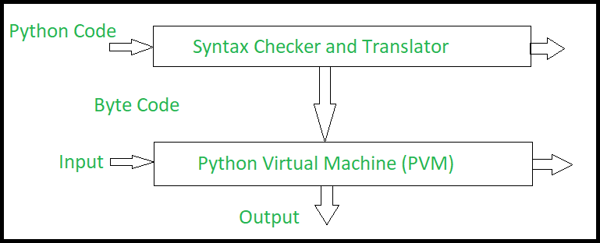

# **Fig 3.1 The Python Interpreter**

**CHAPTER 4**

**4.1 SYSTEM ARCHITECTURE**

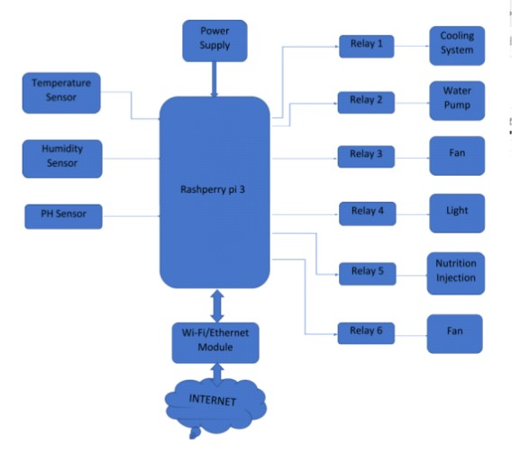

**Figure 4.1 Architecture of proposed system**

In Fig. 4.1 The above diagram denotes the overall system architecture of the proposed system. The major component is the raspberry pi which is connected to main sensors which provide main readings from temperature sensor, humidity sensor and pH sensor. The raspberry pi board is connected to a relay system which is connected to additional devices like cooling system, water pump, fan, light, nutrition injection, and fan which provides nutrition and life-like condition to the leaf system. Thus, plants convert carbon dioxide, water and light into sugars and oxygen through a process called photosynthesis. The photosynthesis process requires that the plant has access to certain minerals, especially nitrogen, phosphorus and potassium. These nutrients can be naturally occurring in soil and are found in most commercial fertilizers. Notice that the soil itself is not required for plant growth: the plant simply needs the minerals from the soil. This is the basic premise behind hydroponics -- all the elements required for plant growth are the same as with traditional soil-based gardening. Hydroponics simply takes away the soil requirements.

**4.3 USE CASE DIAGRAM**

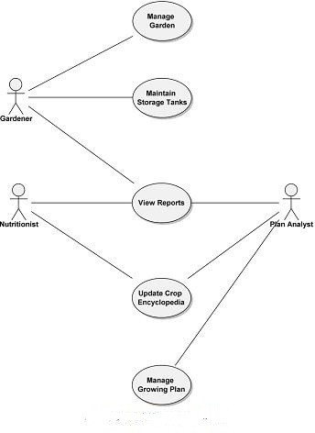

**Fig 4.2 Use case diagram**

**4.4 CLASS DIAGRAM**

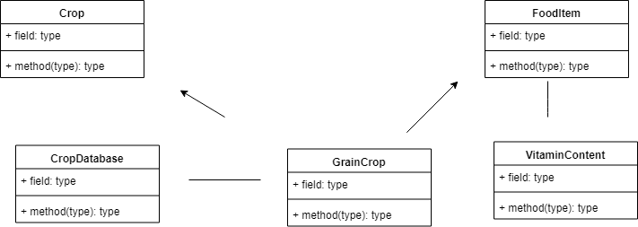

**Fig Class Diagram**

**CHAPTER 5**

**5.1 MODULES**

The modules are

Monitoring

Remote control

Interfacing python with excel

Predictive analytics

**5.1.1** **Monitoring**

This system is built for monitoring the crop field with the help of sensors (light, humidity, temperature, soil moisture, etc.) and automating the irrigation system.One can monitor the field conditions from anywhere. IoT-based smart farming is highly efficient when compared with the conventional approach.

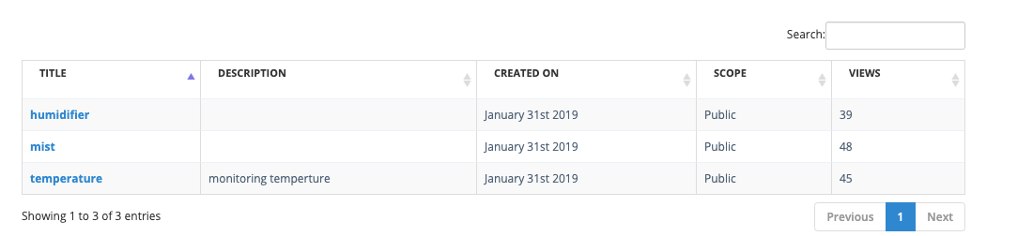

**5.1.2** **Remote control**

Using bebotee cloud platform one can interact with their devices from anywhere and control them remotely which helps the crop to grow effectively even though it is automated.



**5.1.3** **Interfacing python with excel**

A CSV file (Comma Separated Values file) is a type of plain text file that uses specific structuring to arrange tabular data which is used as training model in machine learning.The modules are coded to generate the data sequentially in the spreadsheet for analytics.Once the data is generated we can use it analytics.

**5.1.4 Predictive analytics**

By learning from historical and future data based on measured variables, management and outcomes of decisions can more readily be made that can greatly impact efficiencies and processes.The data collected from cloud platform is often used in machine learning model to improve the plant growth.

**CHAPTER 6**

**CONCLUSION AND FUTURE ENHANCEMENT**

**6.1 CONCLUSION**

Finally, plant production value grows higher without any damages to the ecosystem and self-sufficiency can be in agriculture produces using modern farming methods.

**6.2 FUTURE ENHANCEMENT**

As the system design can be seen in all future farming centers as they practice all type of hydroponics there. As soil is unnecessary for this method of agriculture one can do it easily in any place which he likes and the farmers don't need to worry about infertility, more amount of water, infections by pests and many other problems faced by them in the ancient and normal method of agriculture.

**APPENDIX 1**

**SAMPLE CODE**

**Watertank.py**

import RPi.GPIO as GPIO import time

import Adafruit_DHT

from time import gmtime,strftime GPIO.setmode(GPIO.BOARD)

GPIO.setup(40, GPIO.OUT) #relay9-Water solenoid try:

while 1:

s=0

while s<3602:

if s in range(0, 300): GPIO.output (40,GPIO.LOW)

print(s) s+=1

print("water on")

time.sleep(1)#

elif s in range(300,3600) : #LED_LIGHT GPIO.output (40,GPIO.HIGH)

s+=1

print(s) print("water off") time.sleep(1)

if s == 10: s=0 break

except KeyboardInterrupt: print("Keyboard interrupt")

finally:

print("clean up") GPIO.cleanup()

# Led.py

import RPi.GPIO as GPIO import time

import Adafruit_DHT

from time import gmtime,strftime GPIO.setmode(GPIO.BOARD)

GPIO.setup(16, GPIO.OUT) #relay1-LED light

try:

while 1:

s=0

while s<86401: if s==86400:

s=0

if s>57600:

GPIO.output (16,GPIO.HIGH)

print(s) s+=1

print("led off")

time.sleep(1)

else : #LED_LIGHT GPIO.output (16,GPIO.LOW)

print(s) s+=1

print("led on") time.sleep(1)

except KeyboardInterrupt: print("Keyboard interrupt")

finally:

print("clean up") GPIO.cleanup()

# Humidity.py

import RPi.GPIO as GPIO import time

import Adafruit_DHT

from time import gmtime,strftime

GPIO.setmode(GPIO.BOARD)

GPIO.setup(11, GPIO.OUT) #relay9-Water solenoid try:

while 1:

s=0

while s<2702:

if s in range(0, 300):

GPIO.output (11,GPIO.LOW)

print(s) s+=1

print("mist on") time.sleep(1)#

elif s in range(300,2700) : #LED_LIGHT

GPIO.output (11,GPIO.HIGH) s+=1

print(s) print("mist off") time.sleep(1)

if s == 10: s=0 break

except KeyboardInterrupt: print("Keyboard interrupt")

finally:

print("clean up") GPIO.cleanup()

# Fan1.py

import RPi.GPIO as GPIO import time

import Adafruit_DHT

from time import gmtime,strftime GPIO.setmode(GPIO.BOARD)

GPIO.setup(11, GPIO.OUT) #relay7-Fan 1 try:

while 1:

f1=0

while f1<901: if f1==900:

f1=0

if f1>10: GPIO.output(11,GPIO.HIGH) f1+=1

print(f1) print("fAN OFF")

else: #FAN1(ATMOSPHERE)

GPIO.output(11,GPIO.LOW) f1+=1

print(f1) print("FAN ON")

time.sleep(1) except KeyboardInterrupt:

print("Keyboard interrupt")

finally:

print("clean up") GPIO.cleanup()

# Fan2.py

import RPi.GPIO as GPIO import time

import Adafruit_DHT

from time import gmtime,strftime GPIO.setmode(GPIO.BOARD)

GPIO.setup(13, GPIO.OUT) #relay7-Fan 1 try:

while 1:

f1=0

while f1<61: if f1==60:

f1=0

if f1>30: GPIO.output(13,GPIO.HIGH) f1+=1

print(f1) print("fAN2 OFF")

else: #FAN1(ATMOSPHERE) GPIO.output(13,GPIO.LOW)

f1+=1

print(f1) print("FAN2 ON")

time.sleep(1) except KeyboardInterrupt:

print("Keyboard interrupt")

finally:

print("clean up") GPIO.cleanup()

# Cooling.py

import RPi.GPIO as GPIO import time

import Adafruit_DHT

from time import gmtime,strftim GPIO.setmode(GPIO.BOARD)

GPIO.setup(12, GPIO.OUT) #relay9-Water solenoid try:

while 1:

s=0

while s<1802:

if s in range(0, 900):

GPIO.output (12,GPIO.LOW)

print(s) s+=1

print("coolling on") time.sleep(1)#

elif s in range(300,1800) : #LED_LIGHT

GPIO.output (12,GPIO.HIGH) s+=1

print(s) print("coolling off") time.sleep(1)

if s == 10: s=0 break

except KeyboardInterrupt: print("Keyboard interrupt")

finally:

print("clean up") GPIO.cleanup()

**APPENDIX 2**

**SCREENSHOTS**

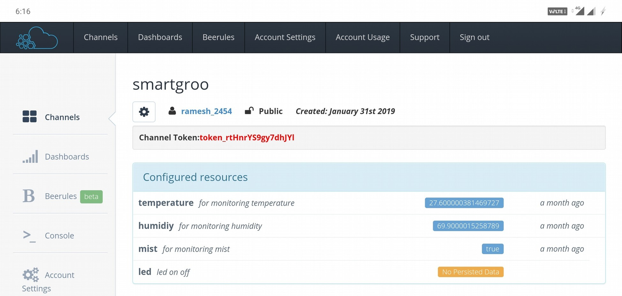

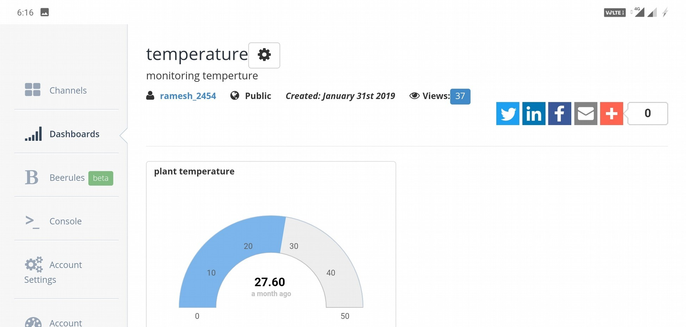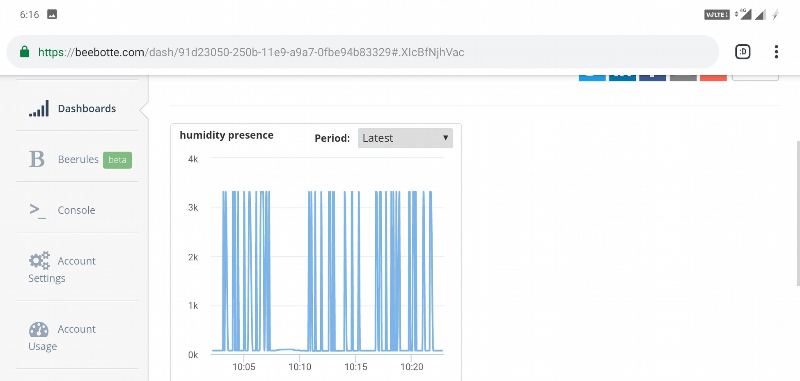

**Pixel selection in first image**



**j**

**REFERENCES**

[1] Weili Han, zhigong Li, Guofei Gu, Wenyuan Xu “shadow attacks based on password reuses: A quantitative empirical analysis”IEEE Transactions on dependable and secure computing, 2018.

[2] Dheepanshu and mayank sharma “Enhancing password security using cyclic groupmatrix”International conference on telecommunication and Networks(TEL-NET),2018.

[3] [Zubayr Khalid,](https://ieeexplore.ieee.org/search/searchresult.jsp?searchWithin=%22First%20Name%22:%22Zubayr%22&searchWithin=%22Last%20Name%22:%22Khalid%22&newsearch=true)[Pritam Paul,](https://ieeexplore.ieee.org/search/searchresult.jsp?searchWithin=%22First%20Name%22:%22Pritam%22&searchWithin=%22Last%20Name%22:%22Paul%22&newsearch=true)[Soummyo Priyo Chattopadhyay](https://ieeexplore.ieee.org/search/searchresult.jsp?searchWithin=%22First%20Name%22:%22Soummyo%20Priyo%22&searchWithin=%22Last%20Name%22:%22Chattopadhyay%22&newsearch=true)“Secure authentication with dynamic password” [IEEE 7th Annual Information Technology, Electronics and Mobile Communication Conference (IEMCON)](https://ieeexplore.ieee.org/xpl/mostRecentIssue.jsp?punumber=7740393),2016.

[4] Lin zhang and zhenfeng zhang“Security analysis of an ID based two server password authenticated key exchange”IEEE Communication letters,2016.

[5] Ashutosh Gupta and Yogesh Kumar“Banking security system using hand gesture recognition”International conference on recent developments in control, automation and power engineering,2015.

[6] Zhigong Li and Weili Han“A Large-Scale Empirical Analysis of Chinese Web passwords”Usenix security symposium,2014.

[7] Adele E. Howe, Indrajit Ray, Mark Roberts, Malgorzata Urbanska“The Psychology of Security for the Home Computer User”IEEE Symposium on security and privacy,2012.

[8] Anupam Das, Joseph Bonneauy, Matthew Caesar, Nikita Borisov and XiaoFeng Wangz “The Tangled Web of Password Reuse”NDSS,2009.

[9] Dino Schweitzer, Jeff Boleng, Colin Hughes, Louis Murphy“Visualizing Keyboard Pattern Passwords”International workshop on visualization for cyber security,2009.

[10] [Fawaz A. Alsulaiman](https://ieeexplore.ieee.org/search/searchresult.jsp?searchWithin=%22First%20Name%22:%22Fawaz%20A.%22&searchWithin=%22Last%20Name%22:%22Alsulaiman%22&newsearch=true), [Abdulmotaleb El Saddik](https://ieeexplore.ieee.org/search/searchresult.jsp?searchWithin=%22First%20Name%22:%22Abdulmotaleb%22&searchWithin=%22Last%20Name%22:%22El%20Saddik%22&newsearch=true)“Three-Dimensional Password for More Secure Authentication”[IEEE Transactions on Instrumentation and Measurement](https://ieeexplore.ieee.org/xpl/RecentIssue.jsp?punumber=19) ,2008.