Implicit wait is globally wait.   
When you give implicitly wait after opening browser. If there are 100 WebElements and it’ll be applied to all of them.   
If the element is not found in expected given time then it will throw NoSuchElementException.   
If you give 10 Seconds to any any element. If element is found in 3 seconds then rest 7 seconds would be ignored.   
It can be applied only to findElement/s.   
  
When element is not found in explicit wait it will thrown TimeOutException.   
Explcitwait can applied to findElement/s and also for other actions as well.   
We don’t have method for explicit wait as like in implicit wait.   
WebDriverWait itself is called as Explicitwait.

[**Devi Sunkari**](https://www.facebook.com/devi.sunkari) Continuous integration (CI) and continuous delivery (CD) embody a culture, set of operating principles, and collection of practices that enable application development teams to deliver code changes more frequently and reliably. The implementation is also known as the CI/CD pipeline and is one of the best practices for devops teams to implement.

Interview Q  
1.what is web service? Can we test web services using selenium?   
2.What is difference between delete and drop?   
3.What is shell scripting nwhat is the basic commands?   
4.How to find colour of elements using selenium?   
5.Difference between backlog and Frontlog?

Int size = list.size();  
List.get(size-1).getText();

[**Devi Sunkari**](https://www.facebook.com/devi.sunkari) For repeated test cases, we can go fir automation because time, energy, money everything will be saved and also quality and transparency will be there. Automation is preferred for regression and functional testing mostly

1. If you define driver as a WebDriver, switching will be very easy. If we use this statement in our script then the WebDriver driver can implement any browser. Every browser driver class implements WebDriver interface and we can get all the methods. It helps you when you do testing on multiple browsers.

2. For example you don't want to test on multiple browsers and you want only one specific browser then you can use ChromeDriver driver = new ChromeDriver();

using this way, you can also have an added advantage to different methods that are only specific to chrome driver and not part of WebDriver interface

3. Using WebDriver driver = new FirefoxDriver(); your achieving the concept of Polymorphism which is a Runtime polymorphism

hope this is clear. Please let me know if you still want to understand in-depth.

How to check the checkbox in popup?

String x = "Selenium";

String y = **new** String("Testing");

String z = **new** String("Automation");  
  
x==y   
x.equals(y)

x.compareTo(y)

x.compareTo(z)

give the output and explain it?

1.what is layout in Jenkins  
2.does Jenkins require a local system for CI?  
3.how to find the broken links on a webpage?  
4.how to check a file size when uploading a document?

How to verify the listbox is dropdown or multiselect list

[8:02:22 PM]Sk:

**> Vidya M**

> How to verify the listbox is dropdown or multiselect list

If multi select list thn it will b a bootstrap dropdown...when yu will inspect you will get "Button" writtn in html dom instead of "Select"

Interview Questions: suppose you have to validate date and time how many scenarios wil you write and how?

I need to change my browser language to Deutch in C# selenium.   
Someone please help me with this.   
I know that we can change using chromeoptions. But how exactly I am not sure.

Answer : Try with this one:  
ChromeOptions options = new ChromeOptions();  
options.addArguments("--lang=de");  
ChromeDriver driver = new ChromeDriver(options);

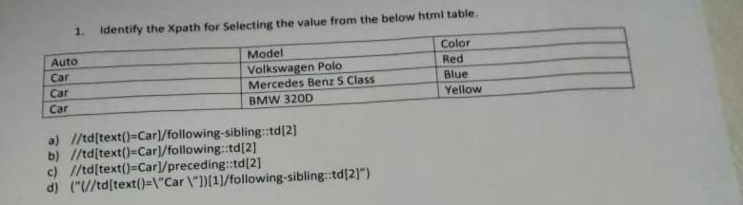

hii naveen yesterday i have interview and interviewer asked me qustion like there is an upload filed need to upload excel file and download that excel file as csv

Interview Questions: suppose you have to validate date and time how many scenarios wil you write and how?

#1.You have to get the format of date and time from requirement   
#2. You have to check each and every part ,For example if date format is , DDMMYYYY and for time if it is HHMMSS, then u have to test with few dates,,like with in12 hours and 13-24 hours,  
#3.you can also test, different time zones like CST EST and all.

nterview question: if there are 1000 records of username and password in excel sheet and if we want to check 400th record how will you read it?  
please tell me if you can

[1:16:45 PM]Raj Chahal:

**> vaishali**

> Interview question: if there are 1000 records of username and password in excel sheet and if we want to check 400th record how

Pass the row number in ur function

[1:17:00 PM]vishuhanda:

**> vaishali**

> Interview question: if there are 1000 records of username and password in excel sheet and if we want to check 400th record how

make a method to getdatafrom 400 th row