Spring BootApplication AggregatorApp_Site

Problem statement
Application Architecture
DBDesign
Class details
Functionalities
● EPIC 1
Note:- Use any Relational DB for the User details
● EPIC 2
Note:- Use any NoSQL DB for the GloQuora_Post
● EPIC 3
Instructions
Sample Data

Problem statement

GloQuora is a community-based questions and answers website. GloQuora app has many features such as registering as a user and posting queries in the GloQuora forums.

Sam has to create an admin module that generates a report to analyze the GloQuora site based on the users and posts.

Help Sam to design an aggregator app for admin users that consumes the data from Userdetails App and GloQuoraPost App which are two separate services.

Application Architecture

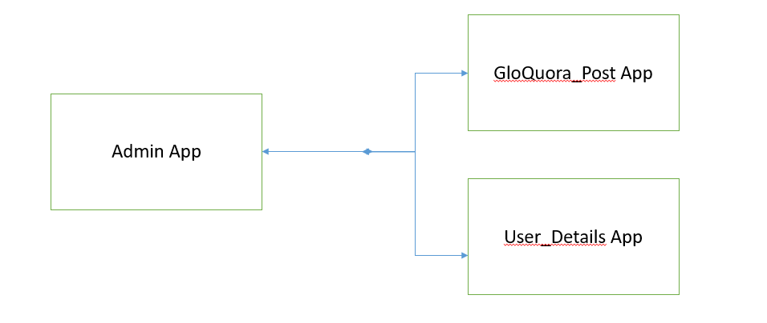

DBDesign
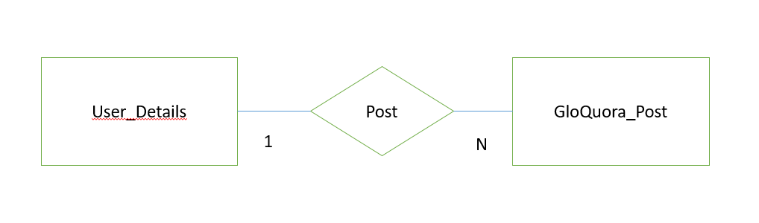

Class details

Class - User_Details
UserId
Name
Username
Email
Address
Phone
Geo

Class- Address
Street
City

Class- Geo
Lat
Long

Class - GloQuora_Post
Userid
Post_id
Title
Body

Functionalities

EPIC 1
- User details App
CRUD service for the User details
- GetAll User details
- GetSpecificUserDetails
- AddUser
- DeleteUser
- UpdateUser

Note:- Use any Relational DB for the User details

EPIC 2
- GloQuora_PostApp
CRUD for the GloQuora_Post details
- GetAllGloQuora_Post
- Add_GloQuora_Post
- Delete_GloQuora_Post
- Update_GloQuora_Post

Note:- Use any NoSQL DB for the GloQuora_Post

EPIC 3
- AdminApp

User Story | User Story | API | Response
US1 | As an admin, one should be able to get all the details of the GloQuora_Post sent by a specific user | http://localhost: port/userspost/{UserId} | All posts by specific user 1 must be displayed at the browser console/Postman console.
US2 | As an admin, one should be able to get all the posts posted by the users with details of users and their posts. | http://localhost: port/userspost | All his/her posts must be displayed at the browser console/Postman console.
US3 | As an admin, one should be able to get all the user names who have posted more than k post.(k can be an integer like 5 or 10) | http://localhost: port/userspost/k | all the user name who has posted more than k posts has to be displayed in the browser console/Postman console.
US4 | As an admin, one should be able to get all the company name of the users who have posted at least one post | http://localhost: port/userspost/company | all the company names has to be displayed in the browser console/Postman console which has posted at least one comment

Instructions

- Use Spring Boot Framework and Microservice Architecture
- Use the Controller /Service /Repository/Entity /DTO Pattern
- Use a centralized registry to register the Services.
- Use RestTemplate to Consume the services.
- Use APIGateway to route the request to GloQuora_PostApp and UserApp
- Use appropriate validations of data at the controller
- Use appropriate exception management.
- Use Logger appropriately
- Use Create appropriate testing modules at Controllers
- Use Swagger API to create a documentation

Sample Data

User_Details Json Data format
{
"userId": 1,
"name": "Graham",
"username": "Bret",
"email": "Sincere@april.biz",
"address": {
"street": "Kulas Light",
"city": "Gwenborough",
"geo": {
"lat": "-37.3159",
"lng": "81.1496"
}
},
"phone": "6546546456",
"company": {
"name": "Romaguera-Crona",
"location": "Multi-layered client-server neural-net",
}
}
GloQuora_Post Json Data format

{
"userId": 1,
"post_id": 1,
"title": "sunt aut facere repellat provident occaecati excepturi optio reprehenderit",
"body": "quia et suscipit\nsuscipit recusandae consequuntur expedit"
}

