AT
ADYSY TECHNOLOGIES

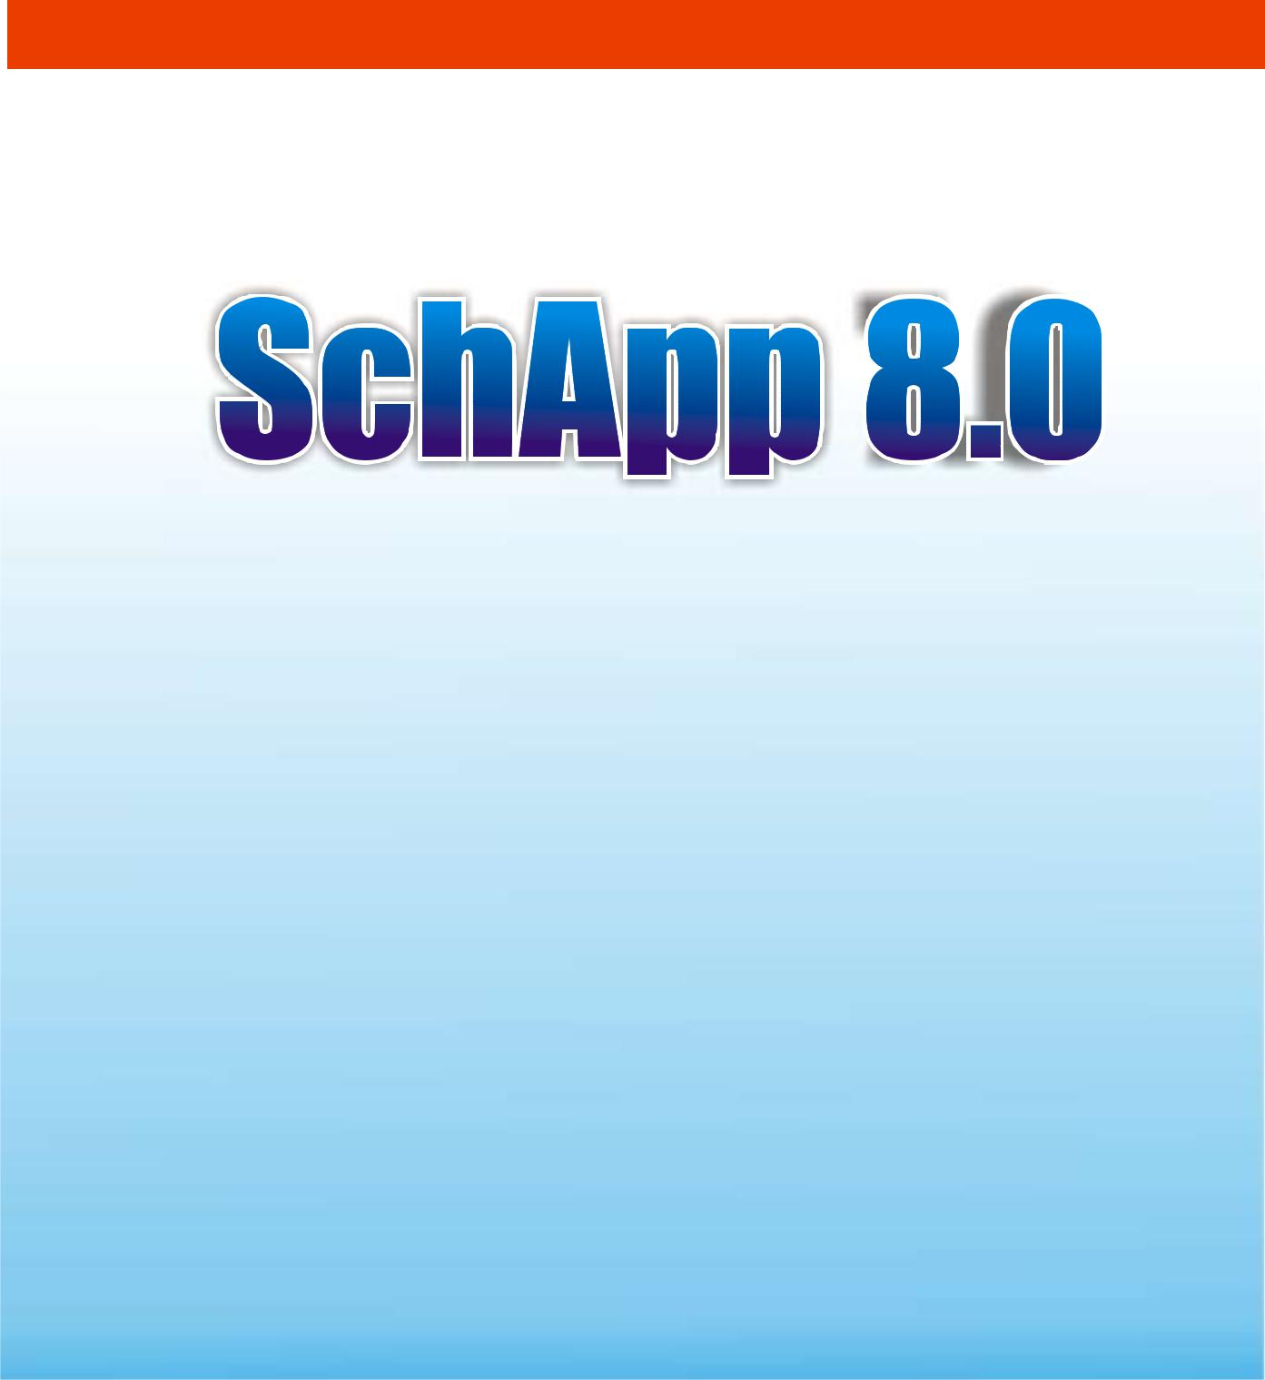
ADYSYS TECHNOLOGIES

+234 (0) 7031009036, 9057894292

A PROPOSAL ON

A COMPUTER-BASED TESTING APP

SUBMITTED TO:

The Head Of School,

Emerald SchoolsGbagada,

8/10, Olawale Dawodu street,

Ifako, Lagos

aPRIL 2019

INTRODUCTION
The plethora of errors besetting manual exam scripts marking has always generated hurtful backlashes from parents, guardians and often times, the students themselves, bringing loads of embarrassing moments to theschool and leaving more to be desired. For many institutions, this problem is as old as the school, with no promise of a permanent solution in view.
While a number of factors may have connived to precipitate these conditions, experts reveal that huge students’ population, overbearing teachers’ workload, inadequate duration earmarked for marking etc are major factors. And it will be completely futile to think that meting out heavy fines or punishmen on the teachers who have made such errors, will effectively curtail this problem.
It is in bid to provide a permanent solution to this challenge and more, that we now proposing our enhanced Computer Based Testing App for proactive and forward looking institutions such as your School.

THE TREND
Interestingly and increasingly, computer-based Examinations are replacing traditional Paper-Based Testing. Its capabilities are and fsr outweighs any drawback arising from their implementation. Furthermore CBT allows for more innovative and authentic assessments due to its more advanced technological capacities.
SchApp 8.0 comes with a result compiler with an auto comment App, in a sleek and elegant design pack and an idiot-friendly interface.
We have no doubts, this App will birth a new era in your institution, when implemented and will completely eradicate the old days of errors and inappropriate marking.

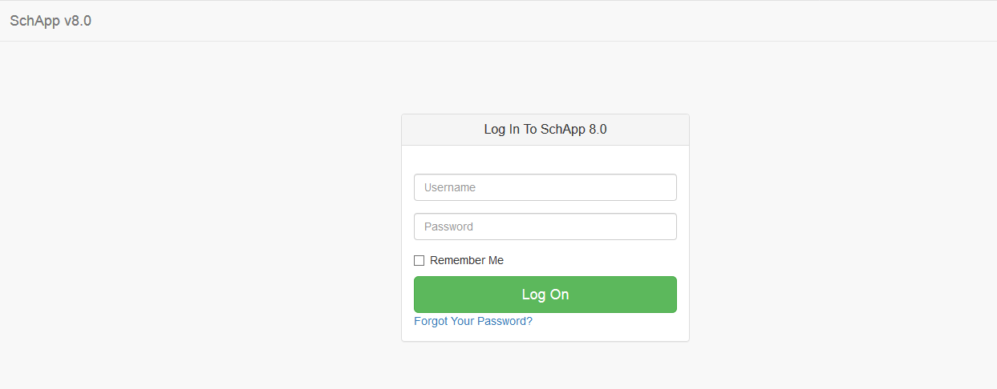
Elegant login

THE SOLUTION

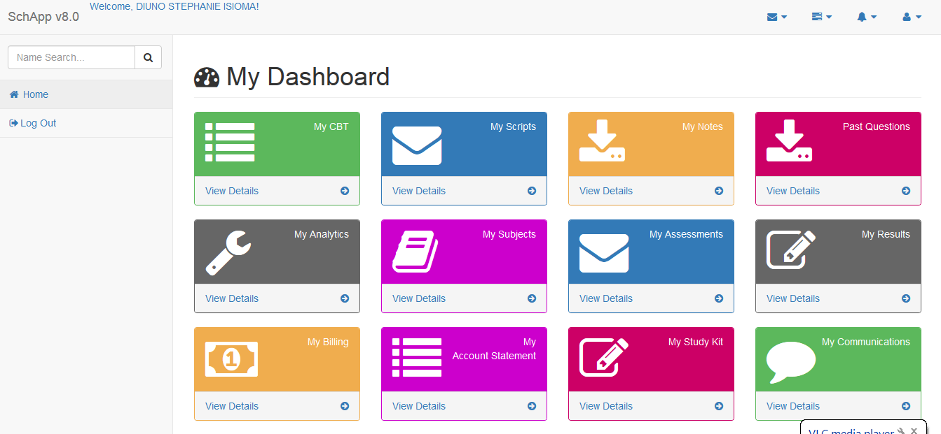

Dashboard

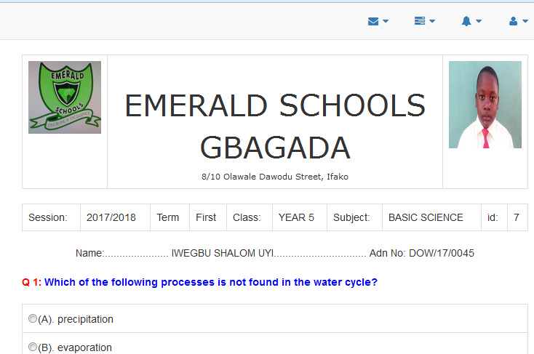
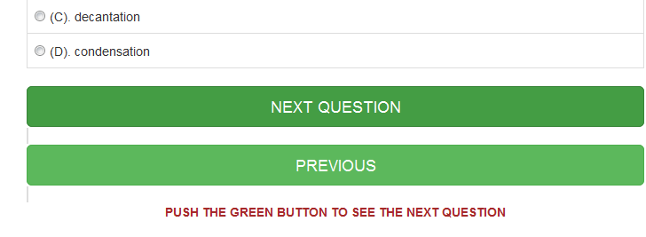
One-question-at-a-time approach

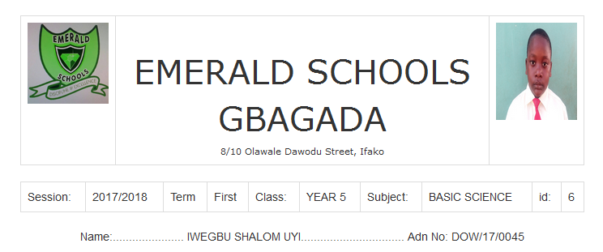
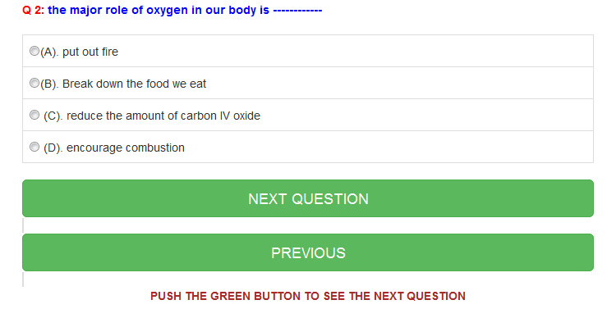

One-question-at-a-time approach

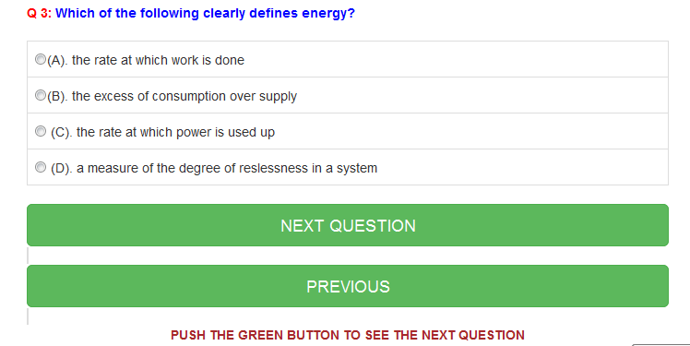

One-question-at-a-time approach

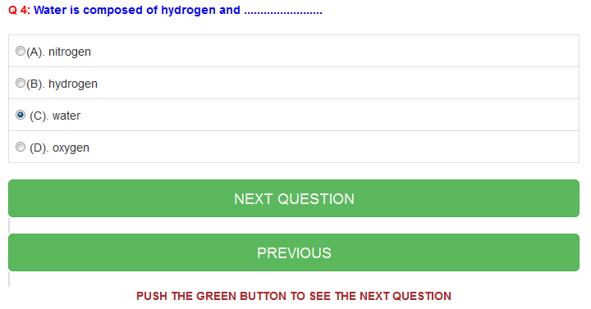

One-question-at-a-time approach

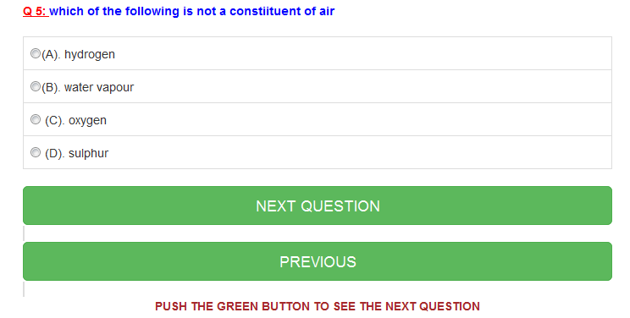

One-question-at-a-time approach

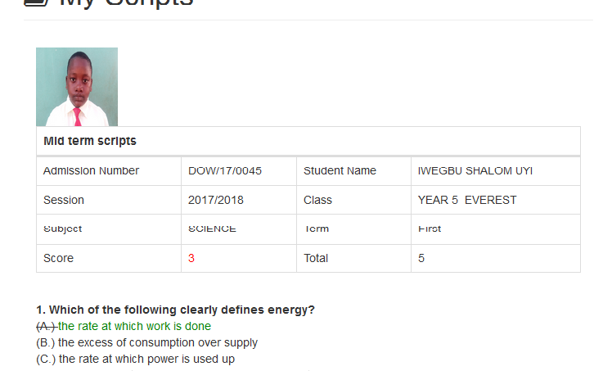
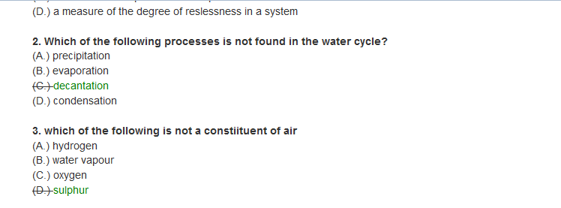
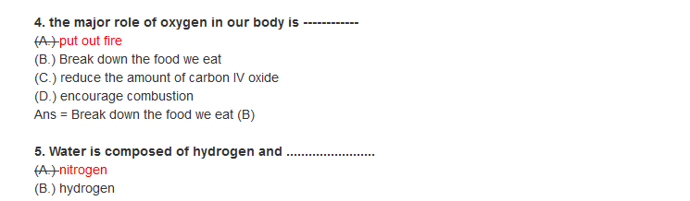

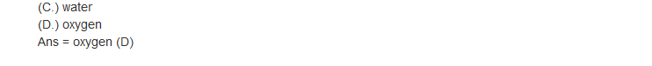

ABOUT SchApp 8.0: OUR ENHANCED CBT APP
Our enhanced CBT program has built-in features that has been personalize for your school.
Important features include;
- One-question-at-a-time approach.
- Result compiler.
- Navigation buttons.
- Auto comment on results.
- Printable Exam scripts.

CLIENTS USING OUR CBT PROGRAM
SchApp 8.0, our flagship App, is currently up and running in the following institutions;
- Salem Academy, Lugbe Abuja.
- Sound Foundation International School, Abuja
- Hilson Academy, Abuja.
- Joel Best Legacy College, Oko-Erin, Ilorin
- Babcock University High School, Ogun State.
- Dowen College, Lagos.
- Tithemi Int’l School, Abuja.

PRICING / MAINTENANCE
To ensure smooth running of this App and that schools of all sizes, big or small, benefit from the services provided by the App, we have made our pricing very competitive and affordable. Kindly find the pricing applicable for your school, based on its size;
- @N1000 per child per term for population less than 500
- @N1500 per child per term for population less than 400
- @N2000 per child per term for population less than 200

Please note that, there shall be
- No deployment costs,
- No training fees,
- No cost on maintenance, and
- No hidden charges whatsoever

It will be our delight to work with you in this regards.

Many thanks
…………………………….
Abaegbu, Mathew O.

