**A DIABETES DETECTION EXPERT SYSTEM**

**BY GROUP 8 MEMBERS**

**GROUP MEMBERS:**

TAIWO ADEBOLA TEMITOPE-GROUP LEAD (17CG023222)

LIADI AKOREDE MUEEZ (17CG023184)

ANI CHIDERA PRISCILLA (17CG023150)

KEKEOCHA GLORY NDUMBUCHI (17CH023258)

ANENE NMESONMA (17CH023244)

EKWUNIFE BLESSING (17CD023304)

# WHAT IS DIABETES?

According to the National Institute of Health (NIH), "Diabetes is a disease that occurs when your blood glucose, also called blood sugar, is too high. Blood glucose is your main source of energy and comes from the food you eat. Insulin, a hormone made by the pancreas, helps glucose from food get into your cells to be used for energy. Sometimes your body does not make enough—or any—insulin or does not use insulin well. Glucose then stays in your blood and does not reach your cells.

Over time, having too much glucose in your blood can cause health problems. Although diabetes has no cure, you can take steps to manage your diabetes and stay healthy. Sometimes people call diabetes “a touch of sugar” or “borderline diabetes.” These terms suggest that someone does not really have diabetes or has a less serious case, but every case of diabetes is serious.

# TYPES OF DIABETES

The most common types of diabetes are type 1, type 2, and gestational diabetes.

1. **Type 1 diabetes:** with type 1 diabetes, your body does not make insulin. Your immune system attacks and destroys the cells in your pancreas that make insulin. Type 1 diabetes is usually diagnosed in children and young adults, although it can appear at any age. People with type 1 diabetes need to take insulin every day to stay alive.
2. **Type 2 diabetes:** with type 2 diabetes, your body does not make or use insulin well. You can develop type 2 diabetes at any age, even during childhood. However, this type of diabetes occurs most often in middle-aged and older people. Type 2 is the most common type of diabetes.
3. **Gestational diabetes:** this develops in some women when they are pregnant. Most of the time, this type of diabetes goes away after the baby is born. However, if you have had gestational diabetes, you have a greater chance of developing type 2 diabetes later in life. Sometimes diabetes diagnosed during pregnancy is usually type 2 diabetes.

This project predicts diabetes among female Pima-Indians.

# WHO IS A PIMA INDIAN?

"The Pima (or Akimel O'odham, also spelled Akimel O'otham, "River People", formerly known as Pima) are a group of Native Americans living in an area consisting of what is now central and southern Arizona. The majority population of the surviving two bands of the Akimel O'odham are based in two reservations: the Keli Akimel O'otham on the Gila River Indian Community (GRIC) and the On'k Akimel O'odham on the Salt River Pima-Maricopa Indian Community (SRPMIC)." Wikipedia

# EXPERT SYSTEMS

An expert system is a computer system that emulates the decision-making ability of a human expert. Expert systems are designed to solve complex problems by reasoning through bodies of knowledge, represented mainly as if–then rules rather than through conventional procedural code.

The expert system built in this project is a Case-Based Reasoning (CBR) expert system. This is an expert system that solves problems and makes decisions based on the solutions of similar past problems. CBR involves developing a case with prior cases or example. It retrieves prior cases relevant to the current problem and decides on a solution based on the outcome of previous cases.

An expert system shell is a software development environment that contains the basic components of expert systems. The components of an expert system include:

1. **Knowledge acquisition subsystem:** this helps experts in building knowledge bases by collecting knowledge needed to solve problems. This is the biggest bottleneck of building an expert system because the quality of data available determines the accuracy of the expert system. For this project, knowledge/data is obtained from a Kaggle repository which was originally adapted from the National Institute of Diabetes and Digestive and Kidney Diseases.
2. **Knowledge base:** this is a store of factual and heuristic knowledge. Expert system tool provides one or more knowledge representation schemes for expressing knowledge about the application domain. Some tools use both frames (objects) and IF-THEN rules. Our expert system is case-based and uses already existing data.
3. **Inference mechanism:** This is also referred to as a reasoning engine. It manipulates the symbolic information and knowledge in the knowledge base. The inference engine can range from simple modus ponens backward chaining of IF-THEN rules to case-based reasoning.
4. **Explanation subsystem:** this is a subsystem that explains the system’s actions. The explanation can range from how the final or intermediate solutions were arrived at justifying the need for additional data.
5. **User interface:** this provides a means for communicating with the user. It is generally not part of the expert system technology but now makes a critical difference in the perceived utility of an expert system.

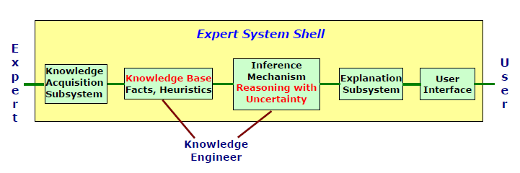

# PROBLEM STATEMENT

Diabetes is a common, chronic disease. It dramatically increases the risk of various cardiovascular problems, including coronary artery disease with chest pain (angina), heart attack, stroke and narrowing of arteries (atherosclerosis). If you have diabetes, you are more likely to have heart disease or stroke. Hence, the prediction of diabetes at an early stage is very essential as it can lead to improved treatment.

The aim of this project is to develop an application that can quickly and efficiently determine if a person has diabetes. Rather than going to a hospital, this system can be used to check if someone is likely to have diabetes. This application system is backed up with data that has been analysed using an effective machine learning model.

# DATA DESCRIPTION

This dataset is originally from the National Institute of Diabetes and Digestive and Kidney Diseases and it was downloaded from Kaggle. It consists of 768 instances and 8 attributes. The objective of the dataset is diagnosis of diabetes of Pima Indians living in America. Out of the 768 instances, 268 are diabetic and 500 are non-diabetic and are described as 1 and 0 respectively in the target attribute (Outcome). In this database, all patients are females and are of age at least 21 years. Attributes in the database are either integers or real numbers.

Based on the various attributes provided in this data set, this paper shows whether a person is diabetes positive or not using Logistic Regression, Decision Tree and Random Forest.

# DATA ATTRIBUTES

The following shows the available attributes in the dataset.

1. **Pregnancies:** The number of times the person was pregnant
2. **Glucose:** This is the concentration of glucose present in the blood (plasma). For a healthy person (a non-diabetic), the normal glucose concentration is between 4.0 to 5.4 mmol/L (72 to 99 mg/dL) and up to 7.8 mmol/L (140 mg/dL) 2 hours after eating.
3. **Blood Pressure:** Diastolic blood pressure (mm Hg). A normal blood pressure should be less than 120/80 mmHg.
4. **SkinThickness**: Triceps skin fold thickness (mm). The triceps skinfold is necessary for calculating the upper arm muscle circumference. Its thickness gives information about the fat reserves of the body. For adults, the standard normal values for triceps skinfolds are 2.5mm (men) or about 20% fat; 18.0mm (women) or about 30% fat.
5. **Insulin:** 2-Hour serum insulin (mu U/ml). The normal insulin level range 2 hours after glucose administration is 16-166 mIU/L.
6. **BMI:** Body mass index (weight in kg/ (height in m²)).BMI is a measure of body fat based on height and weight that applies to adult men and women. An underweight person has a BMI of 18.5 or less, a normal weight person has a BMI range of 18.5-24.9, an overweight person has a BMI in the range of 25-29.9, and an obese person has a BMI of 30 or greater.
7. **DiabetesPedigreeFunction:** A diabetes pedigree function is a function which scores likelihood of diabetes based on family history.
8. **Age:** Age in years
9. **Outcome (target variable):** 0-no diabetes, 1-has diabetes.

# DATA PRE-PROCESSING STEPS

Data pre-processing includes all necessary steps to transform the dataset into a format that is acceptable by the machine model that will be built. This could include missing value detection and imputation/removal, outlier detection, or scaling the variables. In this project, all pre-processing steps were carried out using Python programming language.

The first step was to import all necessary modules that would be used in building the model.

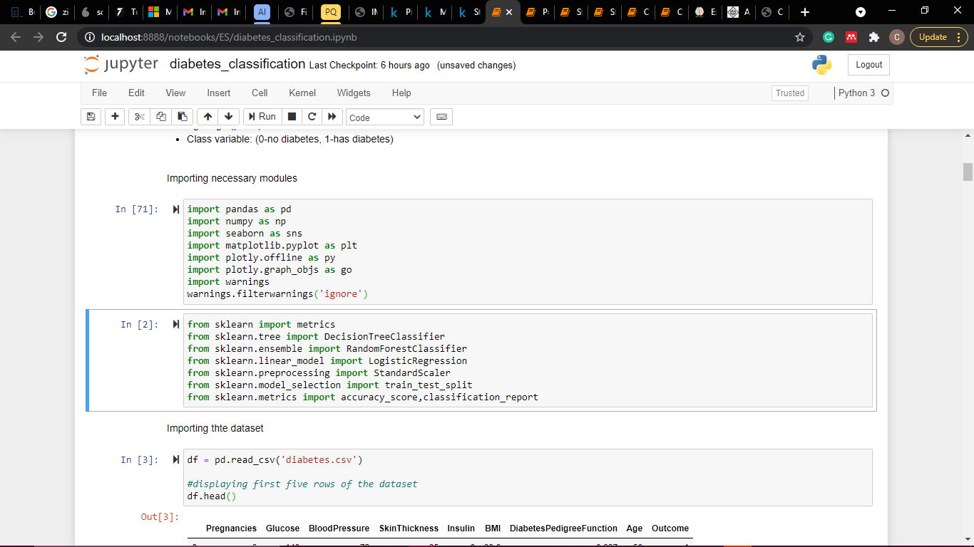

Next, the dataset is loaded, and the first five rows are displayed.

DataFrame.describe() method is called on the data frame to generate descriptive statistics that summarize the central tendency, dispersion, and shape of a dataset’s distribution, excluding NaN values. The describe() method deals only with numeric values and does not work with any categorical values. So if there are any categorical values in a column the describe() method will ignore it and display summary for the other columns unless parameter include="all" is passed. The statistics generated by the describe() method include:

Count depicts the number of non-empty rows in a feature, mean shows the mean value of that feature, std gives the Standard Deviation Value of that feature, min shows the minimum value of that feature, max shows the maximum value of that feature, and 25%, 50%, and 75% are the percentile/quartile of each features. This quartile information helps to detect outliers.

The next pre-processing step is to detect missing values. In this dataset, missing values were represented as 0 in some attributes (Glucose, BloodPressure, SkinThickness, Insulin, and BMI). To handle this, 0 was replaced with NaN then the missing values were imputed using either mean or median.

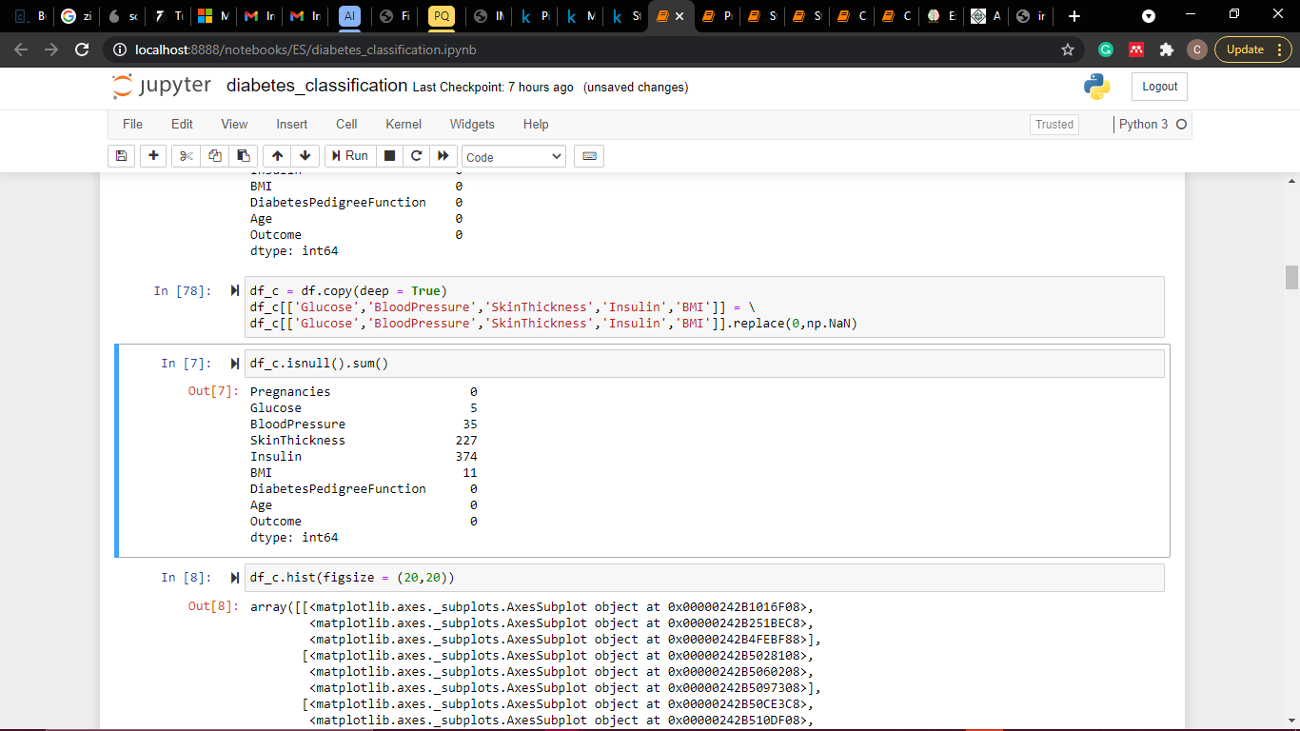

The image below shows the histogram distribution of the dataset before replacing null values.

Null values were then replaced with either mean or median. Then another histogram distribution was plotted.

Finally, the dataset is divided into two data frames: X for the predictor variables and Y for the target variable. The predictor variables are then scaled using Scikit-learn’s StandardScaler() method The Standard Scaler assumes data is normally distributed within each feature and scales them such that the distribution centred around 0, with a standard deviation of 1. This is necessary to prevent higher-ranged values from dominating when calculating distances.

After scaling the dataset is split into a training set of 70% and a testing set of 30% using the train_test_split library from sklearn.

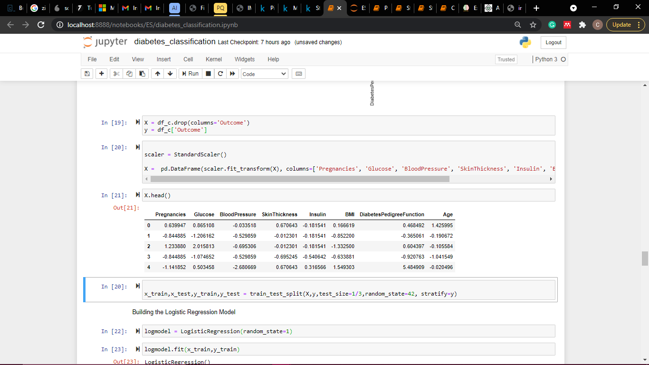

# EXPLORATORY DATA ANALYSIS (EDA)

Exploratory Data Analysis refers to the process of performing initial investigations on data to discover patterns, to spot anomalies, to test hypothesis and to check assumptions with the help of summary statistics and graphical representations. It is a good practice to understand the data first and try to gather insights from it. EDA is all about making sense of data in hand, before building the model.

EDA was carried out using three visualization tools.

1. **Bar Chart:** This was used to show the number of people that are diabetic or healthy. Visualization revealed 500 healthy people and 268 diabetics.

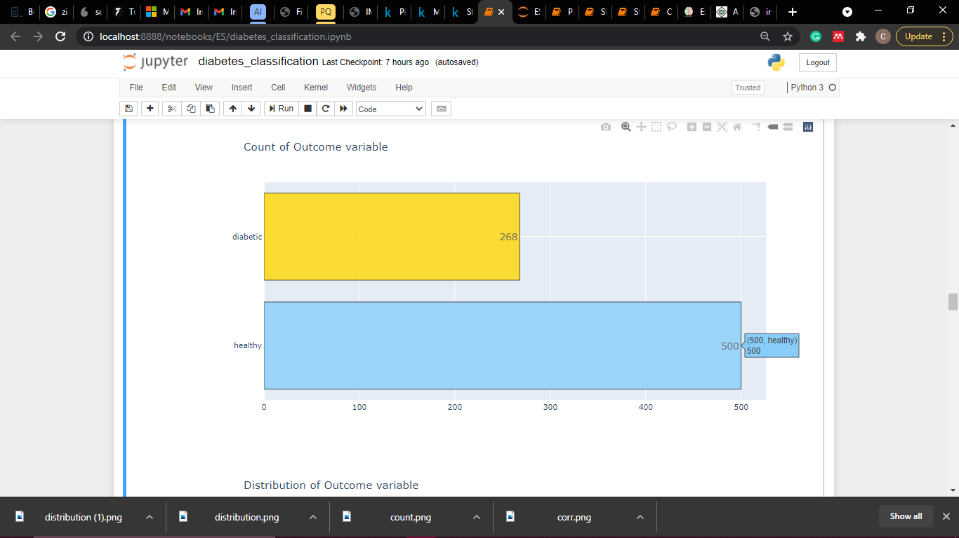

1. **Pie Chart:** This was used to show the population of diabetic and healthy people. Visualization revealed 65.1% of the population are healthy and the remaining 34.9% are diabetic.

1. **Correlation Matrix:** A correlation matrix is used to show the correlation coefficients. Each cell in the table shows the correlation between two variables. A correlation coefficient of 0.5 to 1 is considered high. From the plot below, glucose, BMI, age, pregnancy, and skin thickness have the highest correlation to the outcome variable.A picture containing chart

   Description automatically generated

# MODEL DEVELOPMENT

To build the model, three machine learning classifiers are trained, tested, and evaluated on the dataset. The best one is chosen based on accuracy and f1-score and deployed on the expert system application system.

The accuracy score is a measure of all the correctly identified cases. It is mostly used when all the classes are equally important. It is measures as shown below.

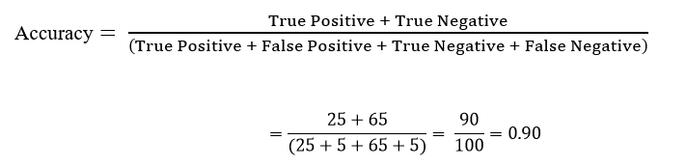

F1-score is the harmonic mean of precision and recall and gives a better measure of the incorrectly classified cases than the accuracy metric. It is measures as shown below.

The classifiers used include:

1. **Logistic Regression:** is used to describe data and to explain the relationship between one dependent binary variable and one or more nominal, ordinal, interval, or ratio-level independent variables.

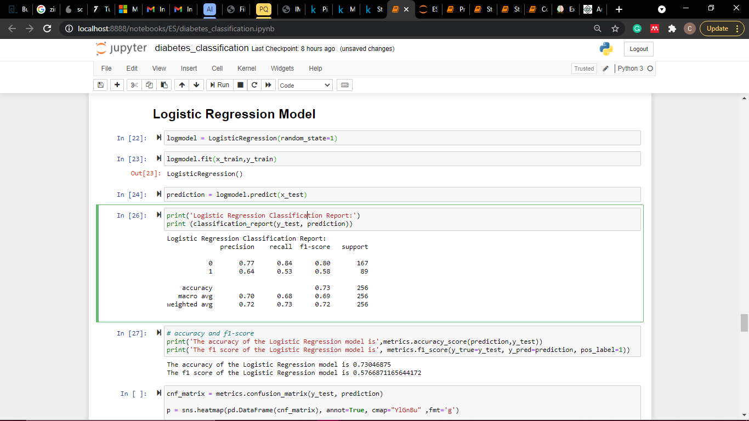

1. **Decision Tree:** aims to create a training model that can be used to predict the class or value of the target variable by learning simple decision rules inferred from prior data (training data).

1. **Random Forest:** a classifier that contains several decision trees on various subsets of the given dataset and takes the average to improve the predictive accuracy of that dataset. 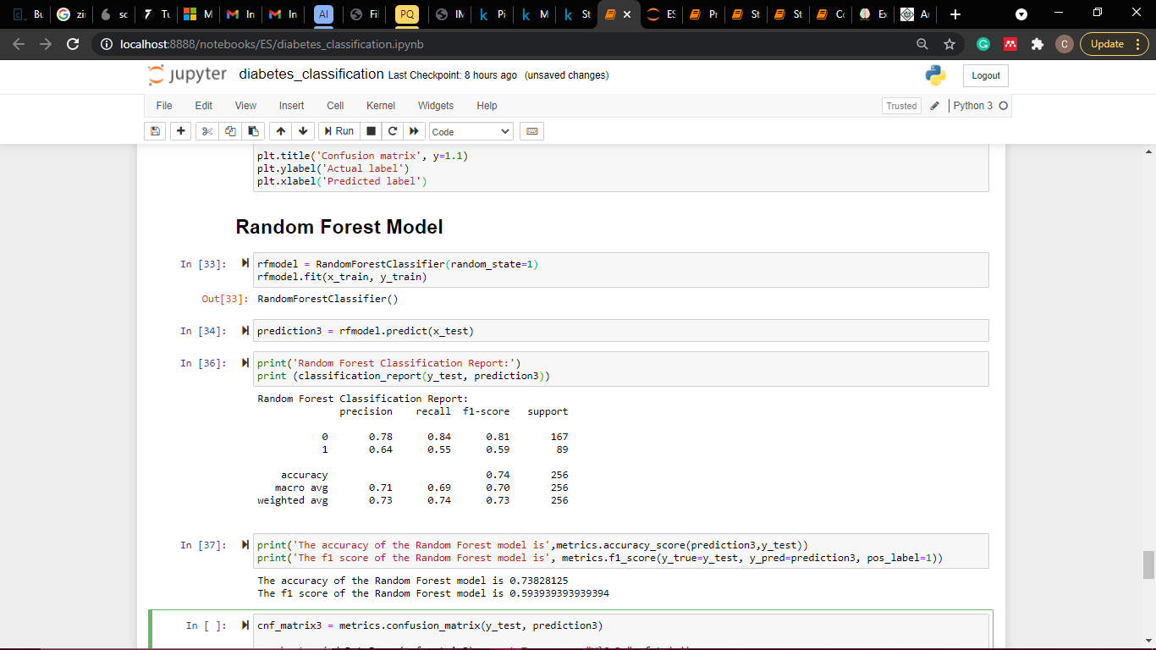

The best classifier score is the Random Forest classifier with accuracy score of 73.8% and f1-score of 59.4%.

# BUILDING THE EXPERT SYSTEM

The expert system was built using Python programming language and Streamlit.

Some codes used to build the system:

# Conclusion

The aim of this project was to build a model that can accurately predict if an individual has diabetes or not. Three different models were built: Logistic Regression, Decision Tree, and Random Forest. The Random Forest classifier gave the best model, so it served as the inference engine for the expert system.

The variables of the Random Forest model were analysed, and the most significant variables were glucose, BMI, age, and diabetes pedigree function. This corresponds to the most correlated variables as seen in the correlation matrix above. The figure below depicts variable importance in a bar chart.

