**School of Computing's MSc project ideas database system**

ENTWA COURSEWORK

UP710297

BSc. (Hons) Software Engineering

INTRODUCTION

DESIGN

IMPLEMENTATION AND TESTING

SUMMARY

REFERENCES

**1. INTRODUCTION**

The new system aims to provide more options to search project ideas and organisations and to ensure that only owners and designated administrators can edit and withdraw or archive projects ideas and organisations. An owner is one who creates the project idea or organisation.

The objectives of the coursework are to:

* implement the search functionality using Ajax
* implement concepts and skills learnt during lectures and tutorials
* develop a secure Java EE application using JSF and a security realm
* develop a robust application by separating concerns into different layers e.g. business logic layer, data access layer, persistence layer

**2. DESIGN**

This section describes the relationship between classes and highlights the user interface design.

The roles available to a user are super user, admin, user (regular user) and anonymous. A super user can create and manage users; and manage all project ideas and organisations. An admin can manage all project ideas and organisations. A user (regular user) can create project ideas and organisations; and can manage only project ideas and organisations the user created. An anonymous user has only read privileges therefore can’t create and manage project ideas and organisations.

**2.1 CLASS DIAGRAMS**

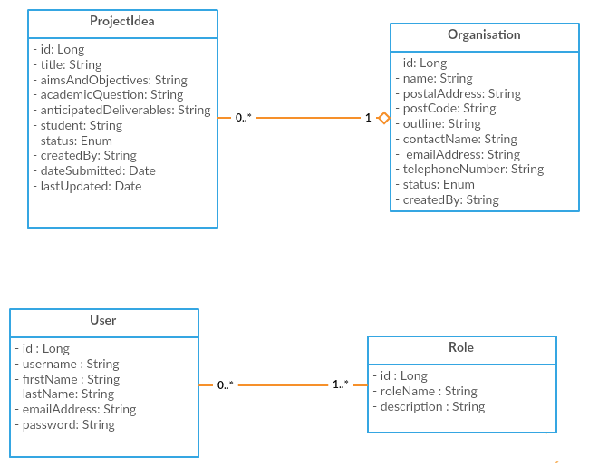

An Organisation has a one-many relationship with ProjectIdea: a project idea belongs to an organisation and an organisation has many project ideas. Whilst the User class has a many-many relationship with the Role class: a user can have one to many roles and a role belongs to zero to many users.

**2.2 USER INTERFACE DESIGN**

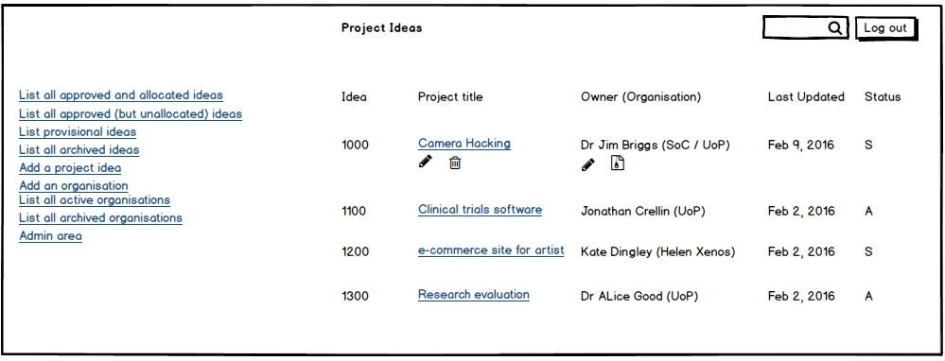

The first four links: list all approved and allocated ideas, list all approved (but unallocated) ideas, list provisional ideas, list all archived ideas enable users to list project ideas based on their status. This provides more options to the user to locate a project idea.

The figure above represents the general view of each of the four links. The logged-in user, Dr. Jim Briggs, is the owner of “Camera Hacking” project idea and “SoC/UoP” organisation and he can consequently only edit, withdraw or delete them. As shown above, the system doesn’t provide the option to edit, withdraw or archive a project idea or organisation that doesn’t belong to Dr Jim Briggs. This provides a good user experience.

The search box at the top is implemented using Ajax and displays, depending on the view, approved and allocated ideas, approved (but unallocated) ideas, provisional ideas or archived ideas. This also provides a good user experience.

The “Add a project idea” and “Add an organisation” links reuse the “Submit a project idea” view in the current system -- editing an organisation and a project idea also makes use of this view. The only change made is to the drop down menu that shows a list of organisations: one can search the list of organisations using Ajax. This makes it easier to select an organisation. I didn’t see the need to majorly alter this view because the aims of the client are to improve the searching functionality of the system and authorise each user; and there was no complaint concerning creating a project idea.

Viewing a project idea is another unchanged view and viewing an organisation is a subset of the view of a project idea.

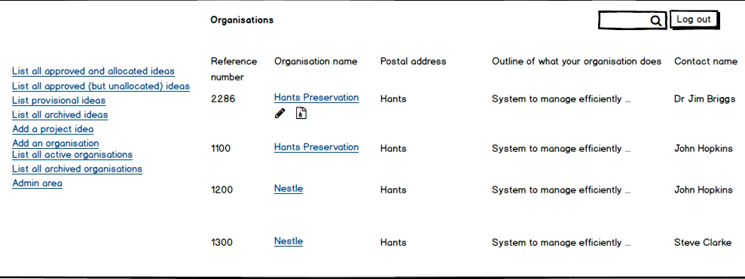

An organisation can be archived by changing its status to “Archived”. This helps to prune down the list of organisations by displaying only active organisations and also maintain a record by not deleting an organisation.

The “List all active organisations” and “List all archived organisations” use the view shown above. As shown Dr. Jim Briggs owns Hants Preservation with a reference number of 2286 but not the other three organisations. The search box is implemented using Ajax.

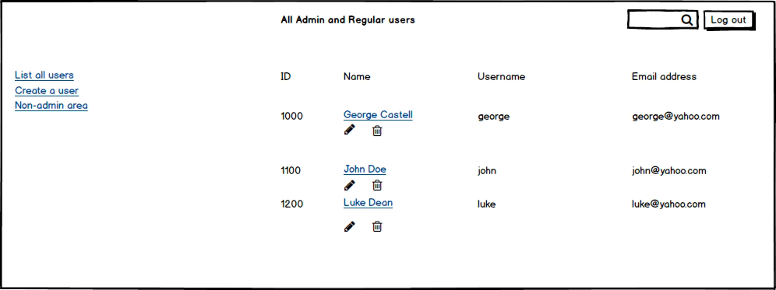

Only super users can visit the admin area. The admin area lists all users and with the search box, a super user can search the list of users by Ajax. Ajax provides a good user experience and the view above makes it easier to manage users.

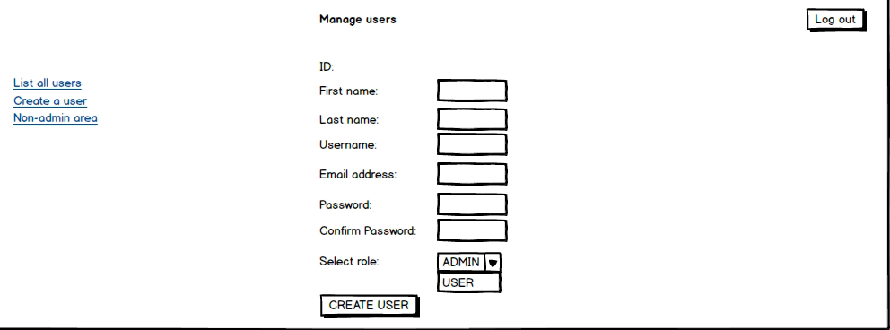

The figure above is used to create and manage users. A super user can assign admin privileges to a designated user with the form above.