**School of Computing's MSc project ideas database system Requirements Specification**

UP710297

BSc. (Hons) Software Engineering

**Contents**

1. Introduction

2. The Stakeholders

3. Definitions

4. Assumptions

5. Scope

6. Use Case

7. Functional Requirements

8. Non-functional Requirements

1. Introduction

This Requirements Specification describes the functions and requirements specified for the new School of Computing's MSc project ideas database system. The project ideas database system allows masters students to submit project ideas. The current system is implemented in a non-MVC (Model View Controller) style. It also has limited searching functionality and does not permit people who submit ideas to be able to edit them or withdraw them.

1.1 Aim

The aim of the new system is to improve the searching functionality and allow only the owners of projects and administrators the ability to edit or withdraw their projects or any project respectively. The new system will be implemented in a MVC style.

2. The Stakeholders

2.1 The Client

Dr. Jim Briggs, Enterprise Web Architecture Lecturer, is the client

2.2 The Customer

The customers are:

* Masters students: All students studying a Masters degree
* Administrators: University of Portsmouth lecturers or a designated user

3. Definitions

3.1 Fit Criterion

The fit criterion details how you can be certain the requirement has been met

3.2 Owner of a project

This is the person who created the project

4. Assumptions

I’m assuming any other person besides the client, Dr. Jim Briggs, viewing this Requirements Specification is familiar with

* the School of Computing's MSc project ideas database system.
* the terms used in this document e.g. MVC (Model View Controller) style.
* web development.

5. Scope

5.1 The Current System

Currently a user can

* List all approved (but unallocated) project ideas
* List all approved and allocated project ideas
* Search for a project idea containing a word
* Create a new project idea
* View a project idea

5.2 New System

The new system will enable the user to

1. Authenticate and authorise a user
2. Provide an anonymous user with READ privileges
3. Allow a regular use to manage only his projects and organisations
4. Allow a user with admin privileges to manage all projects and organisations
5. Allow a superuser to access the Admin section
6. List all approved (but unallocated) project ideas
7. List all approved and allocated project ideas
8. List all provisional project ideas
9. List all archived project ideas
10. Search the title of project ideas using Ajax
11. Search the name of organisations using Ajax
12. Create a new organisation
13. Edit an existing organisation
14. Archive an organisation
15. View an organisation
16. Create a new project idea
17. View a project idea
18. Edit an existing project idea
19. Withdraw (Delete) a project idea
20. Create a new user as an administrator or regular user
21. Edit details of a user
22. Delete a user

6. Use Case

The use case diagram below can be magnified or consult the original copy found in /web/internal

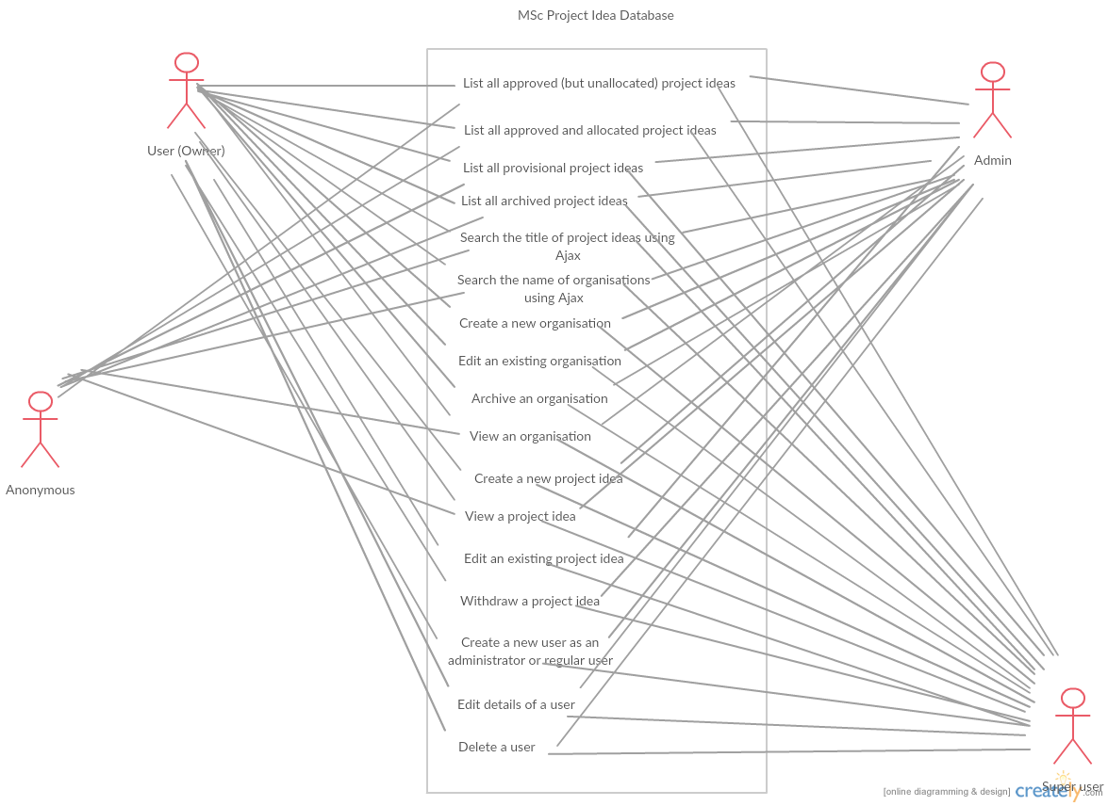

7. Functional Requirements

Requirements with a high priority will be in Version 1 of the app (will be implemented first), whilst those with a Medium priority will be in Version 2 of the app.

|  |  |  |
| --- | --- | --- |
| **NO** | **NAME** | **PRIORITY** |
| 1 | List all approved (but unallocated) project ideas | High |
| 2 | List all approved and allocated project ideas | High |
| 3 | List all provisional project ideas | Medium |
| 4 | List all archived project ideas | Medium |
| 5 | Search the title of project ideas using Ajax | High |
| 6 | Search the name of organisations using Ajax | High |
| 7 | Create a new organisation | High |
| 8 | Edit an existing organisation | High |
| 9 | Archive an organisation | High |
| 10 | View an organisation | High |
| 11 | Create a new project idea | High |
| 12 | View a project idea | High |
| 13 | Edit an existing project idea | High |
| 14 | Withdraw (Delete) a project idea | High |
| 15 | Create a new user as an administrator or regular user | Medium |
| 16 | Edit details of a user | Medium |
| 17 | Delete a user | Medium |

8. Non-Functional Requirements

|  |  |  |
| --- | --- | --- |
| **NO** | **NAME** | **PRIORITY** |
| 1 | Authenticate and authorise a user | High |
| 2 | Provide an anonymous user with READ privileges | Medium |
| 3 | Allow a regular use to manage only his projects and organisations | High |
| 4 | Allow a user with admin privileges to manage all projects and organisations | High |
| 5 | Allow a superuser to access the Admin section | Medium |