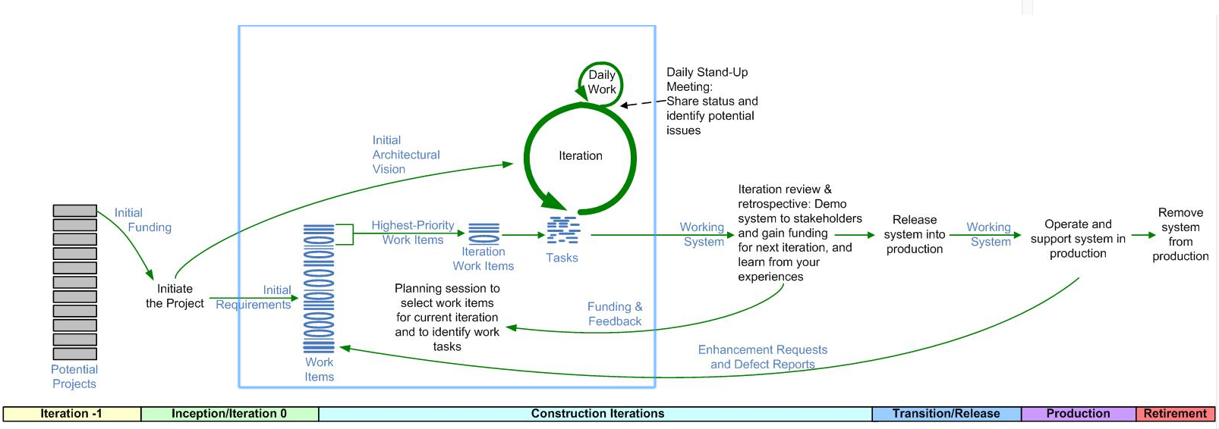Fig 2: The Agile Software Development Life Cycle [1]

1. Ambler, C., *The Agile System Development Life Cycle (SDLC),* Retrieved April, 15, 2016, from <http://www.ambysoft.com/essays/agileLifecycle.html>