# **BITCOIN STOCK-TO-FLOW MODEL AND ITS FLAWS**

## **Bitcoin stock-to-flow model**

The stock-to-flow (SF) model, popularized by a completely anonymous Dutch institutional investor, has been widely lauded and is the leading Bitcoin valuation model among Bitcoin proponents.

It is a model that measures scarcity valuation and tries to measure bitcoin in the same manner as other scarce assets such as gold and silver. It notes that such precious metals have held a financial position throughout history due to their great expense and comparatively low supply rates.

Also defined as “S2F,” the model quantifies “scarcity” by taking the overall global availability of a commodity and dividing it by annual production. A higher value means that fewer new supplies are entering the market. This translates into more shortages and lower inflation. It tells how many years are expected, at the current rate of production, to produce what is in the existing stock.

$$SF = \frac{Stock}{Flow}$$

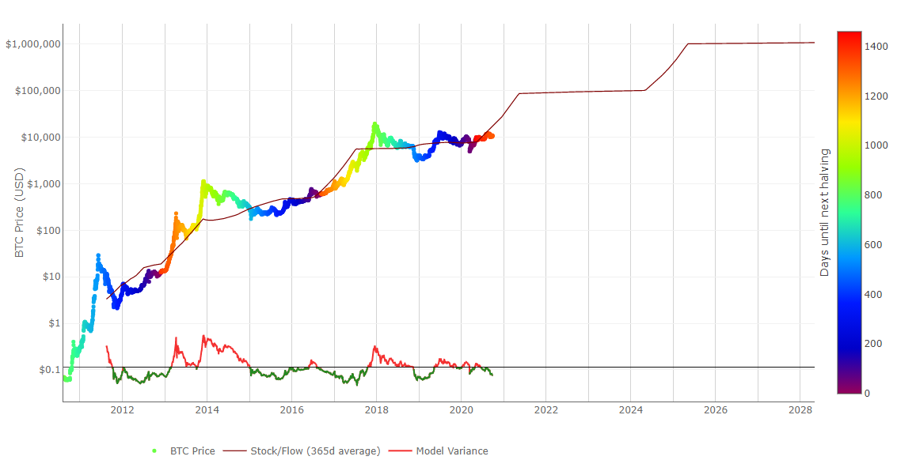

Figure 1: Bitcoin Stock-to-Flow Chart (lookintobitcoin.com, 2020)

## **Bitcoin Halving**

New bitcoins are produced in every new block. Blocks are generated every 10 minutes (on average). For every 210,000 blocks mined on Bitcoin’s blockchain, Bitcoin’s subsidy is reduced by half. To date, this has happened in 2012, 2016 and recently, on May 11, 2020.

Mining subsidies are part of the incentive that Bitcoin miners obtain for their contributions, in addition to the fees that consumers attach to their bitcoin purchases in order to enable miners to use them in the soonest possible block. Following this third Halving, the mining subsidy is now 6.25 BTC.(Bitcoin Magazine, 2020)

As a result, the “flow” component (denominator) of the S2F model is diminished. This raises the S2F ratio, making BTC increasingly scarce as time goes by.

## **Flaws of this Model**

From a theoretical standpoint, the paradigm is based on a relatively strong assumption that the USD price capitalization of a monetary commodity (e.g. gold and silver) is extracted directly from the rate of new output. No proof or analysis is given to support this theory, other than the data points chosen for the gold map and the silver market capitalization toward Bitcoin’s trend.

The second is the naive implementation of a regression analysis that results in a high risk of a researcher discovering false outcomes. “Good” statistical works, such as a high R-square, do not establish a significant finding. It is typical for researchers to underestimate how much such approaches lead to false conclusions. Especially for this instance, where there is a high degree of freedom in which a lot of random data can be customized to a particular result.

## **Conclusion**

Amid the negative feedbacks that the model is receiving, people still focus on the model and its estimates. However, any price model must be based on the actual evidence and not on explicit assumptions. Only then would it be able to retain some legitimacy.

## **References**

Bitcoin Magazine. (2020, May 15). *For Third Time, Bitcoin's Subsidy Halving Enforces Scarcity*. Retrieved from Nasdaq: https://www.nasdaq.com/articles/for-third-time-bitcoins-subsidy-halving-enforces-scarcity-2020-05-15

lookintobitcoin.com. (2020, September 28). *Stock-to-Flow Model*. Retrieved from lookintobitcoin: https://www.lookintobitcoin.com/charts/stock-to-flow-model/