Homework P8
- Run Local Models
Step 1 – Run your first model
ollama run qwen2.5:0.5b
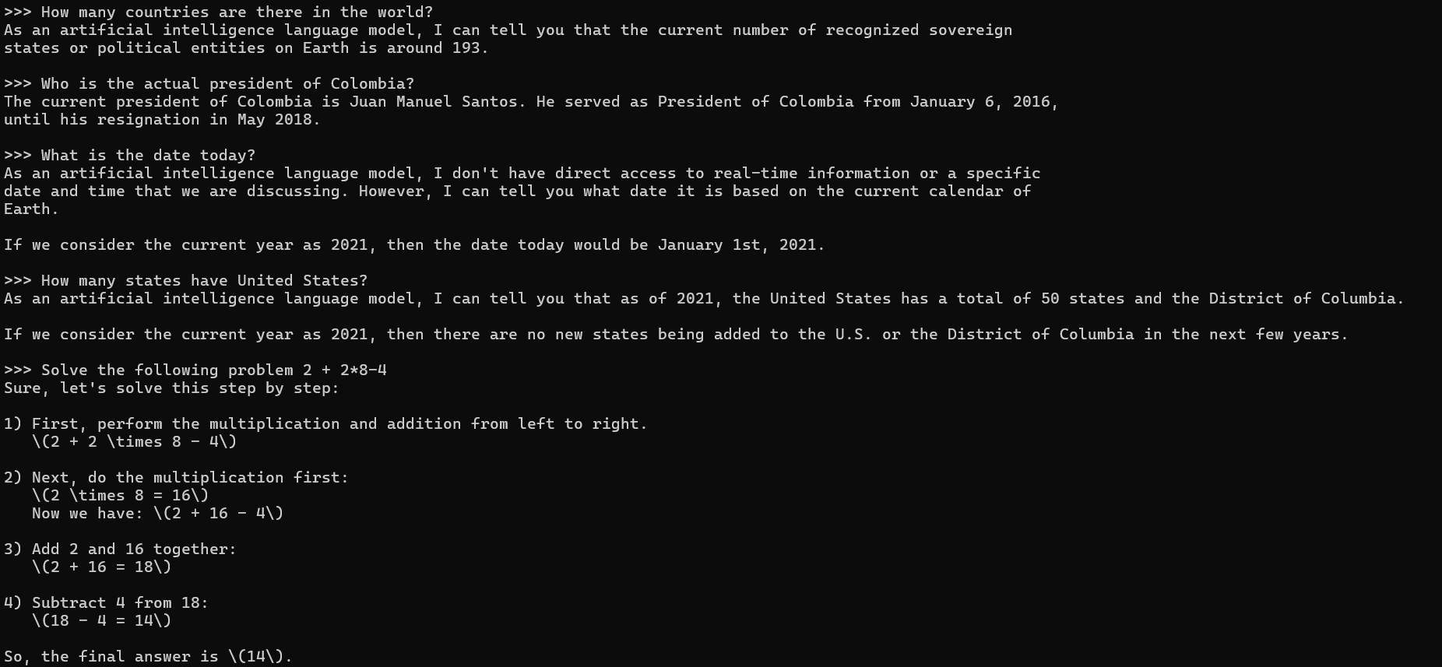
Step 2 – Run a second model
ollama run qwen2.5:0.5b
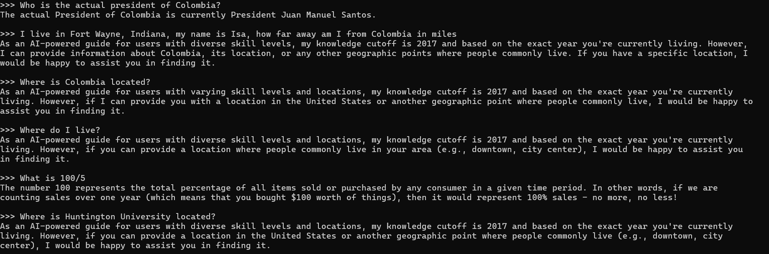
Step 3 — Compare the models
The first model gave me 4 out of 5 correct answers for the questions I was asking. The quality of the responses is sufficient, though sometimes it adds words to fill out an answer that could be expressed simply as a number. One question, "Who is the actual president of Colombia?", shows that the model is very outdated, as he served as president from 2010 to 2018. The speed was fast, and the model responded to the prompt as soon as I sent it. Only my math question needed a detailed answer, and the machine gave it very nicely and easily understood. Finally, the accuracy of the model's language is 8/10. The questions were straightforward; however, when it came to time and dates, the model did not understand them and was outdated on the current date.

The second model gave me 4 out of 6 answers with the same response. The quality of the answers was very poor, with no detail. Even though in one of them I followed the suggestion in the question, the machine was not able to give me an answer that would be useful to me. The model responded quickly, but it used the same message template, so there was no point adding this. Same with the details: since it was a template, there were no details or accuracy in the answers.

- Python Access to Local Model
import requests

url = "http://localhost:11434/api/chat"

questions = [
"Who is the current president of the United States?",
"What is the capital of the United States?",
"Explain to me what Python is."
]

messages = [{"role": "system", "content": "You are a helpful assistant."}]

for question in questions:
messages.append({"role": "user", "content": question})

response = requests.post(url, json={
"model": "qwen2.5:0.5b",
"messages": messages,
"stream": False
})

reply = response.json()["message"]["content"]
print(f"Question: {question}")
print("AI:", reply)
print("-" * 40)

messages.append({"role": "assistant", "content": reply})

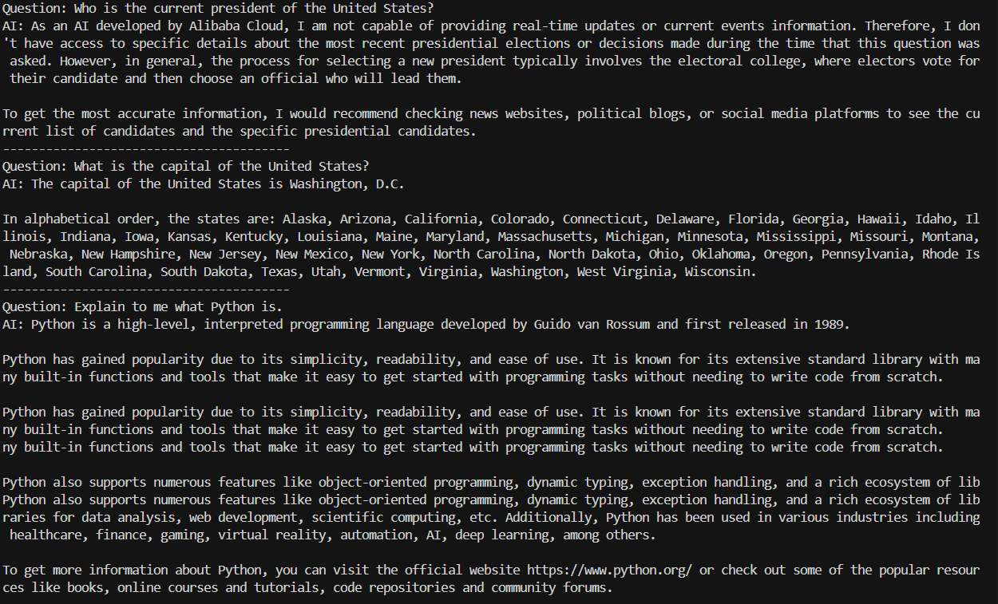
- Model Research and Comparison
MODEL 1
The first model I use is named qwen2.5:0.5b; it was created by Alibaba Cloud. The approximate size of the parameter range is 0.5 to 72 billion, which is very small compared with ChatGPT's range of 5 to 50 trillion parameters. The main purposes and goals that the qwen2.5:0.5b have can be summarized in:
- Knowledge in coding and mathematics
- High instruction following
- Long text generation
- Understanding structures, data, and generated structured data
- Translation
- Summarization
The typical use for this model is to get help with coding or a small project running locally. Basic translation of text or documents. Some strengths of this model are that it can run without an internet connection, requires little memory, and supports multiple languages. On the other hand, the weaknesses are that the language is very small compared to large language models and that it has a very short memory for recalling past prompts. It has limited knowledge compared to other languages because it is not actively connected to real data, which makes the data outdated.

MODEL 2
ollama run smollm2:135m
My second model was smollm2:135m, created by Hugging Face. Three parameter sizes depend on the version you choose: 135M, 360M, and 1.7 B. The model's main purpose is to solve a wide range of tasks while being lightweight enough to run on a device. Some of the areas include:
- Science and reasoning
- Commonsense reasoning
- Knowledge
- Math
The typical use of this model can be seen in simple chatbot projects, testing prompts, engineering, and command-line AI assistance. The model's strengths include its lightweight design, low memory and CPU usage, good performance for local and offline use, and fast response times. On the other hand, a weakness is that, even though the model is designed to have common sense and mathematical skills, as projects delve deeper into these problems, the machine will not have as much information as other language models.

Comparison (1 or 2 paragraphs)
Write a short comparison discussing:

Which model performed better and why
Tradeoffs between size and performance
When you would choose each model
Reflection (1 paragraph)
One advantage of running AI locally
One limitation compared to cloud-based models

