Part 1. Alpha Beta Prunning
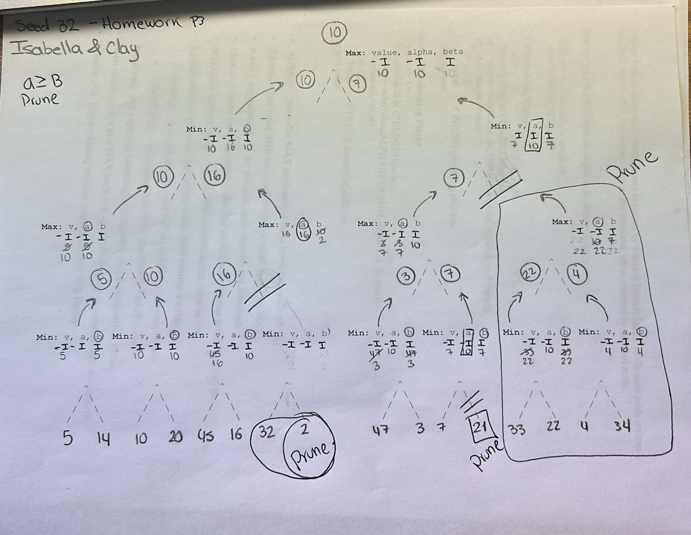

Part 2. Analysis and Further Research (30 points)
Write an overview of Alpha-Beta pruning. (three to four or more paragraphs)
Written by ChatGPT.

Alpha–Beta pruning is an optimization technique for the minimax algorithm, which is commonly used in adversarial search problems such as two-player, zero-sum games (e.g., chess, checkers, or tic-tac-toe). The core goal of minimax is to determine the optimal move for a player by exploring a game tree and assuming that both players act rationally. However, minimax can be computationally expensive because it evaluates every possible game state. Alpha–Beta pruning improves efficiency by eliminating branches of the game tree that cannot possibly affect the final decision, allowing the algorithm to search deeper without increasing computation time.
The technique works by maintaining two values during the search: alpha and beta. Alpha represents the best (highest) value that the maximizing player can guarantee so far, while beta represents the best (lowest) value that the minimizing player can guarantee so far. As the algorithm traverses the game tree, these bounds are updated. If, at any point, the algorithm finds that the current node’s value cannot improve the outcome for the player (i.e., alpha becomes greater than or equal to beta), further exploration of that branch is unnecessary. This condition triggers pruning, as continuing to evaluate those nodes would not influence the final choice.
One of the key advantages of Alpha–Beta pruning is that it does not change the final result produced by the minimax algorithm; it simply reduces the number of nodes that need to be evaluated. In the best-case scenario—when moves are examined in an optimal order—Alpha–Beta pruning can reduce the effective branching factor significantly, allowing the algorithm to run in roughly twice the depth of a standard minimax search for the same computational cost. In the worst case, when move ordering is poor, Alpha–Beta pruning still performs no worse than minimax.
Overall, Alpha–Beta pruning is essential for making game-playing AI practical in complex environments. By cutting off irrelevant parts of the search tree, it enables deeper lookahead and stronger decision-making without sacrificing optimality. For this reason, Alpha–Beta pruning remains a foundational technique in artificial intelligence and is widely used in modern game engines alongside additional enhancements such as heuristic evaluation functions and move ordering strategies.
Briefly list four additional two-player games (beyond tic-tac-toe, chess, checkers, connect-four) that could use alpha-beta pruning. (one or two sentences each)
Information from Google AI, Chatgpt, and
https://www.geeksforgeeks.org/artificial-intelligence/alpha-beta-pruning-in-adversarial-search-algorithms/

Backgammon: Although it involves dice, the deterministic, adversarial, and turn-based nature allows for applying pruning alongside probability models to determine optimal moves.
Mancala: Players move seeds around a board, making it a combinatorial game suitable for minimax with pruning to maximize seed collection.
Othello (Reversi): A deterministic, zero-sum board game where players alternate turns and must anticipate opponent responses, making it well-suited for minimax with alpha–beta pruning.
Reversi.

For #3, #4, #5, and #6 pick one of the games you listed for #2
- Describe the "search" space (one or two paragraphs). Estimate the search space size at each ply and provide actual values if available (include references if applicable). (two or more paragraphs)
Written by ChatGPT and I changed some ideas.
In Backgammon, the search space consists of all possible game states reachable from the current board configuration as players alternate turns. A game state is defined by the positions of all checkers on the 24 points (plus the bar and bear-off), whose turn it is, and—crucially—the outcome of the dice roll. For adversarial search using alpha–beta pruning, Backgammon is often simplified by treating it as a deterministic two-player game, either by fixing dice outcomes, averaging over dice rolls, or analyzing specific deterministic variants. Under this framing, each ply in the search tree represents one player’s move given a particular dice roll, and successor states are generated by all legal checker moves consistent with that roll.
On a given turn, a player rolls two dice, which can result in up to 21 distinct dice combinations (15 non-doubles and 6 doubles). For each dice outcome, there may be anywhere from a few legal moves to several dozen, depending on board complexity. Empirical studies and game engine analyses estimate that the average number of legal moves per dice roll is roughly 20, but in complex midgame positions this can rise to 30–40 legal moves. If dice outcomes are explicitly modeled, the effective branching factor at a single ply can exceed 400 possible move sequences (≈ 21 dice outcomes × ~20 legal moves each).
As a result, the raw search space grows extremely quickly. At depth 1 (one ply), the search space may already include several hundred nodes. At depth 2, this can expand to well over 100,000 nodes, and by depth 3 the number of possible states can reach into the tens of millions. Alpha–beta pruning helps mitigate this by eliminating branches that cannot affect the optimal decision, particularly when strong move ordering heuristics are used to evaluate promising moves first. Nevertheless, in deterministic or expectation-based versions of Backgammon search, alpha–beta pruning can still significantly reduce the number of evaluated nodes and make deeper analysis practical. Modern Backgammon programs often combine limited-depth alpha–beta search with heuristic evaluation functions and probabilistic models to handle the immense search space efficiently.
References (suggested):
- Tesauro, G. (1995). Temporal Difference Learning and TD-Gammon. Communications of the ACM.
- Russell, S., & Norvig, P. (2021). Artificial Intelligence: A Modern Approach (Adversarial Search chapter).
Written by Google AI
The average number of possible moves per turn is relatively low (often 6 to 30), but the sheer volume of 21 possible dice outcomes combined with 21 responses creates a massive search space for AI agents, with potential connections in the sextillions (\(10^{21}\)) when examining deep, multi-turn sequences.
0-Ply (Current Turn): The player has 15 checkers and 21 possible dice outcomes (21 unique pairs). Legal moves per roll are usually limited to under 30 in typical scenarios, though this can vary.
1-Ply (After One Roll): The search tree includes 21 possible dice outcomes. For each, multiple moves are possible.
2-Ply (Your Turn + Opponent's Response): The search space multiplies the moves for your roll by the 21 possible responses of the opponent, resulting in \(21\times \text{moves}\times 21\times \text{moves}\), often creating hundreds or thousands of positions to evaluate.

- Has this game been "solved"? If so, by whom? List the web-link or reference supporting your answer. (two paragraphs) (one or more paragraphs)
Written by ChatGPT
Backgammon has not been fully solved in the way classical deterministic games like checkers have been. Because Backgammon incorporates dice rolls (randomness) and the doubling cube, its full game space is technically stochastic and extraordinarily large, making it not amenable to a complete perfect-play solution that tells you the optimal move for every possible position under all dice outcomes. No widely accepted algorithm has computed an exact optimal strategy for the complete game of Backgammon, and researchers note that such a strategy has not been proven to exist or been fully computed because Backgammon’s chance elements and indefinite doubling make the search space effectively infinite in traditional game solving terms. (bkgm.com)
However, significant progress has been made in solving portions of the game. For instance, bear-off endgame positions—where all checkers are past the midpoint and players are removing them from the board—have been solved with exact equity values for every possible bear-off configuration (with or without doubling) by Hugh Sconyers; this database contains precise answers for approximately 12 billion bear-off situations. (Wikipedia) Additionally, simplified variants of Backgammon like Hypergammon (with only three pieces per side) have been solved fully, with perfect play known for all positions. (Wikipedia)
- Describe a storage requirement for one state of this game. Show the game state and storage.
Written by chatgpt
A single Backgammon game state must encode all information necessary to fully reconstruct the position and determine legal moves. At minimum, this includes the location of all checkers for both players, any checkers on the bar, checkers already borne off, whose turn it is, and (if modeled) the doubling cube and dice. Because Backgammon is a two-player, perfect-information game, no hidden information needs to be stored—everything is visible on the board.
The board itself has 24 points, each of which can hold any number of checkers from only one player at a time. Since each player has exactly 15 checkers, a compact representation stores, for each point, an integer indicating the number of checkers and the owner (positive for one player, negative for the other). Additional integers store the number of checkers on the bar and borne off for each player. A small flag indicates whose turn it is, and optional fields store the dice values and doubling cube status if relevant to the search.
Example Game State Representation
Component | Description | Storage
Points 1–24 | Number of checkers on each point (signed integer) | 24 × 1 byte = 24 bytes
Bar (2 values) | Checkers on the bar for each player | 2 bytes
Bear-off (2 values) | Checkers borne off for each player | 2 bytes
Player turn | Which player moves next | 1 byte
Dice (optional) | Current dice roll (2 values) | 2 bytes
Doubling cube (optional) | Cube value + ownership | - bytes
Total (without dice/cube): ~29 bytes
Total (with dice/cube): ~33 bytes
Compact State Encoding (Conceptual)
Board[24] = [ +2, 0, 0, -5, ... ]
Bar = (1, 0)
BearOff = (5, 3)
Turn = Player A
Dice = (3, 6)
Cube = (4, Player B)
This compact storage is efficient enough for alpha–beta pruning and other search methods, allowing millions of states to be evaluated and cached during gameplay analysis. In practice, professional Backgammon engines further compress this representation using bit-packing or arrays of small integers to reduce memory usage and improve lookup speed.

- Using your storage option for #5, estimate the storage needed to store all possible moves.
Written by ChatGPT
Using the ~33-byte per state storage representation from #5, we can estimate the storage required to hold all possible Backgammon states (moves), keeping in mind that this will necessarily be an approximation because Backgammon’s state space is enormous and not fully enumerable.
First, consider the number of legal board configurations. Each player has 15 checkers distributed across 24 points, the bar, and bear-off. Even ignoring dice and the doubling cube, research estimates the number of distinct legal Backgammon positions to be on the order of 10²⁰ to 10²² states (Tesauro, 1995; Russell & Norvig). This includes all reachable checker arrangements and turn information. Let’s conservatively use 10²¹ states as a middle estimate.
Using the storage size from #5:
- Storage per state: ~33 bytes
- Estimated number of states: ~10²¹
10^21* 33 bytes = 3.3 * 10^22 bytes
That is approximately:
- 33 zettabytes (ZB)
(1 ZB = 10²¹ bytes)
This estimate does not include indexing overhead, pointers, or metadata that would be required in a real database or search table, which would further increase storage requirements.
In practical terms, this amount of storage is far beyond the capacity of any existing or foreseeable computing system. For comparison, estimates of total global data storage are measured in tens of zettabytes. This is why Backgammon cannot be “solved” by brute-force state enumeration and instead relies on alpha–beta pruning, heuristic evaluation functions, and neural networks to evaluate only a tiny fraction of possible states during play.

