

SOFTWARE REQUIREMENTS SPECIFICATION (SRS)

Park Ease – Mobile App

Chidozie Daniel (24SOEIT11604)
Neha Chaudhary [24SOECE11630]
Ndahiriwe Shalom [24SOEIT11603]

This is to certify that the above statement made by the student(s) is correct to the best of my knowledge.

Department of Computer Engineering
RK. University, Rajkot – Gujarat


Academic Year: 2026
SCHOOL OF ENGINEERING, RK UNIVERSITY, RAJKOT

Description
Park Ease is a comprehensive smart parking mobile application designed to streamline the discovery, reservation, and management of parking spaces in urban environments. The client-facing application provides a modern onboarding flow alongside secure authentication, including registration, login, email OTP verification, and password recovery modules. Through an intuitive, map-driven interface, drivers can search for parking by location, compare nearby facilities, review amenities and pricing, select a specific slot, navigate to the site, complete payment, and monitor active or completed bookings in real time. Dedicated profile and vehicle management further allow users to oversee their personal details, saved vehicles, and booking history effortlessly.
The platform integrates a centralized Admin Management Portal to optimize daily parking operations and facility oversight. The administrative dashboard delivers live operational insights, detailing user and booking statistics, revenue metrics, and occupancy rates at a glance. Additionally, administrators can manage registered customer profiles, track booking fulfillment, and update the parking catalogue dynamically through dedicated modules for adding, modifying, and pricing facilities and their slots. This dual-module setup ensures efficient transaction processing and seamless slot-inventory maintenance.

Functional Requirement Summary

User Side
- Splash Screen & Branding
- Onboarding / Welcome Walkthrough
- User Registration
- User Login
- Admin Login Redirection
- Email OTP Verification
- Forgot Password Request
- Password Reset
- Personalized Home Dashboard
- Quick Actions Access
- Nearby Parking Areas Listing
- Interactive Map Search
- Parking Location Results
- Parking Details & Amenities
- Slot Selection Grid
- Turn-by-Turn Navigation
- Booking Confirmation
- Booking Details & Sharing
- Ongoing & Upcoming Bookings Tracking
- Booking History
- Current Parking Session Tracking
- User Profile Management
- Profile Editing
- Vehicle Management (Add / List Vehicles)
- Payment Methods & Checkout
- Notifications

Admin Side
- Admin Authentication & Login
- Operational Dashboard Overview
- User & Booking Statistics
- Revenue Metrics
- Registered User Management & Listing
- User Role & Status Display
- Parking Lots Listing
- Add New Parking Lot
- Edit Parking Lot Details & Pricing
- Manage Bookings Listing
- Booking Details View & Actions
- Booking Cancellation & Check-Out
- Reports & Analytics
- Revenue Trend Visualization
- Occupancy Rate Monitoring
- Admin Notifications Management

App UI

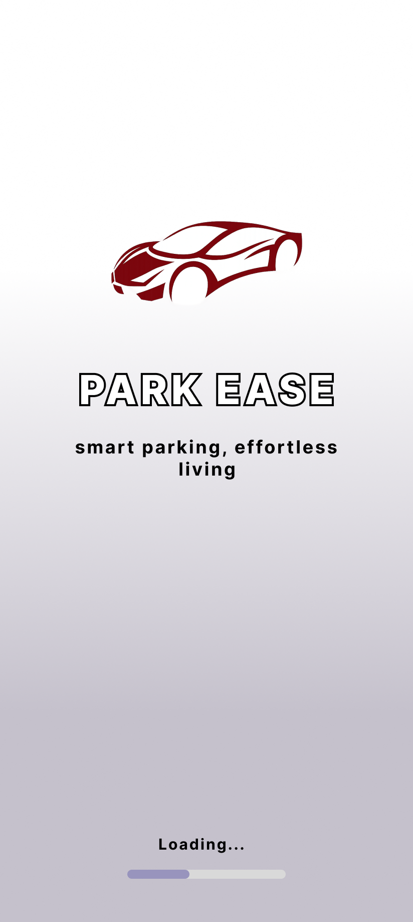

Splash Screen
The Splash Screen serves as the initial launch interface, establishing brand identity with the official Park Ease logo and the tagline "smart parking, effortless living" rendered over a soft gradient background. It initializes the authentication state and automatically transitions the user to the admin dashboard, the user home, or the welcome walkthrough once core application resources have loaded.

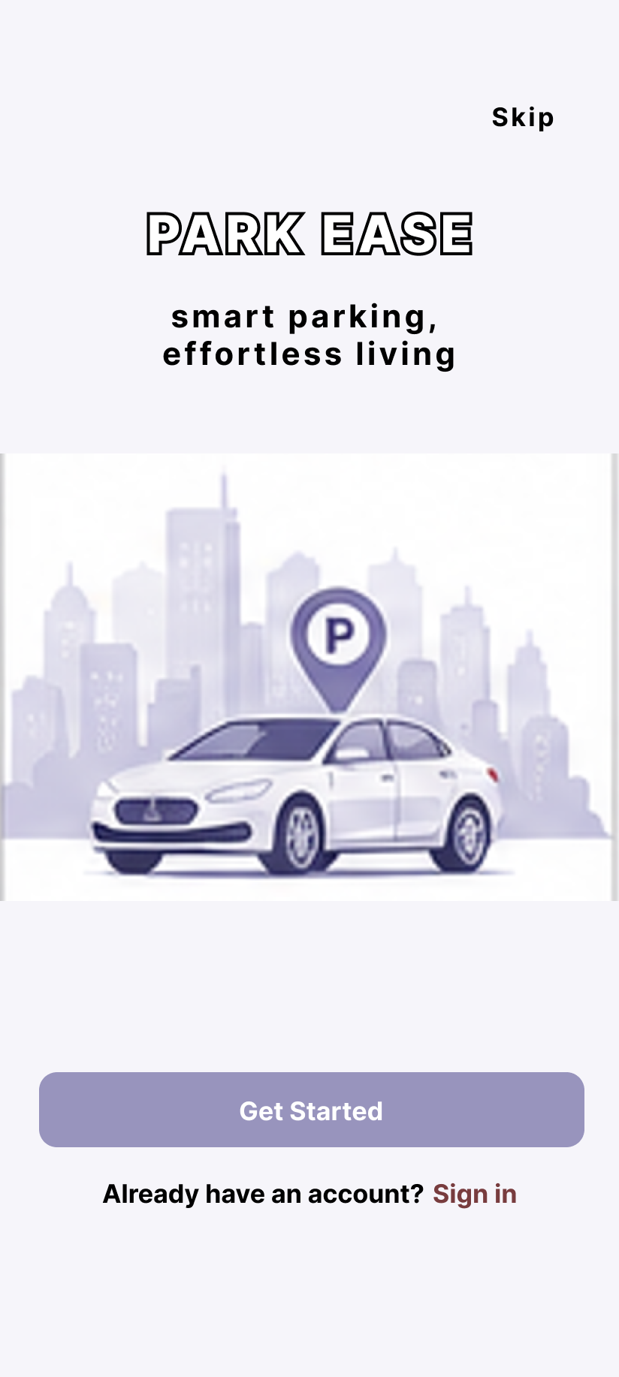

Welcome / Onboarding
The Welcome (Onboarding) screen introduces first-time users to the application through a branded hero visual and the core value proposition "smart parking, effortless living". It provides a "Skip" shortcut to the home dashboard, a prominent "Get Started" call-to-action that begins registration, and an "Already have an account? Sign in" link for returning users.
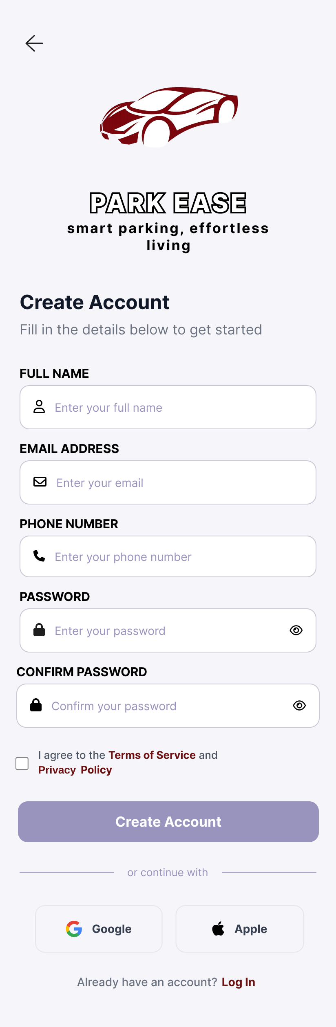

Login & Registration
The Registration screen enables new customers to create an account by capturing their full name, email address, phone number, and password with confirmation and a Terms of Service / Privacy Policy agreement. Complementing this, the Login screen provides secure authentication via registered email and password with field validation, a password-visibility toggle, a "Forgot Password?" path, social sign-in options, a link to registration, and a dedicated "Login as Admin" button that redirects to the administrative portal.
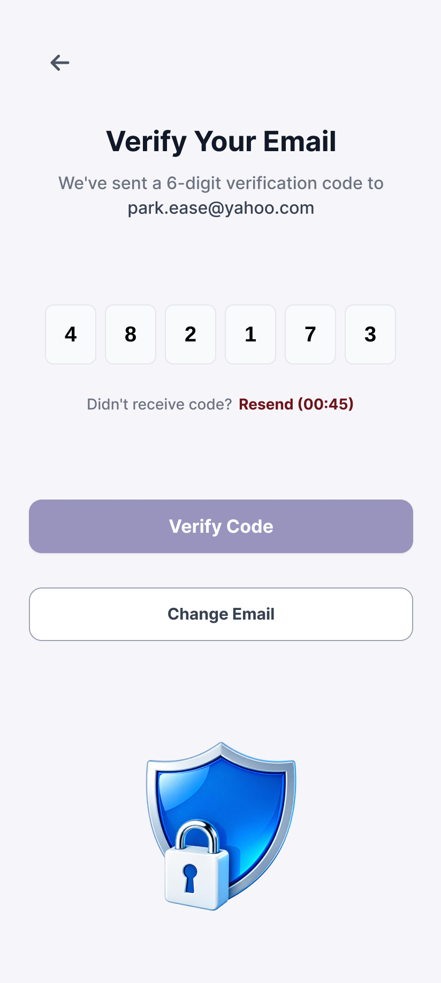

OTP Verification
The OTP Verification screen validates email ownership during registration by dispatching a six-digit code and presenting six auto-advancing input boxes with a Verify action and a 60-second "Resend" countdown, ensuring secure account activation.
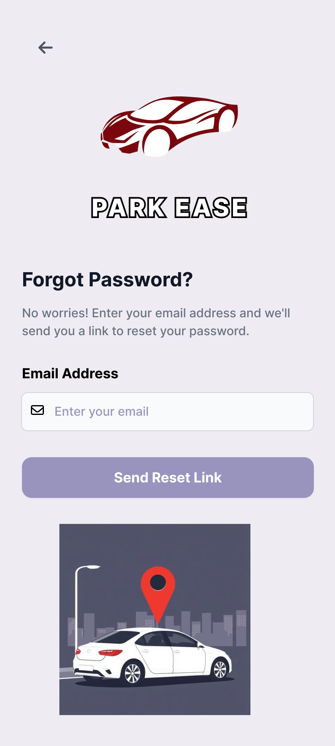

Forgot Password & Reset Password
The Forgot Password screen initiates credential recovery by accepting the user's registered email address and dispatching reset instructions through a "Send Instructions" action. The Reset Password screen then prompts the user to enter and confirm a new password with strength validation, while the Password Reset Successful screen confirms completion and offers a return path to login — delivering a seamless, self-service recovery flow.
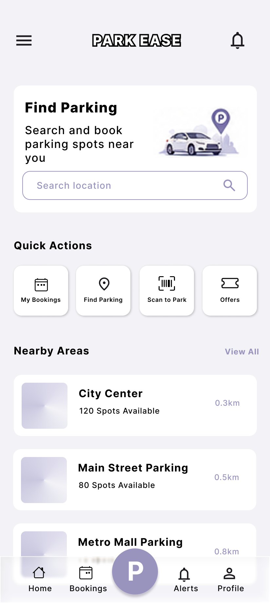

Home
The Home Screen serves as the primary dashboard for authenticated users, presenting a "Find Parking" hero card with a search action, a Quick Actions row (My Bookings, Find Parking, Scan to Park, and Offers), and a "Nearby Areas" listing of parking lot cards. Top-bar shortcuts provide access to notifications and the user profile, with a floating action button for rapid booking.
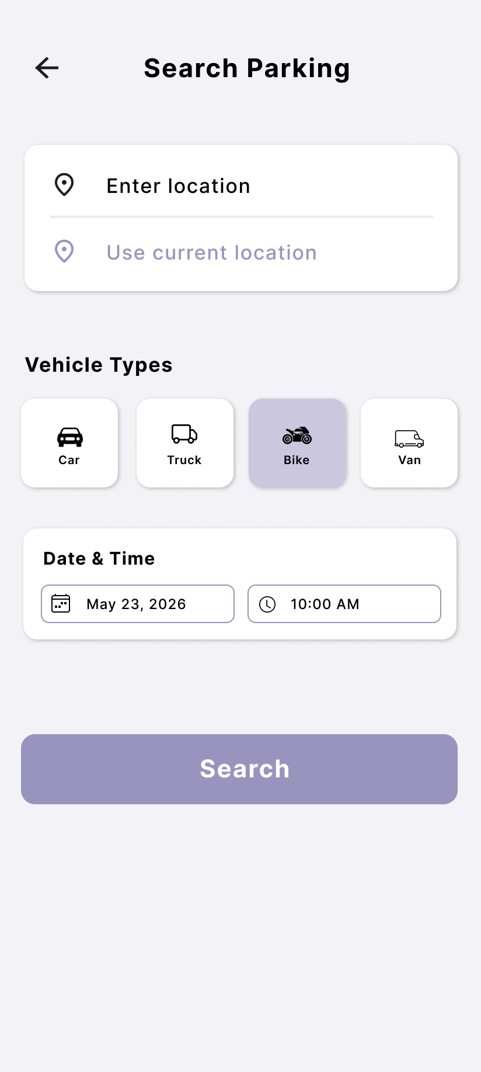

Search Parking
The Search Parking screen presents an interactive OpenStreetMap with a floating location search field, a current-location button, and parking-lot markers colour-coded by availability. A bottom results sheet lists matching facilities with name, address, available spots, and price, allowing users to open full parking details from either a marker or a card.
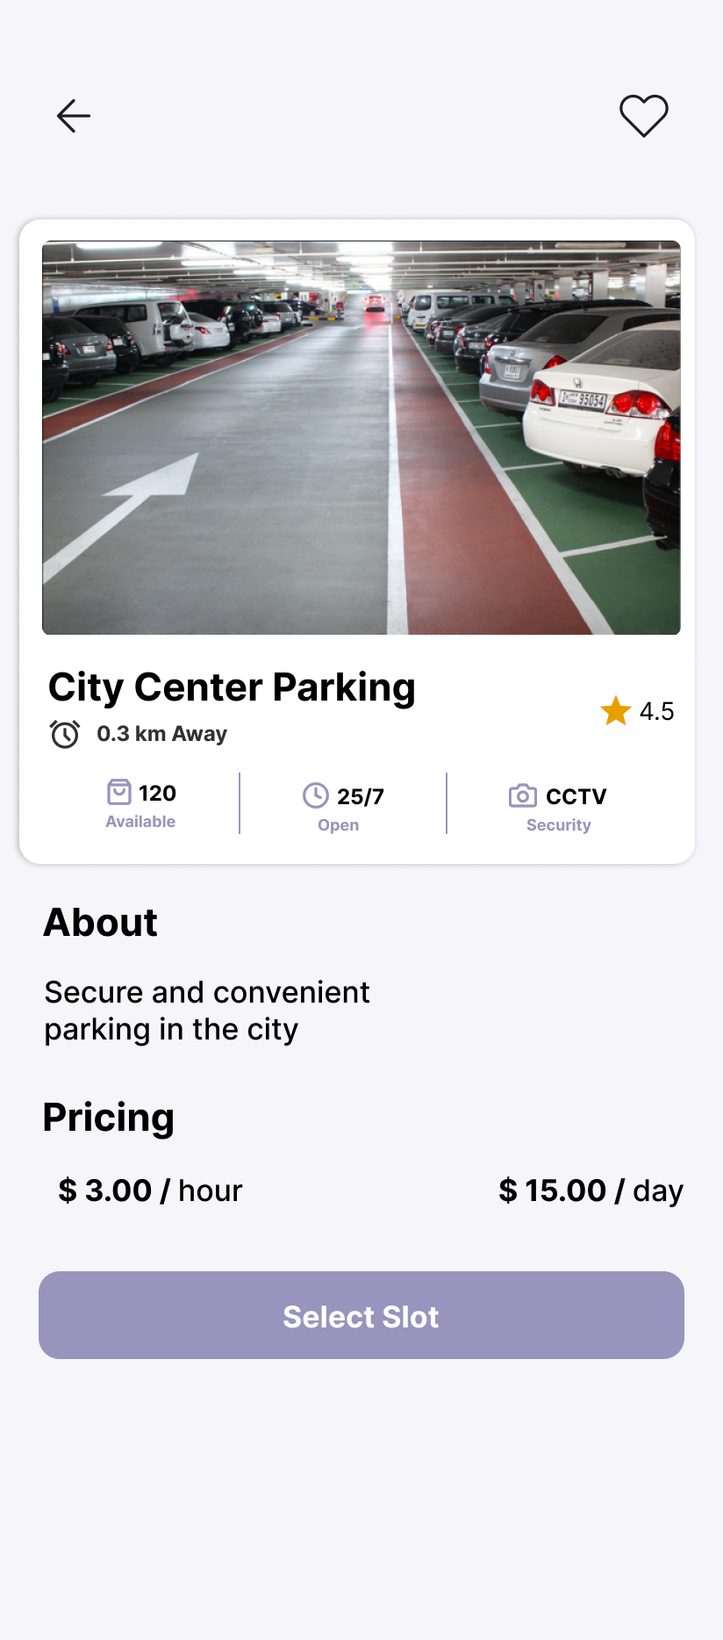

Parking Details
The Parking Details screen displays a comprehensive view of a selected facility, including an image header with share and favourite actions, an "Open" status badge, operating hours, key metrics such as available spots, EV charging and handicap provision, hourly and daily pricing, and amenity chips. A "Select Slot" action advances the user to slot selection.
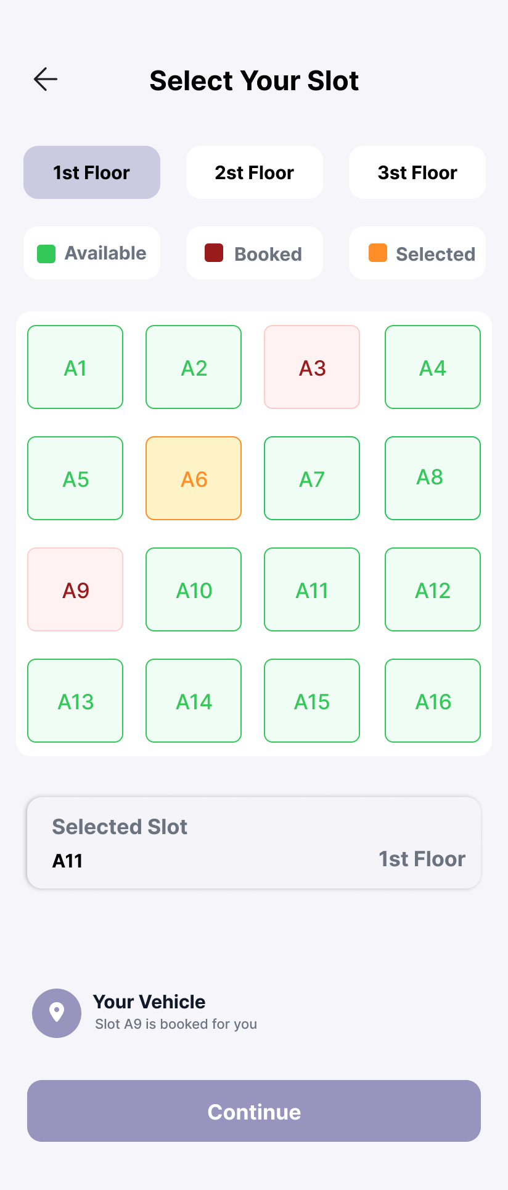

Select Parking Slot
The Select Parking Slot screen allows the user to choose a specific bay from a labelled slot grid (A1–A24), accompanied by a colour legend distinguishing Available, Occupied, and Reserved states for clear, at-a-glance selection.

Navigate to Parking
The Navigate Parking screen provides directional guidance to the booked facility, presenting a map view and a bottom sheet with the lot name, address, estimated drive time, and dedicated "Directions" and "Start Navigation" actions.
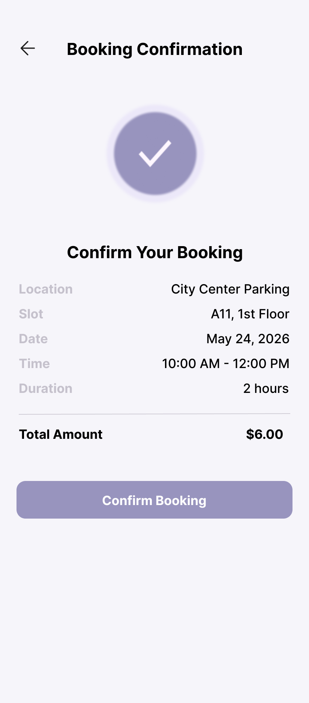

Booking Confirmation & Booking Details
The Booking Confirmed screen acknowledges a successful reservation with a summary card detailing the Booking ID, parking lot, slot, date, time, and amount, alongside "View Booking Details" and "Back to Home" actions. The Booking Details screen expands this into a full record — booking status, slot number, assigned vehicle, entry and exit times, duration, hourly rate, and total amount — with "Navigate to Parking" and "Share Booking" controls.
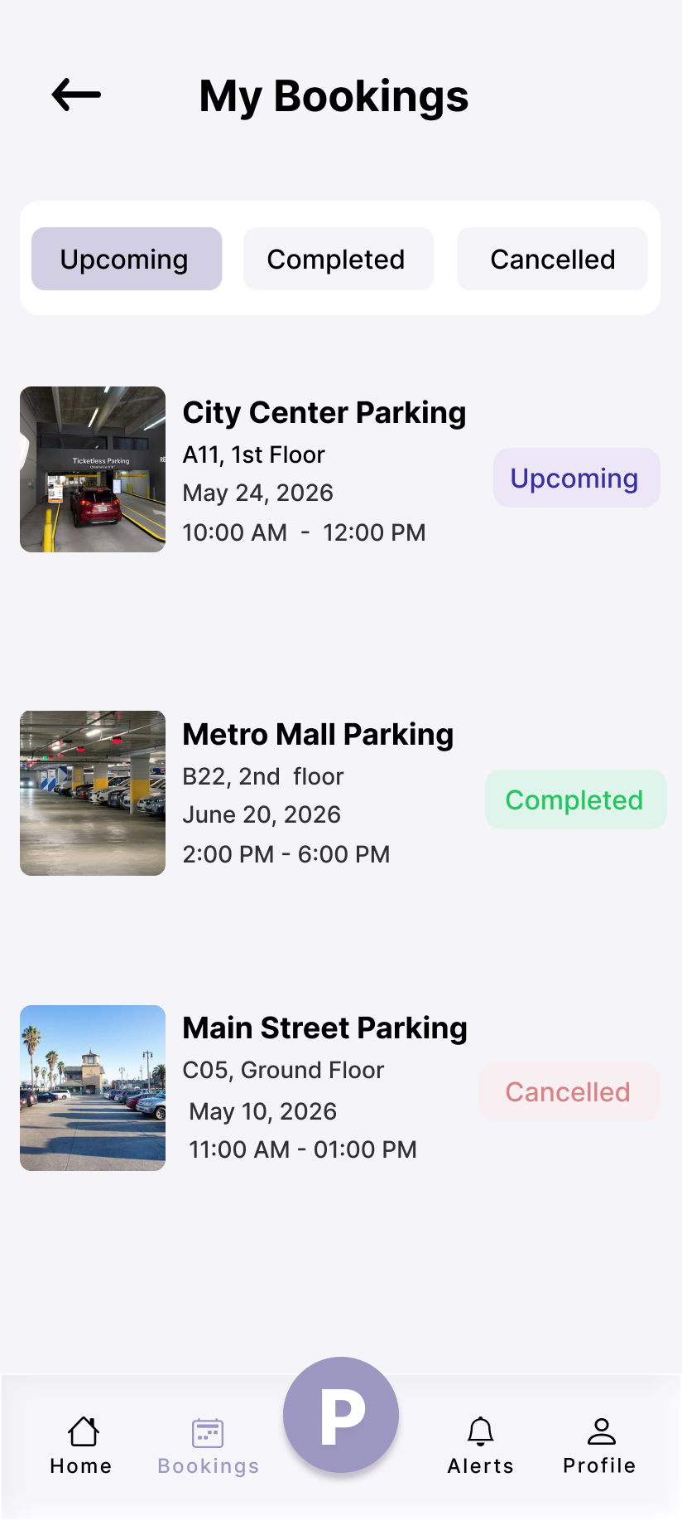

My Bookings
The My Bookings screen organizes reservations into Active, Upcoming, and History tabs, each rendering booking cards with status badges, lot and slot details, timing, amount, and contextual actions such as Navigate, Check Out, or Cancel for real-time trip management.
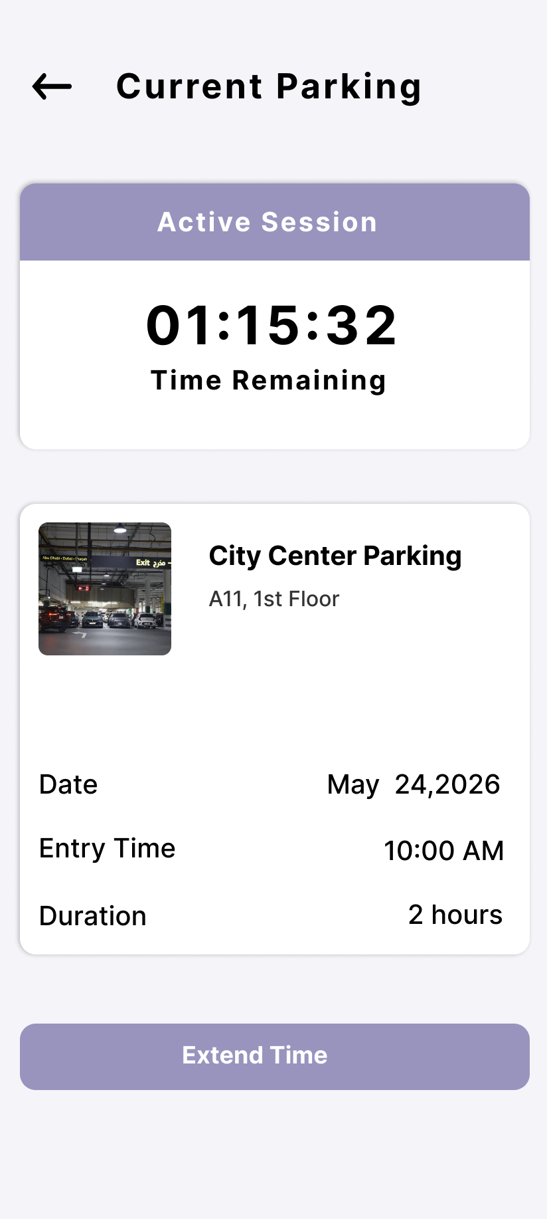

Current Parking
The Currently Parked screen tracks an active parking session, showing the lot, slot, start time, elapsed duration, running cost, and a QR/exit code, with an "End Parking" action to conclude the session.
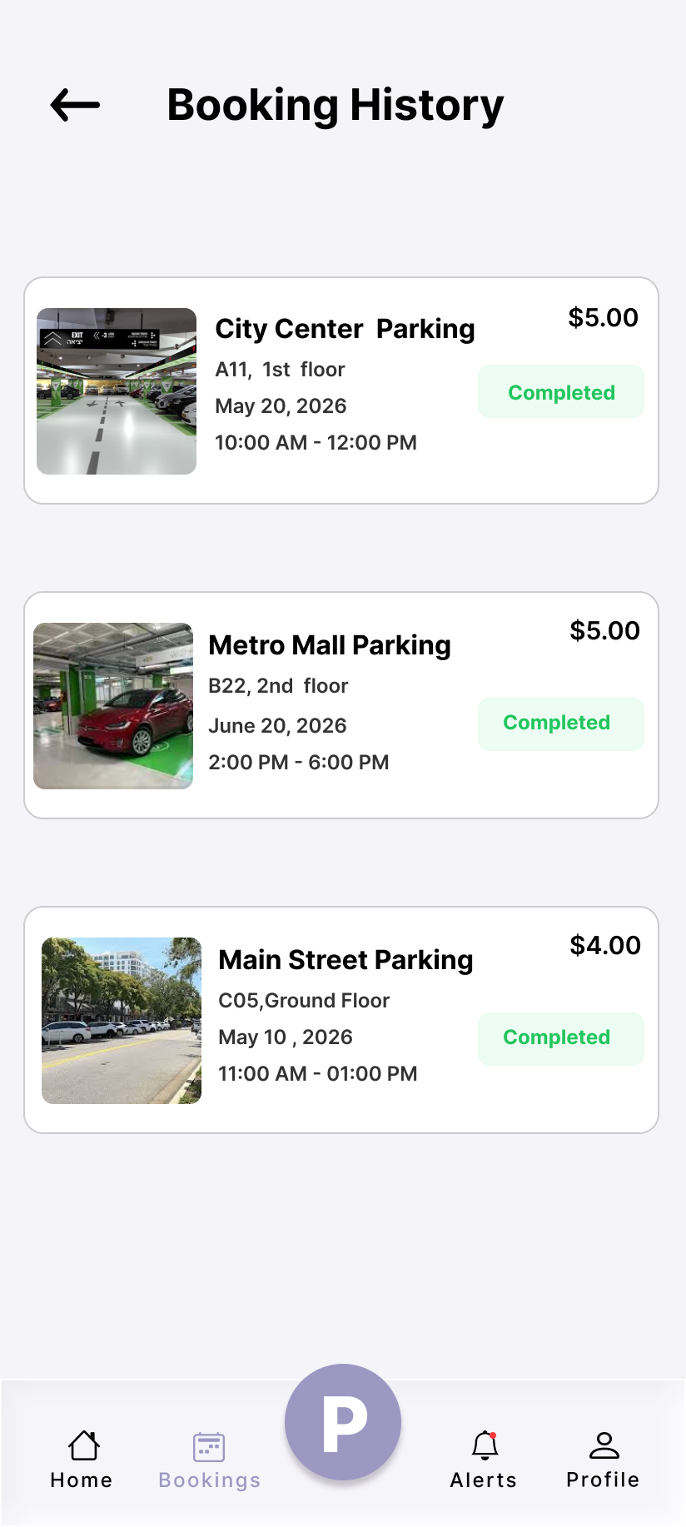

Booking History
The Booking History screen lists past reservations as cards marked Completed, Cancelled, or No Show, each showing the lot, slot, date, status, and amount, and opening the corresponding booking details on tap.
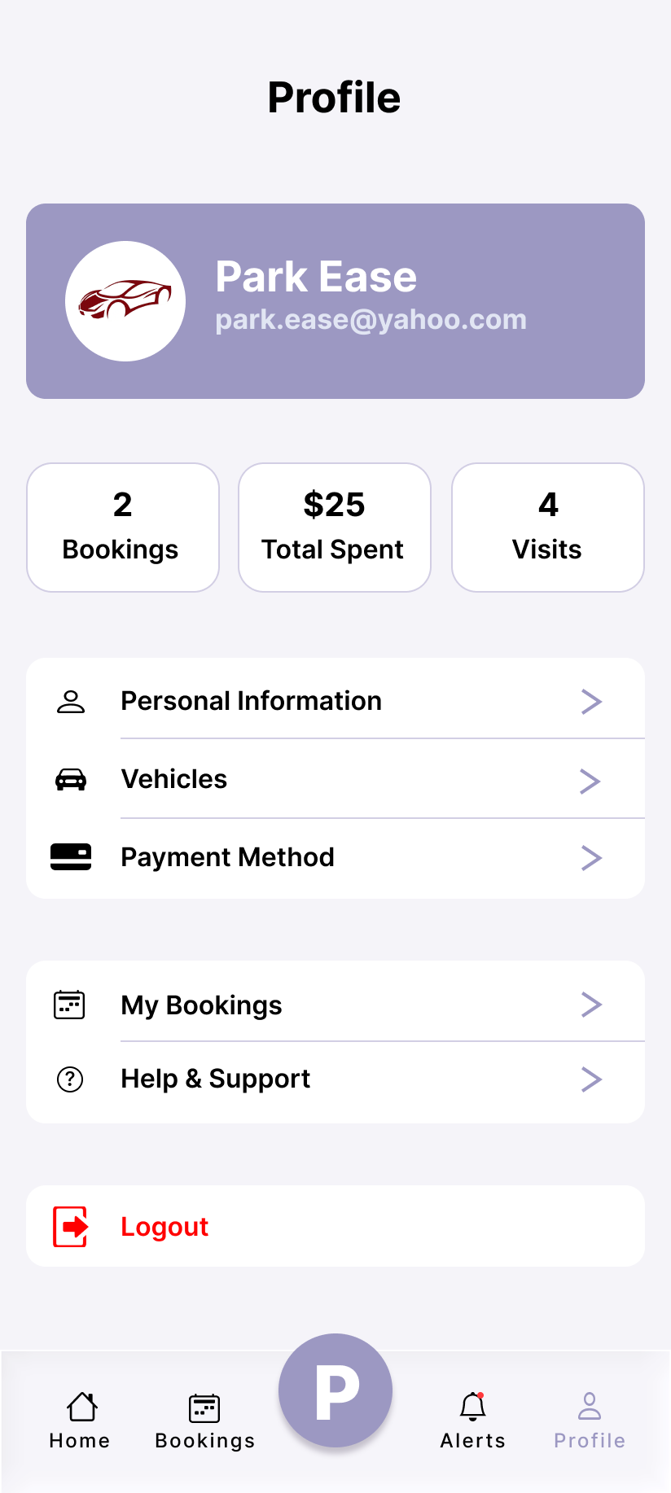

Profile
The Profile screen presents the user's avatar, name, email, and phone, and provides navigation to My Bookings, My Vehicles, Payments, Notifications, and Booking History, together with an edit shortcut and a Logout action that clears the session and returns to the welcome screen.
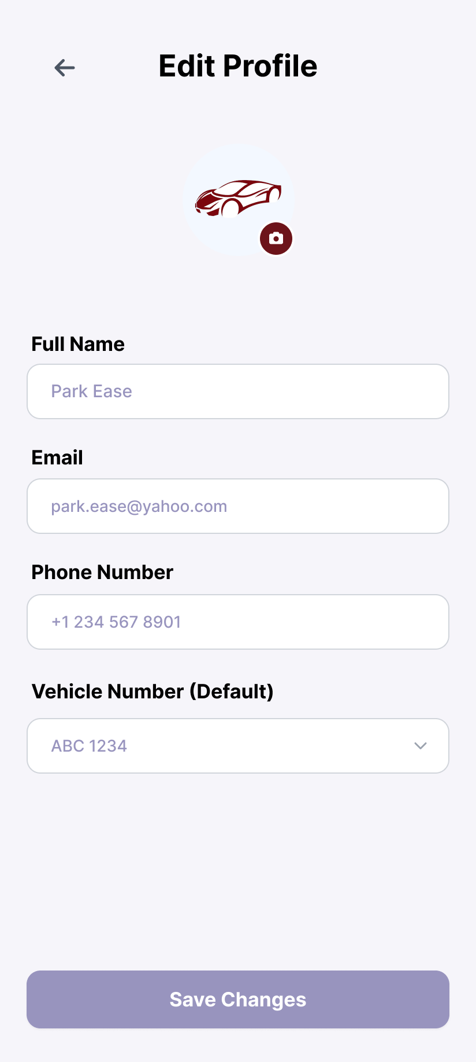

Edit Profile
The Edit Profile screen enables users to update their personal information, offering editable Full Name and Phone Number fields with a read-only email address and a "Save Changes" action that persists the update.
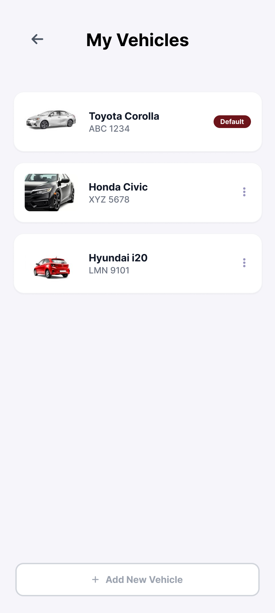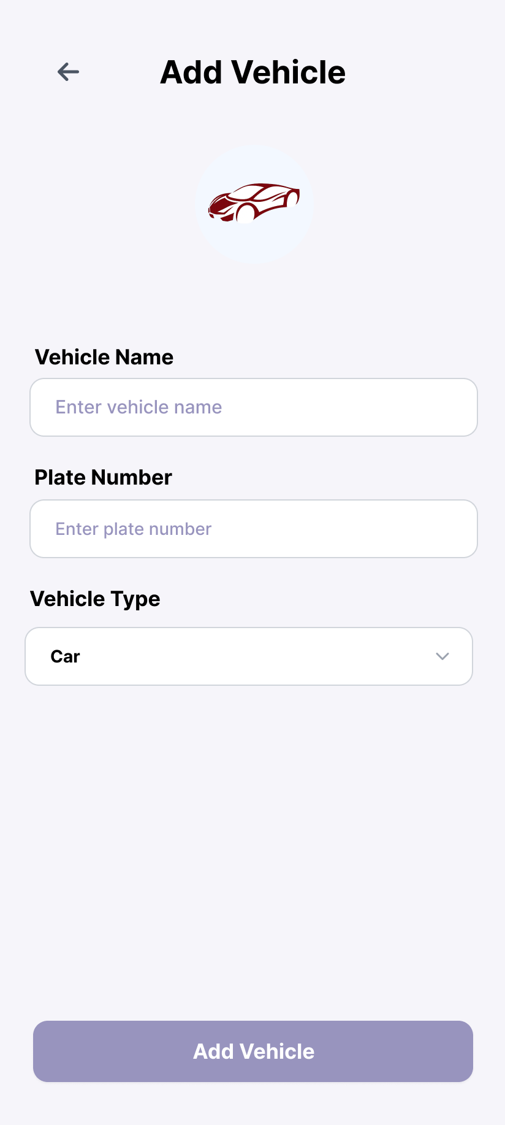

My Vehicles & Add Vehicle
The My Vehicles screen lists saved vehicles as cards showing the name, type/colour, licence plate, and a Default badge. The Add Vehicle screen captures vehicle type through filter chips (Car, Bike, Scooter, Truck) plus brand, model, licence plate, and colour, with a "Set as default vehicle" option and field validation before saving.
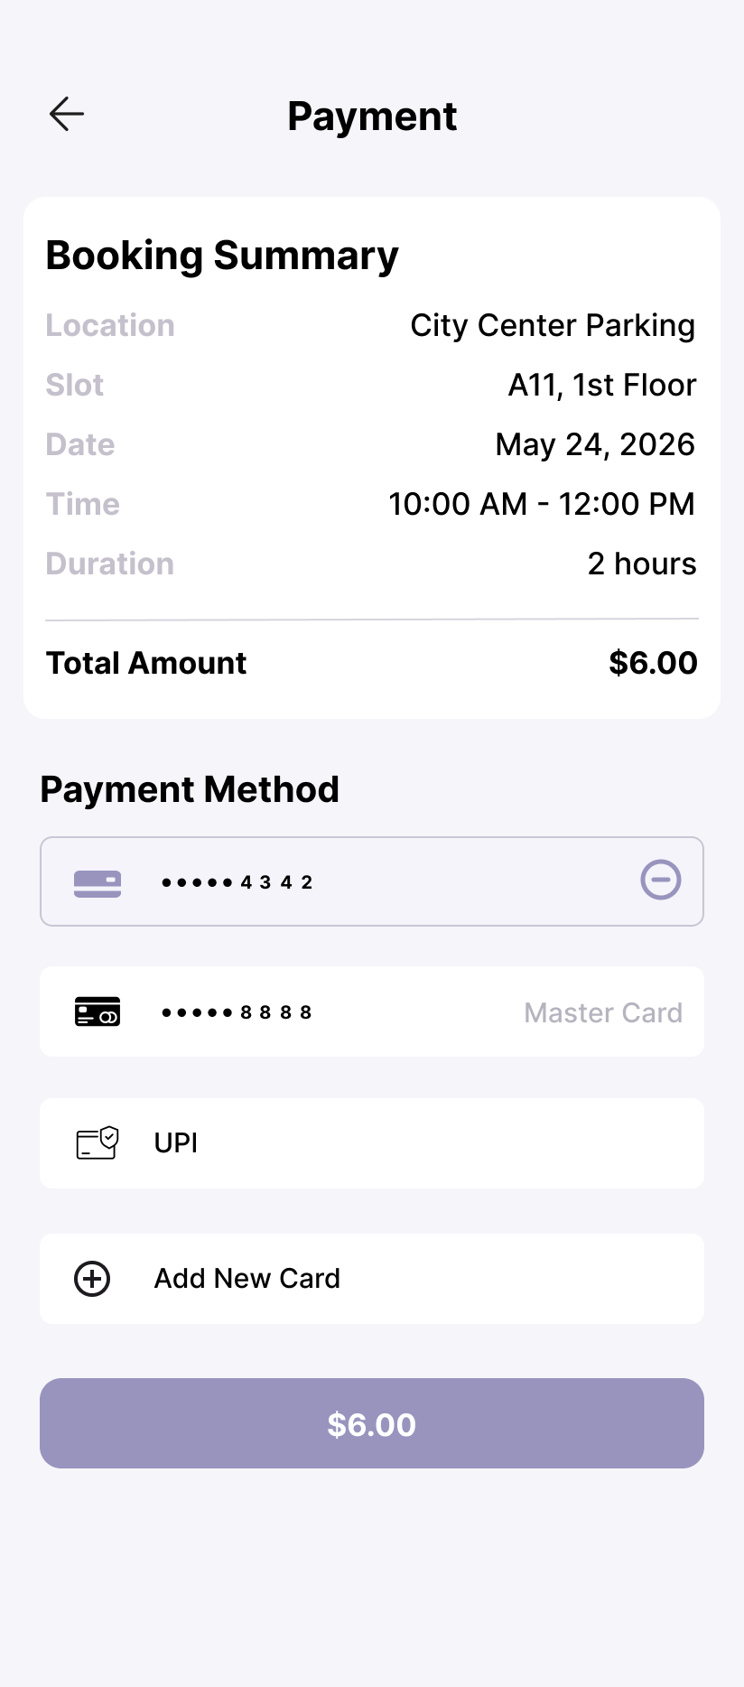

Payment
The Payment screen summarizes the total payable amount with a booking breakdown and presents selectable payment methods — Credit/Debit Card, UPI, Wallet, Net Banking, and Cash — to complete the transaction securely.
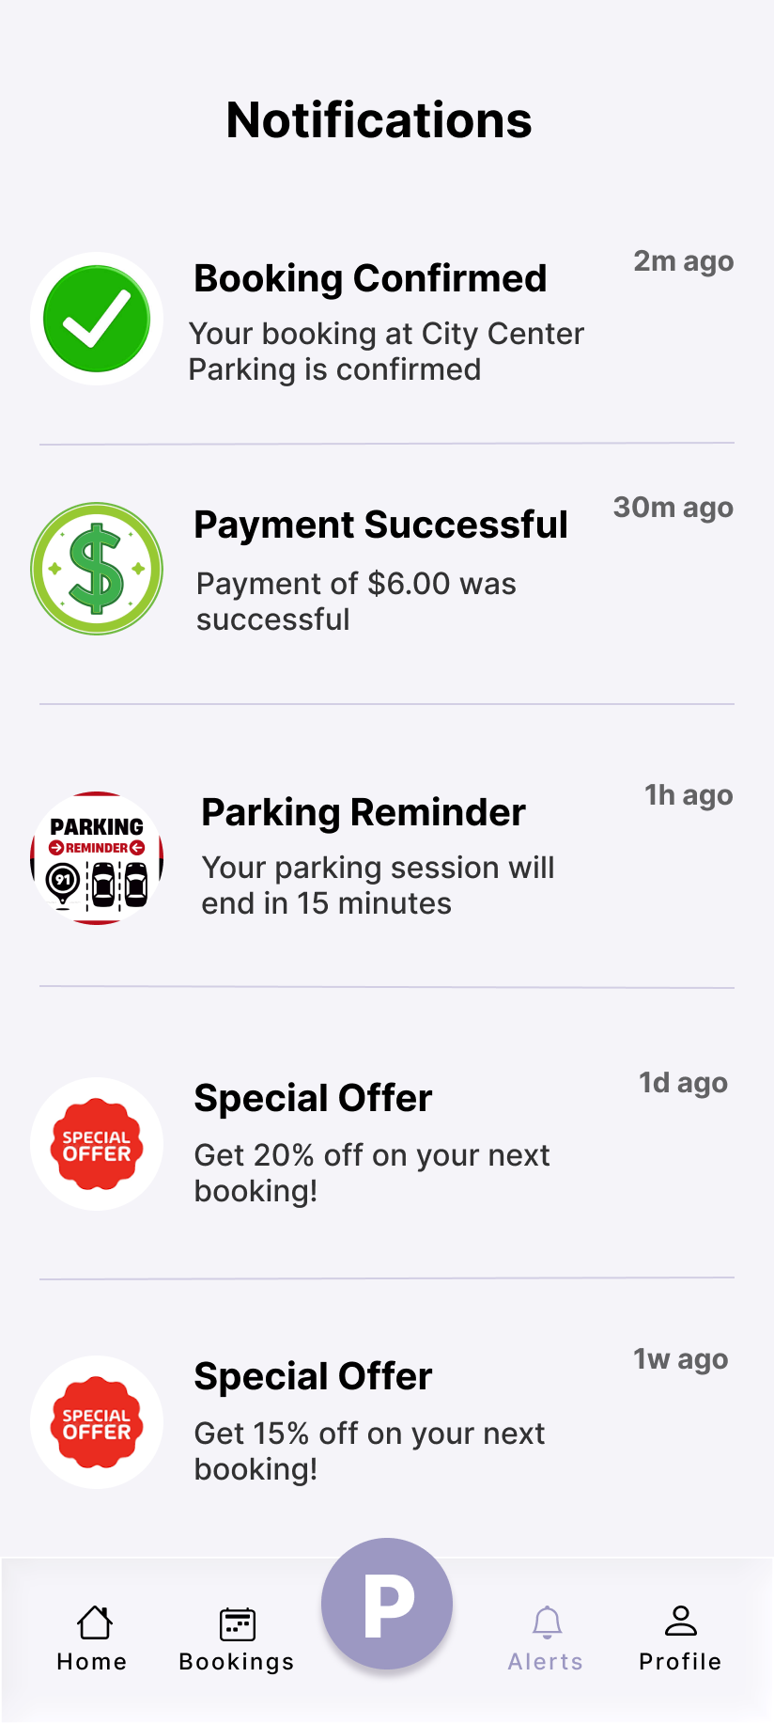

Notifications
The Notifications screen lists user alerts — booking confirmations, payment receipts, offers, reminders, and system updates — each with an icon, title, body, timestamp, and unread indicator, plus a "Mark all read" action.
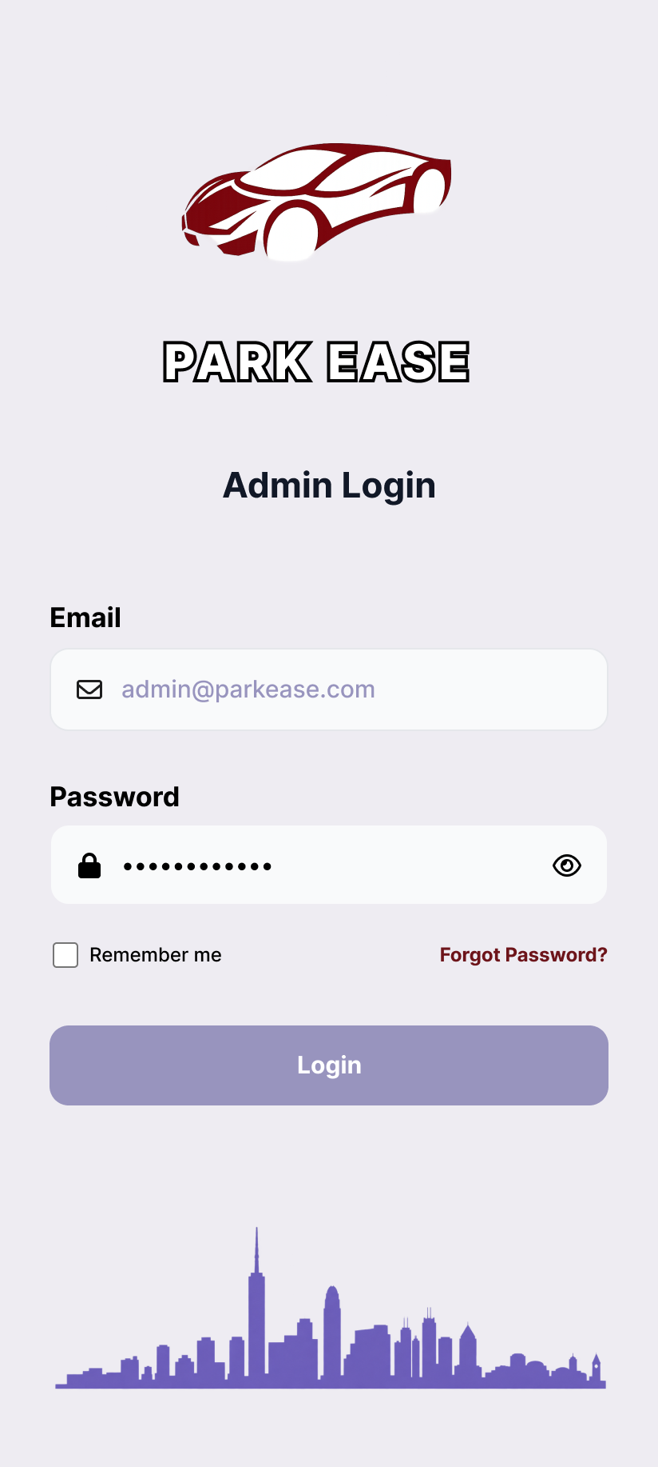

Admin Login
The Admin Login screen provides a dedicated, secure authentication portal for authorized store personnel, capturing email and password credentials. It verifies the administrative role on sign-in, routing valid administrators to the dashboard and rejecting non-admin accounts with an access-denied notice.

Admin Dashboard
The Dashboard Overview serves as the central administrative hub, presenting live metrics through statistic cards (Total Users, Active Bookings, Parking Lots, and Revenue) and a Quick Actions panel linking to Manage Users, Manage Parking Lots, Manage Bookings, Reports & Analytics, and Admin Notifications for effortless system control.
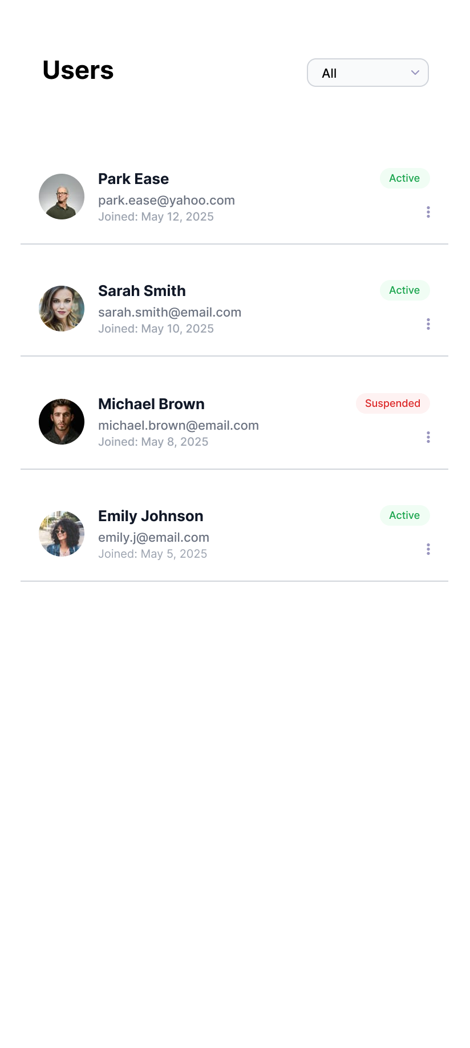

User Management
The User Management screen lists all registered accounts as cards displaying an avatar, full name, email address, phone number, role badge (User/Admin), and an active-status indicator, equipping administrators with a clear overview of the platform's user base and quick access to account actions.
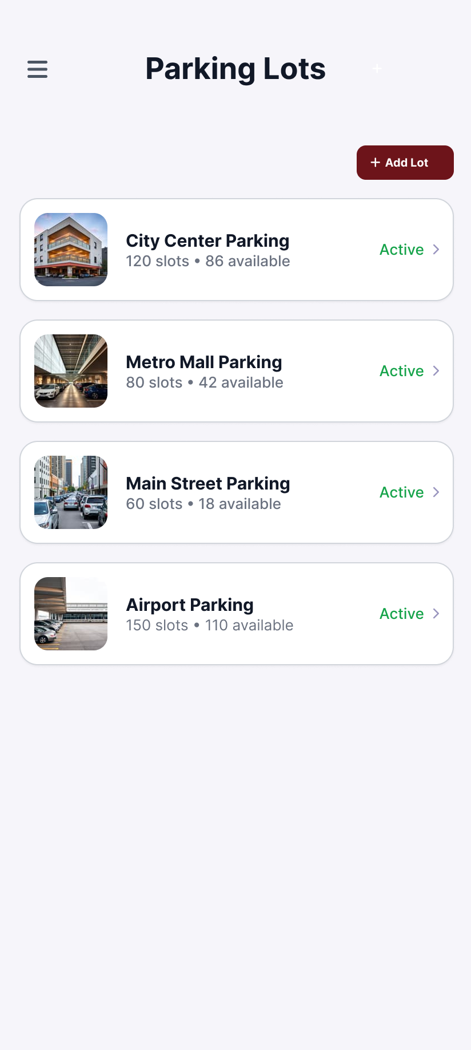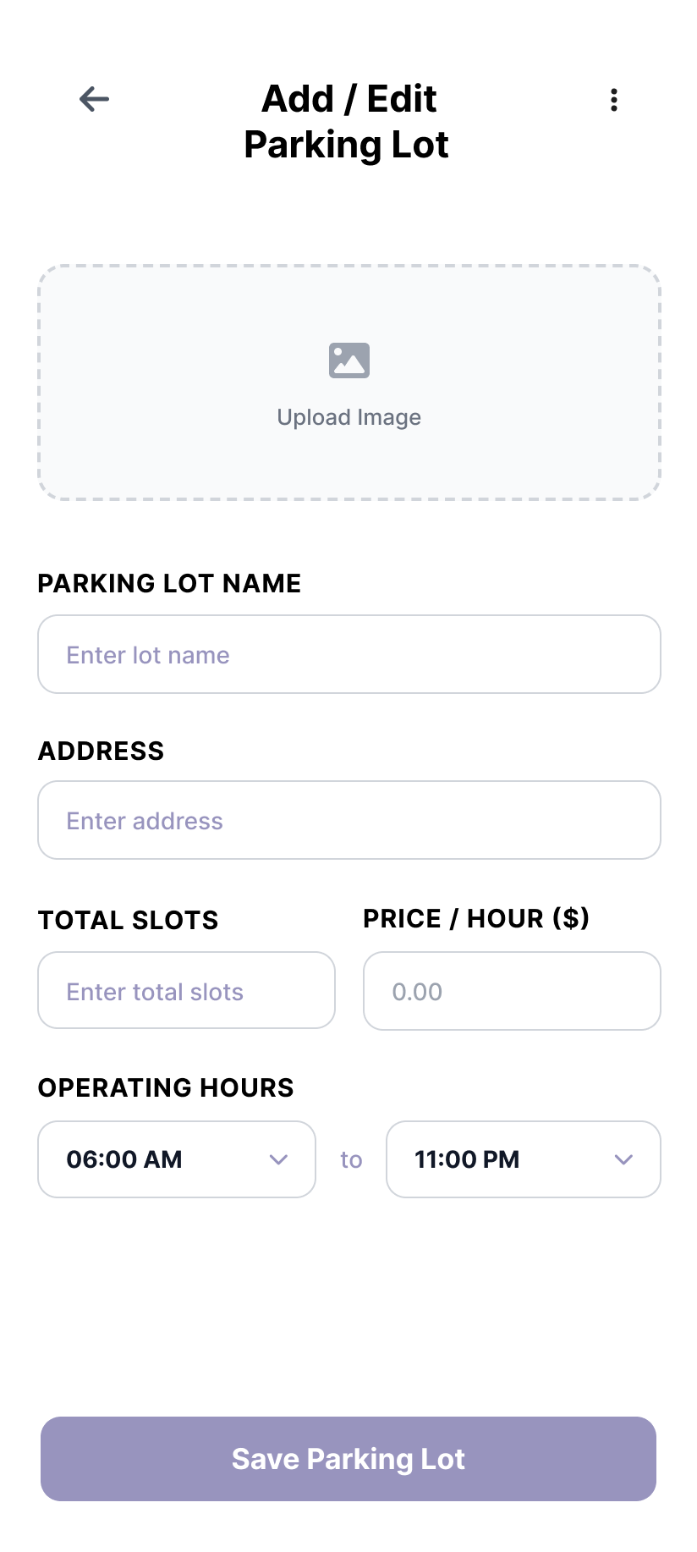

Manage Parking Lots & Add/Edit Parking Lot
The Manage Parking Lots screen presents each facility as a card with its name, spot count, hourly price, active/inactive status, and an edit action. The Add/Edit Parking Lot screen provides a form to create or modify a facility — name, address, latitude/longitude, total slots, hourly rate, and description — with "Add Parking Lot" and "Save Changes" controls to keep the catalogue current.
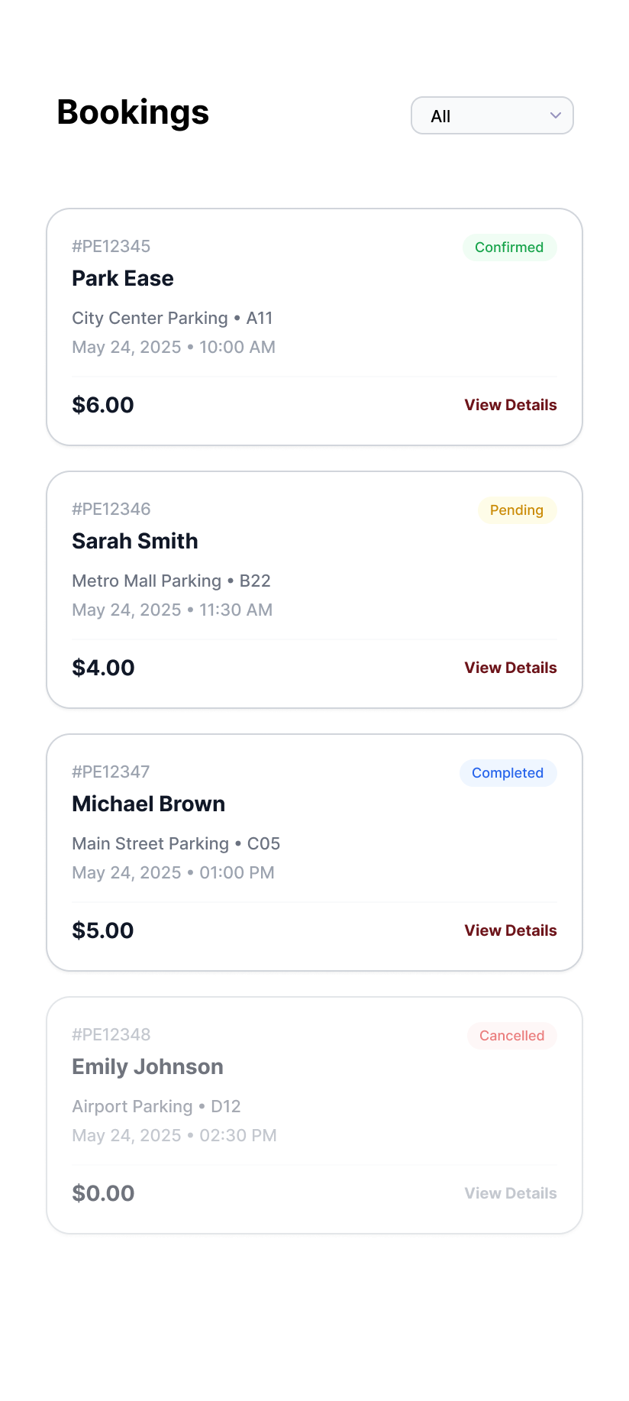

Manage Bookings & Booking Details
The Manage Bookings screen lists reservations as cards showing the user, parking lot, time, and a colour-coded status chip (Active, Confirmed, Completed), with each card opening the Booking Details view. The Booking Details screen provides an itemized record — booking ID, user and email, lot, slot, vehicle, entry/exit times, duration, hourly rate, total amount, payment method, and status — with Cancel and Check Out actions.
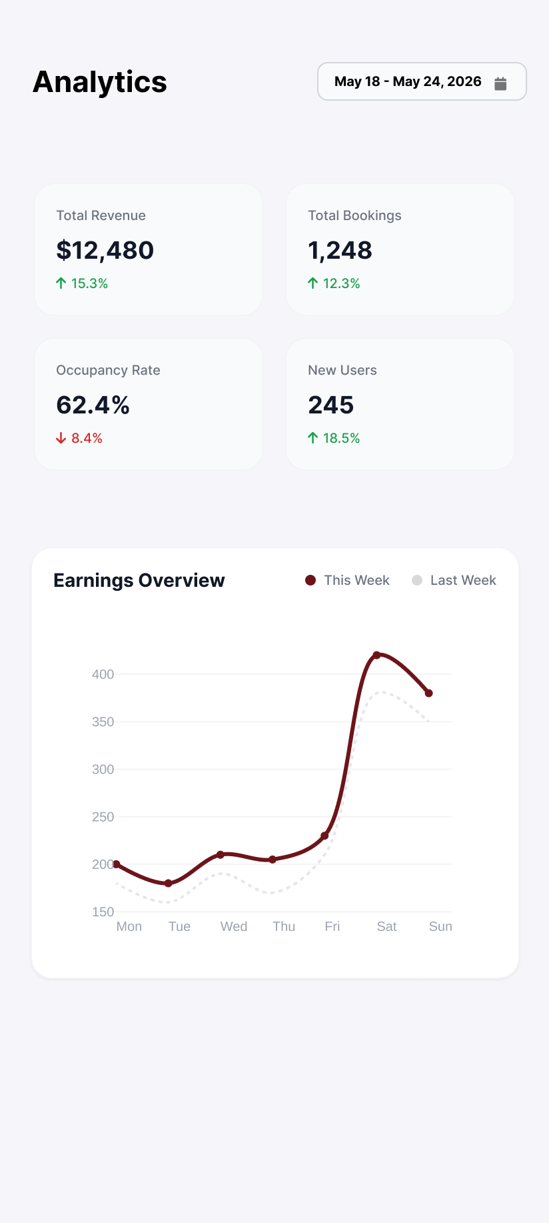

Reports & Analytics
The Reports & Analytics screen delivers business intelligence through summary cards (Total Revenue, Total Bookings, Average Booking value, and Occupancy Rate) and a seven-day Revenue Trend bar chart, enabling data-driven operational decisions.
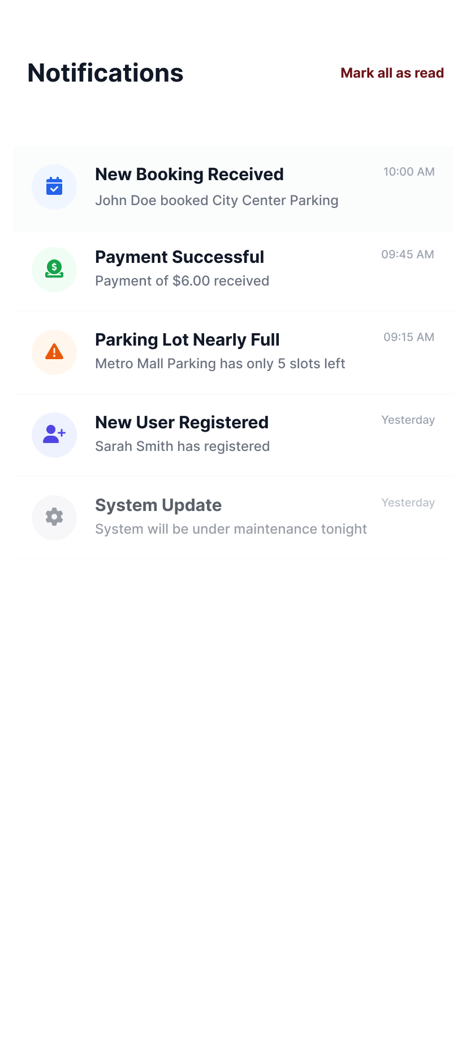

Admin Notifications
The Admin Notifications screen manages platform-wide communications, listing notices such as Maintenance Notices, Promotional Offers, and System Updates — each with an icon, title, body, and timestamp — and offering controls to add or edit notifications.

